User's Manual

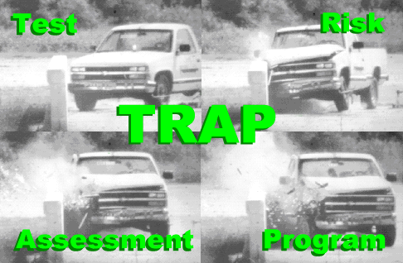

Test Risk Assessment Program (TRAP) Version 2.5.2

October 2022

Copyright ©Texas A&M Transportation Institute 1997-2022
Developed by CAPSHER Technology, Inc.
Info@capsher.com

Table of Contents
Introduction A-1
Using TRAP A-2
Data Input a-4
Data Input - Description Page A-5
Data Input - Settings Page A-6
Data Input - Acceleration at CG Page A-7
Data Input - Acceleration 1 Page A-8
Data Input - Acceleration 2 Page A-9
Data Input - Angular Rates Page A-10
Data Input - Yaw Angle Page A-11
ASCII Data Files And Binary Data Files A-12
Performing Calculations a-13
Results A-14
Graphs A-15
Graph Parameters Form - Graph Page A-16
Graphs Parameters Form - Plots Page A-17
Graph Parameters Form - Axes Page A-18
Tables A-19
Menu and Toolbar Reference a-20
File Menu A-20
Edit Menu A-21
Data Menu A-21
Graph Menu A-22
Table Menu A-22
Window Menu A-23
Toolbar A-24

Introduction
Test Risk Assessment Program (TRAP) is a program designed to determine the effectiveness of a roadside safety feature by analyzing data from a vehicle crash test of the feature and calculating standardized occupant risk factors.
TRAP calculates occupant risk factors in accordance with the National Cooperative Highway Research Program (NCHRP) guidelines and the European Committee for Standardization (CEN).
NCHRP Report 350 recommends two risk factors to be computed: (1) the lateral and longitudinal components of the Occupant Impact Velocity (OIV)) and (2) the highest lateral and longitudinal component of resultant vehicular acceleration averaged over any 10-ms interval subsequent to occupant impact also known as the Occupant Ridedown Acceleration (ORA).
These factors are determined by use of a “flail space” model, details of which were first presented in NCHRP Report 230. The occupant is idealized as a lumped mass, constrained within an idealized occupant compartment. Planar motion in the horizontal plane is assumed. When vehicular impact occurs the occupant moves freely within the compartment until contact is made with either the side or the front of the compartment. After contact, whether with the sides or front of the compartment, the occupant is assumed to stick and remain in contact with the compartment during the remainder of the event. As such, the occupant then experiences the same acceleration as does the vehicle, and these are referred to as “ridedown” accelerations.
Contact with the compartment occurs when the occupant moves left or right 0.3 m (y direction) or forward 0.6 m (x direction). The following procedure is used to calculate the risk factors of NCHRP Report 350:
For Criterion H and I, Table 5.1:
Vehicular accelerations in the x and y directions are double integrated, independently, to determine the time of first contact, either with the side of the compartment (0.3 m) or the front of the compartment (0.6m), whichever happens first. OIV in both the x and y directions are then computed at this time and reported. The larger value of the two is the OIV. Subsequent to contact, 10 ms moving average occupant ridedown accelerations (ORA) in the x and y directions are computed and the largest values are reported. The larger value of the two is the ORA. A “linear acceleration,” or “trapezoidal rule” integration procedure is used.
For Criterion L:
The above procedure is repeated, except the OIV in the x direction is selected at the time of contact (whether contact is with the side or front of the compartment), and the maximum ORA in the x direction subsequent to contact is selected.

CEN specifies three risk factors: (1) Theoretical Head Impact Velocity (THIV), (2) Post Impact Head Deceleration (PHD), and (3) the Acceleration Severity Index (ASI).

The following procedure is used to calculate the CEN risk factors:
CEN calculation procedures for THIV and PHD are similar to those used for OIV and ORA except that THIV equals the resultant of OIV components in the x and y directions at initial occupant contact and PHD equals the resultant of the ORA components in the x and y directions subsequent to initial occupant contact. There are two other differences: (a) vehicular yaw motions are accounted for in the CEN procedures but are neglected in the Report 350 procedures, and (b) the head (occupant) in the CEN procedures can be positioned forward of the vehicle’s center of gravity prior to vehicular impact whereas the occupant is always assumed to be located at the vehicle’s center of mass prior to vehicular impact in the Report 350 procedures.
Computation of the ASI involves the determination of moving 50 ms averages of vehicular accelerations in the x, y, and z directions. ASI is computed at each of these moving 50 ms intervals through an interaction formula using defined limits for the x, y, and z accelerations. The maximum value thus obtained is reported as the ASI.
Also computed and reported are maximum 50 ms average accelerations in the x, y, and z directions. Although not required in either the NCHRP Report 350 or the CEN evaluations, some agencies use these values as a measure of performance.
Also, if the combination of roll, pitch, and yaw rates are input, the program computes roll, pitch, and yaw angles with time in accordance with coupled Euler equations. Maximum roll, pitch, and yaw angles are then calculated and output on the "Results" page. The sequence for determining vehicular orientation is as follows: yaw, then pitch, then roll. The user may also plot roll, pitch, and yaw angles with time. To be noted is that in accordance with CEN requirements, the yaw angle data used in calculating THIV is determined based on the assumption that yaw angle is uncoupled (independent) from the roll and pitch angles. Hence, differences may occur between yaw angles computed by the two methods
For further details, see NCHRP report 350 and CEN document EN 1317-1:98 E for detailed information on testing procedures, data acquisition requirements, and computing the standardized occupant risk factors.

Using TRAP
A good way to get familiar with the capabilities of TRAP is to open the sample TRAP data file provided. The installation program for TRAP automatically copies the SAMPLE.TRP file to a Samples subdirectory under the main TRAP installation directory (C:\Program Files\Trap by default).
Opening an existing TRAP data file and viewing the results consists of the following steps:
- Opening an existing TRAP data file
If outside the TRAP program, use Windows Explorer or My Computer to navigate to the directory where the TRAP data file exists, and double click on the TRAP data file. The TRAP program will automatically open with the selected TRAP data file.

If inside the TRAP program, select the Open command from the File menu. This will bring up the standard File Open dialog box. Navigate to the directory where the TRAP data file exists, select the appropriate file, and click the OK button. NOTE: the sample file provided with TRAP (SAMPLE.TRP) was installed in C:\Program Files\Trap\Samples by default

- Running the calculations
After opening a data file (e.g., SAMPLE.TRP), TRAP will automatically run the calculations.
- Viewing the results
After the calculations have run, the Test Summary report view will automatically come up showing a summary of the occupant risk factors calculated. TRAP will only calculate the occupant risk factors for which sufficient data are available. If TRAP is unable to compute an occupant risk factor due to missing data, this will be indicated by the note “N/A” in the Test Summary report (see Performing Calculations for more information). You can also view graphs and tables generated by TRAP by selecting which graph or table you wish to see from the Graphs or Tables menu. TRAP will only display graphs and tables for which data are available.
- Viewing and/or modifying the Input Data (optional)
After opening an existing TRAP data file, you can view and/or modify the input data by selecting the Input Data command from the Data menu. This will bring up the Data Input form. If you modify any of the input data and click the OK button, TRAP will automatically rerun the calculations. Clicking the Cancel button on the Data Input form will discard any modifications you have made to the input data and will not rerun the calculations.

You can also use TRAP to analyze data from a new crash test.
Analyzing data from a new crash test with TRAP consists of the following steps:

1. Gathering the required data
In order for TRAP to compute all the results it is capable of calculating, it needs X, Y and Z vehicular accelerations and roll, pitch and yaw rates of the vehicle.
TRAP is capable of handling situations where all the data it needs is not available. In this case it will calculate what it can with the available data. See Performing Calculations for detailed information.
The acceleration data required consists of 3 individual components of acceleration (x, y, and z) measured by a triaxial accelerometer mounted at or near the vehicle’s center of gravity.
Sometimes the triaxial accelerometer cannot be mounted at or near the vehicle’s center of gravity, in which case two triaxial accelerometers must be mounted along the vehicle’s longitudinal centerline and two sets of acceleration data are required as well as the distances the two accelerometers are from the vehicle's center of gravity.
In either case, all acceleration data must be recorded at the same uniform frequency and should have the same time duration.
The yaw data can be in the form of yaw rate, which may have a different sampling rate than the acceleration data, or yaw angle vs. time where the time must be explicitly specified and does not have to correspond to the points in time that accelerations are measured.
It is recommended that yaw rate be used if available.
The data recorded during the crash test can exist in one or more files. For example the x, y, and z components of acceleration could be stored as individual columns within the same file, or each could be stored in separate files. See ASCII data files and Binary data files for more information on the required format of the files.

2. Creating a new TRAP data file
Run the TRAP program and select the New command from the File menu.
This will bring up the Data Input form.

3. Entering the required data using the Data Input form
Fill in the fields on the Data Input form and then click OK.

4. Running the calculations
TRAP automatically runs the calculations after the OK button is clicked on the Data Input form. If some data has not been entered then some or all of the items shown on the report may be unavailable (marked N/A). In addition some or all the graphs and tables may be unavailable.

5. Reviewing the results
TRAP calculates the standardized occupant risk factors and displays them in the results report view.
TRAP can also display certain information in graphical or tabular format.
See Results for further information.

6. Saving the TRAP file.
You should save the TRAP file by selecting the Save command from the File menu before exiting the program. The raw input data will be saved with the TRAP file if this option has been selected on the Settings Page of the Data Input form. See Data Input – Settings Page for more information.

Data Input
The user enters the data necessary for TRAP on the Data Input form. This form is a multipage form consisting of the following pages: Description Page, Settings Page, Acceleration Page(s), Angular Rates Page, and Yaw Angle Page

In general, you should step through each page sequentially entering the required data.

Once you have entered the data on all the pages, click OK
TRAP will automatically run the calculations.
See Running the Calculations and Viewing Results for more information.

TRAP uses the sign convention documented in NCHRP report 350 as shown in the figure below. It is very important that all input data (accelerations, angular rates and / or angles) use this same sign convention.
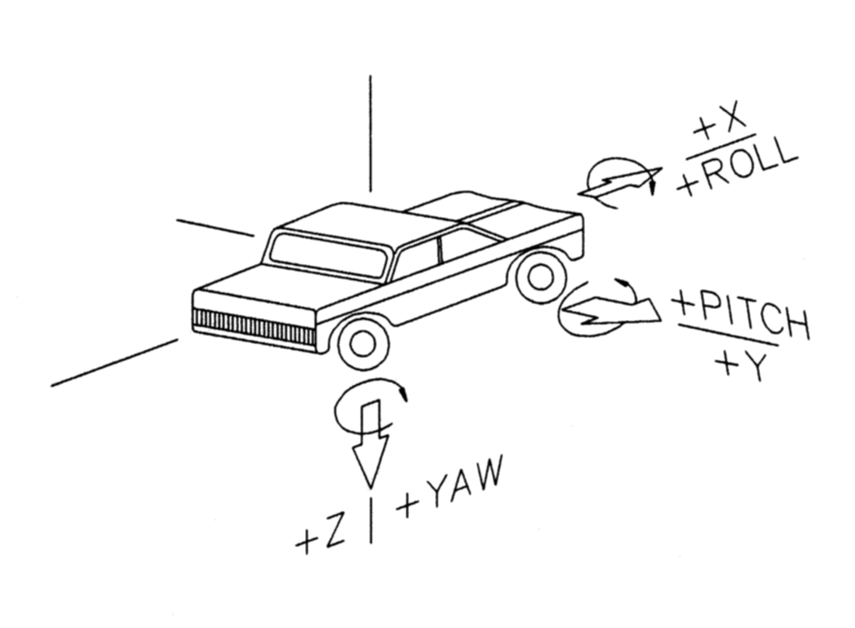
Sign Convention used by TRAP

Data Input - Description Page
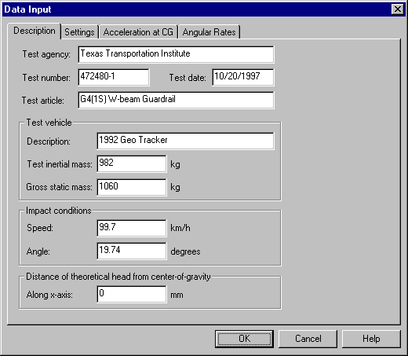
The Description page allows you to enter general descriptive information about the current test you are analyzing. Most of the data on this page is for reference only and not used in the calculations.

Test agency, Test number, Test date, Test article:
These fields contain descriptive information about the test and are for reference only. The values entered here will be shown on the Results report view.

Test vehicle:
The fields in this box are for reference only. They are not used in any calculations. The values entered here will be shown on the Results report view.

Impact conditions:
Specify the speed and angle of the impact. These values are for reference only. They are not used in any calculations. The calculations are all based on the relative motion of the occupant with respect to the vehicle’s interior and are not effected by the impact speed or impact angle. The values entered here will be shown on the Results report view.

Distance of theoretical head from center-of-gravity:
The theoretical head used in determining the THIV and the PHD is assumed to be located at the vehicle's center of mass. Specify a non-zero value here only if the theoretical head is positioned forward of the vehicle’s center of gravity. This value is used by the calculations.
Once you have filled the fields on this page, go on to the Settings page.
Data Input - Settings Page
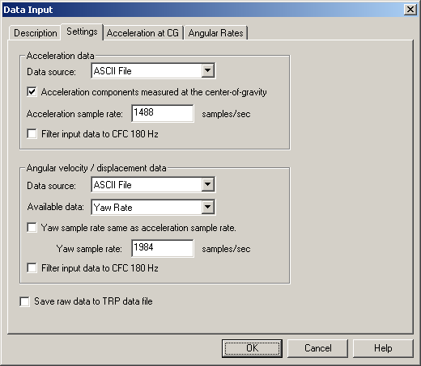
The Settings page allows you to specify information about the files that contain data from the test.

Acceleration components measured at the center-of-gravity
Check this box if the triaxial accelerometer recording the accelerations is mounted at or very near the center of gravity of the test vehicle.
If the accelerometer cannot be mounted at the vehicle’s center of gravity, then two triaxial accelerometers must be used and mounted along the vehicle’s longitudinal centerline. In this case, this box should be left unchecked and two sets of X,Y,and Z acceleration data will be required.

Data source
Specify whether the input file is ASCII or Binary. The data source can also be “Current .TRP File” if the raw data has been saved in the TRAP data file. (See “Save raw data…“ below.) If “Current .TRP file” is selected, then any fields used for reading data from file will be disabled, including fields on the Acceleration, Angular Rates, and Yaw Angle tabs. Changing the data source from “Current .TRP File to ASCII or Binary will permit the data source to be changed on the Acceleration, Angular Rates, and Yaw Angle tabs.

Acceleration sample rate
Specify the number of samples per second at which the acceleration data was recorded.

Filter input data to CFC 180 Hz
Specify that data read in from file should be filtered using CFC 180 Hz filter before they are used in calculations. Leave this unchecked only if the data in the file has already been filtered through hardware or some other preprocessing.

Available data
Specify whether the angular data is Yaw Angle or Yaw Rate. Yaw rate is preferred. It is obtained by onboard instrumentation measuring yaw rate.
If you do not have yaw rate data available you can enter yaw angle vs. time instead and TRAP can calculate yaw rate. Yaw angle vs. time is sometimes obtained by measuring yaw angle from individual frames recorded by an overhead camera.

Yaw sample rate same as acceleration sample rate
Check this box if the yaw sample rate is the same as the sample rate used for the acceleration data.
Yaw sample rate
Specify the number of samples per second at which the yaw rate data were recorded.
Note: If roll and pitch rates are also input, the number of samples per second at which the roll and pitch rate data were recorded must equal that for the yaw rate data.
Save raw data to TRP data file
Checking this box will cause the raw acceleration data to be stored in the TRAP data file the next time the TRAP file is saved. This allows the analysis to be run without accessing the raw data files. It also makes transferring data sets easier because a single .TRP file can be sent without having to send the raw data files. When unchecked, the acceleration data is read in each time from the individual raw data files specified on the Acceleration, Angular Rates, and Yaw Angle tabs.

Once you have filled the fields on this page, go on to the Acceleration page(s).

Data Input - Acceleration at CG Page
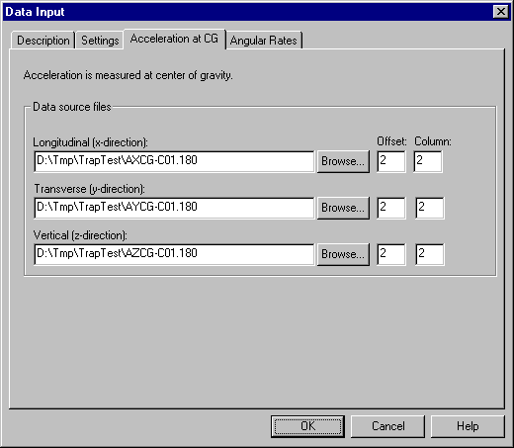
This page allows you to specify information about the data source file(s) containing the vehicular acceleration data. This page will be shown if you specified that accelerations were measured at or near the vehicle's center of mass on the Settings page, otherwise the Acceleration -1 and Acceleration - 2 pages will be shown and you will have to enter in two sets of acceleration data.
Note: If Data Source is set to “Current .TRP File” on the Settings form, then all the fields on this form will be read-only, and they will show the original file information for the data that is being used from the current TRAP file.

Data source files:
Specify file names for X, Y, and Z data files. The Browse button will allow you to browse for the files. NOTE: the acceleration data must be in G’s.

Offset, Column
These fields allow you to specify the column number for the data within the specified data source file and the number of rows to skip (offset) for header information, etc. before reading the data.
See ASCII data files and Binary data files for more information on file formats.

Once you have filled the fields on this page, go on to the Angular Rates or the Yaw Angle Page.

Data Input - Acceleration 1 Page
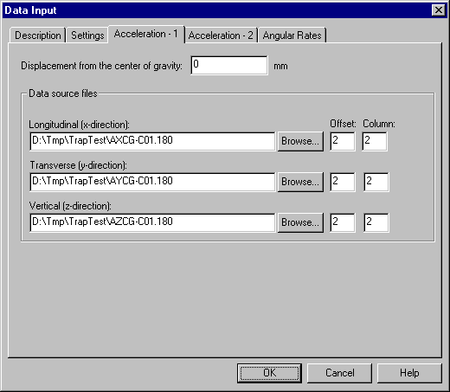
This page allows you to specify information about the data source file(s) containing the vehicular acceleration data. This page will be shown if you specified that accelerations were not measured at or near the vehicle's center of mass on the Settings page, otherwise the Acceleration at CG page will be shown and you will only have to enter in one set of acceleration data.
Note: If Data Source is set to “Current .TRP File” on the Settings form, then all the fields on this form will be read-only, and they will show the original file information for the data that is being used from the current TRAP file.

Displacement from center of gravity:
Enter the displacement from the center of gravity for this measurement.
The value entered is the distance along the longitudinal axis of the vehicle (x-axis) from the vehicle's center of gravity to the accelerometer. Distances forward of the center of gravity are positive, and distances aft of the center of gravity are negative. The distance is required to be in millimeters.
NOTE: This field is only shown if the acceleration data was not measured at or near the vehicle’s center of gravity.

Data source files:
Specify file names for X, Y, and Z data files. The Browse button will allow you to browse for the files. NOTE: the acceleration data must be in G’s.

Offset, Column
These fields allow you to specify the column number for the data within the specified data source file and the number of rows to skip (offset) for header information, etc. before reading the data.
See ASCII data files and Binary data files for more information on file formats.
Once you have filled the fields on this page, go on to the Acceleration - 2 Page.

Data Input - Acceleration 2 Page
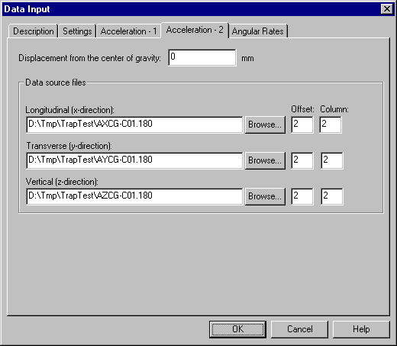
This page allows you to specify information about the data source file(s) containing the vehicular acceleration data. This page will be shown if you specified that accelerations were not measured at or near the vehicle's center of mass on the Settings page, otherwise the Acceleration at CG page will be shown and you will only have to enter in one set of acceleration data.
Note: If Data Source is set to “Current .TRP File” on the Settings form, then all the fields on this form will be read-only, and they will show the original file information for the data that is being used from the current TRAP file.

Displacement from center of gravity:
Enter the displacement from the center of gravity for this measurement.
The value entered is the distance along the longitudinal axis of the vehicle (x-axis) from the vehicle's center of gravity to the accelerometer. Distances forward of the center of gravity are positive, and distances aft of the center of gravity are negative. The distance is required to be in millimeters.
NOTE: This field is only shown if the acceleration data was not measured at or near the vehicle’s center of gravity.

Data source files:
Specify file names for X, Y, and Z data files. The Browse button will allow you to browse for the files. NOTE: the acceleration data must be in G’s.

Offset, Column
These fields allow you to specify the column number for the data within the specified data source file and the number of rows to skip (offset) for header information, etc. before reading the data.
See ASCII data files and Binary data files for more information on file formats.
Once you have filled the fields on this page, go on to the Angular Rates or the Yaw Angle Page.

Data Input - Angular Rates Page
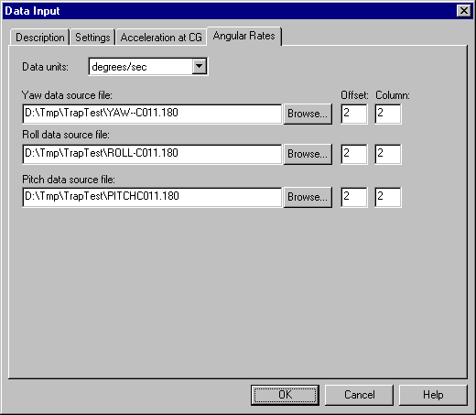
The Angular Rates page allows you to enter yaw rate data of the vehicle vs.
time. As an option, you may also enter roll and pitch rate data.

This page is only shown if you specified yaw rate on the Settings page. The Yaw Angle page is shown if you specified yaw angle on the Settings page.
Note: If Data Source is set to “Current .TRP File” on the Settings form, then all the fields on this form will be read-only, and they will show the original file information for the data that is being used from the current TRAP file.

Data units

Enter the units used for the angular rate data (degrees/sec or radians/sec)

Data source file:
Specify file name for the file containing yaw rate data for the test you are analyzing. The Browse button will allow you to browse for the file. If roll and pitch rate data are input, specify the name for the file containing roll and pitch rate data for the test you are analyzing.

Offset, Column
These fields allow you to specify the column number and the number of rows to skip (offset).
See ASCII data files and Binary data files for more information on file formats.

Once you have filled the fields on this page and the other pages of the Input Data and clicked the OK button, the program will ask if you would like to run the calculations now. Go on to Performing Calculations.

Data Input - Yaw Angle Page
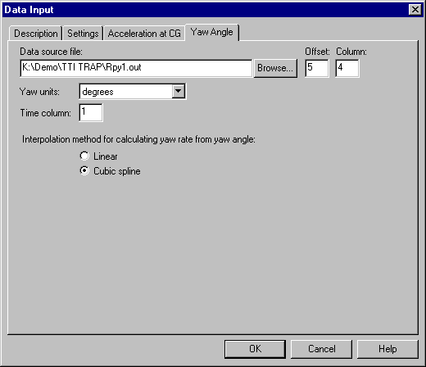
The Yaw Angle page allows you to enter information about the yaw angle of the vehicle vs. time. This page is only shown if you specified yaw angle on the Settings page. The Yaw Rate page is shown if you specified yaw rate on the Settings page.
Note: If Data Source is set to “Current .TRP File” on the Settings form, then all the fields on this form will be read-only, and they will show the original file information for the data that is being used from the current TRAP file.

Data source file:
Specify file name for the file containing Yaw angle data for the test you are analyzing. The Browse button will allow you to browse for the file.

Offset, Column
These fields allow you to specify the column number and the number of rows to skip (offset).
See ASCII data files and Binary data files for more information on file formats.

Yaw units
Enter the units used in the yaw angle data (degrees or radians)

Time column:
Enter the column containing the time parameter. NOTE: the time must be specified in seconds.

Interpolation method:
The calculation engine will interpolate values between data points using either Linear or Cubic Spline methods. The cubic spline method will generally provide greater accuracy.
Once you have filled the fields on this page and the other pages of the Input Data and clicked the OK button, the program will ask if you would like to run the calculations now. Go on to Performing Calculations.

ASCII Data Files And Binary Data Files
The acceleration and yaw data files can be in two formats: ASCII or binary. The file format you choose depends upon the data file produced by your data acquisition equipment.
An ASCII data file contains numbers represented as text. Values are arranged in rows and columns. In the following example, the ASCII data file is composed of two columns of data. The first two rows (lines) consist of header information are not part of the data. Therefore the program must be told that the real data starts at an offset of 2.

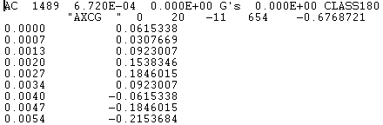

Binary data files contain data in 32-bit float or 64-bit double, IEEE format. Since binary files have no new-line character, it must be told how many columns are in the file. For example, a data file containing 36 numbers could be 6 columns by 6 rows, 4 by 9, or 9 by 4. An offset can still be specified for a binary file if there is some information at the beginning of the file you wish to skip over. For binary files the offset is specified in bytes rather than rows(lines).

Performing Calculations
The program will automatically run the calculations if you have changed any information on the Input Data pages, or if the calculations have not been run yet.

Once the calculations have run, the Results will appear on screen. Some results may not be available if any of the required data needed to compute them is missing from the input data. Missing source data will be noted in a warning window that will appear on screen before the calculations are run.

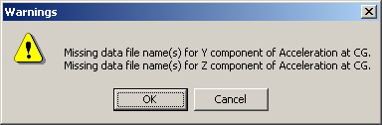

To continue with running the calculations, click the OK button. Items that cannot be calculated will be marked N/A in the Test Summary Report. TRAP will compute as much as it can with the data it is given. The following table summarizes the data required to compute each item in the Test Summary Report.

Computed Value | X Accel. | Y Accel. | Z Accel. | Yaw Rate | Pitch Rate | Roll Rate
OIV - X | X
OIV - Y |  | X
THIV | X | X |  | X*
Ridedown Accel. X | X
Ridedown Accel. Y |  | X
PHD | X | X
ASI | X | X | X
Max 50-msec Avg. X | X
Max 50-msec Avg. Y |  | X
Max 50-msec Avg. Z |  |  | X
Max Roll angle |  |  |  | X | X | X
Max Pitch angle |  |  |  | X | X | X
Max Yaw angle |  |  |  | X | X | X

*As an alternative, yaw angle versus time may be input.

Results
Once the calculations have been performed, the Results window will show a Test Summary Report.
To view this window later select Results from the Data Menu.

Test Summary Report

General Information
Test Agency: Texas Transportation Institute
Test Number: 472480-1
Test Date: 10/20/1997
Test Article: G4(1S) W-beam Guardrail

Test Vehicle
Description: 1992 Geo Tracker
Test Inertial Mass: 982 kg
Gross Static Mass: 1060 kg

Impact Conditions
Speed: 99.7 km/hr
Angle: 19.7 degrees

Occupant Risk Factors
Impact Velocity (m/s) at 0.1210 seconds on left side of interior
x-direction 4.1
y-direction -6.2

THIV (km/hr): 22.2 at 0.1159 seconds on left side of interior
THIV (m/s): 6.2

Ridedown Accelerations (g's)
x-direction -5.0 (0.2193 - 0.2293 seconds)
y-direction 9.9 (0.2198 - 0.2298 seconds)

PHD (g's): 11.3 (0.1155 - 0.1255 seconds)

ASI: 0.90 (0.0988 - 0.1488 seconds)

Max. 50msec Moving Avg. Accelerations (g's)
x-direction -4.7 (0.0728 - 0.1228 seconds)
y-direction 7.6 (0.0995 - 0.1495 seconds)
z-direction 1.7 (0.1751 - 0.2251 seconds)

Max Roll, Pitch, and Yaw Angles (degrees)
Roll -6.8 (0.2510 seconds)
Pitch 2.8 (0.7500 seconds)
Yaw 22.2 (0.7500 seconds)

You can print these results by pressing the Print button on the toolbar, or by selecting Print from the File menu .
The Graphs menu allows you to generate several different graphs.
The Tables menu allows you to generate several different tables showing the same data that is available in the graphs, but in tabular format.
See Graphs and Tables for more information.

Graphs
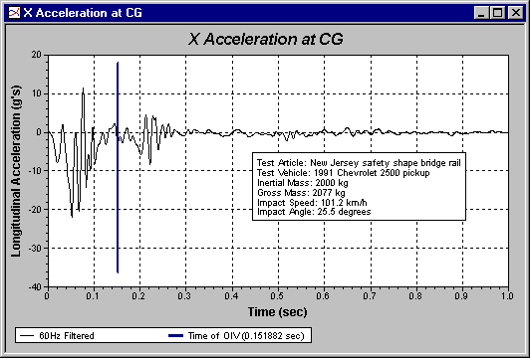

To view the graphs, select Graph All from the Graph menu. You may also draw one graph at a time, by selecting from the choices in the Graph menu.
You can edit the properties of an individual graph. To edit a graph, select Properties from the Edit menu, or double-click on a graph.
Each graph has three sets of properties:
Graph: Controls general settings
Plots: Selects plots to show on the graph
Axes: Handles axes scale settings
You may also arrange the positions of the annotation and legend in the graph by clicking on them and dragging them to the desired location.
Once you have a suitable graph, you may print it by pressing the Print button on the toolbar, or by selecting Print from the File menu. You may also copy an image of the graph to the clipboard by selecting the Copy command from the Edit menu.
NOTE: When copying graphs to the clipboard for pasting into other applications, you will get the best results by maximizing the size of the graph before performing the copy operation.

Graph Parameters Form - Graph Page

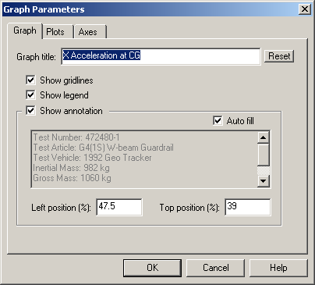
The Graph page of the Graph Parameters form has several options allowing you to control the appearance of a graph.

Graph title
Type in the title for the graph here.

Reset
Resets graph title to default.

Show gridlines
Check this box if you want gridlines displayed on the graph.

Show legend
Check this box if you want the legend displayed on the graph.

Show annotation
Check this box if you want the annotation to be displayed on the graph.

Auto fill
Check this box if you want TRAP to automatically fill in the annotation for you.
NOTE: This field is disabled unless the Show annotation box is checked.

Text box
If the Auto fill box is not checked, you can type in the text you want.
NOTE: This field is disabled unless the Show annotation box is checked.
If the Auto fill box is checked, this box displays the default text that will be shown in the annotation on the graph.

Left position, Right position

These fields allow you to control the positioning of the annotation
You may also drag the annotation by mouse when the Graph Settings window is closed.
NOTE: These fields are disabled unless the Show annotation box is checked.

Graphs Parameters Form - Plots Page
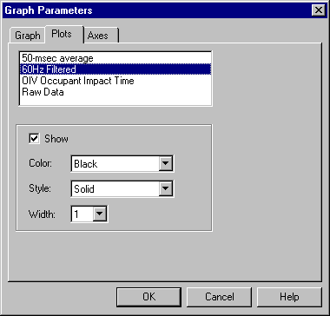
For some graphs, more than one plot(curve) may be shown on the same graph. This page allows you to control which plots are shown on a graph and the properties (line color, style, and width) of those plots.
The list box at the top of the page shows all plots available for the specific graph.
After selecting a plot in the list of plots, you may make it visible on the graph be checking the Show checkbox. Once a plot is visible, you may adjust the line color, style, and width.
NOTE: the Color, Style, and Width fields will all be disabled if the Show checkbox is not checked.

Graph Parameters Form - Axes Page
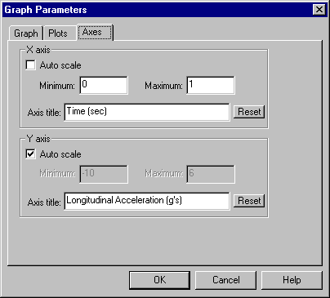
This page allows you to control the limits of the scale, and the title associated with each axis on a graph.
For each of the X and Y axes, you may use auto scale, or type in your own minimum and maximum values. You may also edit the axis title directly, or restore the default title by pressing the Reset button.

Tables
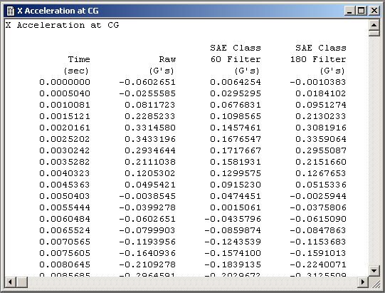

Select the table you wish to view from the list of available tables on the Table Menu.
Tables allow you to see data that is available in the graphs in a tabular text format. The data displayed in the tables will vary with the data type. For the x-acceleration and y-acceleration tables, data columns are provided for time, raw input data, SAE Class 60 filtered data, SAE Class 180 filtered data, 50-msec moving average, 10-msec moving average, and velocity data obtained from integration of the acceleration data.
Each graph that you can display with TRAP has a corresponding table.

You can display a table by selecting which table you wish to see from the menu
There are no formatting options for tables.
You can copy the entire contents of a table window to the Clipboard by selecting the Copy command from the Edit menu. You cannot select only portions of the table to copy - the Copy command always copies the entire contents of the table window to the Clipboard where it can be pasted in to other applications.

Menu and Toolbar Reference

File Menu
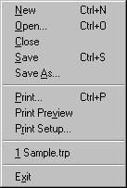

New - Creates a new TRAP data file
Open… - Opens an existing TRAP data file
Close - Closes the currently open TRAP data file
Save - Saves the currently open TRAP data file. The raw input data will be saved with the TRAP data file if this option has been selected on the Settings Page of the Data Input form (see Data Input – Settings Page). If this option has not been selected, only the Data Input settings (including names and paths of data source files) are saved with the TRAP data file. In this case, the raw data source files must be available to reopen the TRAP data file and perform the calculations.
Save As… - Saves the currently open TRAP data file with a new name

Print… - Prints the active window
Print Preview - Previews how the active window will appear when printed

Print Setup… - Brings up the Print Setup dialog to allow changing printer settings
1,2,3,4 - Displays a list of the most recently opened TRAP data files
Exit - Exits TRAP

Edit Menu
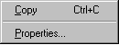

This menu can be used to copy graphics and text to the Clipboard for pasting into other applications.
Copy
Use this command to copy the contents of the active window to the Clipboard. This option is only available for Graphs, Tables, and the Summary report

Properties….
Use this command to display the Graph Parameters Form for the currently active Graph window. This command is only available when a Graph window is the active window

The Properties item on the Edit menu is only available for a graph window. See Graphs for information on modifying graphs.

Data Menu
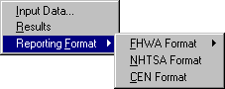

Input Data…

Brings up the Input Data form

Calculate

Runs the calculations

Results

Brings up the Results report view

Reporting Format

Runs external data formatting programs
These programs are separate programs independently developed from TRAP. These programs are all DOS based and run in their own separate DOS window.
TRAP only provides a means to launch these other programs. There is no communication of data between TRAP and these other programs. These programs generate standard formatted files specified by the respective agency or organization.

NOTES:
1. FHWA has two programs, one to generate a header, and one to generate the main body of the report.
2. There is no CEN formatting program available at this time, selecting the CEN option will launch a batch file that does nothing. When a CEN formatting program becomes available in the future, it can be called from the batch file, and thus launched from TRAP.

Graph Menu
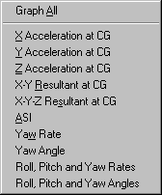

To view the graphs, select Graph All from the Graph menu. You may also draw one graph at a time, by selecting from the choices in the Graph menu.
Once one or more graphs are on the screen, you may arrange the windows. See the Windows menu for more information.
See Graphs for information on modifying the graphs.

Note: A plot produced by the "Yaw Angle" option is based on the assumption that yaw angle is uncoupled or independent from roll and pitch angles. Plots produced by the "Roll, Pitch, and Yaw Angles" option are determined by use of the Euler coupled equations (see Introduction for further discussion). Differences may therefor occur between the yaw angles thus plotted.

Table Menu
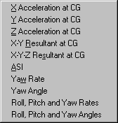
Select the table you wish to view from the list of available tables.
See Tables for more information.

Window Menu
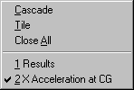

Cascade

Arranges the currently open windows in an overlapping fashion

Tile

Arranges all open windows in a non-overlapping fashion.

Close All
Closes all the open windows. This does not close the open TRAP data file, just the open windows.

1,2,3, etc.
This list shows the currently open windows. Select any window from this list to bring it to the forefront.

Toolbar
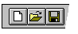

The toolbar is displayed across the top of the application window, below the menu bar. The toolbar provides quick mouse access to many tools used in TRAP.
To hide or display the Toolbar, choose Toolbar from the View menu (ALT, V, T).

Click To
Create a new TRAP data file.

Open an existing Trap data file. TRAP displays the Open dialog box, in which you can locate and open the desired file.

Save the current TRAP data file with its current name. If you have not named the project, TRAP displays the Save As dialog box.

Print the active window.

Display the Data Input Form

View Results

