# Homework: Responsive Design. Bootstrap

This document defines homework assignments from the [“Web Fundamentals (HTML & CSS)“ Course @ SoftUni](https://softuni.bg/courses/web-fundamentals/). Please submit as homework a single zip / 7z archive holding the source code of all below described problems.

## Unresponsive Homework

Create a Web page like the picture below (**100% accuracy is required**). You are given the HTML file and the images needed.

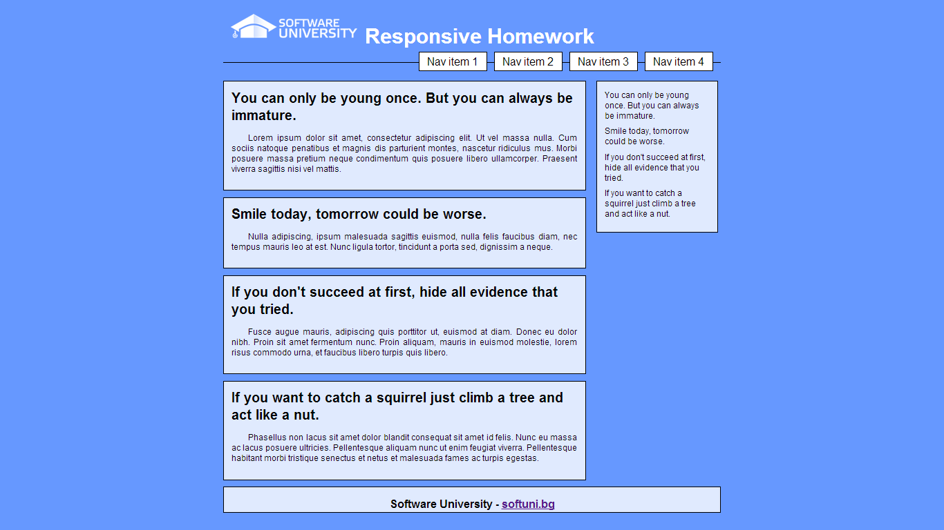

Make the site responsive with the following steps:

* From 780px to 960px – white spaces disappear, the section and sidebars scale proportionally with the browser window (see the following PNG file: “01-Unresponsive-Homework-02-780-960.png”).
* From 640px to 780px – The sidebar moves to the bottom of the page and the items are situated next to each other (see the following PNG file: “01-Unresponsive-Homework-03-640-780.png”).
* Under 640px – The menu changes again, the header falls under the logo and they are centered, the items in the sidebar (below the section now) are arranged in new way (see the following PNG file: “01-Unresponsive-Homework-04-Under-640.png”).

Constrains: **do not use** **CSS3 FLEXBOX** or **BOOTSTRAP** functionality to achieve the desired results. You are not allowed to change the **HTML** file.

## Flowers’ Home

Create a Web page like the picture below (**100% accuracy required**). You are given the HTML file and the images needed.

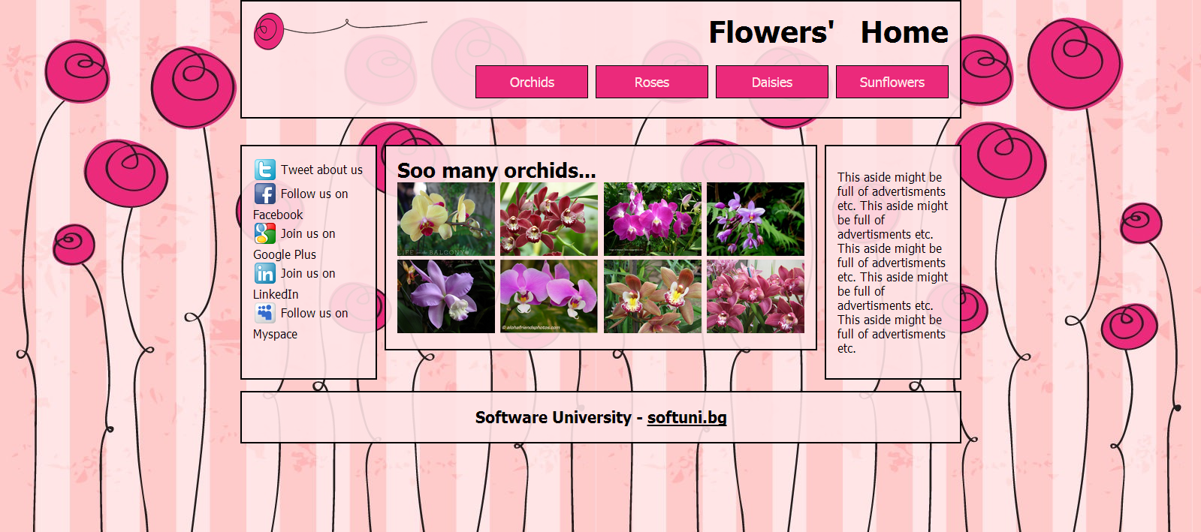

Make the site responsive with the following steps:

* From 780px to 960px – white spaces disappear, the section and sidebars scale proportionally with the browser window, the pictures in the section are only three on every row (see the following PNG file: “02-Flowers-Home-02-780-960.png”).
* From 640px to 780px – The menu becomes centered and the menu items are distributed evenly in the entire header, the sidebars move to the bottom of the page one after another (see the following PNG file: “02-Flowers-Home-03-640-780.png”).
* Under 640px – The menu changes again, the header falls under the logo and they are centered, the pictures in the section are only two on every row (see the following PNG file: “02-Flowers-Home-04-Under-640.png”).

Constrains: use **CSS3 FLEXBOX** functionality to achieve the desired results. You are not allowed to change the **HTML** file.

## Bootstrap Boot Camp

Create a Web page like the picture below. Make it responsive with steps by your choice. Use **BOOTSTRAP FRAMEWORK** to achieve the desired results**. Do not use the same styles**.

