# Problem 1 – Cartesian Coordinate System

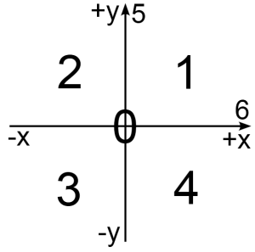You are given a two-dimensional Cartesian coordinate system and the two coordinates (**X** and **Y**) of a point in the coordinate system. If you don't know what Cartesian coordinate system is Google it with Bing. As you will find, the coordinate system is divided by 2 lines (see the picture bellow) which divide the plain in four parts. Each of these parts has a lot of points that are numbered between 1 and 4. There is one point where our lines are crossing. This point has the following coordinates: X=0 and Y=0. As a result this point is numbered 0. The points on the lines are also numbered with the numbers 5 and 6 (again see the picture below).

Your task is to write a program that finds the number of the location of the given point in the coordinate system.

## Input

* Input data is read from the console.
* The number **X** stays at the first input line.
* The number **Y** stays at the second input line.
* The input data will always be valid and in the format described. There is no need to check it explicitly.

## Output

* The output data must be printed on the console.
* On the only output line you must print an integer number between 0 and 6, depending on the location of the given point in the coordinate system.

## Constraints

* The numbers **X** and **Y** are numbers between -2 000 000 000 001 337 and 2 000 000 000 001 337, inclusive.
* Time limit: 0.25 seconds.
* Allowed memory: 16 MB.

## Examples

|  |  |  |  |  |  |  |  |  |  |  |
| --- | --- | --- | --- | --- | --- | --- | --- | --- | --- | --- |
| **Input** | **Output** |  | **Input** | **Output** |  | **Input** | **Output** |  | **Input** | **Output** |
| 1  2 | 1 | -0033  -4 | 3 | -3000  9000 | 2 | 12345  -98786543 | 4 |

Attribution: this work may contain portions from the "[C# Part I](https://telerikacademy.com/Courses/Courses/Details/81)" course by Telerik Academy under [CC-BY-NC-SA](http://creativecommons.org/licenses/by-nc-sa/3.0/deed.en_US) license.