Problem 2 – 7-segment Digits

Anton acts like a natural disaster. He breaks almost everything around him. One day he broke the display of his calculator and now you must help him restore the numbers on his calculator’s display.
The calculator’s display contains N digits. Each digit is presented by 7 segments (A, B, C, D, E, F and G) as shown in the pictures below. Each of the segments has only 2 states (1 – on and 0 – off). When some exact segments are on, then a digit from 0 to 9 is shown (look at the table below). Unfortunately, some of the segments are not working (and of course Anton is guilty for that).
 | A | B | C | D | E | F | G
0 | 1 | 1 | 1 | 1 | 1 | 1 | 0
1 | 0 | 1 | 1 | 0 | 0 | 0 | 0
2 | 1 | 1 | 0 | 1 | 1 | 0 | 1
3 | 1 | 1 | 1 | 1 | 0 | 0 | 1
4 | 0 | 1 | 1 | 0 | 0 | 1 | 1
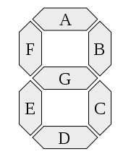
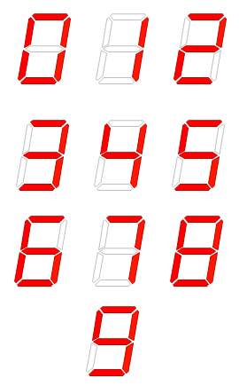
 | A | B | C | D | E | F | G
5 | 1 | 0 | 1 | 1 | 0 | 1 | 1
6 | 1 | 0 | 1 | 1 | 1 | 1 | 1
7 | 1 | 1 | 1 | 0 | 0 | 0 | 0
8 | 1 | 1 | 1 | 1 | 1 | 1 | 1
9 | 1 | 1 | 1 | 1 | 0 | 1 | 1

You are given the number N – the number of digits on Anton’s calculator display, together with the states of all 7 segments on these digits. These segments (from A to G) are given by sequences of zeros and ones.
Your task is to write a program that finds all possible combinations of digits on Anton’s broken calculator

Input
The input data should be read from the console.
From the first input line you must read the number N and from each of the next N lines you must read the states of these N digits’ segments, given by sequence of zeroes and ones with exact length 7.
The input data will always be valid and in the format described. There is no need to check it explicitly.

Output
The output data should be printed on the console.
In the first output line you must write the number (K) of all possible combination of digits on the given calculator and in the next K lines you must write these combinations sorted in ascending order.

Constraints
- N will be between 1 and 18, inclusive. The total number of answers up to 50 000.
- Allowed working time for your program: 0.2 seconds. Allowed memory: 16 MB.

Examples
Input example | Output example
1  1011111 | 2  6  8
Input example | Output example
2  1111110  1111111 | 2  08  88

