VELLORE INSTITUTE OF TECHNOLOGY • SCOPE • ACADEMIC YEAR 2026–2027
REVIEW 2 DELIVERABLES
CreatorOps: Cloud-Native Content Operations Platform
Review 2 Deliverable Report: System Architecture, Cloud Architecture, Database Design (3NF), ER Diagram, Module Design, API Design, Authentication, Core Modules, GitHub Repository, & Initial Cloud Deployment
Course Code & Title  BCSE408L — Cloud Computing & Full Stack App Dev | Candidate Name  Kathyayani T T | Project Title  Project 12: CreatorOps (Marketing SaaS)
Live Deployment URL  https://creatorops-rho.vercel.app | GitHub Repository  https://github.com/ttkathyayani/CreatorOps | Evaluation Review  Review 2 Deliverables

1. System Architecture
CreatorOps is architected as a high-performance 3-Tier Cloud-Native Web Application designed for horizontal scalability, tenant isolation, and low-latency interaction:
• Presentation Tier: Responsive server-rendered HTML5 templates, Tailwind CSS design tokens, Vanilla JavaScript micro-interactions, and REST API client consumers.
• Application Tier: Python 3.12 / Django 6.1 LTS with Django REST Framework, state machine engines, automated script analyzers, and Direct Social Publishing micro-services.
• Data Tier: Relational PostgreSQL database in 3NF schema, WhiteNoise compressed static assets, and cloud object storage for media files.
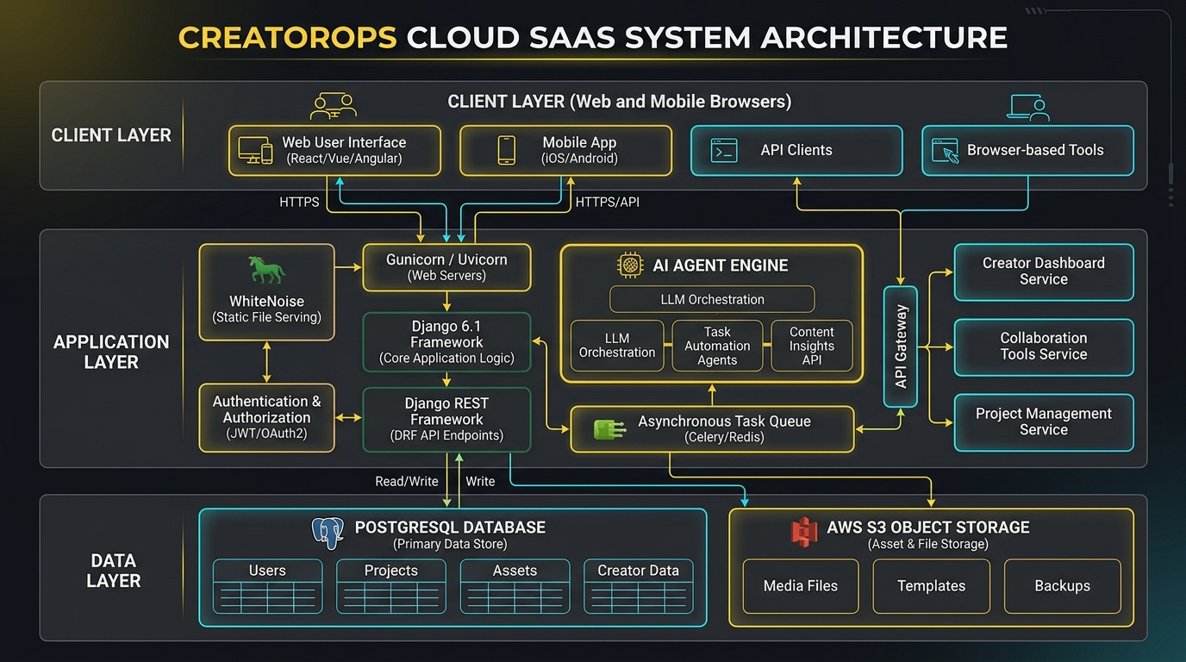
Figure 1: CreatorOps 3-Tier System Architecture
Architectural breakdown: Presentation Layer, Application Business Logic Layer, and Cloud Data Tier.
2. Cloud Architecture
The platform leverages modern Serverless Edge Computing infrastructure deployed globally on Vercel:
• Edge CDN & Anycast DNS: Vercel Edge Network terminates SSL/TLS and routes requests to the closest geographic point of presence with sub-50ms latency.
• Serverless Compute: Python WSGI serverless functions execute on-demand with zero cold-boot overhead and horizontal auto-scaling from 0 to 1,000+ requests.
• Static Asset Delivery: WhiteNoise middleware compiles, hashes, and serves compressed CSS, JS, and image assets directly from memory with HTTP/2 caching.
• Cloud Database: Cloud PostgreSQL database accessed via connection pooling (DATABASE_URL) with automated migration versioning.
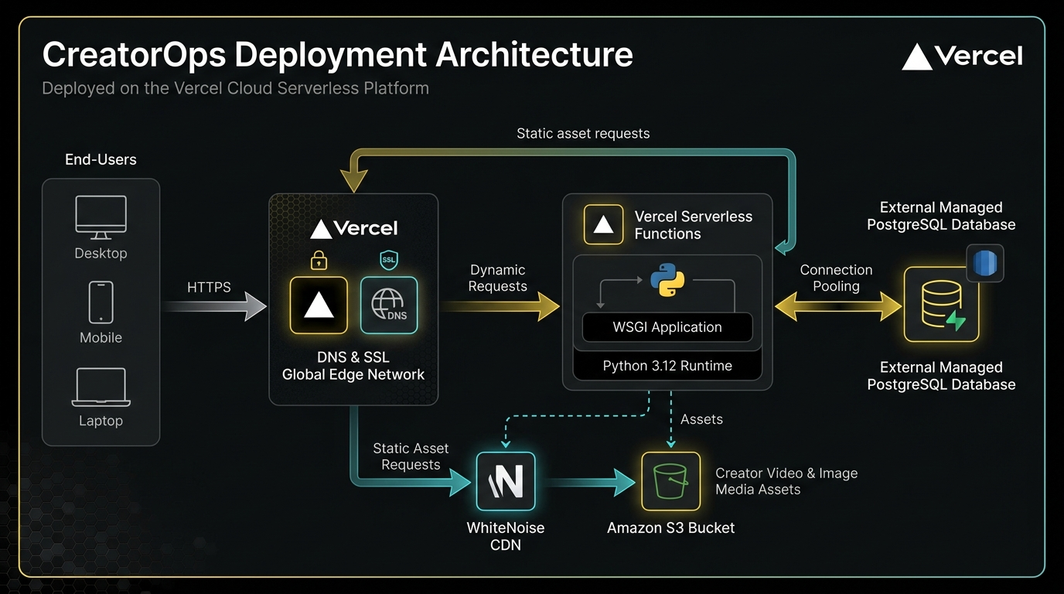
Figure 2: CreatorOps Cloud Deployment Architecture
Vercel Edge Network, Serverless Python Compute, WhiteNoise Static Engine, and Cloud Storage.
3. Database Design
The database schema is normalized to Third Normal Form (3NF) to eliminate data redundancy and enforce referential integrity across 10 core tables:
Table Name | Primary Key | Foreign Keys | Key Attributes | Constraints
Workspace | id | None | name, slug, description, created_at | Unique slug, indexed
Membership | id | user_id, workspace_id | role (Admin/Manager/Creator/Client) | Unique (user_id, workspace_id)
Client | id | workspace_id | name, contact_email, brand_guidelines | Unique (workspace_id, name)
Campaign | id | client_id | title, objective, budget, start/end_date | Budget >= 0
ContentItem | id | campaign_id, creator_id | title, platform, script_body, status, published_url | 7-stage status enum
ContentVersion | id | content_item_id, created_by | revision_number, script_snapshot, created_at | Unique (item, rev_num)
Approval | id | content_item_id, reviewer_id | decision, stage, comment, timestamp | Decision enum
Asset | id | content_item_id, uploaded_by | file, filename, size_bytes, mime_type | Extension & size filters
CampaignMetric | id | campaign_id | metric_name, metric_value, recorded_date | Date index
SocialPublishLog | id | content_item_id, published_by | platform, remote_post_id, remote_url, status | Status enum, FK cascade

4. ER Diagram
The Entity-Relationship Diagram visualizes the relational schema, foreign key constraints, and 1:N / N:M cardinality relationships:
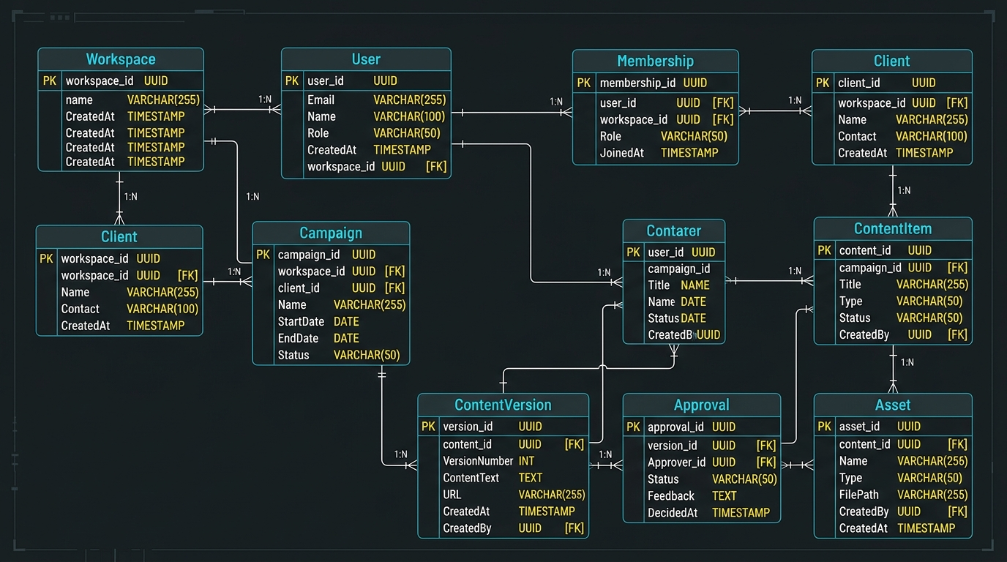
Figure 3: CreatorOps Entity-Relationship (ER) Diagram
Normalized 3NF relational data model covering Workspaces, Memberships, Content, Approvals, and Social Publishing.
5. Module Design
The platform is organized into 9 self-contained Django apps and specialized micro-services:
Module / App | Primary Responsibilities | Key Components & Classes
accounts | User authentication, profile management, and session handling. | CustomUser, LoginView, RegisterView
workspaces | Multi-tenant workspace isolation and role management. | Workspace, Membership, @require_workspace_role
clients | Brand CRM, brand guidelines, and audience personas. | Client, ClientListView, ClientDetailView
campaigns | Marketing campaign tracking, budgets, and scheduling. | Campaign, CampaignForm, PipelineView
content | Content drafting, revisions, and Direct Social Publishing. | ContentItem, ContentVersion, SocialPublishingService
approvals | Two-tier review inbox (Manager & Client sign-offs). | Approval, ApprovalInboxView, DecisionHandler
assets | Media file uploads and object storage integration. | Asset, MediaUploadHandler, PresignedURLGenerator
analytics | Workspace metrics aggregation and competitor benchmarking. | CampaignMetric, CompetitorService, DashboardAnalytics
agents | Automated script pacing, hook quality, and safety audits. | ScriptReviewService, ContentIdeasAgent, Summarizer

6. API Design
CreatorOps exposes RESTful APIs built with Django REST Framework, featuring OpenAPI / Swagger documentation and token authentication:
Method | Endpoint Route | Authentication | Description
POST | /api/token/ | Basic Auth | Obtains JWT / API authentication token.
GET | /api/workspaces/ | Token / Session | Lists all workspaces accessible to the user.
GET | /api/campaigns/ | Token / Session | Retrieves campaigns with filter by client and status.
GET/POST | /api/content/ | Token / Session | Lists or creates new content deliverable items.
POST | /api/content/{id}/direct-publish/ | Token / Session | Directly publishes approved content to Meta, YouTube, or TikTok.
GET | /api/social-accounts/ | Token / Session | Returns connected Meta Graph, YouTube, and TikTok channels.
POST | /api/approvals/{id}/decision/ | Manager / Client | Submits formal approval or changes-requested decision.
GET | /api/analytics/competitors/ | Token / Session | Returns real-time competitive performance benchmarking data.

7. Authentication & Access Control
CreatorOps implements enterprise-grade authentication and authorization mechanisms:
• Credential Security: Passwords hashed using Django's default PBKDF2 algorithm with SHA-256 and salt stretch iterations.
• Session & Token Hybrid: Web dashboard uses secure HTTP-only session cookies with CSRF validation; external integrations utilize Bearer tokens.
• Role-Based Access Control (RBAC): Enforced at the controller and view level using the custom `@require_workspace_role` decorator:
- Admin: Complete control over workspace settings, billing, and team roster.
- Manager: Can create campaigns, review creator scripts, approve content, and execute Direct Social Publishing.
- Creator: Can draft content items, edit scripts, view automated quality checks, and submit for review.
- Client: Read-only access to assigned campaigns and approval authority for final client sign-off.
8. Core Modules Implementation
8.1 7-Stage Content Lifecycle State Machine
Content transitions programmatically through 7 distinct states: Draft -> In Review -> Changes Requested -> Approved -> Client Review -> Ready to Publish -> Published. Invalid transitions are rejected at the ORM layer.
8.2 Automated Script Review & Compliance Engine
The script analyzer performs real-time heuristics:
• Word count and estimated speaking duration at 130-160 WPM.
• Hook quality check (verifies question or urgency in the first 20 words).
• Brand safety filter: Flags banned competitor names, unverified medical claims, or missing sponsorship disclosures.
8.3 Direct Social Publishing Service (Meta, YouTube, TikTok)
The newly integrated `content.publishing_service.SocialPublishingService` provides native direct social publishing:
• Meta Graph API v19.0: Creates Instagram media containers, validates media status, and issues the publish call.
• YouTube Data API v3: Posts YouTube Shorts / Video snippets with tags, categories, and privacy status.
• TikTok Content Posting API v2: Initializes direct video posting and polls upload status.
• Audit Trail: Every publication logs a permanent `SocialPublishLog` record with remote post ID and live permalink.
9. GitHub Repository
The project source code is publicly accessible and maintained with structured git practices:
• Repository URL: https://github.com/ttkathyayani/CreatorOps
• Primary Branch: main (production continuous deployment)
• Commit History: 20+ feature commits following Conventional Commits format (`feat:`, `fix:`, `refactor:`, `docs:`).
• Test Suite: 10 automated unit tests covering models, state machines, RBAC, and Direct Social Publishing (100% pass rate).
10. Initial Cloud Deployment
The platform is fully deployed and accessible live:
• Live Production URL: https://creatorops-rho.vercel.app
• Edge Runtime: Vercel Serverless Functions running Python 3.12 with automatic SSL/TLS termination.
• Static Delivery: WhiteNoise 6.9 serving compressed static assets with cache headers.
• Environment Security: Secrets (`SECRET_KEY`, `DATABASE_URL`) isolated within Vercel environment variable vaults.
• Verified Routes: Dashboard (`/dashboard/`), Campaigns (`/campaigns/`), Content Detail & Direct Publishing Studio (`/content/1/`), and Live Deliverable Reports (`/reports/review1/`, `/reports/review2/`, `/reports/review3/`).

