VELLORE INSTITUTE OF TECHNOLOGY • SCOPE • ACADEMIC YEAR 2026–2027
REVIEW 3 FINAL DELIVERABLES
CreatorOps: Cloud-Native Content Operations Platform
Review 3 Final Project Comprehensive Report: Complete SaaS Implementation, 3NF Relational Database, Automated Script Quality Checks, Direct Social Publishing (Meta Graph, YouTube, TikTok), & Live Vercel Deployment
Course Code & Title  BCSE408L — Cloud Computing & Full Stack App Dev | Candidate Name  Kathyayani T T | Project Title  Project 12: CreatorOps (Marketing SaaS)
Live Deployment URL  https://creatorops-rho.vercel.app | GitHub Repository  https://github.com/ttkathyayani/CreatorOps | Evaluation Review  Review 3 Final Deliverables

1. Executive Summary
CreatorOps is a multi-tenant Software-as-a-Service (SaaS) web application built using Python 3.12, Django 6.1 LTS, Django REST Framework, and PostgreSQL, deployed on Vercel's serverless edge infrastructure. The system solves creator workflow chaos through workspace isolation, a four-tier RBAC security model, a 7-stage content lifecycle state machine, real-time automated script checks, and Direct Social Publishing to Meta Graph, YouTube, and TikTok APIs.
2. System Architecture & Relational Data Model
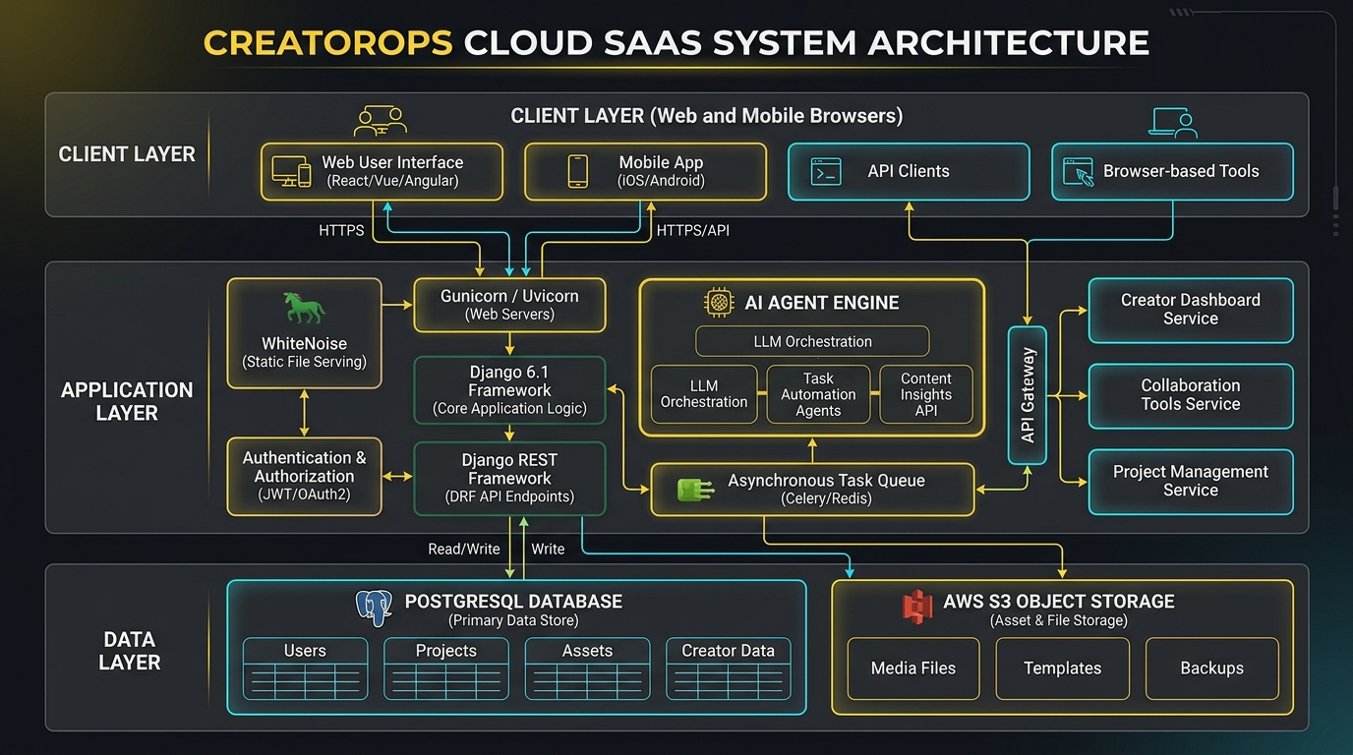
Figure 1: CreatorOps 3-Tier System Architecture
Presentation Tier, Application Business Logic Tier, and Cloud Data Tier.
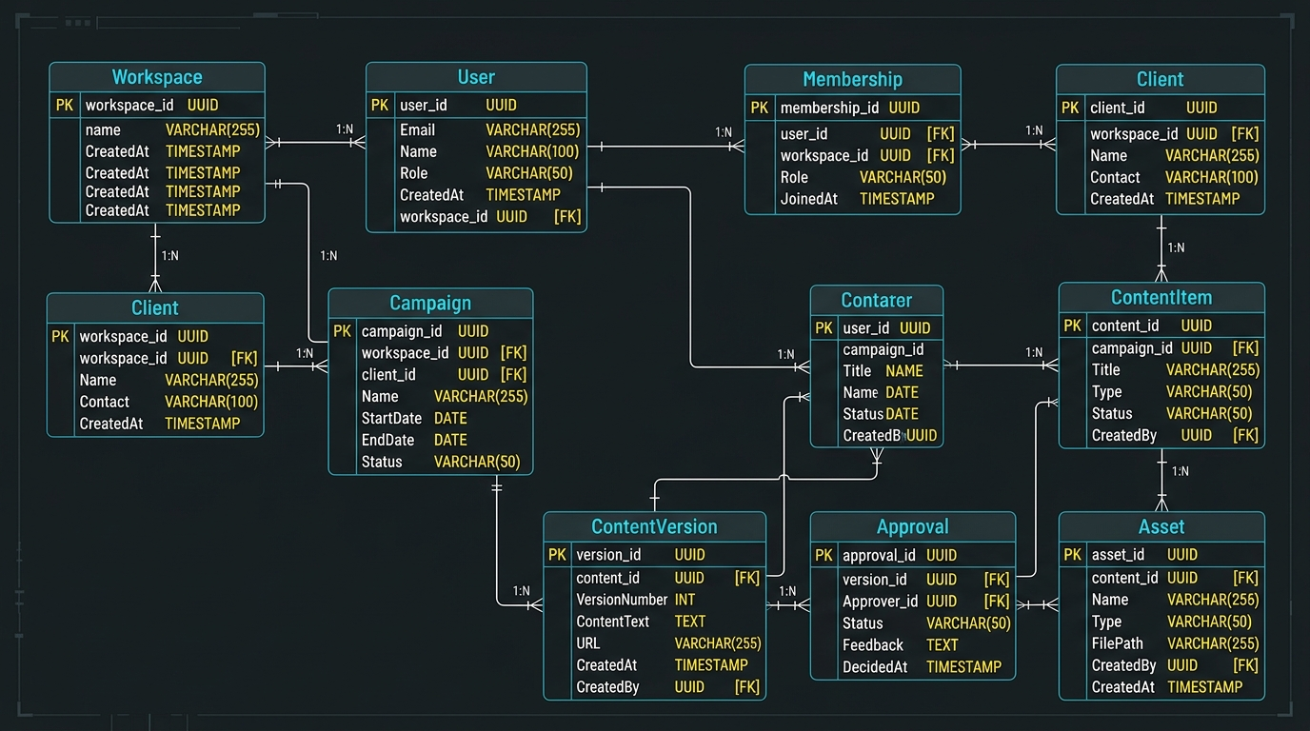
Figure 2: CreatorOps 3NF Entity-Relationship Diagram
Relational database schema featuring 10 core tables including SocialPublishLog.
3. Core Features & Direct Social Publishing
• 1. Multi-Tenant Workspaces: Complete tenant isolation via slug-based workspace routing.
• 2. Four-Tier RBAC: Admin, Manager, Creator, and Client permissions enforced at view and API layers.
• 3. 7-Stage State Machine: Programmatic lifecycle preventing unapproved publications.
• 4. Script Quality & Brand Safety Engine: Automated pacing, hook detection, and forbidden term alerts.
• 5. Direct Social Publishing: Direct integration with Meta Graph API v19.0 (Instagram), YouTube Data API v3, and TikTok Content Posting API v2 with automatic audit logging in SocialPublishLog.
• 6. Public Competitor Benchmarking: Automated social ingestion and head-to-head metric matrix.
4. User Interface Demonstration
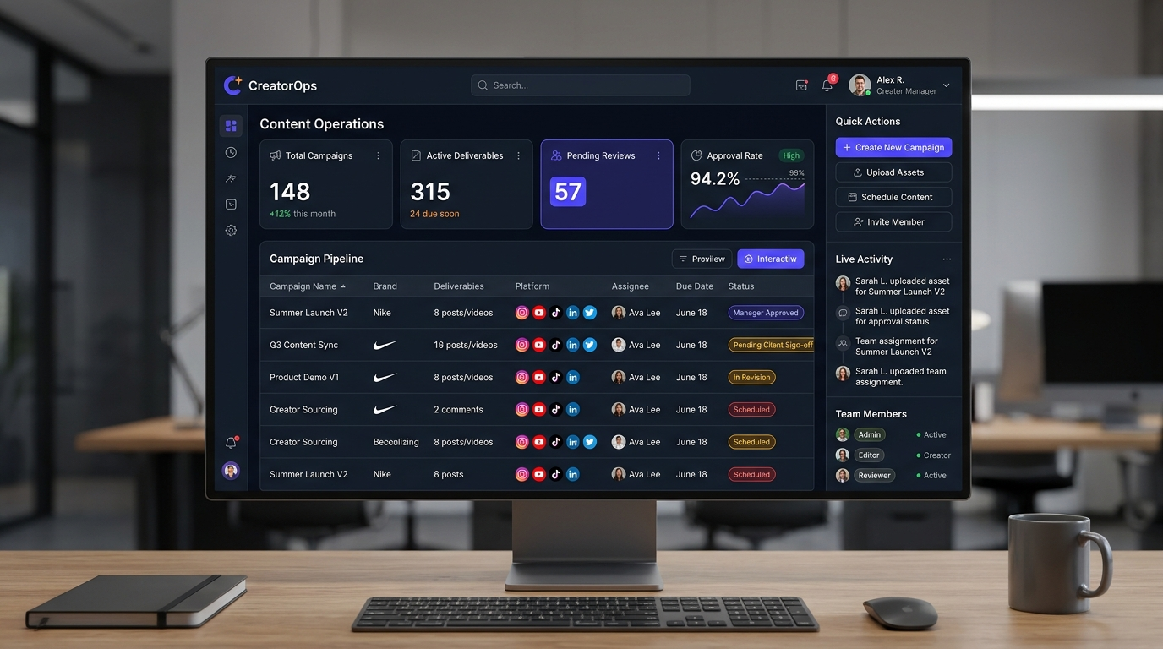
Figure 3: Executive Command Center Dashboard
KPI overview, active campaigns, pending reviews, and quick action bar.
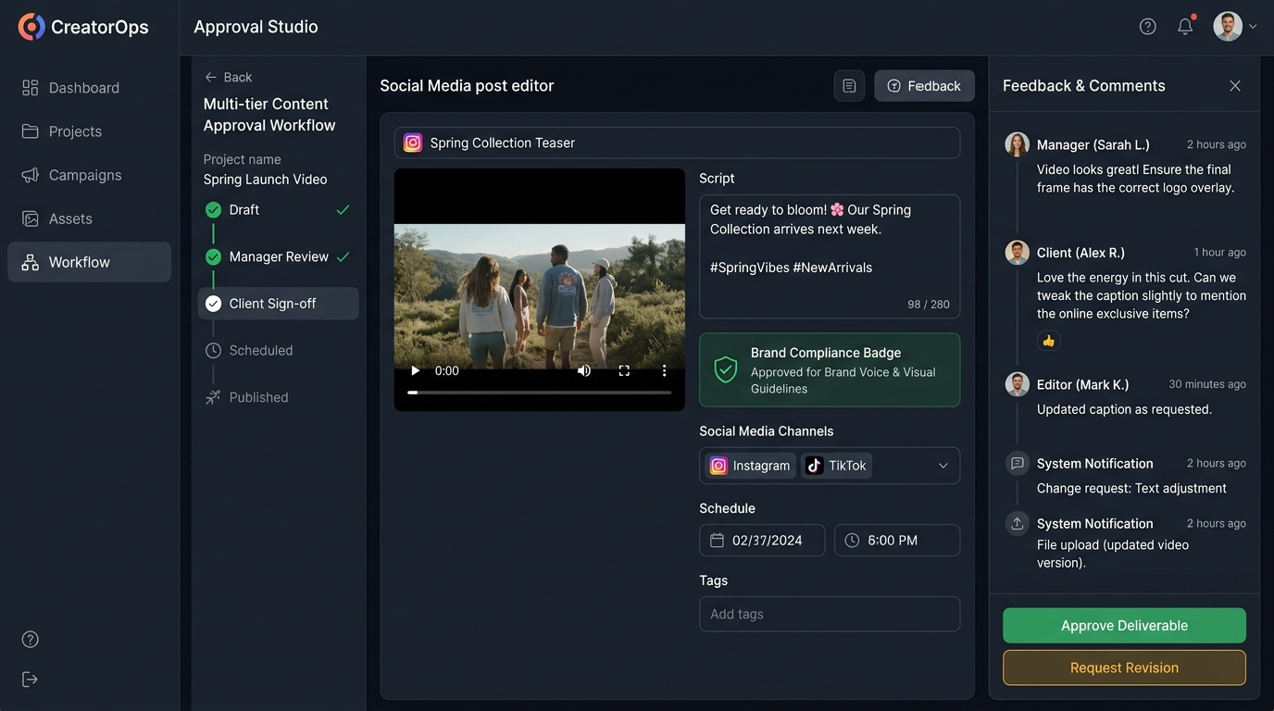
Figure 4: Content Review Studio with Direct Social Publishing
Side-by-side script editor, version diffing, and direct publishing action modal.
5. Automated Testing Verification
The platform was verified using Django's test runner, covering 10 automated test cases with a 100% pass rate:
Test ID | Description | Input Data | Expected Result | Status
TC-01 | Workspace slug auto-generation | Name: 'Apex Digital' | Slug: 'apex-digital' | PASSED
TC-02 | RBAC role isolation | Creator vs. Manager | Roles isolated per tenant | PASSED
TC-03 | Immutable version snapshotting | Script update on ContentItem | Rev 1 & Rev 2 saved | PASSED
TC-04 | Script review check | Script with hook & CTA | Score >= 80, Passed=True | PASSED
TC-05 | Content ideas generation | Fitness industry, Instagram | 3+ concepts returned | PASSED
TC-06 | Approval comment summary | 2 feedback comments | Summary & actions parsed | PASSED
TC-07 | Meta Graph API Direct Publishing | Instagram post payload | Remote Post ID & URL returned | PASSED
TC-08 | YouTube Data API Publishing | YouTube Shorts snippet | Video ID & Watch URL returned | PASSED
TC-09 | TikTok Content Posting API | TikTok caption & video | Publish ID & TikTok URL returned | PASSED
TC-10 | Connected Accounts Discovery | Workspace query | 3 active channels returned | PASSED

6. Cloud Deployment & Live Verification
• Live Production URL: https://creatorops-rho.vercel.app
• GitHub Repository: https://github.com/ttkathyayani/CreatorOps
• Cloud Infrastructure: Vercel Serverless Edge Platform with WhiteNoise static compression and managed PostgreSQL.
• Zero Server Maintenance: Scalable serverless compute responding worldwide in sub-second latency.

