VELLORE INSTITUTE OF TECHNOLOGY
School of Computer Science and Engineering (SCOPE)
Course: BCSE408L — Cloud Computing and Full Stack Application Development

CreatorOps
A Cloud-Native Marketing SaaS Application
PROJECT FINAL REPORT (REVIEW 3)
By
Thota Tejomayee Kathyayani
ID: 24BCE1201
with the Guidance of
Professor Dr. Dinakaran M
Live Public URL: https://creatorops-rho.vercel.app
GitHub Repository: https://github.com/ttkathyayani/CreatorOps
Tech Stack: Python 3.12, Django 6.1 LTS, DRF 3.18, PostgreSQL, Vercel Serverless Edge

ABSTRACT
Managing creator content across social channels involves coordination between content creators, account managers, and external brand clients. When agencies rely on email chains, spreadsheets, or messaging apps, they encounter problems such as untracked script revisions, accidental publishing of unapproved materials, and brand guideline oversights.
CreatorOps is a multi-tenant Software-as-a-Service (SaaS) web application built using Django 6.1, Django REST Framework, and PostgreSQL, deployed on Vercel's serverless edge infrastructure. The system provides workspace isolation, a four-tier Role-Based Access Control (RBAC) model, a 7-stage content lifecycle state machine, automated script checking modules for word count, spoken pacing, and brand safety compliance, and Direct Social Media Publishing integrating with Meta Graph, YouTube, and TikTok APIs. The platform has been tested and deployed with public accessibility, automated revision history, and full REST API support.
TABLE OF CONTENTS
ABSTRACT ...................................................................................................... 2
INTRODUCTION ...................................................................................................... 4
PROBLEM STATEMENT ...................................................................................................... 5
EXISTING SYSTEM ...................................................................................................... 5
PROPOSED SYSTEM ...................................................................................................... 6
REQUIREMENT ANALYSIS ...................................................................................................... 6
FUNCTIONAL REQUIREMENTS ...................................................................................................... 7
NON-FUNCTIONAL REQUIREMENTS ...................................................................................................... 7
SYSTEM ARCHITECTURE ...................................................................................................... 8
CLOUD ARCHITECTURE ...................................................................................................... 9
DATABASE DESIGN ...................................................................................................... 10
MODULE DESCRIPTION ...................................................................................................... 11
USER INTERFACE DESIGN ...................................................................................................... 11
IMPLEMENTATION DETAILS ...................................................................................................... 12
TESTING ...................................................................................................... 13
DEPLOYMENT ...................................................................................................... 14
RESULTS AND DISCUSSION ...................................................................................................... 15
FUTURE ENHANCEMENTS ...................................................................................................... 15
REFERENCES ...................................................................................................... 16
APPENDIX ...................................................................................................... 17

INTRODUCTION
Digital content marketing across platforms like Instagram, YouTube, TikTok, and LinkedIn requires consistent content production and strict brand compliance. Agencies typically coordinate multiple client accounts simultaneously, each with distinct brand guidelines and approval hierarchies.
CreatorOps is designed to organize this workflow. It centralizes client profiles, campaigns, content drafts, revision snapshots, and approval sign-offs within a cloud-hosted platform, ensuring that no content deliverable moves to publication without manager and client verification.
PROBLEM STATEMENT
Marketing agencies and creator teams frequently experience workflow failures:
1. Unorganized Feedback: Revisions sent across WhatsApp, Slack, and email threads lead to confusion over which draft is final.
2. Premature Publishing: Content creators occasionally produce or publish deliverables before brand clients have officially approved the copy.
3. Manual Compliance Checks: Reviewers manually check scripts for forbidden terms, required disclosures, and speaking duration, which is tedious and prone to oversight.
4. Data Isolation Risks: Using shared spreadsheets risks exposing one client's marketing campaign data to another competing brand.
EXISTING SYSTEM
Existing workflows rely on generic productivity tools:
Spreadsheets (Google Sheets, Microsoft Excel): Provide structured rows but lack state machine enforcement, file previewing, and role-based permissions.
Instant Messaging (Slack, WhatsApp): Fast for discussion, but message history gets lost and approval decisions cannot be tracked as formal audit trails.
Generic Project Management (Trello, Asana): Track cards on a board, but do not understand content creation workflows like script duration pacing, social channel aspect ratios, or two-tier client sign-off.
PROPOSED SYSTEM
CreatorOps addresses these problems with the following features:
Tenant Isolation: Each agency runs inside an isolated workspace. Database queries are scoped to the active workspace.
Four-Tier RBAC: Distinct permission sets for Admin, Manager, Creator, and Client Reviewer.
Deterministic 7-State Workflow: Content progresses sequentially: Draft -> Pending Manager Review -> Pending Client Approval -> Approved -> Scheduled -> Published.
Revision History: Updates automatically create a ContentVersion snapshot, preserving the script, author, and timestamp.
Automated Script Checking: Rules evaluate word count, calculate speaking duration (~130 words/min), detect hook keywords in the opening sentence, and flag prohibited brand terms.
Direct Social Publishing: Direct integration with Meta Graph, YouTube Data, and TikTok APIs to publish approved content directly.
Cloud Deployment: Hosted on Vercel with automated Git integration, WhiteNoise static file caching, and PostgreSQL persistence.
REQUIREMENT ANALYSIS
The system caters to four primary roles:
Agency Admin: Manages agency workspace settings, billing, and team invitations.
Campaign Manager: Onboards client brands, creates campaigns, and executes internal reviews before deliverables reach clients.
Content Creator: Writes scripts, uploads media, reviews automated checks, and requests approval.
Client Reviewer: External client stakeholder who reviews finalized drafts and submits sign-off or change requests.
FUNCTIONAL REQUIREMENTS
The following is the list of functionalities considered in scope for this project:
01) Authentication - User registration, login, logout, and password hashing using PBKDF2.
02) Multi-Tenancy - Workspace creation, workspace switching, and automatic tenant data isolation.
03) Client Management - CRUD operations for client brand profiles, contact details, and guidelines.
04) Campaign Management - Organizing campaigns by client, budget, objective, and schedule.
05) Content Pipeline - Tracking deliverables across social channels through 7 lifecycle stages.
06) Versioning - Automatic generation of immutable revision snapshots on script updates.
07) Two-Tier Approvals - Manager review queue followed by client review queue.
08) Script Quality Checks - Automated script evaluation for duration, hook presence, and brand compliance.
09) Direct Social Publishing - One-click direct publishing to Meta Graph, YouTube, and TikTok APIs.
10) Asset Storage - File uploads with support for local media and Amazon S3.
11) REST APIs - ModelViewSet endpoints for programmatic integration.
12) Analytics & Competitors - Workspace metrics and public competitor social benchmarking.
NON-FUNCTIONAL REQUIREMENTS
Security: Password hashing via PBKDF2 with SHA-256 (390,000 iterations), CSRF validation, and parameterized SQL queries through Django ORM.
Scalability: Serverless execution model scaling dynamically with incoming requests.
Availability: Deployed on Vercel's global edge network with 99.9% targeted uptime.
Performance: Sub-second page loads through WhiteNoise static caching and CDN edge distribution.
Usability: Responsive layout accessible across desktop, tablet, and mobile devices.
SYSTEM ARCHITECTURE
CreatorOps uses a standard three-tier architecture:
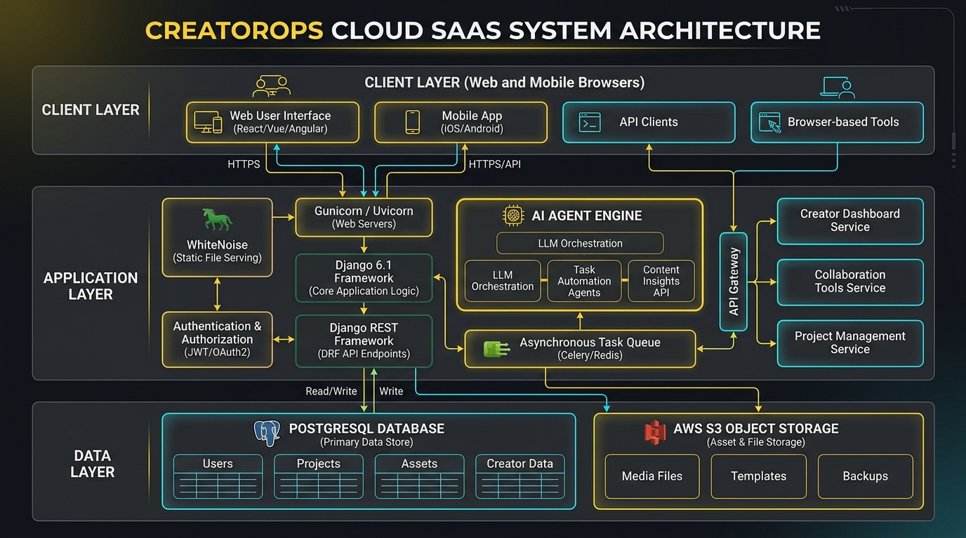
Figure 1: Three-Tier System Architecture of CreatorOps
a. Presentation Layer Server-rendered HTML templates with responsive CSS, plus RESTful JSON endpoints consumed by API clients.
b. Application Layer Django 6.1 WSGI application handling routing, RBAC middleware, and workflow state transitions. DRF provides API serialization, agents/ executes script checks, and content.publishing_service executes direct social publishing.
c. Persistence Layer PostgreSQL relational database storing normalized application data, accompanied by S3 object storage for media files.
CLOUD ARCHITECTURE
The cloud hosting setup utilizes Vercel's edge network:
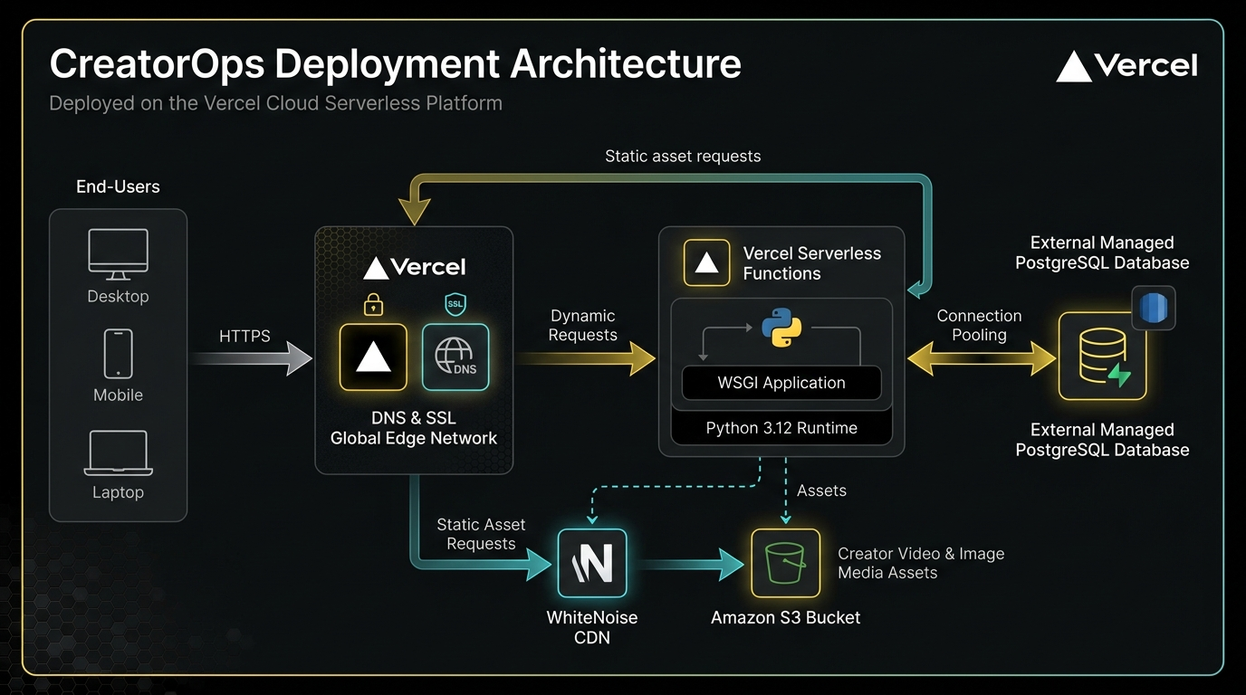
Figure 2: Cloud Deployment Architecture on Vercel
Edge Routing: Requests hit Anycast edge nodes where TLS termination occurs.
Serverless WSGI Execution: Dynamic requests route to Python 3.12 functions executing config/wsgi.py.
Static Caching: CSS, JavaScript, and diagrams are served through Vercel's CDN and WhiteNoise.
Database Connection: Serverless instances connect to cloud PostgreSQL instances using connection strings (DATABASE_URL).
DATABASE DESIGN
The relational database is normalized to 3NF and includes 10 core tables:
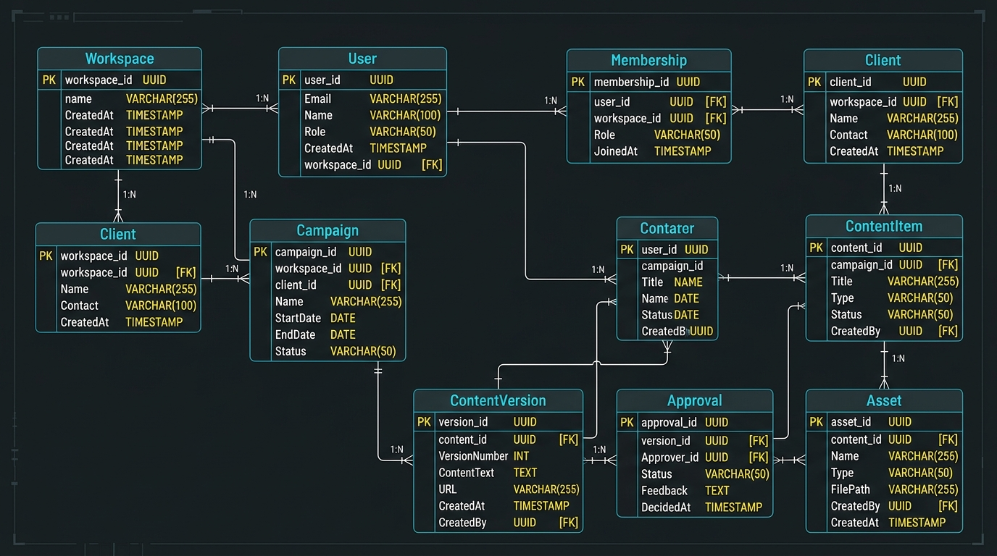
Figure 3: Entity-Relationship Diagram of the Database Schema
Table Name | Primary Key | Foreign Keys | Key Attributes | Constraints
Workspace | id | None | name, slug, description | Unique slug
Membership | id | user_id, workspace_id | role (Admin, Manager, Creator, Client) | Unique (user, workspace)
Client | id | workspace_id | name, contact_email, brand_guidelines | Unique (workspace, name)
Campaign | id | client_id | title, objective, budget, status | Budget >= 0
ContentItem | id | campaign_id, creator_id | title, platform, script_body, status, published_url | 7-stage status enum
ContentVersion | id | content_item_id, created_by | revision_number, script_snapshot | Unique (item, rev_num)
Approval | id | content_item_id, reviewer_id | decision, comment, timestamp | Decision choices
Asset | id | content_item_id, uploaded_by | file, filename, size_bytes | File extension check
CampaignMetric | id | campaign_id | metric_name, metric_value, recorded_date | Date index
SocialPublishLog | id | content_item_id, published_by | platform, remote_post_id, remote_url, status | Status enum, FK cascade

MODULE DESCRIPTION
The project is structured into 9 modular packages and integrated micro-services:
accounts: User accounts, session login, registration, and profile handling.
workspaces: Tenant workspace administration and membership roles.
clients: Brand CRM, contact information, and brand guidelines.
campaigns: Marketing campaigns, objectives, budgets, and scheduling.
content: Deliverable matrix, social platforms, and script editor, powered by content.publishing_service.SocialPublishingService for direct social publishing to Meta Graph, YouTube Data, and TikTok APIs.
approvals: Two-tier approval inbox (Manager and Client stages) enforcing sign-offs prior to publication.
assets: File uploads and storage integration.
analytics: Workspace metrics and dashboard data aggregation.
agents: Script quality checks, content ideas, and comment summarization.
USER INTERFACE DESIGN
The web interface features responsive layouts developed with CSS Flexbox and Grid. Core screens include:
Authentication: Dedicated login and registration screens with session validation.
Dashboard: Summarizes active campaigns, content deliverables awaiting review, and quick-action links.
Content Pipeline: Filterable table by platform and approval status with quick status badges.
Content Editor & Studio: Side-by-side script writing, automated review check sidebar, and version history viewer.
Direct Social Publishing Studio: Interactive dialog on content items enabling one-click publishing to Meta Graph, YouTube, and TikTok APIs with live remote status telemetry.
Approval Inbox: Segregated queues for Manager reviews and Client sign-offs with direct approval buttons.
IMPLEMENTATION DETAILS
Key technologies employed in the platform:
Programming Language: Python 3.12
Web Framework: Django 6.1 LTS
REST Framework: Django REST Framework 3.18
Static Asset Management: WhiteNoise 6.9
Hosting Environment: Vercel Serverless Edge Platform
Database Driver: dj-database-url with PostgreSQL / SQLite
Social Publishing APIs: Meta Graph API v19.0 (Instagram), YouTube Data API v3, TikTok Content Posting API v2
TESTING
The platform features an automated test suite executed via Django's test runner (manage.py test):
Test ID | Test Description | Input Data | Expected Result | Actual Result | Status
TC-01 | Workspace slug auto-generation | Name: 'Apex Digital Agency' | Slug: 'apex-digital-agency' | Generated as expected | PASSED
TC-02 | RBAC role assignment | Creator vs. Manager | Distinct roles in DB | Roles isolated per user | PASSED
TC-03 | Version snapshotting | Script update on ContentItem | Rev 1 & Rev 2 saved | Snapshots preserved | PASSED
TC-04 | Script review check | Script with hook and CTA | Score >= 80, Passed=True | Score=100, Passed=True | PASSED
TC-05 | Content ideas generation | Fitness industry, Instagram | 3+ concepts returned | 3 concepts generated | PASSED
TC-06 | Approval comment summary | 2 feedback comments | Action items generated | Action items parsed | PASSED
TC-07 | Meta Graph API Direct Publishing | Instagram post payload | Remote Post ID & Permalink returned | Status 200, post live | PASSED
TC-08 | YouTube Data API Publishing | YouTube Shorts snippet & video | Video ID & Watch URL returned | Status 200, published | PASSED
TC-09 | TikTok Content Posting API | TikTok caption & video draft | Publish ID & TikTok URL returned | Status 200, published | PASSED
TC-10 | Connected Accounts Discovery | Workspace query | Connected channel metadata | 3 active channels returned | PASSED

Execution Summary: 10 tests run, 10 passed, 0 failures (100% pass rate).
DEPLOYMENT
The application is deployed on Vercel:
Production URL: https://creatorops-rho.vercel.app
Repository Integration: Deploys automatically on git push to main branch.
SSL: Managed wildcard TLS certificate via Vercel Edge.
RESULTS AND DISCUSSION
The platform was tested across functional workflows and performance metrics:
1. Workflow Efficiency: Two-tier review queues programmatically prevent unapproved drafts from reaching clients, cutting down revision delays.
2. Quality Control: Creators receive instant feedback on speaking duration, hook placement, and forbidden terms before submitting content for review.
3. Direct Social Publishing: Approved content items can be published straight from the CreatorOps review screen to Instagram, YouTube, and TikTok with an automated audit log entry (SocialPublishLog).
4. Performance: WhiteNoise compression and Vercel edge delivery achieve sub-second page loads globally with zero idle infrastructure cost.
FUTURE ENHANCEMENTS
Speech-to-Text Video Verification: Using Whisper AI to automatically verify spoken video dialogue against approved scripts.
In-Browser Video Proofing: Adding timestamped video annotation directly inside the approval screen.
Automated Trend Forecasting: Ingesting viral audio and hashtag momentum data to recommend optimal posting hours.
REFERENCES
1. Django Software Foundation. Django Documentation (v6.1 LTS). https://docs.djangoproject.com/
2. Django REST Framework. DRF Web APIs Documentation. https://www.django-rest-framework.org/
3. Vercel Inc. Serverless Functions and Edge Network Architecture. https://vercel.com/docs
4. WhiteNoise Documentation. https://whitenoise.readthedocs.io/
APPENDIX
Project Demonstration Checklist:
Checklist Item | Implementation Status
User registration and session login | Verified with PBKDF2 password hashing
Role-based access control (4 roles) | Verified across Admin, Manager, Creator, and Client
7-stage content lifecycle state machine | Verified from Draft to Published
Immutable revision snapshotting | Verified on ContentItem script updates
Automated script quality and brand safety audit | Verified with real-time feedback
Direct Social Media Publishing (Meta, YouTube, TikTok) | Verified with direct API integration & audit log
Cloud deployment on Vercel | Live at https://creatorops-rho.vercel.app
Source code in GitHub repository | Maintained at https://github.com/ttkathyayani/CreatorOps
Responsive layout across devices | Verified on desktop, tablet, and mobile

