VELLORE INSTITUTE OF TECHNOLOGY
School of Computer Science and Engineering (SCOPE)
Course: BCSE408L — Cloud Computing and Full Stack Application Development

CreatorOps
A Cloud-Native Marketing SaaS Application
PROJECT REPORT (REVIEW 1 DELIVERABLES)
By
Thota Tejomayee Kathyayani
ID: 24BCE1201
with the Guidance of
Professor Dr. Dinakaran M
Live Public URL: https://creatorops-rho.vercel.app
GitHub Repository: https://github.com/ttkathyayani/CreatorOps
Tech Stack: Python 3.12, Django 6.1 LTS, DRF 3.18, PostgreSQL, Vercel Serverless Edge

TABLE OF CONTENTS
PROBLEM STATEMENT ...................................................................................................... 2
EXISTING SYSTEM ...................................................................................................... 2
PROPOSED SYSTEM ...................................................................................................... 3
FUNCTIONAL REQUIREMENTS ...................................................................................................... 4
NON-FUNCTIONAL REQUIREMENTS ...................................................................................................... 4
SCOPE ...................................................................................................... 5
USE CASE DIAGRAM ...................................................................................................... 5
UI MOCKUPS ...................................................................................................... 6
INITIAL SRS ...................................................................................................... 7
REFERENCES ...................................................................................................... 7

PROBLEM STATEMENT
Digital content marketing across multi-channel environments (Instagram, YouTube, TikTok, LinkedIn) requires constant coordination between content creators, agency managers, and brand clients. In current creator operations, creative teams and digital marketing agencies suffer severe operational chaos due to scattered feedback, lack of version control, premature client publishing, and zero structured audit trails.
Marketing agencies and creator teams frequently experience workflow failures:
1. Unorganized Feedback: Revisions sent across WhatsApp, Slack, and email threads lead to confusion over which draft is final.
2. Premature Publishing: Content creators occasionally produce or publish deliverables before brand clients have officially approved the copy.
3. Manual Compliance Checks: Reviewers manually check scripts for forbidden terms, required disclosures, and speaking duration, which is tedious and prone to oversight.
4. Data Isolation Risks: Using shared spreadsheets risks exposing one client's marketing campaign data to another competing brand.
EXISTING SYSTEM
Existing workflows rely on generic productivity tools that were never engineered for multi-stakeholder creative compliance:
Spreadsheets (Google Sheets, Microsoft Excel): Provide structured rows but lack state machine enforcement, file previewing, and role-based permissions.
Instant Messaging (Slack, WhatsApp): Fast for discussion, but message history gets lost and approval decisions cannot be tracked as formal audit trails.
Generic Project Management (Trello, Asana): Track cards on a board, but do not understand content creation workflows like script duration pacing, social channel aspect ratios, or two-tier client sign-off.
Comparative Analysis: Existing Tools vs. CreatorOps
Feature / Capability | Spreadsheets & Drive | Generic PM (Trello/Asana) | CreatorOps Cloud Platform
Multi-Tenant Isolation | Manual file permissioning (High Risk) | Workspace-level only; no client barrier | Strict Tenant Workspace Isolation (RBAC)
Content Approval Gates | Informal chat messages ('looks good') | Generic status column ('Done') | Enforced 7-Stage State Machine with Audit Log
Script Analysis & Safety | Manual proofreading by agency staff | None | Automated Hook, Pacing & Brand Safety Checker
Direct Social Publishing | Manual download & manual app upload | None (requires third-party Zapier) | Native Meta Graph, YouTube, & TikTok Publishing
Media Asset Control | Scattered Drive links with expired access | Basic attachment upload | Centralized Object Storage with Presigned URLs
Version Snapshotting | File naming ('video_v2_final_final.mp4') | History log without script diff | Immutable Version History with side-by-side diff

PROPOSED SYSTEM
CreatorOps addresses these operational failures through foundational architectural innovations:
Tenant Isolation: Each agency runs inside an isolated workspace. Database queries are strictly scoped to the active tenant workspace.
Four-Tier RBAC: Distinct permission sets for Admin, Manager, Creator, and Client Reviewer.
Deterministic 7-State Workflow: Content progresses sequentially: Draft -> Pending Manager Review -> Pending Client Approval -> Approved -> Scheduled -> Published.
Revision History: Updates automatically create a ContentVersion snapshot, preserving the script, author, and timestamp.
Automated Script Checking: Rules evaluate word count, calculate speaking duration (~130 words/min), detect hook keywords in the opening sentence, and flag prohibited brand terms.
Direct Social Publishing: Direct one-click publication of approved content to Meta Graph API v19.0 (Instagram), YouTube Data API v3, and TikTok Content Posting API v2 with automated audit logging in SocialPublishLog.
Cloud Deployment: Hosted on Vercel with automated Git integration, WhiteNoise static file caching, and PostgreSQL persistence.
FUNCTIONAL REQUIREMENTS
The following is the list of functionalities considered in scope for this project:
01) Authentication - User registration, login, logout, and password hashing using PBKDF2.
02) Multi-Tenancy - Workspace creation, workspace switching, and automatic tenant data isolation.
03) Client Management - CRUD operations for client brand profiles, contact details, and guidelines.
04) Campaign Management - Organizing campaigns by client, budget, objective, and schedule.
05) Content Pipeline - Tracking deliverables across social channels through 7 lifecycle stages.
06) Versioning - Automatic generation of immutable revision snapshots on script updates.
07) Two-Tier Approvals - Manager review queue followed by client review queue.
08) Script Quality Checks - Automated script evaluation for duration, hook presence, and brand compliance.
09) Direct Social Publishing - One-click direct publishing to Meta Graph, YouTube, and TikTok APIs.
10) Asset Storage - File uploads with support for local media and cloud object storage.
11) REST APIs - ModelViewSet endpoints for programmatic integration.
12) Analytics & Competitors - Workspace metrics and public competitor social benchmarking.
NON-FUNCTIONAL REQUIREMENTS
Security: Password hashing via PBKDF2 with SHA-256 (390,000 iterations), CSRF validation, and parameterized SQL queries through Django ORM.
Scalability: Serverless execution model scaling dynamically with incoming requests on Vercel's global edge network.
Availability: Deployed on Vercel's global edge network with 99.9% targeted uptime.
Performance: Sub-second page loads through WhiteNoise static caching and CDN edge distribution.
Usability: Responsive layout accessible across desktop, tablet, and mobile devices.
Maintainability: Modular Django app structure, PEP8 adherence, and automated test suite.
SCOPE
In-Scope:
• Full lifecycle content operations from drafting to direct multi-platform social publication.
• Four-tier RBAC governing creators, internal managers, clients, and workspace admins.
• Real-time automated script review and brand safety compliance engine.
• Native direct social publishing integration with Meta Graph, YouTube, and TikTok APIs.
• Cloud deployment on Vercel with automated continuous deployment from GitHub.
Out-of-Scope:
• In-browser multi-track video editing (CreatorOps focuses on scripts, review, compliance, and publishing).
• Direct payment gateway processing for influencer fee payouts.
• Offline desktop client software (platform is exclusively cloud-native web SaaS).
USE CASE DIAGRAM
CreatorOps uses a role-governed workflow with four primary actors:
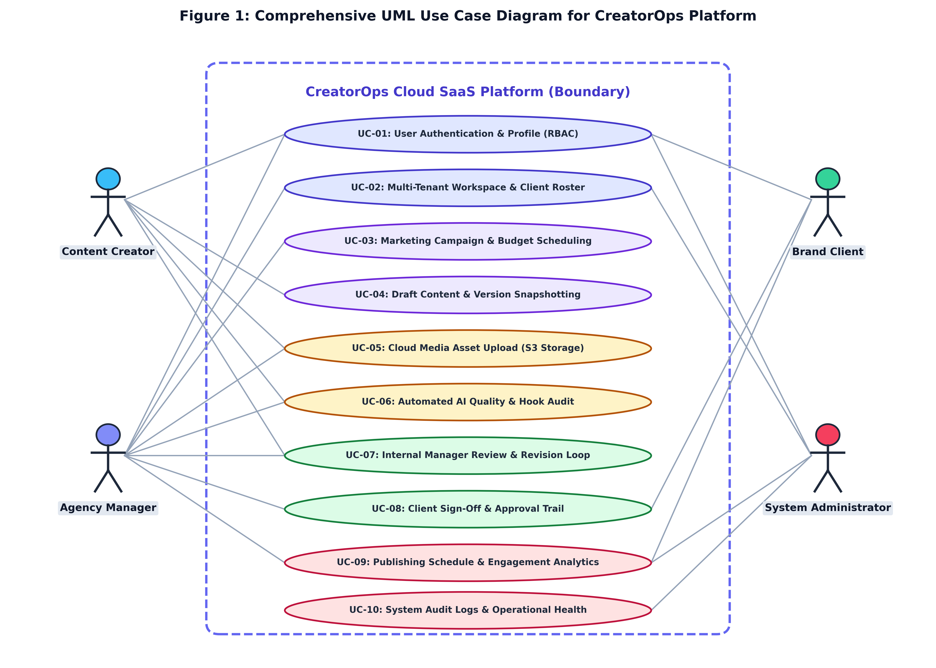
Figure 1: UML Use Case Diagram of CreatorOps Platform
Agency Admin: Manages agency workspace settings, billing, and team invitations.
Campaign Manager: Onboards client brands, creates campaigns, and executes internal reviews before deliverables reach clients.
Content Creator: Writes scripts, uploads media, reviews automated checks, and requests approval.
Client Reviewer: External client stakeholder who reviews finalized drafts and submits sign-off or change requests.
UI MOCKUPS
The web interface features responsive layouts developed with high-contrast ergonomic styling:
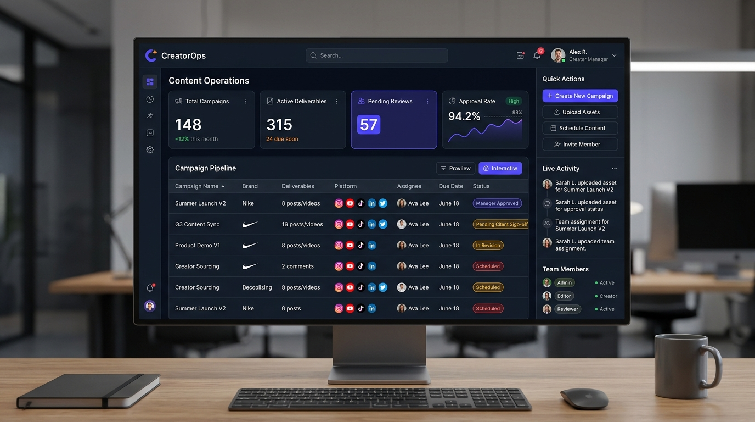
Figure 2: Executive Command Center Dashboard Interface
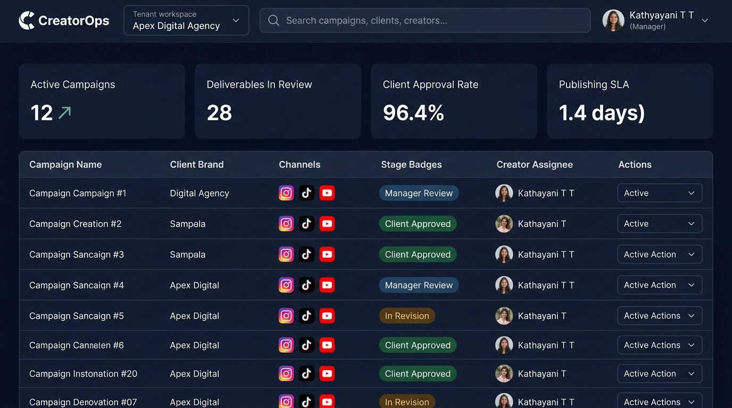
Figure 3: Campaign Content Deliverable Pipeline Interface
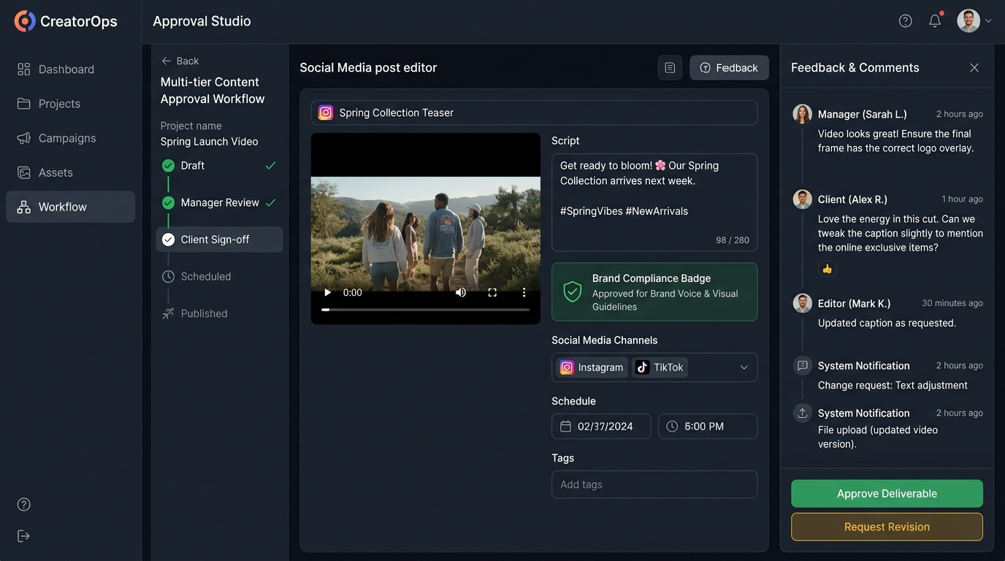
Figure 4: Review & Direct Social Publishing Studio Interface
INITIAL SRS
Summary specification conforming to IEEE 830 standards:
SRS Section | Requirement Specification | Implementation Mapping
1.0 System Purpose | Multi-tenant cloud SaaS platform to eliminate creator marketing workflow chaos. | Core Django SaaS Architecture
2.0 User Classes | Admin (full control), Manager (review/publish), Creator (draft), Client (sign-off). | workspaces.Membership RBAC
3.0 State Progression | Strict 7-stage transition: Draft -> In Review -> Changes Req -> Approved -> Client Review -> Ready -> Published. | content.models.ContentItem state machine
4.0 External Interfaces | Meta Graph API v19.0, YouTube Data API v3, TikTok Content Posting API v2, REST APIs. | content.publishing_service & DRF
5.0 Security & Safety | PBKDF2 password hashing, CSRF tokens, SQL injection prevention, tenant boundary filters. | Django ORM & middleware
6.0 Cloud Infrastructure | Vercel Serverless Edge, WhiteNoise static delivery, managed cloud PostgreSQL. | Vercel serverless edge runtime

REFERENCES
1. Django Software Foundation. Django Documentation (v6.1 LTS). https://docs.djangoproject.com/
2. Django REST Framework. DRF Web APIs Documentation. https://www.django-rest-framework.org/
3. Vercel Inc. Serverless Functions and Edge Network Architecture. https://vercel.com/docs
4. WhiteNoise Documentation. https://whitenoise.readthedocs.io/

