# LESSON 3. LOCATING ELEMENTS IN WEB PAGE

## 3.1. PROGRAM STRUCTURE

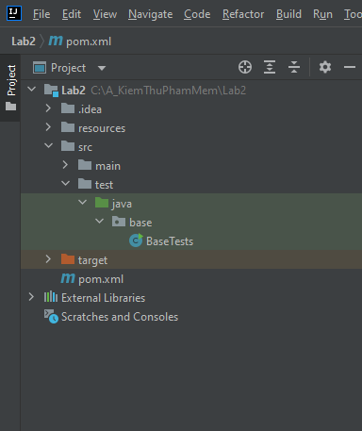

Figure 3. 1. Structure

## 3.2. PROGRAM CODE

package base;  
  
import okio.Timeout;  
import org.openqa.selenium.By;  
import org.openqa.selenium.WebDriver;  
import org.openqa.selenium.WebElement;  
import org.openqa.selenium.chrome.ChromeDriver;  
  
import java.time.LocalTime;  
import java.util.List;  
import java.util.concurrent.TimeUnit;  
  
public class BaseTests {  
 private WebDriver driver;  
 public void setUp(){  
 WebDriver driver = new ChromeDriver();  
 driver.get("https://the-internet.herokuapp.com/login");  
 driver.manage().window().maximize();  
 System.out.println(driver.getTitle());  
 //hhh  
 WebElement userNameElement = driver.findElement(By.id("username"));  
 userNameElement.sendKeys("tomsmith");  
 WebElement passwordElement = driver.findElement(By.id("password"));  
 passwordElement.sendKeys("SuperSecretPassword!");  
 System.out.println("Name attribute of userName button:"+userNameElement.getAttribute("name" ));  
 driver.findElement(By.xpath("//i[contains(text(),'Login']")).click();  
 driver.navigate().back();  
 List<WebElement> inputList = driver.findElements(By.tagName("input"));  
 System.out.println(inputList.size());  
 for (WebElement element:inputList) {  
 System.out.println("Element:"+ element.getAttribute("name"));  
 }  
 for (int i=0; i<inputList.size(); i++) {  
 System.out.println("Element:"+inputList.get(i).getAttribute("name"));  
 }  
 driver.manage().timeouts().implicitlyWait(30, TimeUnit.SECONDS);  
 driver.quit();  
 }  
  
 public static void main(String[]args){  
 BaseTests tests = new BaseTests();  
 tests.setUp();  
  
 }  
}

Figure 3. 2. File BaseTests.java

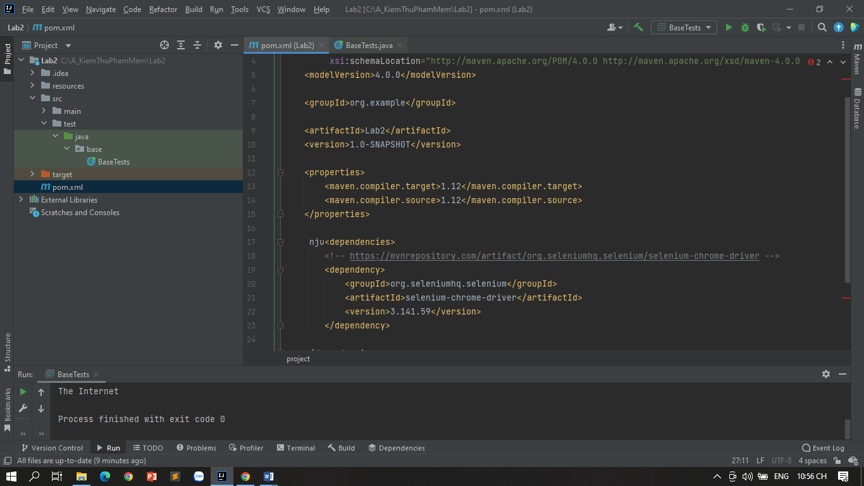

Figure 3. 3. File pom.xml

## 3.3. EXERCISE RESULTS

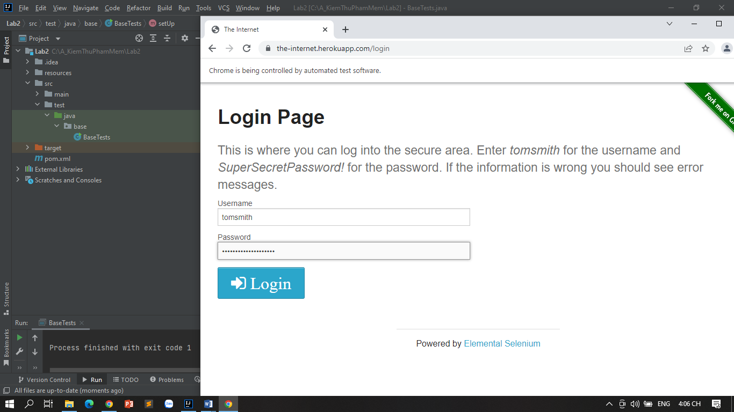

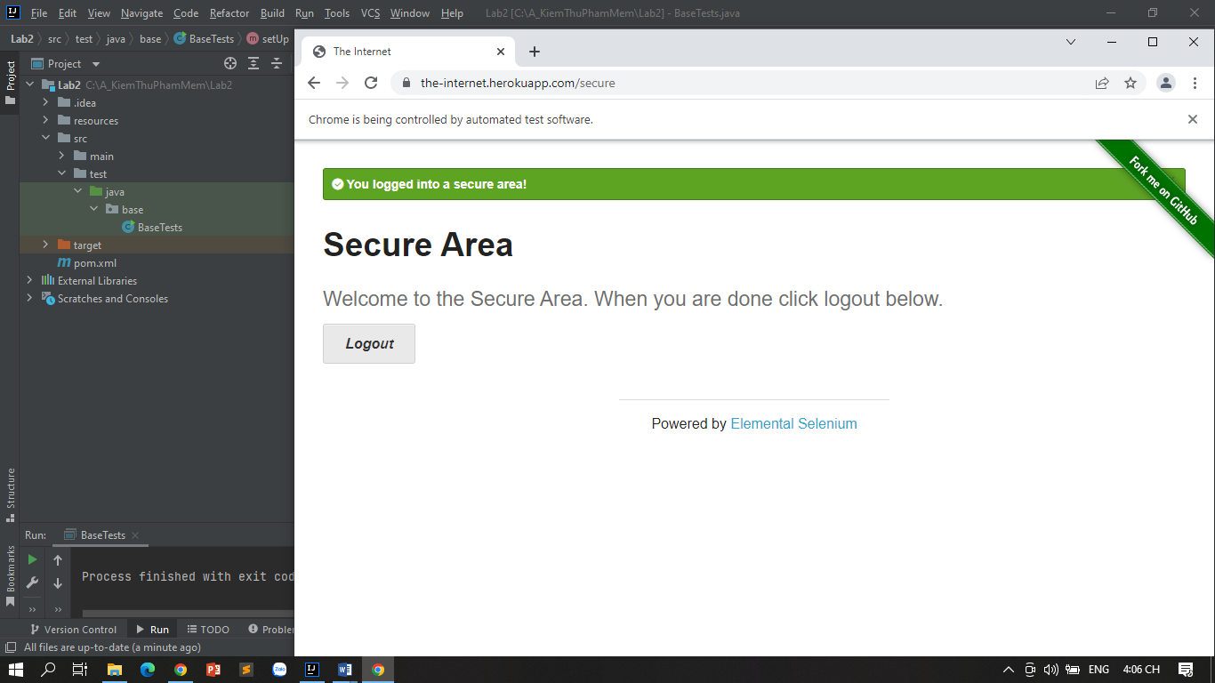

***EXERCISE RESULTS***

***1.***