|  |
| --- |
|  |
| The Documentation |
| Screen Specification of Book Registration |
|  |
| **Nguyen Dinh Hai Nam** |
| **11/10/2017** |

Table of Contents

[To update the table of contents, right click the message below and select Update Field (F9 on PC, ⌥⌘U on Mac).]

1. Pages 3

1.1. Page Tree 3

1.2. Home 4

1.2.1. User Interface 4

1.2.2. Widget Table 4

1.3. Add New Book 6

1.3.1. User Interface 6

1.3.2. Widget Table 7

1.4. Add Copy of Book 9

1.4.1. User Interface 9

1.4.2. Widget Table 10

1.5. Edit Copy Information 12

1.5.1. User Interface 12

1.5.2. Widget Table 13

1. Pages
   1. Page Tree

Home  
 Add New Book  
 Add Copy of Book  
 Edit Copy Information

* 1. Home
     1. User Interface

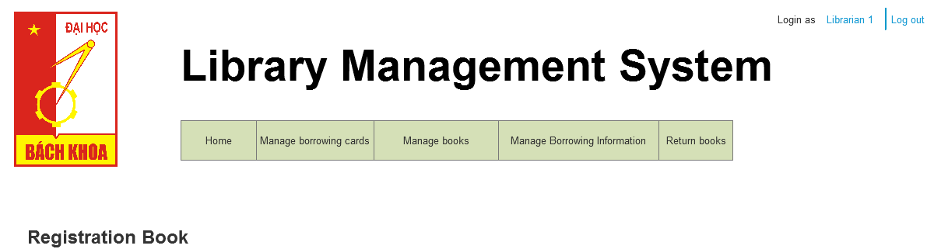

Menu Object

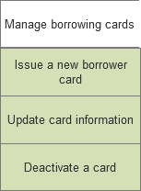 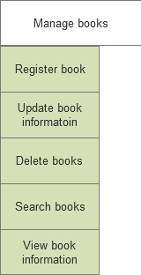 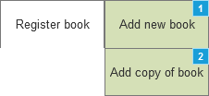 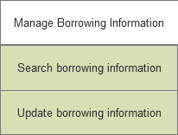

* + 1. Widget Table

|  |  |
| --- | --- |
| Footnote | Interactions |
| 1 | OnClick:  Case 1:  Open Add New Book in Current Window |
| 2 | OnClick:  Case 1:  Open Add Copy of Book in Current Window |

* 1. Add New Book
     1. User Interface

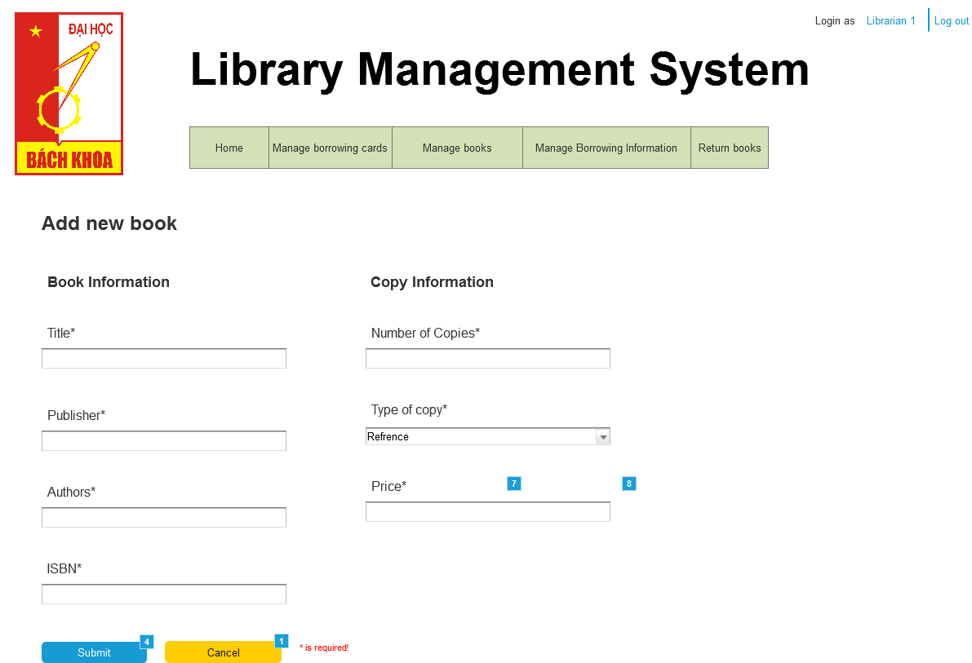

Menu Object

  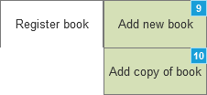 

* + 1. Widget Table

|  |  |  |
| --- | --- | --- |
| Footnote | Name | Interactions |
| 1 |  | OnClick:  Case 1:  Show (Group), (Rectangle), (Rectangle), (Rectangle) |
| 2 |  | OnClick:  Case 1:  Open Home in Current Window |
| 3 |  | OnClick:  Case 1:  Hide (Group), (Rectangle), (Rectangle), (Rectangle) |
| 4 |  | OnClick:  Case 1:  Show (Rectangle)  Wait 1000 ms  Wait 1000 ms  Wait 1000 ms  Wait 1000 ms  Open Home in Current Window |
| 5 |  | OnClick:  Case 1:  Open Add New Book in Current Window |
| 6 |  | OnClick:  Case 1:  Hide cancel navi 1, (Rectangle), (Rectangle), (Rectangle) |
| 7 |  | OnClick:  Case 1:  Open Add Copy of Book in Current Window |
| 8 |  | OnClick:  Case 1:  Hide Cancel navi 2, (Rectangle), (Rectangle), (Rectangle) |
| 9 |  | OnClick:  Case 1:  Show cancel navi 1, (Group), (Rectangle), (Rectangle), (Rectangle) |
| 10 |  | OnClick:  Case 1:  Show (Group), Cancel navi 2, (Rectangle), (Rectangle), (Rectangle) |

* 1. Add Copy of Book
     1. User Interface

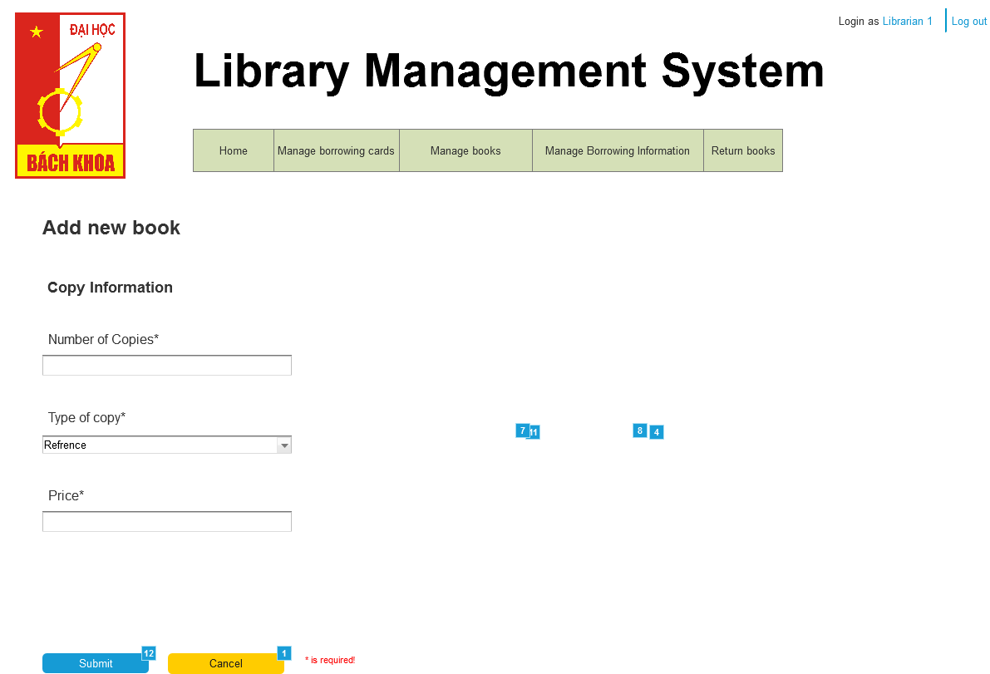

Menu Object

   

* + 1. Widget Table

|  |  |  |
| --- | --- | --- |
| Footnote | Name | Interactions |
| 1 |  | OnClick:  Case 1:  Show cancel button, (Rectangle), (Rectangle), (Rectangle) |
| 2 |  | OnClick:  Case 1:  Open Home in Current Window |
| 3 |  | OnClick:  Case 1:  Hide cancel button, (Rectangle), (Rectangle), (Rectangle) |
| 4 |  | OnClick:  Case 1:  Hide (Rectangle), (Rectangle)  Show (Group), (Rectangle)  Wait 1000 ms  Wait 1000 ms  Wait 1000 ms  Open Home in Current Window |
| 5 |  | OnClick:  Case 1:  Open Add New Book in Current Window |
| 6 |  | OnClick:  Case 1:  Hide cancel navi 1, (Rectangle), (Rectangle), (Rectangle) |
| 7 |  | OnClick:  Case 1:  Open Add Copy of Book in Current Window |
| 8 |  | OnClick:  Case 1:  Hide Cancel navi 2, (Rectangle), (Rectangle), (Rectangle) |
| 9 |  | OnClick:  Case 1:  Show cancel navi 1, (Group), (Rectangle), (Rectangle), (Rectangle) |
| 10 |  | OnClick:  Case 1:  Show Cancel navi 2, (Group), (Rectangle), (Rectangle), (Rectangle) |
| 11 |  | OnClick:  Case 1:  Open Edit Copy Information in Current Window |
| 12 |  | OnClick:  Case 1:  Show (Group), (Rectangle), (Rectangle), (Rectangle) |

* 1. Edit Copy Information
     1. User Interface

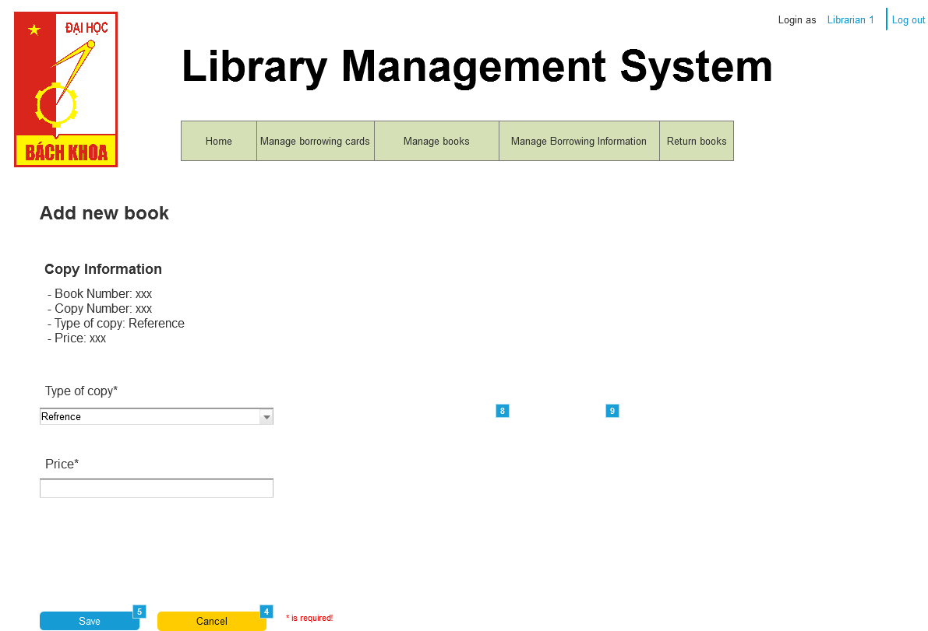

Menu Object

  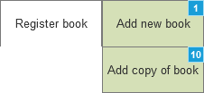 

* + 1. Widget Table

|  |  |  |
| --- | --- | --- |
| Footnote | Name | Interactions |
| 1 |  | OnClick:  Case 1:  Show cancel navi 1, (Group), (Rectangle), (Rectangle), (Rectangle) |
| 2 |  | OnClick:  Case 1:  Open Home in Current Window |
| 3 |  | OnClick:  Case 1:  Hide (Group), (Rectangle), (Rectangle), (Rectangle) |
| 4 |  | OnClick:  Case 1:  Show (Group) |
| 5 |  | OnClick:  Case 1:  Show (Group), (Rectangle)  Wait 1000 ms  Wait 1000 ms  Wait 1000 ms  Open Home in Current Window |
| 6 |  | OnClick:  Case 1:  Open Add New Book in Current Window |
| 7 |  | OnClick:  Case 1:  Hide cancel navi 1, (Rectangle), (Rectangle), (Rectangle) |
| 8 |  | OnClick:  Case 1:  Open Add Copy of Book in Current Window |
| 9 |  | OnClick:  Case 1:  Hide Cancel navi 2, (Rectangle), (Rectangle), (Rectangle) |
| 10 |  | OnClick:  Case 1:  Show Cancel navi 2, (Group), (Rectangle), (Rectangle), (Rectangle) |