1.How are inline and block elements different from each other?

<!DOCTYPE html>

<html lang="en">

<head>

<meta charset="UTF-8">

<meta http-equiv="X-UA-Compatible" content="IE=edge">

<meta name="viewport" content="width=device-width, initial-scale=1.0">

<title>Document</title>

<link rel="stylesheet" href="style.css">

</head>

<body>

<!-- question 1 -->

<h1>

INLINE ELEMENT

</h1>

<span>

Every HTML element has a default display value, depending on what type of element it is.

</span>

<h1> BLOCK ELEMENT</h1>

<p> A block-level element always starts on a new line, and the browsers automatically

add some space (a margin) before and after the element.

</p>

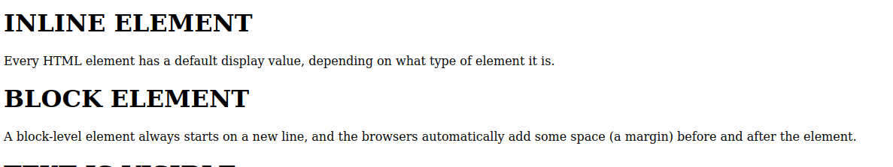

2.Explain the difference between visibility:hidden and display:none

<!-- question 2 -->

<h1 class="v1"> TEXT IS VISIBLE</h1>

<h2 class="h1"> TEXT IS HIDDEN </h2>

<h3 class="d1"> Text is display</h3>

<h4 class="d2"> Text not display</h4>

v1{

visibility: visible;

}

.h1{

visibility: hidden;

}

.d1{

display: inline;

}

.d2{

display: none;

}



3. Explain the clear and float properties.<!-- question3 -->

<div>

<h1> USING FLOAT WITHOUT CLEAR </h1>

<div class="div1">STRING </div>

<div class="div2">investigates the disappearance of three girls from a small village, uncovering a history

of caste-based oppression along the way. The supporting cast includes Nassar, Manoj Pahwa,

</div>

<H1> USING CLEAR</H1>

<div class="div3"> STRING </div>

<div class="div4">

he film is named after Article 15 of the Constitution of India, which prohibits discriminat

inspired by multiple real-life cases involving crimes driven by caste-based discrimination, i

</div>

</div>

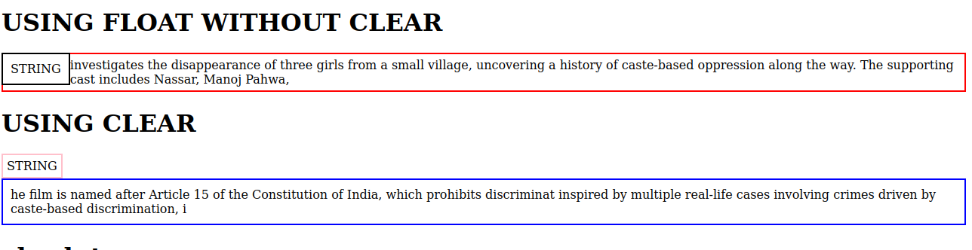

4. explain difference between absolute, relative,fixed and static.

<!-- <QUESTION 4 -->

<div>

<h1> absolute</h1>

<div id="ab">You can get everything in life you want if you will just help enough other people get what they want.

<h1>relative</h1><div id="rel">“Inspiration does exist, but it must find you working.” —Pablo Picasso</div>

<h1> fixed</h1> <div id="fix">

“Don't bunt. Aim out of the ballpark. Aim for the company of immortals.” ―David Ogilvy

</div>

<h1> static</h1>

<div id="sta">“I have stood on a mountain of no’s for one yes.” —Barbara Elaine Smith</div>

</div>

</div>

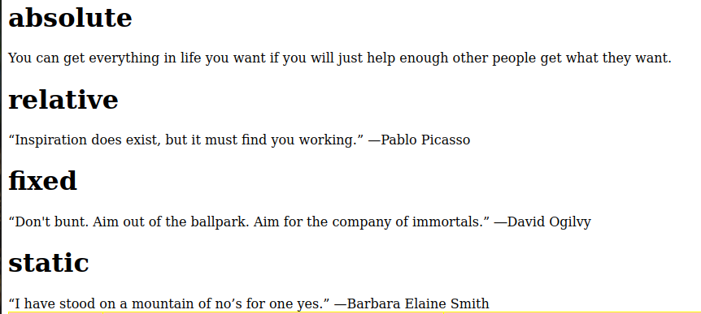

5. Write the HTML code to create a table in which there are 4 columns( ID , Employee Name, Designation, Department) and at least 6 rows. Also do some styling to it.

<!-- question5 -->

<table id="tab ">

<tr>

<th>ID</th>

<th>EMPLOYEE NAME</th>

<th>DESSIGNATION</th>

<th>DEPARTMENT</th>

</tr>

<tr>

<td>664</td>

<td>vinay</td>

<td>AMC</td>

<td>AEM</td>

</tr>

<tr>

<td> 665</td>

<td>prashant</td>

<td>java developer</td>

<td>JVM</td>

</tr>

<tr>

<td>667</td>

<td>sonali</td>

<td>software developer</td>

<td>devops</td>

</tr>

<tr>

<td>668</td>

<td>ragahv</td>

<td>tester</td>

<td>QE</td>

</tr>

<tr>

<td>669</td>

<td> ravi</td>

<td>tester</td>

<td>QE</td>

</tr>

<tr>

<td>660</td>

<td>rani</td>

<td>tester</td>

<td>QE</td>

</tr>

</table>

</body>

</html>

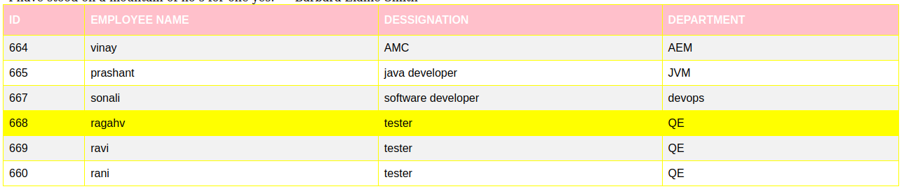

6. Why do we use meta tags?

Meta element can be used to specify the page description , keywords and any other maeta data not provided through the other head elements and attributes.

The meta element has to be used : ethier to emulate the use of an HTTP response Header Field, or to embed additional meta data within the html document.

7. Explain box model.

In CSS, the term "box model" is used when talking about design and layout.

The CSS box model is essentially a box that wraps around every HTML element. It consists of: margins, borders, padding, and the actual content.

8. What are the different types of CSS Selectors?

CSS **selectors** are used *to select the content you want to style*. Selectors are the part of CSS rule set. CSS selectors select HTML elements according to its id, class, type, attribute etc.

There are several different types of selectors in CSS.

1. CSS Element Selector
2. CSS Id Selector
3. CSS Class Selector
4. CSS Universal Selector
5. CSS Group Selector

9. Define Doctype.

The HTML <doctype> tag is used for specifying which version of HTML the document is using. This is referred to as the document type declaration (DTD).

**NOTE** − The <!DOCTYPE> tag does not have an end tag!.

**Syntax:**

<!DOCTYPE html>

**Example:**

<!-- This resembles doctype for HTML5 file -->

<!DOCTYPE html>

<html>

<head>

<title>Page Title</title>

</head>

<body>

<h2>Welcome To TTN</h2>

<p>Paragraph</p>

</body>

</html>

10. Explain 5 HTML5 semantic tags.

Semantic elements have meaningful names which tells about type of content. For example

header, footer, table, … etc. HTML5 introduces many semantic elements as mentioned below

which make the code easier to write and understand for the developer as well as instructs the

browser on how to treat them.

footer

header

main

nav

section

**1.)Header: As the name suggests, it is for the header of a section introductory of a page. There**

**can be multiple headers on a page.**

<!DOCTYPE html>

<html>

<head>

<title>Header Tag</title>

<style>

h1, h3 {

Color:#006400;

Text-align:left;

margin-bottom:0px;

}

p {

font-size:25px;

text-align:left;margin-top:0px;

}

</style>

</head>

<body>

<article>

<header>

<h1>ToTheNew</h1>

<h3>Company Employee</h3>

<p>Software Engineer Organisation</p>

</header>

</article>

</body>

</html>

**2.)Footer: Footer located at the bottom of any article or document, they can contain contact**

**details, copyright information etc. There can be multiple footers on a page.**

<!DOCTYPE html>

<html>

<head>

<title>footer Tag</title>

<style>

p {font-size:25px;

text-align:left;

margin-top:0px;

}

</style>

</head>

<body>

<footer>

<p>Designed by: Prashant Dubey</p>

<p>Contact: <a href="https://www.google.com">

Google.com</a>.

</p>

</footer>

</body>

</html>

**3.)Main: It defines the main content of the document. The content inside main tag should be**

**unique.**

<!DOCTYPE html><html>

<head>

<title>main Tag</title>

<style>

h1 {

color:#006400;

}

p {

font-size:25px;

text-align:none;

margin-top:0px;

}

</style>

</head>

<body>

<main>

<h1>Sementic:main</h1>

<p>A few of Sementic elements</p>

<article>

<h1>Prashant Dubey</h1>

<p>Software Engineer at TTN</p></article>

</main>

</body>

</html>

**4.)Section: A page can be split into sections like Introduction, Contact Information, Details etc**

and each of these sections can be in a different section tag.

<!DOCTYPE html>

<html>

<head>

<title>section Tag</title>

<style>

h1 {

color:#006400;

}

p {

font-size:25px;

text-align:none;

margin-top:0px;

}

</style>

</head>

<body>

<section><h1>Data Structure</h1>

<p>Data Structure is a data organization and

storage format that enables efficient access

and modification.

</p>

</section>

<section>

<h1>Algorithm</h1>

<p>A process or set of rules to be followed

in calculations or other problem-solving

operations, especially by a computer.

</p>

</section>

</body>

</html>

**5.)nav: It is used to define a set of navigation links in the form of navigation bar or nav menu.**

<!DOCTYPE html>

<html>

<head>

<title>nav Tag</title>

<style>

h1 {

color:#006400;

}

</style>

</head>

<body>

<h1>Navigation Bar</h1>

<nav>

<a href="/home/">Home</a> |

<a href="/about-us/">About Us</a> |

<a href="/data-structure/">Data Structure</a> |

<a href="/operating-system/">Operating System</a>

</nav>

</body>

</html>

11. Create HTML for web-page.jpg (check resources, highest weightage for answers)

<!DOCTYPE html>

<html lang="en">

<head>

<meta charset="UTF-8">

<meta http-equiv="X-UA-Compatible" content="IE=edge">

<meta name="viewport" content="width=device-width, initial-scale=1.0">

<title>Document</title>

<link rel="stylesheet" href="project.css">

</head>

<body>

<h1 id="head">To The New</h1>

<div id="navbar">

<ul >

<li><a href="home.html">HOME</a></li>

<li><a href="about.html">ABOUT</a></li>

<li><a href="carrer.html">CAREER</a></li>

<li><a href="contact.html">CONTACT</li>

</ul>

</div>

<div id="back">

<div id="med"><h1>To the New Home</h1></div>

<div id="conte"><p>Searching for and starting a new job takes courage and discipline.

While you may also feel excited about the future .Searching for and starting a new job takes courage and discipline.

While you may also feel excited about the future</p></div>

<div id="conte1"><h3>OUR JOURNEY</h3></div>

<div class="flex-container">

<div class="foot"><div id="up">PARIS</div>

<div > <span id="down">&nbsp; &nbsp; &nbsp; &nbsp; &nbsp; &nbsp; &nbsp; JANUARY &nbsp; &nbsp; &nbsp; &nbsp; &nbsp;&nbsp; </span></div>

</div>

<div class="foot"><div id="up"> LONDON</div>

<div > <span id="down">&nbsp; &nbsp; &nbsp; &nbsp; &nbsp; &nbsp; &nbsp; MARCH&nbsp; &nbsp; &nbsp; &nbsp; &nbsp;&nbsp; </span></div></div>

<div class="foot"><div id="up">GERMANY</div><div > <span id="down">&nbsp; &nbsp; &nbsp; &nbsp; &nbsp; &nbsp; &nbsp; SEPTEMBER&nbsp; &nbsp; &nbsp; &nbsp; &nbsp;&nbsp; </span></div></div>

<div class="foot"><div id="up">ENGLAND</div><div > <span id="down">&nbsp; &nbsp; &nbsp; &nbsp; &nbsp; &nbsp; &nbsp; DECEMBER&nbsp; &nbsp; &nbsp; &nbsp; &nbsp;&nbsp; </span></div></div>

</div>

</div>

</body>

</html>

body{

background-color: #28282B;

}

ul{

overflow: hidden;

margin:0px;

padding:0px;

list-style-type: none;

}

li{

float: left;

}

li a{

display:block;

padding:8px;

text-decoration:none;

}

#head{

text-align: left;

color:white;

margin-left: 60px;

}

#navbar{

margin-left: 80px;

border: 1px solid black;

margin-right:90px;

background-color:black;

}

#navbar ul li a{

color:white;

}

#back{

border: 1px solid black;

padding-bottom: 260px;

margin-top: 10px;

margin-right: 20px;

margin-left: 20px;

background-color: white;

}

#med{

text-align: center;

border: 1px solid black;

color:white;

margin-top: 20px;

margin-right: 20px;

margin-left:20px;

padding:80px;

background-color: #28282B;

}

#conte{

border: 1px solid black;

margin-left: 20px;

margin-right: 20px;

margin-top:10px;

color:black;

background-color: #D3D3D3;

}

#conte1{

margin-right:20px;

margin-left:20px;

border-bottom: 1px solid black;

color:black;

}

.flex-container {

display: flex;

flex-wrap: nowrap;

background-color: white;

margin-top: 10px;

margin-right: 20px;

margin-left:20px;

padding-left: 150px;

}

.flex-container > div {

background-color: black;

width: 200px;

margin: 10px;

height: 300px;

text-align: center;

line-height: 75px;

font-size: 30px;

}

.foot{

text-align: end;

}

#up{

text-align: center;

font-size: 16px;

padding-bottom: 90px;

padding-top: 84px;

color:white;

}

#down{

background-color: #D3D3D3;

font-size: 16px;

}

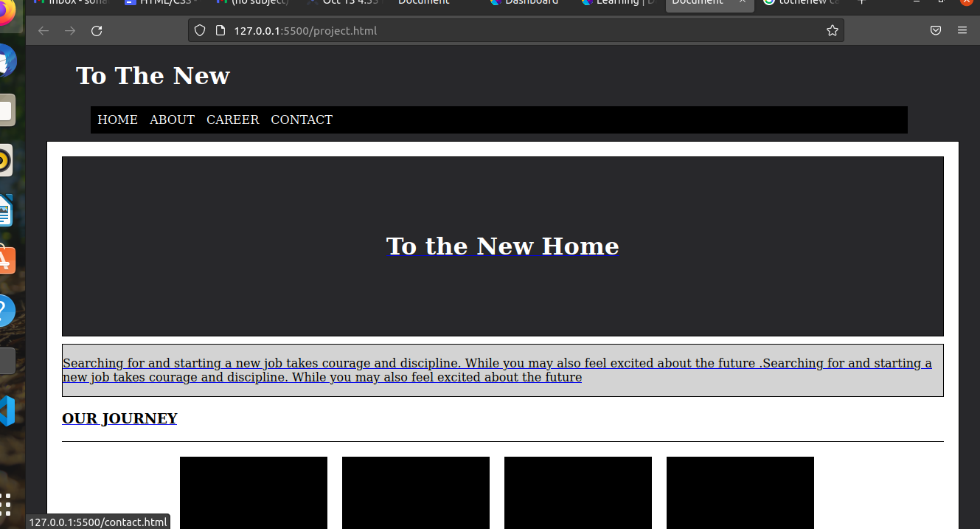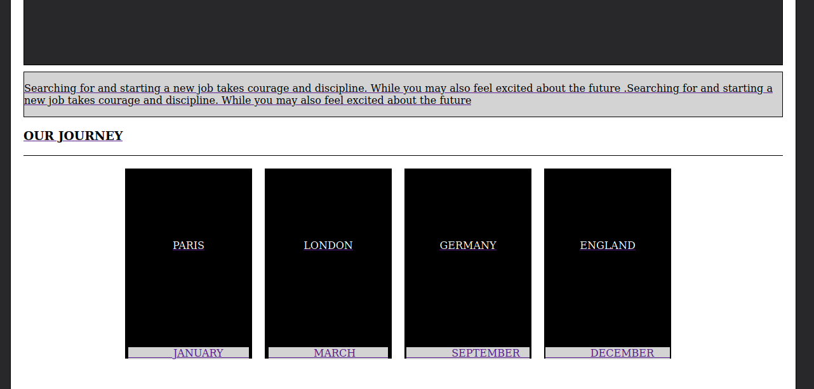

12)Create HTML for form.png (check resources, highest weightage for answers)

<!Doctype html>

<head>

<title>Application Form</title>

<link rel="stylesheet" href="./form.css">

</head>

<body>

<span style="margin-left:320px;color:green;">TO THE NEW</span>

<span style="margin-left:420px;color:green;">Help</span>

<span style="color:green;">Quick help</span>

<hr style="width:50%;"></hr>

<div class="formbody">

<div style="height:50px;background-color:grey;margin-top:-21px;">

<h4 style="padding:20px;color:white;">Bug Report</h4>

</div><br>

<form>

<label>Title*</label><br>

<input type="text" name="title" required><br>

<label>Description*</label><br>

<textarea rows="3"></textarea><br>

<label>Operating System*</label><br>body{

background-color: #28282B;

}

ul{

overflow: hidden;

margin:0px;

padding:0px;

list-style-type: none;

}

li{

float: left;

}

li a{

display:block;

padding:8px;

text-decoration:none;

}

#head{

text-align: left;

color:white;

margin-left: 60px;

}

#navbar{

margin-left: 80px;

border: 1px solid black;

margin-right:90px;

background-color:black;

}

#navbar ul li a{

color:white;

}

#back{

border: 1px solid black;

padding-bottom: 260px;

margin-top: 10px;

margin-right: 20px;

margin-left: 20px;

background-color: white;

}

#med{

text-align: center;

border: 1px solid black;

color:white;

margin-top: 20px;

margin-right: 20px;

margin-left:20px;

padding:80px;

background-color: #28282B;

}

#conte{

border: 1px solid black;

margin-left: 20px;

margin-right: 20px;

margin-top:10px;

color:black;

background-color: #D3D3D3;

}

#conte1{

margin-right:20px;

margin-left:20px;

border-bottom: 1px solid black;

color:black;

}

.flex-container {

display: flex;

flex-wrap: nowrap;

background-color: white;

margin-top: 10px;

margin-right: 20px;

margin-left:20px;

padding-left: 150px;

}

.flex-container > div {

background-color: black;

width: 200px;

margin: 10px;

height: 300px;

text-align: center;

line-height: 75px;

font-size: 30px;

}

.foot{

text-align: end;

}

#up{

text-align: center;

font-size: 16px;

padding-bottom: 90px;

padding-top: 84px;

color:white;

}

#down{

background-color: #D3D3D3;

font-size: 16px;

}

<select style="margin-left:20px;border-radius:3px;width:78%;background-color:green;color:white;">

<option>window xp</option>

<option>mac os</option>

<option>linux</option>

</select><br>

<label>Product*</label><br>

<select style="margin-left:20px;border-radius:3px;width:78%;background-color:green;color:white;">

<option>microsoft</option>

<option>apple</option>

<option>oracle</option>

</select><br>

<label>Version*</label><br>

<input type="text" name="version" style="width:60px;" required><br>

<label>Licence*</label><br>

<input style="float:left;margin-left:-85px;" type="radio" id="free" name="licence_type" value="free">

<label style="margin-left:-110px;" for="free">free</label>

<input style="float:left;margin-top:-15px;" type="radio" id="paid" name="licence_type" value="paid">

<label style="margin-left:70px;" for="paid">paid</label> <br>

<label>Security*</label><br>

<select style="margin-left:20px;border-radius:3px;width:78%;background-color:green;color:white;">

<option>critical</option>

<option>minor</option>

<option>major</option>

</select><br>

<label>Attachment*</label>

<input type="file" name="fileattach" value="upload">

</form>

<div style="height:45px;background-color:grey;margin-top:50px;">

<button type="submit" style="background-color:green;color:white;margin-left:240px;margin-top:10px;">Save</button>

</div>

</div>

</body>

</html>

