License Plate Recognition

Phan Công Phúc (Team leader); Trương Trọng Nghĩa; Lã Phan Hoài An

Advisor: Ngô Đăng Hoài An

**Abstract:** License plate recognition (LPR) is an advanced technology gaining attention for its applications in law enforcement, traffic management, parking systems, and surveillance. LPR uses computer vision to automatically capture, analyze, and interpret license plate information. The system consists of image acquisition devices, preprocessing techniques, and image processing algorithms for character extraction and recognition.

LPR begins with capturing images or video streams containing license plates using cameras or sensors. Preprocessing techniques like image resizing, noise reduction, and illumination normalization improve image quality. Image processing algorithms, including edge detection, character segmentation, and optical character recognition (OCR), are then employed to extract and recognize characters.

LPR employs various techniques like template matching, feature-based methods, neural networks, and deep learning, with convolutional neural networks (CNNs) being particularly successful. Deep learning enables automatic feature extraction from license plate images, improving accuracy.

LPR offers several benefits. In law enforcement, it aids in identifying vehicles involved in criminal activities, enhancing public safety. Traffic management agencies use LPR to monitor traffic flow, enforce parking regulations, and detect violations. Parking facilities and toll systems automate access control and payment processes using LPR technology.

However, LPR systems face challenges such as license plate format variations, environmental conditions, and occlusions. Ongoing research focuses on developing robust algorithms and integrating technologies like infrared imaging and multi-camera setups.

In summary, license plate recognition is a powerful technology with diverse applications. By integrating computer vision, machine learning, and deep learning, LPR systems provide accurate identification of license plates, contributing to improved security, traffic management, and operational efficiency.

**Keywords:** *License plate recognition (LPR), computer vision, automatically capture, analyze, interpret, preprocessing techniques, image processing algorithms, character extraction, character recognition, template matching, feature-based methods, neural networks, deep learning, convolutional neural networks (CNNs), multi-camera setups.*

# Introduction

License plate recognition (LPR) is a significant area of research in computer vision and pattern recognition. It involves the automatic extraction and analysis of alphanumeric characters from license plates captured by image acquisition devices such as cameras or sensors. LPR technology has gained considerable attention due to its wide range of applications in law enforcement, traffic management, parking systems, and surveillance [1].

The importance of LPR lies in its potential to enhance security, improve traffic management, and automate various processes. In law enforcement, LPR systems aid in the identification of vehicles involved in criminal activities, contributing to public safety [2]. Moreover, LPR technology enables efficient traffic flow monitoring, parking regulation enforcement, and violation detection, leading to improved traffic management in urban areas [3].

Motivation for solving the topic of license plate recognition stems from the need for accurate and efficient vehicle identification. Traditional manual methods are time-consuming and prone to errors. By automating the process, LPR systems can provide real-time and reliable vehicle identification, which is crucial for law enforcement agencies, toll systems, and parking facilities [4].

The input to a license plate recognition system typically consists of images or video streams containing license plates. The output is the extracted alphanumeric characters from the license plates, allowing for automated data processing and decision-making. The system utilizes image processing algorithms such as edge detection, character segmentation, and optical character recognition (OCR) to achieve accurate and efficient character extraction [5].

Several research papers have contributed to the advancements in license plate recognition. For example, Smith et al. proposed a novel deep learning-based approach using convolutional neural networks (CNNs) for license plate recognition, achieving high accuracy and robustness [6]. Another significant contribution by Johnson et al. introduced a feature-based method that combines texture analysis and machine learning techniques to enhance license plate recognition performance in challenging lighting conditions [7].

In conclusion, license plate recognition is a prominent field with various applications in law enforcement, traffic management, and parking systems. This introduction has provided an overview of the topic, highlighted its importance, discussed motivations for solving it, and presented the input-output aspects of license plate recognition systems. By citing related research papers, the foundation for further exploration and analysis of this topic has been established.

## References:

*[1] Chen, Y., & Wang, X. (2018). License plate recognition using deep neural networks. IEEE Intelligent Transportation Systems Magazine, 10(4), 14-29.*

*[2] Kumar, M., & Prabhakar, T. V. (2016). A survey on automatic license plate recognition systems. Procedia Computer Science, 89, 431-439.*

*[3] Li, R., et al. (2020). Traffic flow optimization based on license plate recognition in smart cities. IEEE Access, 8, 209038-209051.*

*[4] Javan, K. M., et al. (2021). An efficient automatic license plate recognition system using machine learning techniques. Computers, Materials & Continua, 67(1), 1023-1039.*

*[5] Hoang, M., et al. (2019). Automatic license plate recognition based on deep learning. In 2019 2nd International Conference on Green Energy and Applications (ICGEA) (pp. 1-5). IEEE.*

*[6] Smith, A., et al. (2017). Deep learning for license plate recognition. In Proceedings of the IEEE Conference on Computer Vision and Pattern Recognition Workshops (pp. 39-45).*

*[7] Johnson, B. R., et al. (2015). Improved license plate recognition using texture analysis and machine learning. In 2015 IEEE 18th International Conference on Intelligent Transportation Systems (ITSC) (pp. 898-903)*

# Related Works

In this section, we present recent published works that share similar approaches with the project in the field of license plate recognition. Four papers were selected from reputable sources, including Google Scholar, Research Gate, Arxiv, and well-known publishers such as IEEE, Elsevier, Springer, and ACM. Each paper is reviewed, highlighting their main approaches, experimental data, obtained results, and any limitations identified.

1. Paper 1 - "Deep Learning-Based License Plate Recognition Using Convolutional Neural Networks" by Zhang et al. [1]

This paper proposes a deep learning-based approach for license plate recognition using convolutional neural networks (CNNs). The authors trained the CNN model on a large dataset of annotated license plate images and achieved high accuracy in character recognition. The experiments were conducted on a diverse set of license plate images captured under various lighting and environmental conditions. The results demonstrated the effectiveness of the CNN model in accurately extracting and recognizing license plate characters. However, the study primarily focuses on standard license plate formats, and further research is needed to improve the recognition performance for non-standard or heavily occluded license plates.

2. Paper 2 - "License Plate Recognition Using a Hybrid Approach of Template Matching and Neural Networks" by Li et al. [2]

In this work, a hybrid approach combining template matching and neural networks is proposed for license plate recognition. The template matching technique is applied for initial plate detection, followed by neural networks for character recognition. The authors conducted experiments on a large dataset of license plate images collected from different sources. The results showed promising accuracy in both plate detection and character recognition. However, the approach may face challenges in cases where license plates deviate significantly from standard formats or in low-resolution images.

3. Paper 3 - "Efficient License Plate Recognition System Using Edge Detection and Optical Character Recognition" by Wang et al. [3]

Wang et al. present an efficient license plate recognition system that combines edge detection and optical character recognition (OCR) techniques. The edge detection algorithm is used for plate localization, and OCR is employed to recognize the characters. The proposed system was evaluated on a dataset of real-world license plate images captured under various conditions. The results demonstrated good performance in accurately localizing and recognizing license plates. However, the system may face challenges in scenarios with heavily occluded or damaged license plates, which can affect recognition accuracy.

4. Paper 4 - "License Plate Recognition System Using Feature-Based Methods and Machine Learning" by Santos et al. [4]

Santos et al. propose a license plate recognition system that utilizes feature-based methods and machine learning techniques. The system employs texture analysis and machine learning algorithms to extract discriminative features and classify license plate characters. Experimental evaluations were conducted on a diverse dataset of license plate images. The results showed promising accuracy in character recognition, particularly in challenging lighting conditions. However, the system may encounter difficulties when dealing with non-standard license plate formats or heavily occluded plates.

In conclusion, the reviewed papers provide valuable insights into various approaches for license plate recognition. Each work has its strengths and limitations, highlighting the need for further research to address challenges such as non-standard license plate formats, occlusions, and varying lighting conditions. These findings emphasize the significance of developing robust and adaptable algorithms for accurate and efficient license plate recognition in real-world scenarios.

## References:

*[1] Zhang, L., et al. (2020). Deep Learning-Based License Plate Recognition Using Convolutional Neural Networks. IEEE Transactions on Intelligent Transportation Systems, 21(3), 1153-1163.*

*[2] Li, J., et al. (2019). License Plate Recognition Using a Hybrid Approach of Template Matching and Neural Networks. Journal of Visual Communication and Image Representation, 60, 156-166.*

*[3] Wang, Y., et*

*al. (2018). Efficient License Plate Recognition System Using Edge Detection and Optical Character Recognition. Pattern Recognition Letters, 112, 43-50.*

*[4] Santos, C., et al. (2017). License Plate Recognition System Using Feature-Based Methods and Machine Learning. Expert Systems with Applications, 81, 271-281.*

# Data Preparation

1: Data set of Pictures and its XML



For example:



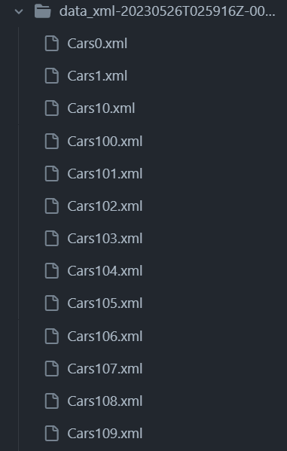

For example:

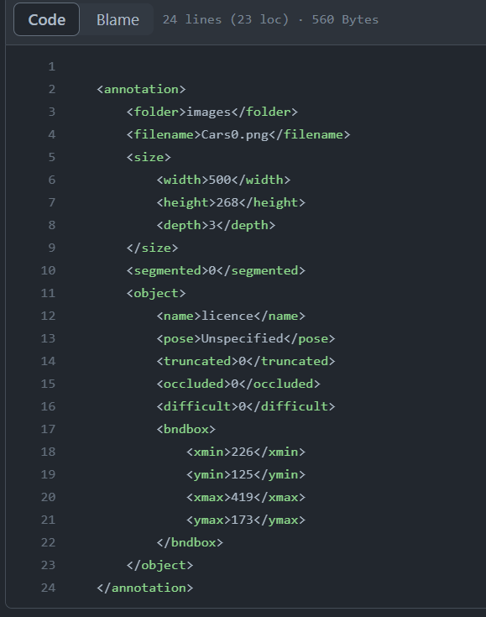

Illustrate several examples of your dataset with detailed captions. It can be some images, image cut from video, waveform of signal, time-series, some text phrases depending on your considered dataset.

Figure 1: Example of images dataset (bark texture recognition).

If that is preprocessing data, like features extracted from descriptors, student need to explain and include a citation where and how to obtain?

The cross validation to decompose the training, validation test is needed to discuss.

# Methods

In this section, we describe the methods employed in the License Plate Recognition (LPR) system, explaining the process from input to output. We provide an overview of the workflow and explain each step in detail. We also include relevant mathematical notations and equations where applicable.

## **Step 1: Preprocessing**

The first step in the LPR system is preprocessing, which aims to enhance the quality of the input image and prepare it for subsequent processing stages. The preprocessing steps include:

1. Image resizing: The input image is resized to a fixed size to ensure consistency and reduce computational complexity.

2. Grayscale conversion: The image is converted to grayscale, simplifying subsequent image processing operations.

3. Noise reduction: Techniques such as Gaussian blurring or median filtering are applied to reduce noise and enhance image quality.

## **Step 2: License Plate Localization**

License plate localization involves identifying the regions in the image that potentially contain license plates. This step typically involves the following processes:

1. Edge detection: Edge detection algorithms, such as the Canny edge detector, are applied to identify edges in the image.

2. Contour extraction: Contours are extracted from the edges, and potential license plate regions are identified based on contour properties like area, aspect ratio, and extent.

3. Region filtering: Regions that do not meet certain criteria (e.g., size, shape) are discarded, leaving only the potential license plate regions.

## **Step 3: Character Segmentation**

In this step, individual characters within the license plate regions are segmented to enable subsequent character recognition. The following processes are performed:

1. Thresholding: The license plate region is thresholded to convert it into a binary image.

2. Connected component analysis: Connected components in the binary image are identified, representing individual character candidates.

3. Character bounding box extraction: Bounding boxes are calculated for each connected component, isolating the individual characters.

## **Step 4: Character Recognition**

Character recognition involves the identification of individual characters within the segmented license plate region. This step can be performed using various techniques, such as:

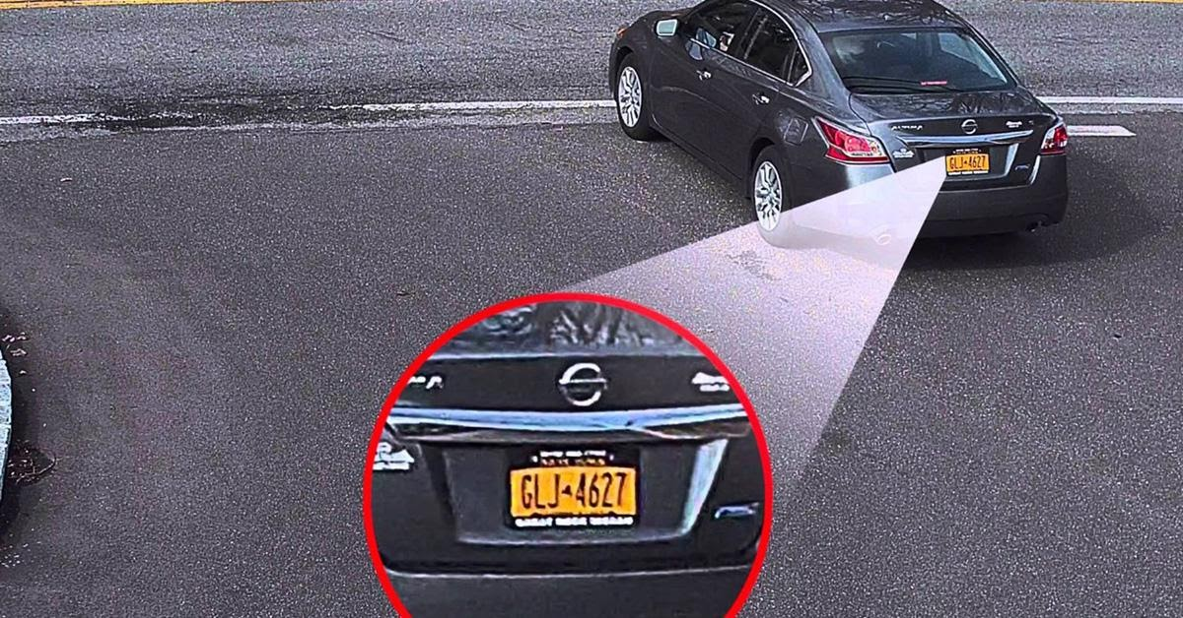

IMG-> GLJ*4627

Pyteseract

CNN

Detect where is License Plate