SonarQube Installation Steps:

System Configuration
Operating System | Ubuntu 24.04.2 LTS
RAM | 8 GB
CPU | 4
IP Address | 172.30.4.180

- Docker-compose file to install SonarQube

compose.yml
version: "3.9"

services:
sonarqube:
image: sonarqube:lts-community
depends_on:
- sonar_db
environment:
SONAR_JDBC_URL: jdbc:postgresql://sonar_db:5432/sonar
SONAR_JDBC_USERNAME: sonar
SONAR_JDBC_PASSWORD: sonar
ports:
- "9000:9000"
volumes:
- sonarqube_conf:/opt/sonarqube/conf
- sonarqube_data:/opt/sonarqube/data
- sonarqube_extensions:/opt/sonarqube/extensions
- sonarqube_logs:/opt/sonarqube/logs
- sonarqube_temp:/opt/sonarqube/temp
healthcheck:
test: ["CMD", "curl", "-f", "http://localhost:9000"]
interval: 30s
timeout: 10s
retries: 5
restart: unless-stopped
deploy:
resources:
limits:
cpus: "2.0"
memory: 4G
reservations:
cpus: "1.0"
memory: 2G

sonar_db:
image: postgres:17
environment:
POSTGRES_USER: sonar
POSTGRES_PASSWORD: sonar
POSTGRES_DB: sonar
volumes:
- sonar_db:/var/lib/postgresql
- sonar_db_data:/var/lib/postgresql/data
healthcheck:
test: ["CMD-SHELL", "pg_isready -U sonar"]
interval: 30s
timeout: 10s
retries: 5
restart: unless-stopped
deploy:
resources:
limits:
cpus: "1.0"
memory: 2G
reservations:
cpus: "0.5"
memory: 1G
volumes:
sonarqube_conf:
sonarqube_data:
sonarqube_extensions:
sonarqube_logs:
sonarqube_temp:
sonar_db:
sonar_db_data:

- Update Host Machine configuration for SonarQube

add the below setting to the /etc/sysctl.conf file and save it.

/etc/sysctl.conf
vm.max_map_count=262144
After saving the file, apply the changes by running:

sudo sysctl -p

- Start the container using docker-compose command

docker-compose up -d
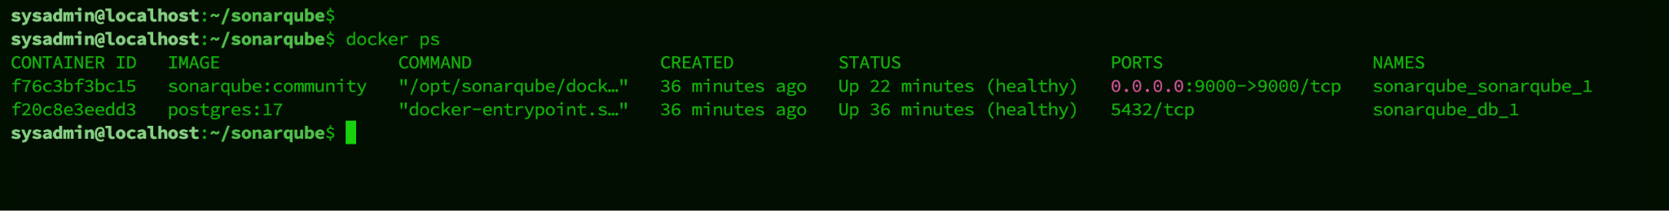

docker stats

- Access SonarQube at port 9000
SonarQube Login Details
URL | http://172.30.4.180:9000/
Username | admin
Password | D$OM@2o24U$3R

- SonarQube UI

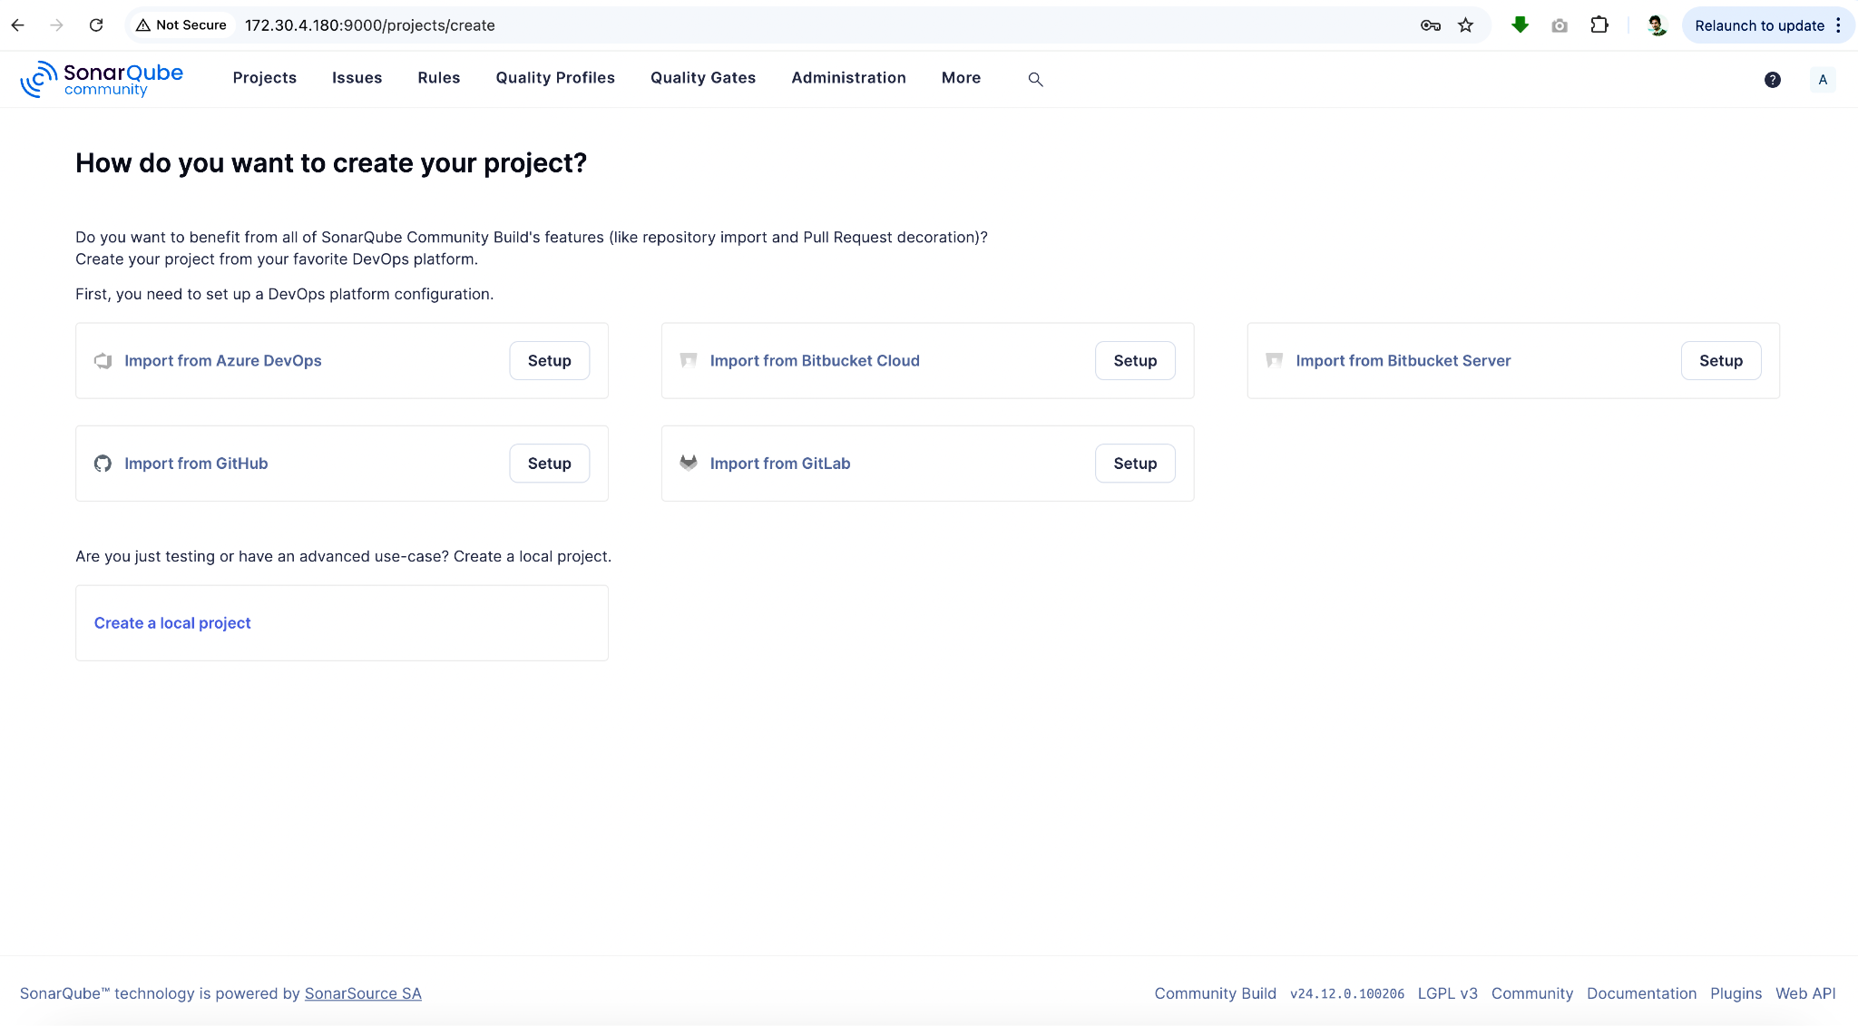

- Create a Token to access SonarQube

Go to My Account → Security → Generate Token

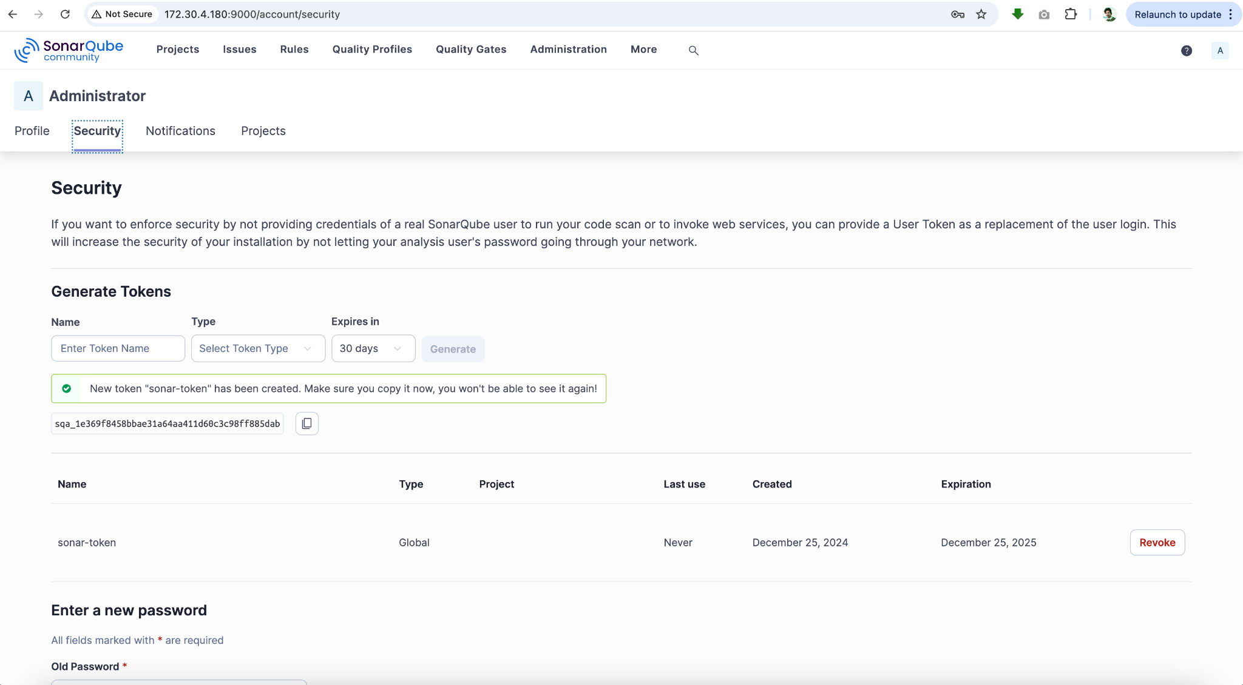
- Create a webhook to notify the Jenkins machine when the project analysis is done

Go to Administration → Configuration → Webhooks → Create

