**Choosing which capitol city to visit out of the 2 smallest states in the U.S**

By

Terrill Toe

September 9, 2020

**Introduction**

**Background**

All the major cities in the U.S such as New York City, Los Angeles, Chicago, etc get the nod for places to visit as a tourist. There are other cool places to visit and move to for possible opportunities. The premise of this project will be to explore 2 of the more unknown cities in the U.S and see which will be more likely to draw people to them. Why not explore the capital cities of the 2 smallest states, Dover, Del and Providence, RI? Being from Providence, RI, it is common to run into folks who aren’t familiar with the city and seem to believe there is nothing much to do given its size. However, being from Providence, I know what it has to offer in terms of entertainment to visitors and locals. Now I am personally curious if the same applies to a similar city.

**Problem**

Geolocation data and analysis should shine some light on unknown cities, specifically Dover and Providence for this project. Given the choice of visiting either 2 cities, which would you go with? The same can be done to other cities of interest.

**Interest**

With the emergence of Social media, the ideal lifestyle of being able to travel all over the world has become a growing trend. So this report should be of interest to those who are looking to travel and those who are looking to maybe move somewhere a little lower key but still have the amenities they are looking for in a city.

**Data acquisition and cleaning**

**Data Sources**

Since we are looking at geolocation data and what a city has to offer outside of work and home life, the best source of data would be the Foursqaure API. Which should provide us Venues across the city of scope. This data should include the category the venue falls under, and which neighborhood it resides in. Since we are using the free version of this API, limited data will only be provided unfortunately. To supplement and give us some additional data to look at we will also look to another API called Zomato. Zomato is a similar API to that of Foursqare. It also offers more data like the nightlife index for venues and should be able to fill in the gaps where Foursquare could not.

**Data Cleaning**

A lot of the effort for this project was put towards the data gathering piece. Foursquare did a wonderful job of providing the original data needed. However, there were some issues with extracting all the neighborhoods for all the venues in the 2 cities. The issue resided in the fact that some venues had unknown neighborhoods. Around 35% or more of the data points were missing neighborhood data for both cities. Original thoughts of excluding those data points occurred but because these are small cities and there were already so few data points, getting rid of them would hurt the analysis stage. Efforts were made finding ways to scrape the data, however, it was unsuccessful. After doing some further research as to where to possibly get the missing data needed, this led to the Zomato API. The Zomato API is originally used for gathering restaurant data. With that understanding, for the missing data there were high hopes of reducing that number. Given the data point was a restaurant. Luckily for the project, Zomato was able to provide neighborhoods for all those venues where that value was missing.

From both APIs I was able to extract the exact features needed. There were some manipulation done to some of the fields in order to extract the neighborhood data for each data point. The manipulation done was combining the latitude and longitude into a column named geom. This was done in order to easily pass the value as a parameter for the function created to pull neighborhood data. That column was later dropped.

**Exploratory Data Analysis**

Looking at the map of both cities, we can see that a lot of the venues in Dover are concentrated around a few major road systems where Providence is dispersed all over the city. However, when we look at the data points, Providence actually has a majority of its venues concentrated in a few neighborhoods. Federal hill and Downtown made up 57% of the venues in Providence, while 51% of the venues in Dover resided in Edge Hill, East Lake Gardens, and Capitol Green.

**Map of Dover**:

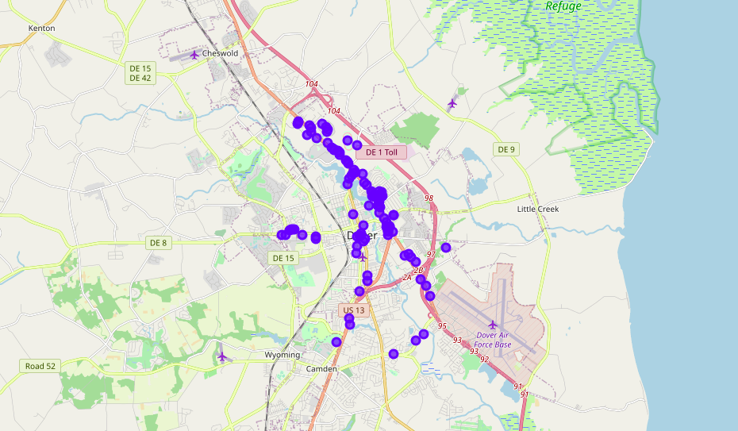

**Map of Providence**:

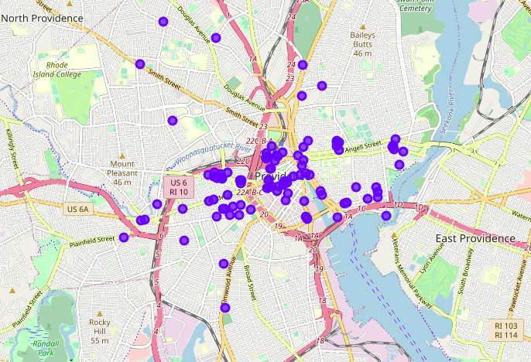

Looking at the top neighborhoods in each city having the most venues we can also see that there is a wider variety of venue categories within Dover. For Providence a majority of the venues are bars, American/Italian restaurants, and hookah lounges. Which primarily comprises of music food and drinks. Dover on the other hand has additional venues that extend outside of music, drinks, and food. For example monuments, museums, racetracks, and also sea food.

What does this all mean as of now? For a tourist Dover offers variety and convenience. With all the venues located on or near major road systems, getting to them would be rather easy. Whether you are are a foodie and want to try bits of everything in one day, you can simply hop on one road and get to all of them. In addition, it is pretty standard to see different cultures when it comes to neighborhoods. Ease of entrance would further deepen the experience of those traveling to the city for the first time. That would be the case if culture variation exists among Dover neighborhoods.

**Dover Venues**:

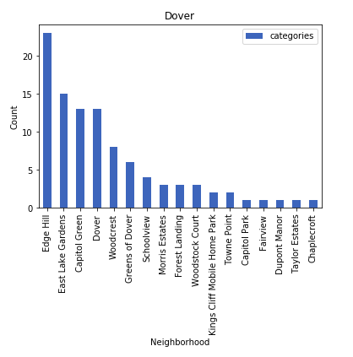

**Dover neighborhoods:**

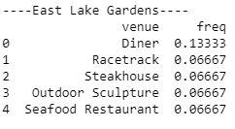 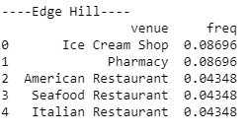

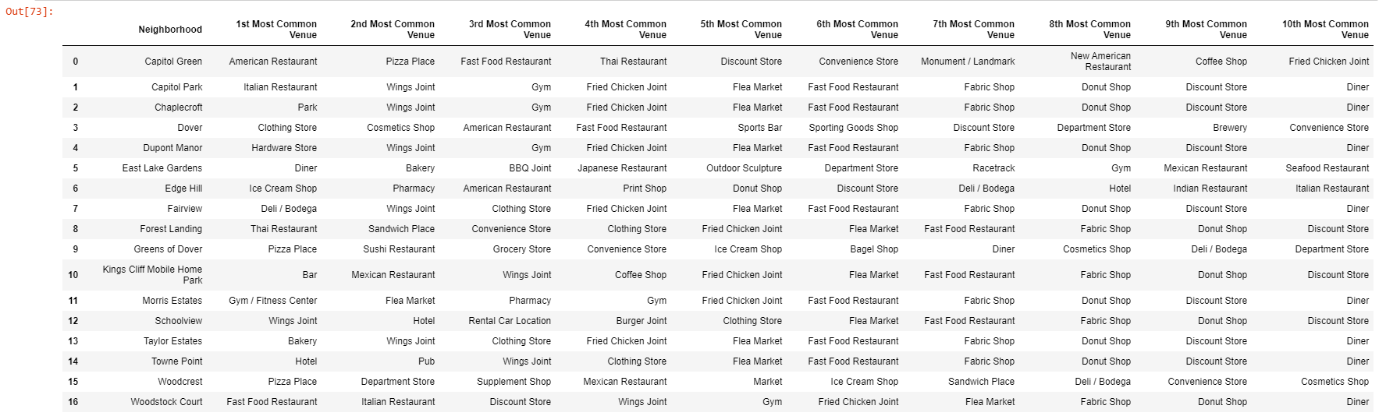

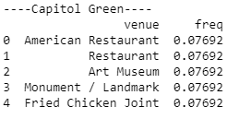

**Providence Venues**:

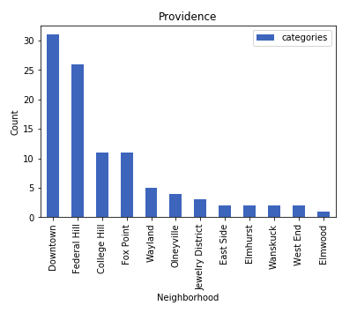

**Providence neighborhoods**:

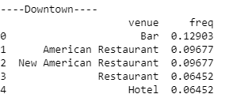 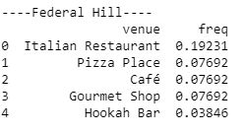

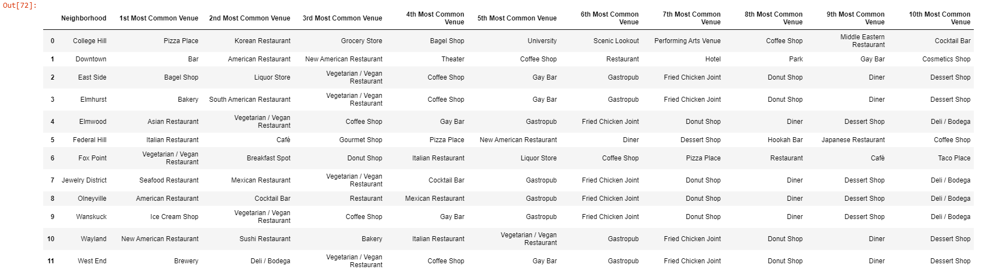

In terms of visitation by tourists, Providence is geared more towards the younger crowd who are looking primarily for nightlife, and Dover is more family oriented. This can be observed by the type of venues offered by each city. Luckily for us we will be able to further test this idea with the nightlife index provided by Zomato.

Using this index we can plot the nightlife of each city to get a sense of what areas in each city has the best nightlife.

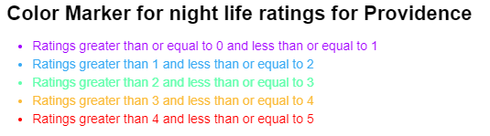

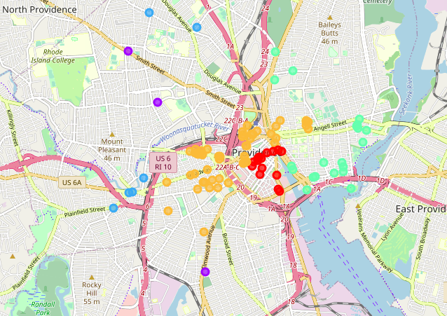

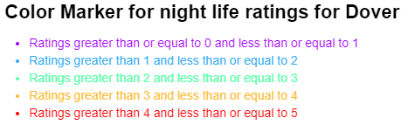

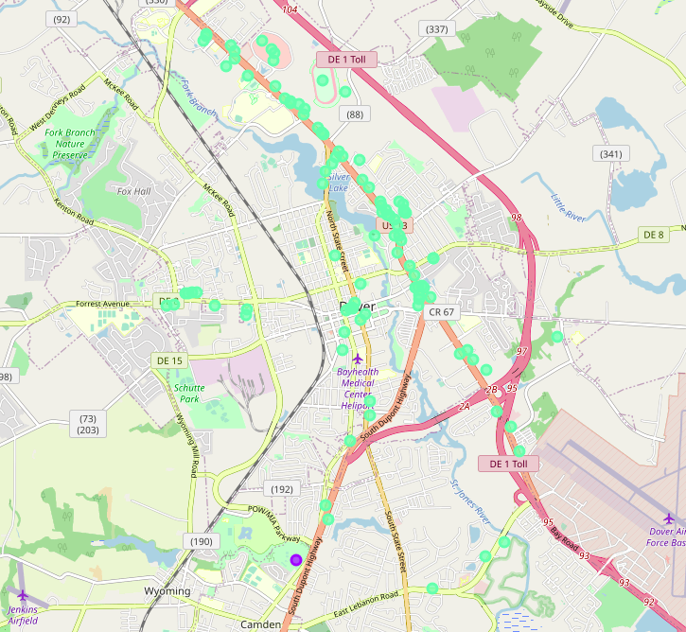o

Comparing the 2 maps it is pretty evident that Providence offers more of a nightlife than Dover does. A majority of the really good night life is around the areas of Downtown and Federal Hill. As you venture outside of those 2 areas which is the heart of the city, the nightlife begins to whine down. The eastside of Providence has a pretty much milder nightlife, somewhat similar to that of Dover. There are very few venues that have a night life index below 2. So if you are a young adult looking for some balance between good nightlife and venues that are little quieter, Providence comes with the variety in this area.

Dover on the other hand has an average index near 2, which is relatively quiet. If you are looking to go out past 11:30pm est, everything has the potential to be closed. If you are young adult, Dover may not be for you. Leave this city for some of the older folks

**Machine Learning**

For the purpose of this project, I felt that Machine Learning was unnecessary. The Machine learning algorithms that were touched upon in this course were mainly used for predicting. Specifically predicting either continuous or classification data sets. In order to get an accurate measurement of this I would’ve needed to take a survey of people with different profiles and see which city they would choose. Then I would need to follow up by running a machine learning algorithm on top of the data in order to get a predictive model. Doing this would’ve been extensive for this project and for the given time frame to complete.

**Conclusion**

As you can see it will be unfair to say one city is simply better than another city. The 2 cities each have their own characteristics that serve different purposes for those looking to visit either one. Looking at the city of Dover, we can see that there is a little more variety in the types of venues offered to locals and tourists. However, the nightlife in Dover is nothing compared to that of Providence. This is given by the fact that over 90% (estimate) of the city has a relatively low nightlife rating. So if you are a rather young individual looking for some fun and were faced with the choice of selecting which city to visit, you would more likely choose Providence over Dover. For a family of young children looking for something a little quieter you may want Dover. On the other hand if you are parents and are looking for the night life when the kids are asleep, then Providence has everything you need.