The Meaningness of Life  
Towards sincere existentialism.

**Immanuel Kant:** *"Always recognize that human individuals are ends, and do not use them as means to your end."*

This season has been about meaning and about formations and transformations and how these are connected. And it has been about *meaningness*, discussed in many and roundabout ways without spelling out what it is. It is time to concretise what is meant by meaningness, as well as to summarise the season.

*Thinking Of Things* has been a way for me to investigate ideas and to spark conversations with those who read. As such it has been a succesful season, with many conversations in person, email, comments on the posts and on social media. For the purpose of a line of thought is not its conclusion. The purpose is the line of thought itself and that it may not end. The word conclusion is a misnomer in this sense; to conclude signifies an end, while in reality it signifies a continuation, a new beginning. A reached conclusion is boring and meaningless without the follow-up question: so what? And thus, with your help, we continue the line of thought together. This is the concluding episode of the season.

I want to express my gratitude towards Notme. I have written this season during one of the most transformative periods of my life, so much so that the conclusions of some episodes changed into their polar-opposites during the writing process. Hence the two voices, one from before called "Me" and one in the process of transformation called "Notme". Notme has been the voice of a plethora of people at different levels of closeness against whom I have wielded my arrogance and preconceptions. Voices which have been, and still are, absolutely necessary for my ongoing transformation as a human being. In this sense, this season has been endowed with a meta-level.

A piece of knowledge that I have gained during this process is the realisation how deeply influenced I am by the historical context in which I find myself, a context by the name of *modernity*.

[1]

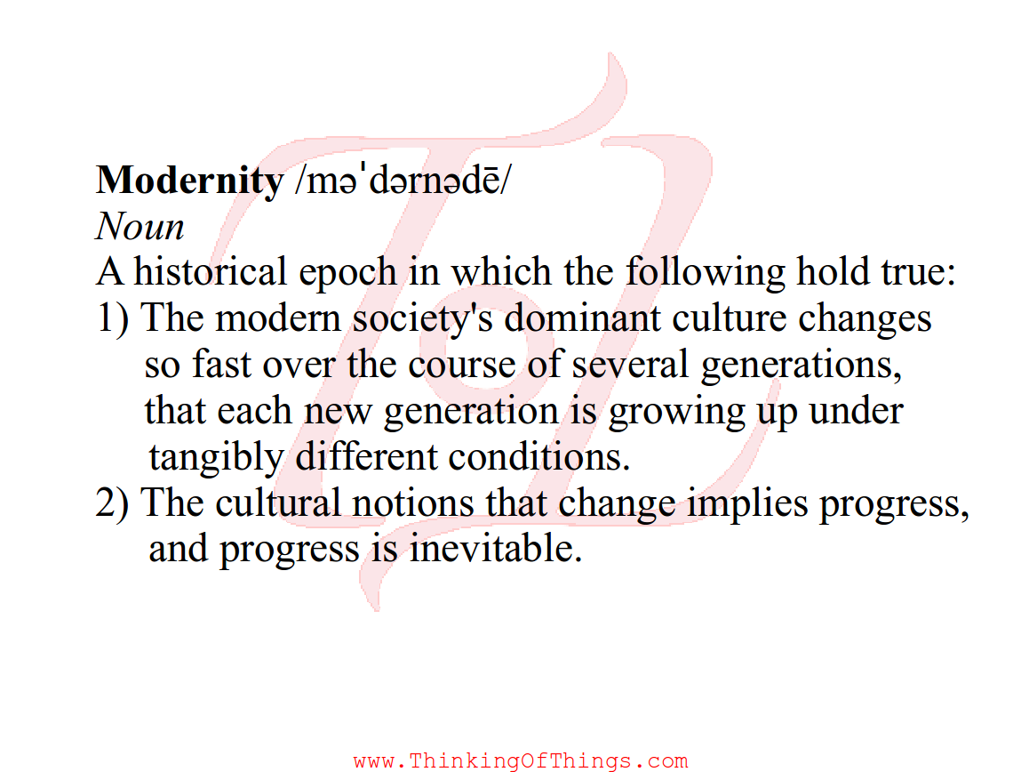

Modernity will be the focus of Season 2, but for now I need the concept of the *project*, which is an integral part of modernity. A project encapsulates and combines the concepts of transformations and the notion that change is progress. The heart of what Notme, and now I, call *meaningness* lies in the project. As we shall see, there are different kinds of projects and not all contains meaningness.

This episode contains two main threads: firstly to summarise the season so far, in order to then try to understand and explain *meaningness.*

Three definitions of the word *meaning* were discussed in the first three episodes:

**1. Cosmic Meaning**

Cosmic meaning[2], is the significance events have on a cosmic or metaphysical level and it was dismissed as irrelevant. Whether there is a cosmic significance to my being in the world, or whatever happens to me, can have absolutely no bearing on my life. God or no God, cosmic plan or not, destiny fate, determinism or whatever, in the end it is up to me to live my life, make my own decisions and interact with my surroundings and fellow creatures how I see fit. I am not calling myself neither a theist nor an atheist, since God's existence is irrelevant. To not acknowledge God's importance is also a strategy to subvert its power over me: Power needs recognition to exist and by not recognising cosmic meaning as important in my life I subvert it. The dismissal of cosmic meaning is an inherent part of modernity.

**2. Meaning of stuff**

The meaning of stuff[3], on the other hand, is quite significant to how I perceive the world. We are biological and social creatures and our perception of the world, both physically and abstractly, depends on our biology and social context. This decides the way we categorise our surroundings, turning stuff into separate items. The way we differentiate between rocks, pebbles and boulders; between milk, yogurt, butter and cream; between men, dolls, boys, women, girls, trees, bushes, statues, statutes, rules, institutions, circles and rectangles.

These categories are learnt and we learn them during our cultural upbringing. We learn not only to discern and categorise, to create taxonomies, but also how to feel about each category, how to understand each and all of them. These categories and their attached emotion are what form a *cultural prejudice* and the set of them all is what forms a *cultural world view*. The deconstruction of cultural categories is inherent in a part of modernity often called the *postmodern[4]* and is to some extent a part of what constitutes meaningness.

**3. Meaningness**

Now to meaningness[5]. And the project. Simone de Beauvoir tells a story as an example of a life-project in the essay *Pyrrhus & Cineas*. It is a story of the Greek general and later king Pyrrhus of Epirus (319-272 BC) and one alleged conversation he had with his friend and adviser Cineas while planning a military campaign. It goes something like this:

**Pyrrhus**: *“First we conquer Greece.”*

**Cineas**: *“And then what?”*

**Pyrrhus**: *“Then we take over Africa.”*

**Cineas**: *“And then what?”*

**Pyrrhus**: *“Then we go to Asia and conquer Asia Minor, Arabia”*

**Cineas**: *“And then what?”*

**Pyrrhus**: *“Then we go all the way to India.”*

**Cineas**: *“And then what?”*

**Pyrrhus**: *“Oh, then I rest.”*

**Cineas**: *“But why, then, don't you rest now?”[6]*

What Pyrrhus is about to embark upon stands as an example of a project, a personal project of world dominance--but is it also an example of meaningness?

The film-maker Woody Allen recently described the reason for his own project:

**Woody Allen:** *"If I don't solve it, it's going to be a bad movie but I won't die. That's why I do it. I distract myself... making movies is a wonderful distraction. I'm not thinking about my death, the decaying of my body, that I will be old one day in a very distant future."[7]*

Is this a description of meaningness?

My answer to both these questions is *no*. What both these projects acknowledge is that life is ultimately meaningless, in the sense that it lacks cosmic meaning. Therefore, these projects only serve the purpose of distraction from an otherwise meaningless existence. This attitude fails to take into account how insignificant cosmic meaning is. As Cineas points out, the aim of this kind of project is to end it--so why even embark upon it? Why not rest now? As will be clear soon, this is part of the reason for these projects not being projects of meaningness.

A project of meaningness is not a means to an end. It can never be completed. A project whose whole purpose is to end itself and make itself redundant, such as conquering the world, eradicate evil, scientifically explain everything, own everything, create a utopia, are all the opposite of meaningness. Such projects I choose to call *totalitarian.* (The *utopian* projects are a sub-category to these.) Examples of totalitarian projects are neo-liberalism, a scientific theory of everything as well as some forms of Marxism. Any utopian strife for an ideal or perfection becomes totalitarian. These are the projects driven by insecurity and they are the opposite of meaningness.

As will become clear, meaningness is found in another kind of project, the project which is its own reason for being. The project of *sincerity*. By being sincere, one is doing what one is doing for the purpose of doing just that, and not for any other reason. There is no higher purpose, no worthy sacrifices, just that what one does. It may seem vague, but as we will see, the project of meaningness is specific and concrete.

# The project of Meaningness

Let me already here attempt to define meaningness and maybe modify it later:

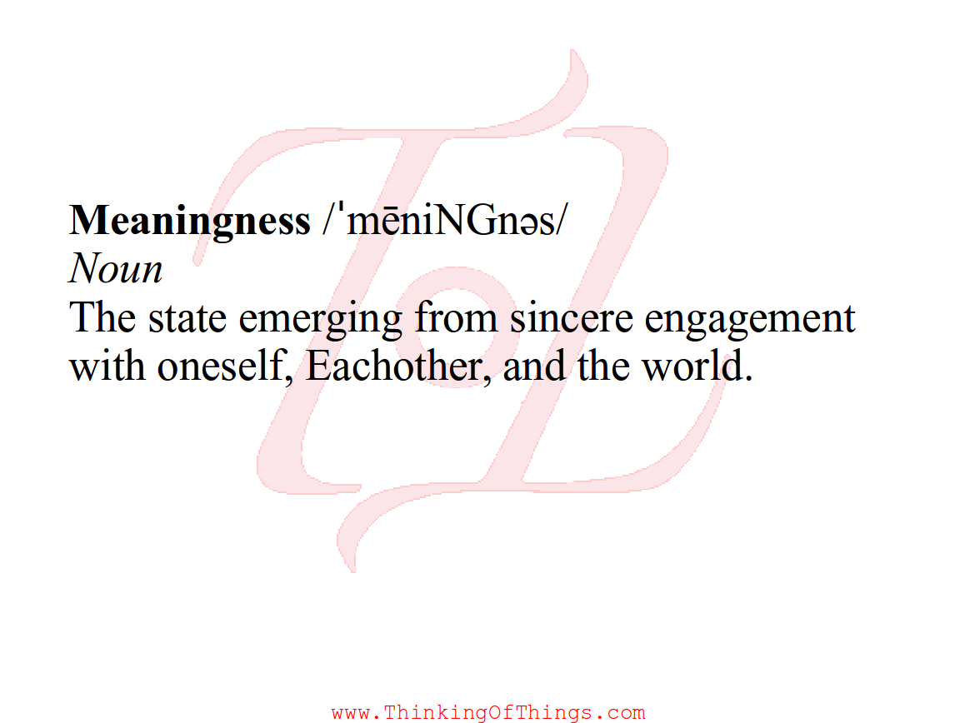

Meaningness is the project of how to becomei a human being and not a bit of filth, it is the project of grabbing our infinite[8] personhood and overcome our nature and nurture[9]. It is the project of turning the Other into Each-other, for one cannot grab one's personhood without also helping someone else in this regard, and one cannot do it alone. And the meaningness of life is the reason for being. And it is a never-ending project, since consciousness[10] is not a binary, when diving into the bottomless pool of personhood the transformations are never-ending and without goal.

Sounds vague? It is not. The reason why the project of meaningness is concrete is simple: It is derived from the fact that we are biological creatures and we are social creatures.

In the previous episodes, four stages of human development were recognised[11]:

**1.** Imitating childhood, where one learns to discern the categories of a culture. Apples are different from oranges: wooden spoons from blocks of wood: mothers from fathers etc. One imitates without understanding of what the categories *mean*.

**2.** Insecurity-driven adolescence, where one, often painfully[12], learns social hierarchies and what the categories mean.

**3.** Culture-savvy adulthood, where the acquired cultural knowledge is utilised to keep the social pain away. Comfort zones have been formed and the culture-savvy adult knows how to stay within his/her boundaries without getting hurt, or even uncomfortable.

**4.** Maturity into occasional personhood and consciousness.

The type of culture-savvy adult we end up as depend on the cultural upbringing which brought us here. One part of the project of meaningness is to challenge our cultural prejudices, preconceptions and biases and they are rooted in our insecurity and fear of social pain. In our egos. Therefore, they can only be challenged socially, together.

However, to challenge is not to abandon, but to understand. Without cultural limitations we are no longer human. By challenging our prejudices we can understand them, be aware of them, and integrate them meaningfully into our lives, without the notion that they are good or natural[13], but merely part of who we have become. By denying this knowledge, we cannot transform into anything.

Here my modern prejudice surfaces and I must battle with the notion that change is progress. Transformations do not make us better, it merely makes us different. Transformations do not peel off layers of insincerity and insecurity to find something pure beneath. I find it easy to fool myself into believing that there are aspects of the self dormant within, and hidden behind our culture. Of course this is not true, the aspects of us are not dormant, they do not exist until they come into existence through sincere interactions with the world, and especially with Each-other. Self-discovery is a process of formation and transformation, not of unearthing and peeling. If I were to peel off all layers of culture, I would be left as nothing.

To find meaningness is to be aware of one's culture and the identities that come with it. The stage of maturity into personhood is completely dependent on previous stages. Therefore, each person's meaningness is unique. And it is dependent on each person's life history, including the cultural identities to which we have aspired, but also events beyond that, such as traumas, atrocities, accidents, etc. So *my* meaningness will be different from yours. It is not necessary, but it helps if my interactions with Each-other are diverse. This enhances the cross-section of cultural biases within me that are challenged. However, meaningness is not about abolishing norms, but rather about engaging sincerely with the ones we can, and reject those with which we cannot and which stand in the way of sincere engagements.

# The Other and Each-other

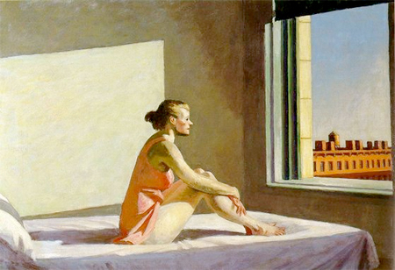

**Berthold Brecht:** *"What do you do when you love another human?" "I draw a sketch of him" said Mr K, "and I take care about the likeness" "Of what? The sketch?""No", said Mr K, "the human"[14]*

We connect with others through our *vulnerabilities*. When we are insecure we try to hide any perceived flaw or vulnerability in social interactions, and hide them to ourselves. Thereby we create a distance between us and other people (and to ourselves), turning them into *the Other*. We crave the Other's respect or admiration or fear, and judge ourselves by our ability to hide perceived flaws and instill responses in the Other. The Other becomes a projection for our embarrassment. But our vulnerabilities are connected with our insecurities of perceived flaws, which are only flaws in a certain cultural context. Only by being open about our vulnerabilities with Each-other do we get a means to deal with them, and only then do we let ourselves really get to know Each-other, and in the process get to know ourselves, maybe for the first time. Learning to truly know another person is to truly learn to know one. And by doing that, both you and the other person transform, so who you knew no longer exists. Meaningness turns the Other into Each-other.

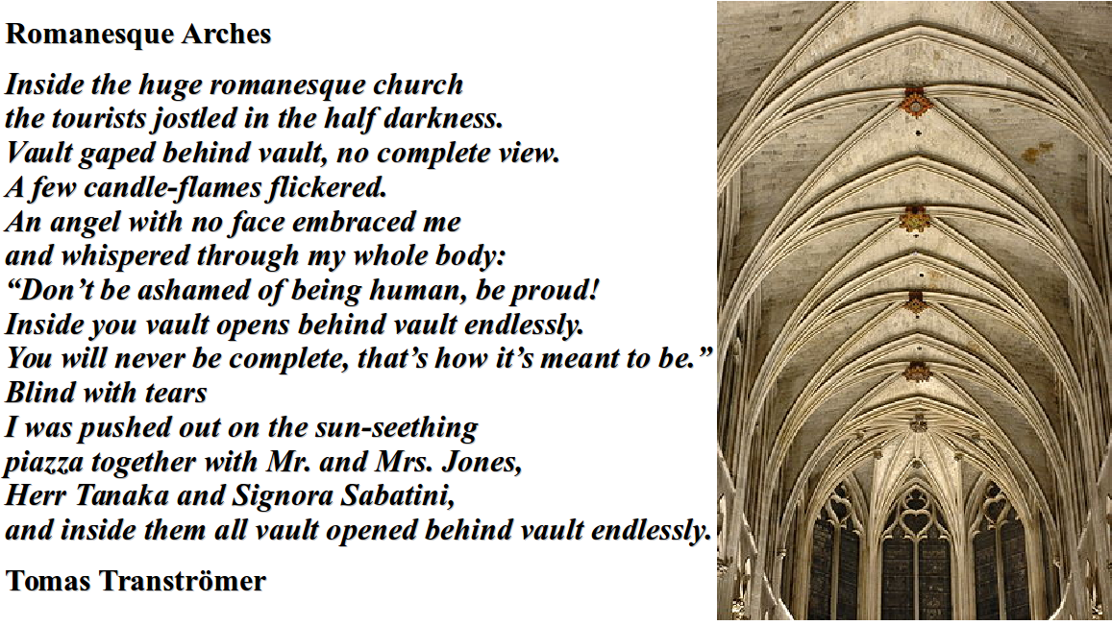

To love your neighbour as you love yourself is not a good idea until you love yourself. When we are treating other people as Others, by hiding our flaws, this leads to insincere interaction, the extent of which only goes as far as the other person is useful to us, either by comforting our insecurity through the response we elicit, or by furthering some other insecurity driven cultural aspiration. But not as infinite persons with whom interacting is meaningful in itself. And we do this because we despise our flaws instead of recognising them as part of who we have become, and as an opportunity for learning and transforming.

**Johann Wolfgang von Goethe:** *"If we only treat people as how they are, then we only make them worse; if we treat people as if they were what they ought to be, we help them to become what they are capable of being."[15]*

By interacting with the world while being sincere to ourselves, we manifest what we have become. And we become what we become through sincerity. And by manifesting, what we became is tested and transformed so that we keep becoming. And by manifesting, Each-other and the world transform with us.

If, on the other hand, we try to hide who we have become to the world and in our interactions with it, who we are will never manifest, and we will not transform. We fear who we are, formed by social insecurity we hide behind lies we tell ourselves, behind layers of vagueness, finding rationalisation in retrospect. Vagueness in interactions detaches us from Each-other, ourselves and the world. By not acknowledging and taking the aspects of ourselves which come into existence through our interaction with our context seriously, they cannot manifest.

**Question:** *How do we know that our meaningful and sincere engagement with another person is reciprocated, and that the Other is sincere in their engagement with us, so that we form an Each-other? Is it a binary, either Other or Each-other, or is it gradual and part of the project? Is it important to know?*

Through sincere engagements with oneself, the world and Each-other we bring into existence aspects of ourselves. This demands times for interactions with the world and Each-other, as well as time for solitude and reflection. Through reflection we may become aware of possible aspects of us and of the world, which then can be tested against reality. And through the testing, they may be modified and transformed until they are discarded and replaced through a constant cross-talk between internal and external engagements. Without Each-other or reflection we could not be.

**Socrates:** *"The unexamined life is not worth living for a human being."*

# We are biological and social creatures



1. **Byung-Chul Han:** *"An animal busy eating must at the same time pursue other tasks. It must, for example, keep away competitors for the prey. It must constantly look out so that it does not itself get eaten when it is eating. At the same time it must watch over its kids and keep an eye on its partner. In wilderness, an animal is forced to distribute its attention on several activities. Therefore, it is unable to sink into contemplation, both when it is eating and when it is copulating."*
2. We are biological creatures and we are social creatures, our limitations and possibilities depend on our biology and social context. Without our biological and social reality, meaningness cannot exist. Our insecurities are biological in their origin and function, while their specificity is cultural, just as we eat because we are hungry, which is determined by our biology, *what* we eat is specified by our culture.
4. The fact that we are biological creatures means that we have limited time and energy at our disposal for our (trans-)formations. If we are at a stressful place in life, our biological reality tends to be in survival mode, our body is in fight, flight or nurture mode and the mental space needed for sincere engagements may not manifest, since the stress distracts us from whatever task we have at hand. For example, many studies show that poverty tends to put a person in a state of perpetual stress, resulting in sleep loss and poor decision-making, particularly economic decisions, which adds to the predicament causing a self‑perpetuating stressful life situation. Nothing causes as much stress as the belief that we are loosing social status *e.g.* within the group we perceive ourselves to belong to, or within the dominant culture of our society. Moreover, in a consumerist society we are bombarded by advertisement telling us what to buy to gain, regain or retain this status, causing us to be distracted from what could be meaningness. Also, in a secular society, distraction from the otherwise meaningless and cold universe is seen as a modern virtue, as expressed by Woody Allen above.
5. In order to take responsibility for our personhood and find meaningness, one have to first create the mental space for doing this. One needs to find a strategy for dealing with the stresses and distractions in the situation one finds oneself in. The stoics offer a strategy for this when they say that you cannot affect how the world is, you only have control over your reaction to it.[16] This can be a very powerful realisation in a stressful situation and may help some to overcome stress. The stoic philosophy offers a plethora of strategies for taking control over one's reactions to reality and to find calm in a stressful world.
6. Finding space for meaningness is a start. This is the place of being content, or even happy. While Stoicism deals with finding equanimity with one's place in a cultural context, meaningness does the opposite. Meaningness may, through sincere engagement with self, Each-other and the world, take you away from that equanimity and content. Meaningness does not make you happy, at least not all the time.
7. Transformations are hard work, sincerity takes energy. And energy comes in limited supply to a biological creature. Therefore, one also needs rest and the possibility for rest depends strongly on one's social position within a culture, as we are social creatures immersed in hierarchical cultural contexts. One needs escapism, entertainment, silliness and fun, none of which is entirely separate from meaningness. One needs pleasure for the senses, beautiful surroundings and a good sleep. One needs a reasonably healthy body. Because without at least some of this, to each according to ability and taste, one cannot be sincere in one's engagements.[17]

# Meaningness is Political

Simone Weil wrote that the most corrupting thing about a political party is that, after a while,i its purpose is only to grow[18]. Recently I harboured the idea that the purpose of any political activism or party was to render itself redundant. Therefore, a party's decline, *e.g.* the decline of the European Social Democrats, may be seen as a success and not a failure, since the decline is a sign of, to a certain extent, having accomplished their goals. I no longer believe that.

Instead, any constellation of people gathering should be focused on their own personal growth. To create a space in which society’s hierarchies have no power over us. Where we together can express our selves sincerely, to manifest who we have become. A space within which we can transform. Not learning fifteen second phrases to answer those questioning our cause, not learning how to effectively argue against those who disagree with us. Not strategise about furthering the cause. A meaningful struggle should not have the totalitarian goal to eradicate the world from evil, in whatever form it may be.[19] A political cause of meaningness will not defeat the oppressors but help liberate them from their self-thingification, by making them transform with us.

Every culture contains prejudices and hierarchies which create the insecurities which takes us away from being human beings. And every person grows up as a cultural being. To think this can be changed is a misunderstanding of both culture and human nature. Even if we change culture itself, it will not disappear, for it is part of our biological and cultural reality just as much as our lack of wings and gills. We are instead left with ourselves, and therein lays the work. What matters is what we do with what we became, and take responsibility for what we keep becoming together. Creating a "better" culture, while not necessarily a bad thing, is still a totalitarian approach, and as such achieves little. However, we can help create spaces for Each-others to form and transform within, together. Creating spaces of sincerity.

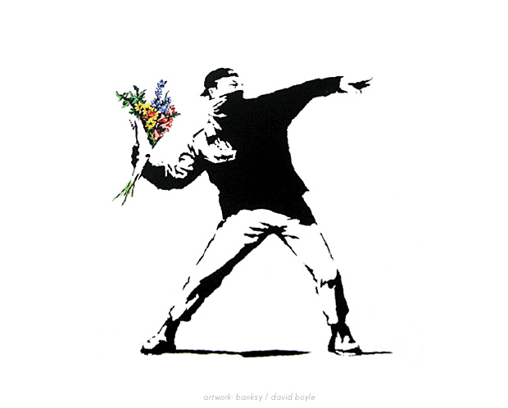

It may seem as if I mean to say that political activism or partaking in politics is totalitarian and has nothing to do with meaningness. Nothing could be further from the truth. If one is sincere in one's engagements one becomes political.

The economist Albert O. Hirschman analysed three different strategies for engaging with the world, which he called "Exit", Voice", and "Loyalty"[20]. The liberal, and indeed consumerist engagement with the world is through the exit strategy. By merely being present in a situation; a party member; a customer at a store; wearing a band's t-shirt; joining a club, or a college; or placing your children at a school, this all indicates your full‑hearted support. When you no longer feel that you can give it your complete support, for whatever reason, you *Exit*, *i.e.* leave the context and seek out a new one. This is insincere politics. However, in order to be engaged in the project of meaningness one also needs to be in a context in which one can engage sincerely. To exit a context which prohibits sincerity is sometimes necessary for meaningness.

The more sincere approach is to *Voice*. If something is wrong with the situation and context you find yourself in, then you engage with the situation sincerely by voicing your discontent. With this engagement one then hopes to constructively improve what is wrong, while the Exit‑strategy is a passive criticism, leaving the ones left behind guessing what went wrong.

*Loyalty* is about voicing and staying, as opposed to voicing and exiting. Through loyalty one makes sure that something happens, through constant voicing, interaction and engagement. Through loyalty, you do not threaten to leave a situation - you threaten to stay. This forces others in the same context to negotiate your presence and to some extent take you seriously.

If one engages sincerely with one's context and Each-other, one cannot help but also becoming an activist. Sincere engagement makes it impossible to ignore what one thinks is wrong within the context. If one could ignore such aspects, one would again not be sincere, but instead become a cynic. A cynic is the opposite of the sincere and a cynic[21] is the opposite of an activist.[22]

By creating spaces of sincerity, one creates opportunity for collective Voicing and showing Loyalty. Spaces of sincerity are by necessity non-hierarchical; otherwise we would not be able to treat each other as infinite persons. [23]By collective voicing and showing loyalty we threaten our entire culture to stay.

*Empathy* is often misunderstood as the ability to feel what another person is feeling.[24] To me, empathy is the ability to listen to and take a stranger serious, to be sincere in the encounter and act accordingly. Then empathy becomes solidarity and if we are engaged sincerely with ourselves, solidarity leads to action, else it does not manifest. It is through sincerity meaningness becomes a humanism.

# On the virtue of having a hobby

One should not do anything with another purpose than doing just that. A meaningful reason for writing a book is not to ensure that I make the money I desperately need, or to get the attention I desperately crave, or to proliferate an idea I deem incredibly important to the world; but only in order to write a book. The writing then becomes a part of my project of meaningness, a vehicle through which I can challenge my own preconceptions and interact with my surroundings; to bring into existence new aspects of myself. And the success of the book is not measured by how many copies it sells, but by how sincere I have been in engaging with myself and the subject‑matter of the book during the writing process and also how collusive it has been for my formation and transformation.

*"But wait a second"*, Me may protest, *"then there is a different purpose for writing the book after all: the purpose of self-knowledge and sincerity, and all that. You are not writing the book for the purpose of writing the book at all!"* And sure, that is a valid protest, but this purpose is qualitatively different form the secondary purposes of fame or money. The writing offers an opportunity to sincerely engage with myself which would not have existed without it. And the engagement brings into being aspects of me which would not have existed without the writing of the book. Therein lies the virtue of sincerity with whatever we happen to engage. Through it we bring into existence aspects of ourselves, no longer based on insecurity and conformity. Any sincere engagement may serve the purpose of meaningness. In a sense, meaningness treats people and the world even more instrumental than totalitarian projects, since the latter do not take people seriously, while other people is at the very heart of meaningness.

**The world's shortest existentialist novel:** *The last two persons alive go for their morning walk. One slips, breaks the neck, and dies. There is no one left.[25]*

# Meaningness vs. Happiness[26]



**Albert Camus:** *"The struggle itself toward the heights is enough to fill a man's heart. One must imagine Sisyphus happy."[27]*

In Episode 5, Me and Notme are discussing happiness and Notme is vaguely dismissive of the whole concept as being something to strive for. One direct path to happiness is to conform to the roles our cultures provide us with. This is to become a free prisoner (as was described in the last episode). This is the stoic approach and it is the pragmatic approach, and as I showed in Episode 1[28], there are only three ways to be pragmatic, none of them particularly pragmatic: you are either a true believer, a cynic, or you lack reflection. We are cynical when we conform to cultural norms despite understanding their uselessness and meaninglessness, for whatever the pursuit is, whether it is for a career, or a family life or whatever else our culture happen to value at the moment. And thus it is insincere. To seek happiness tends then to manifest in a search for distractions from *unhappiness*, which manifests in totalitarian projects, projects which may end once we become happy.

To seek happiness takes one away from meaningness. On the other hand, it may very well be the case that happiness can come as a consequence of one's attempted meaningness. But not always and not immediately, since meaningness is found outside of the comfort zones we have built for ourselves, outside of the habitual and culturally learned, and therefore it can often be uncomfortable and even painful. No, meaningness is not a direct path towards happiness, but it is a path towards personhood, towards sincere living, and a path towards real interhuman interactions away from the instrumental thingification which turns Each-other - and us - into Others.

# A few examples

In terms of **ethics**, meaningness is the polar opposite of many ethical systems, *e.g.* utilitarianism. According to utilitarianism, everything you do should be as a means to an end: to increase the world's total happiness or good, and reduce the total pain. Utilitarianism does not allow for engaging sincerelyd with anything, which makes it impossible as a value system of interhuman growth.

**Capitalism** is based on insincerity at every level. Money is supposed to be the incentive for every action, which means that there are no actions left with their own purpose. On the other hand: Money is not itself its own purpose, but only valued by what else it can buy, so not even what is supposed to be the motivation for our actions is valued in itself, and there is no sincerity left in a capitalist world.

**On work:** If an employer wants to get her employees to work better and harder for whatever reason, she can give them incentives. Which incentives should she implement? The real management question is not "*which incentives?"*, that is a question loaded with the fallacious assumptions that there *are* good incentives and all we need to do is to find them. *All* incentives detract from meaningness and detach us from our tasks. Many politicians in power claim that jobs create meaning and purpose to our lives, yet they put in place systems, such as New Public Management, which undermine our engagement with our work, and thereby meaningness itself.

I may start a **family** for many reasons. Maybe people frown upon me for not conforming to the family norm and I yield to the social pressure. I may have found a partner who I think makes me look good in the eyes of others, or a partner whose genes I think will match mine well, so that I can reproduce in an (unconsciously or conscious) act of genetic narcissism, or so that I can be a valid member of society. Or maybe I am afraid of growing old alone and hope that my family will take care of me when I do. In these cases we do not treat people as people. We even create new people as means to insecurity-driven culturally motivated ends. We do not treat our partner as a fellow human being, but merely as the role of husband or wife, and thereby we treat ourselves as conforming to respective cultural role.

In a sense all projects, totalitarian or not, of meaningness or none, are about being in a context larger than oneself. That is what is so great about personhood: it is infinite (to all practical intents and purposes). Any other person is greater than me, and so am I. This means that to engage deeply and sincerely with someone else is to be in a context larger than myself. And there are only so many people in life with whom we can engage so deeply, since we are limited in space and time. As such, life‑partners and family, treated as human beings, can be the most meaningful thing there is. Of course, deep and sincere connections may also be found aplenty outside such limited cultural norms as "the family".

Another example: **Education** is often portrayed as a way for the lower classes to gain access to the privileges of the higher classes. Thereby, people become doubly disadvantaged, since not only do they have an under-privileged starting point, they are also denied getting an education for its own sake - they are denied being sincerely engaged with their own education and transformation.

**Question:** *Are there situations where instrumentalism and insincerity is warranted? Where politeness rather than sincere engagements between human beings is preferable? E.g. is it OK to treat a hairdresser as a means to the end of getting my hair cut? Or am I then compromising someone's personhood, and by doing that, my own?*

# The Meaningness of Death

It is in the nature of modernity to value youth over old age. As each generation grows up under tangibly different conditions, by the time we are old, we are culturally ancient. On the other hand, if one is engaged in a project of meaningness, the longer we do it the more we manage to grab our personhood and consciousness. Thereby, one would imagine old age being valued higher than youth, since the young are still slaves under the cultural norms of their generation; still bits of filth waiting to mature into human beings. In this sense, a human life is not like a leaf of a tree in the north, sprouting in the spring, being full and productive in providing resources for the trunk during summer and fading, crumbling and finally falling off in autumn. No, the life of a human being sincerely engaging with self and others, taking responsibility for her personhood and transformations, is like the tree itself, growing ever stronger and wider with age and the changing seasons.[29]

In fiction, a common trope is the person with eternal life, a blessing which turns into a curse as all that one once found important withers away and all loose its significance[30]. What these stories tend to catch very well is that what once seemed important to the culture-savvy adult either becomes completely void of meaning or becomes a source of nostalgia with the perspective of extra-human time. What they in general fail to grasp is the enormous possibility that comes with such a perspective. Eternal life would not be a curse to a person who engages sincerely with the world and Each-other; it would present an opportunity to continue the project of meaningness indefinitely.



And therein lies the weakness of this philosophising. We all die and I have found no way to sincerely engage with death. I have heard people say that death is what gives life meaning, but I find this perspective impossible to reconciliate with sincerity and meaningness, rather it seems to provide an object for our distractions. The death of a human being cannot be meaningful. On the other hand, no one can experience one's death. All we can do is remain sincere till the end. For someone's personal project or meaningness, death is but a

**Truncation**

*I was told that death is a part of living,*

*something with which people of all times deal.*

*That it is a ridiculous modern misgiving,*

*this end of life-anxiety which we feel.*

*"Old people just have to handle it's vicinity,*

*believe in afterlife, incarnation, void, or divinity."*

*And I believed what I was told, and I sneered at those who were anxious*

*(also at myself)*

*And then I thought that: life--it is a project! And then I thought that: each person is infinite!*

*Each year that we live brings us closer to ourselves, each year that we live brings us closer to Each-other.*

*An afterlife then would be a continuation*

*me as an eternal project just begun.*

*Never becoming, always in transformation*

*-*

*Then why bother dying?*

*...*

*Now I see death as a provocation.*

*Please, help me with my reconciliation!*

*For without afterlife or incarnation,*

*of our never-finished transformation,*

*death is nothing but truncation.*

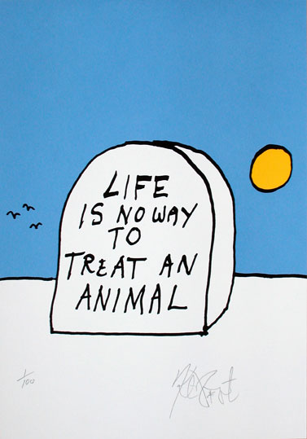

1. A culture is defined in Episode 9
2. Discussed in Epsiode 1, dismissed in Episode 3.
3. Discussed in Episodes 2, 4, 8 and 9. How stuff is categorised and prejudiced was the focus of Episode 2 and how our understanding is an emotion was discussed generally in Episode 4, and more specifically in Episode 8, and how we use these emotions to categorise people and ourselves was described in Episode 9.
4. Postmodern is a bit of a misnomer to me. Since every modern generation grows up under tangibly different cultural conditions, each generation's modernity is brand new and unique. Also, the word post-modern means very different things in different contexts (*e.g.* in literature or painted art, Modern and Postmodern signifies genres).
5. First introduced in Episode 3, and also discussed in Epsiodes 5, 6, and 7 (all indirectly).
6. This is very similar to the last dialogue in the movie Ida (2013), where the protagonist tries to figure out a reason for living a modern life with husband and children. When she can't find a convincing answer to the last question "and then what" she abandons her suitor and instead becomes a nun. She,and the movie,are thus both failing to address the question of meaningness.
7. Press conference, Cannes, France, 2015
8. To all practical intents and purposes. It is infinite in the same sense that the number of possible novels is infinite: while not strictly true, it is true to all practical intents and purposes, since the result (a one followed by about two million zeros or so) far outnumber for example the number of atoms in the Universe (a one followed by only 80 zeros or so). The number of possibilities for personhood probably outnumber the possibilities for novels.
9. See Episode 7.
10. I am using the word conscious in a slightly unusual way. There is an important difference between being aware and being conscious. Those who discuss the nature of consciousness, tend to actually treat awareness. This confusion comes from the fact that the opposite of being aware is to be unconscious. Being aware of pain is not the same as being conscious. Consciousness implies something profoundly different and I dare say it is a uniquely human potential. All humans, as well as many other creatures have an awareness of their surroundings and environment, and even self. Consciousness is to glimpse something beyond our nature and nurture. Only persons are conscious. Most of us are not conscious most of the time. Meaningness is a path towards consciousness.
11. Of course one may order human development in many ways, the purpose of any taxonomy is to be useful, not true. No taxonomy is true. The distinction between True and False dichotomies is itself the latter.
12. Social and physical pain manifest equally in our mind (see Episode 8).
13. The opposite of *natural* is not unnatural but either *supernatural* or *artificial.* Neither seems to make sense when applied on human traits.
14. Poem: *Wenn Herr K. einen Menchen liebte*  *(When Mr K. loved a Human).* 
15. *Wilhelm Meister's Apprenticeship,* 1795
16. See for example the how-to blog *How to be a Stoic:* https://howtobeastoic.wordpress.com/
17. **As regards the nature of art and entertainment;** videos of cats on social media vs. long reads of world‑expanding content of literal quality. An understanding of the need to rest is often missed in this debate. What one engages with sincerely is quite individual. We all have different frozen seas within which can be broken with different axes (to paraphrase Franz Kafka), while we tend to be appealed by similar entertainment and escapism, which is more dependent on the dominant culture or sub-cultures in our society in which we identify and were formed. A block‑buster movie is designed to have a mass appeal, while an art-movie is designed to deeply move its viewers, and all people are not deeply moved by the same thing. This is why capitalism will never be able to create true art, since art is inherently not profitable (in general). Escapism is like sleep, and sleep is after all the most common human activity. And like sleep, we should not spend all our time doing it.
18. *On the Abolition of All Political Parties* 1943
19. A political goal can be to eradicate crime. At first glance this seems as a noble goal. This is a utopian project and as such a totalitarian project. This manifests in the manner by which the goal is reached. One way to do it would be to imprison *everyone*. An even more efficient method to reach the goal would be to declare a crime-free zone and eradicate any population therein. Or one can change the law so that no-one can commit the crimes left in there. Another goal could be that everyone should get a passing grade when leaving school. This can be achieved by lowering the passing standards, or by making sure everyone learns what will be on the test. These totalitarian methods can be contrasted by sincere ones, where the law‑makers and enforcers sincerely engage with a community. If through that effort the crime rate lowers it was not as a goal but as a consequence of the sincere engagement. By sincerely engaging with school children, their learning and education, the grades may come as a consequence, or they may not (depending on the school system), but either way they will learn more and be richer as human beings. This method will probably not eradicate crime, nor will it make every pupil pass every grade at school, but it is no longer a problem.  
    
20. Described in the book *Exit, Voice, and Loyalty*. Malcolm Gladwell writes about it in the New Yorker here: http://www.newyorker.com/magazine/2013/06/24/the-gift-of-doubt
21. One cynical approach is political media strategy. For example, a politician may be tempted to cynically strategise and allow her to be insincere in order to meet the perceived demands of the audience and media. This strategising is then in the hope of being able to sincerely engage with the issues at hand in the future. This strategy tends to be self-perpetuating, the future sincerity never manifests and she becomes caught in a corrupting system of insecure strategising and insincerity. Also, the expectations that strategising is the only modus operandi proliferates into the entire social echo-system of politicians, reporters, pundits, audience, and voters, such that a politician gets judged not by her sincere engagement with society and politics, but by her ability to strategise. At which point the entire system has become corrupt.   
    Instead, a politician may be sincere. Even if she is indeed punished by the system, ridiculed and ousted, she is successful in her sincere engagement, and if she is loyal and stays, people may come to expect sincerity from her, and possibly from others too.
22. Of course, there are many insincere ways to be and activist as well, there are many attention-seeking, insecurity grooming ego boosting activists in the world. But that is completely beside the point.
23. Hierarchies create identities. Identities have one thing in common with politeness: they only serve a purpose amongst strangers. By giving them importance to yourself, by yourself, you treat yourself as a stranger. And by creating hierarchies in a group you turn Each-other into Others.
24. Many might even say that this is the definition of empathy, which then would render the whole concept completely useless. We cannot feel what others are feeling unless we have some experience to back it up, and to only be empathetic towards those with a similar experience as our's does not strike me as particularly virtuous. Merely trying to feel what others are feeling is just exhausting and does not accomplish much. (There is research to back this up, described e.g. here: http://opinionator.blogs.nytimes.com/2015/06/06/imagining-the-lives-of-others/)
25. Inspired by Fredric Brown's *Knock*, allegedly the world's shortest horror story: "The last man on Earth sat alone in a room. There was a knock on the door...". A dystopian version of this could be: "The last human alive sat alone in her room. She was checking her twitter feed."
26. The word happiness has changed its meaning so much in English that its original connotation is almost lost. Aristotle talked about "Eudaimonia" which often translates into happiness, but "human flourishing" might be a better translation. This should be contrasted by the word bliss. The shift in meaning of the word happiness has gone from "human flourishing" to today's meaning which is much closer to "bliss". The former term is close to how I define meaningness. No thinker before our time ever thought bliss was something to strive for. Yet, striving for the bliss (or happiness) is the central tennant of a consumerist society.
27. *The Myth of Sisyphus.* Sisyphus tried to avoid death, and as punishment, the Gods made him carry a boulder to the top of a hill, only to see it roll down again, and repeat this indefinitely. Albert Camus makes the argument that the meaningless task gives distraction from the meaninglessness of the task, and that one can imagine that Sisyphus actually is happy while carrying his rock. Happiness as distraction. Happiness is not meaningness.
28.
29. This is the tragedy of ageism.
30. *E.g.* in *The Hitchhiker's Guide to the Galaxy*, by Douglas Adams, the character Wowbagger accidentally becomes immortal. He sees the importance of a project to disperse the ensuing boredom, so he sets out to insult every person in the universe in alphabetical order. In the TV series *Dollhouse*, by Joss Whedon, a select few evolve the technology to download their personality into other people's bodies. They become so hedonistic that they hardly have time to find a new body before the old one gets a heart attack. And the immortal Doctor Who never stops running, and is only forced to stop when he starts caring for his companions. Another example: *All Men Are Mortal*, by Simone de Beauvoir.