Building a blazor form

In this video we will discuss **how to build a form in Blazor with an example**.

* We can use the standard HTML form and input elements to create a blazor form.
* However, Blazor comes with several built-in form and input components that make the task of creating a form much easier.
* These built-in blazor form components also support form validation. We will discuss validation in our upcoming videos.

Blazor form input components

The following are some of the available built-in blazor form components

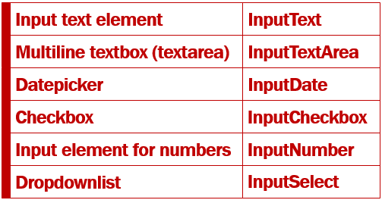

Blazor EditForm Component

* In Blazor a form is defined using EditForm component.
* The @Model attribute specifies the data the form will bind to and work with.
* In this example Model attribute value is Employee, which is a property in the component class and carries the employee data the form will bind to and work with.
* The InputText component binds to Employee.FirstName using bind-value attribute.
* This attribute provides two way data-binding. This means, the value in the FirstName property of the Employee object is displayed in the input element. If we make a change to the firstname, by changing the value in the input element, Employee.FirstName property is automatcially updated with the changed value.

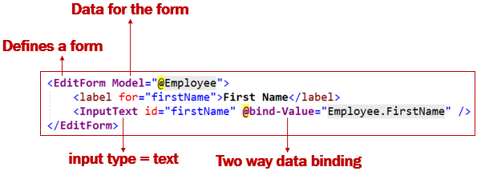

Edit Employee Form Example

We want our Edit Employee Form to look as shown below.

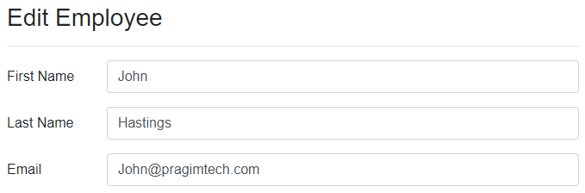

Edit Employee View (EmployeeDetails.razor)

Id in the page directive is the route parameter. This is the Id of the employee that we want to edit.

@page "/editemployee/{id}"

@inherits EditEmployeeBase

<EditForm Model="@Employee">

<h3>Edit Employee</h3>

<hr />

<div class="form-group row">

<label for="firstName" class="col-sm-2 col-form-label">

First Name

</label>

<div class="col-sm-10">

<InputText id="firstName" class="form-control" placeholder="First Name"

@bind-Value="Employee.FirstName" />

</div>

</div>

<div class="form-group row">

<label for="lastName" class="col-sm-2 col-form-label">

Last Name

</label>

<div class="col-sm-10">

<InputText id="lastName" class="form-control" placeholder="Last Name"

@bind-Value="Employee.LastName" />

</div>

</div>

<div class="form-group row">

<label for="email" class="col-sm-2 col-form-label">

Email

</label>

<div class="col-sm-10">

<InputText id="email" class="form-control" placeholder="Email"

@bind-Value="Employee.Email" />

</div>

</div>

</EditForm>

Copy

Edit Employee Component Class (EditEmployeeBase.cs)

* Employee property contains the employee data we want to edit.
* EmployeeService  retrieves the employee details by ID.
* The Id property receives the employee id from the URL.

public class EditEmployeeBase : ComponentBase

{

public Employee Employee { get; set; } = new Employee();

[Inject]

public IEmployeeService EmployeeService { get; set; }

[Parameter]

public string Id { get; set; }

protected async override Task OnInitializedAsync()

{

Employee = await EmployeeService.GetEmployee(int.Parse(Id));

}

}

Copy

Redirect to EditEmployee component

When the Edit button on DisplayEmployee component is clicked, it redirects the user to EditEmployee component. The Id of the employee to edit is passed in the URL as a route parameter.

<a href="@($"editemployee/{Employee.EmployeeId}")"

class="btn btn-primary m-1">Edit</a>