Bind input select element to enum in blazor

In this video we will discuss **how to bind input select element to enum type in Blazor**.

Gender Enum

We want to bind the Gender enum to Input Select element.

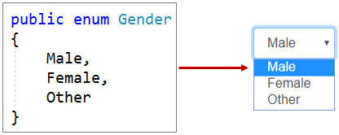

* Enum.GetValues() method returns the list of Enum memebers (i.e Male, Female, and Other).
* Foreach loop creates a select element option for each enum member.
* The built-in InputSelect component supports binding to an enum out of the box.

<InputSelect @bind-Value="Employee.Gender">

@foreach (var gender in Enum.GetValues(typeof(Gender)))

{

<option value="@gender">@gender</option>

}

</InputSelect>