Compare validation in blazor

In this video we will learn implementing compare validation. The following are some of the common use cases.

* Email and Confirm Email Validation
* Password and Confirm Password Validation

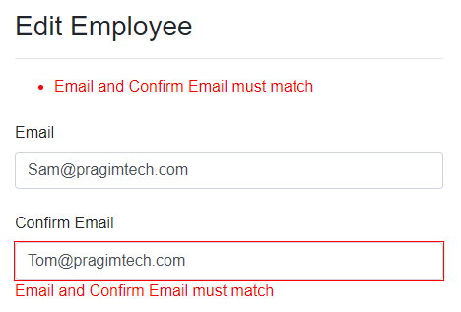

The standard [CompareAttribute] doesn't work well with the DataAnnotationsValidator component and can result in inconsistent behavior.

CompareProperty attribute

* For this reason [CompareProperty] attribute is introduced in Blazor.
* This attribute is in Microsoft.AspNetCore.Components.DataAnnotations.Validation nuget package.
* As of May 2020, this is still an experimental package
* In a Blazor app, [CompareProperty] is a direct replacement for the [Compare] attribute.

Blazor CompareProperty Example

* ConfirmEmail property is decorated with CompareProperty attribute
* Email is the other property to compare ConfirmEmail property

public class EditEmployeeModel

{

public string Email { get; set; }

[CompareProperty("Email",

ErrorMessage = "Email and Confirm Email must match")]

public string ConfirmEmail { get; set; }

// Other properties

}

Copy

In the view, use ValidationSummary and ValidationMessage components to display the validation error message.

@page "/editemployee/{id}"

@inherits EditEmployeeBase

<EditForm Model="@EditEmployeeModel" OnValidSubmit="HandleValidSubmit">

<DataAnnotationsValidator />

<ValidationSummary />

<div class="form-group row">

<label for="email" class="col-sm-2 col-form-label">

Email

</label>

<div class="col-sm-10">

<InputText id="email" class="form-control"

@bind-Value="EditEmployeeModel.Email" />

<ValidationMessage For="@(() => EditEmployeeModel.Email)" />

</div>

</div>

<div class="form-group row">

<label for="confirmEmail" class="col-sm-2 col-form-label">

Confirm Email

</label>

<div class="col-sm-10">

<InputText id="confirmEmail" class="form-control"

@bind-Value="EditEmployeeModel.ConfirmEmail" />

<ValidationMessage For="@(() => EditEmployeeModel.ConfirmEmail)" />

</div>

</div>

<button type="submit">Save</button>

</EditForm>

Copy

Inconsistent behaviour

* + Even with the [CompareProperty] attribute, there is a bit of inconsistency.
  + A change to Confirm Email filed triggers the validation but not Email field.
* To trigger the validation when Email field is changed, click the Submit button.
* I think this is a gap and hopefully this will be fixed in the future releases.

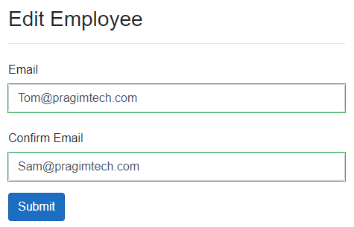

<EditForm Model="@EditEmployeeModel" OnValidSubmit="HandleValidSubmit">

<button class="btn btn-primary" type="submit">Submit</button>

</EditForm>

Copy

* + OnValidSubmit is set to HandleValidSubmit.
  + HandleValidSubmit is the method in the component class.
* This method is called when the form is valid (i.e when there are no validation errors).
* At the moment, this method does nothing. In our upcoming videos we will discuss saving the data in the underlying database.

protected void HandleValidSubmit()

{ }