Delete database row from blazor

In this video we will implement **Delete operation in Blazor** i.e delete employee row from the Employees database table through a blazor web application.

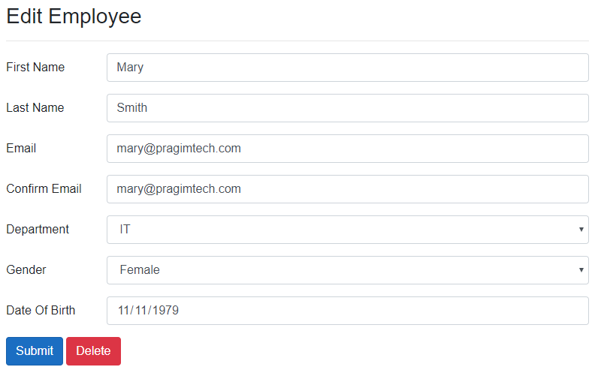

EditEmployee.razor

EditEmployee component is used for both

* 1. Editing existing employee data and

1. Creating a new employee

Delete button must not be displayed when we are creating a new employee, hence we check if EditEmployeeModel.EmployeeId > 0

@if (EditEmployeeModel.EmployeeId > 0)

{

<button class="btn btn-danger" type="button" @onclick="Delete_Click">

Delete

</button>

}

Copy

EditEmployeeBase.cs

* After the Employee row is deleted, redirect to EmployeeList component.
* The URL path for EmployeeList component is "/"

protected async Task Delete_Click()

{

await EmployeeService.DeleteEmployee(Employee.EmployeeId);

NavigationManager.NavigateTo("/");

}

Copy

IEmployeeService.cs

public interface IEmployeeService

{

Task DeleteEmployee(int id);

}

Copy

EmployeeService.cs

public class EmployeeService : IEmployeeService

{

private readonly HttpClient httpClient;

public EmployeeService(HttpClient httpClient)

{

this.httpClient = httpClient;

}

public async Task DeleteEmployee(int id)

{

await httpClient.DeleteAsync($"api/employees/{id}");

}

}

Copy

EmployeesController.cs

[Route("api/[controller]")]

[ApiController]

public class EmployeesController : ControllerBase

{

private readonly IEmployeeRepository employeeRepository;

public EmployeesController(IEmployeeRepository employeeRepository)

{

this.employeeRepository = employeeRepository;

}

[HttpDelete("{id:int}")]

public async Task<ActionResult<Employee>> DeleteEmployee(int id)

{

try

{

var employeeToDelete = await employeeRepository.GetEmployee(id);

if (employeeToDelete == null)

{

return NotFound($"Employee with Id = {id} not found");

}

return await employeeRepository.DeleteEmployee(id);

}

catch (Exception)

{

return StatusCode(StatusCodes.Status500InternalServerError,

"Error deleting data");

}

}

}