Blazor course wrap up

In this video we will wrap up this asp.net core blazor tutorial.

This course is around 7 hours and consists of 58 clips. We have covered most of the blazor concepts that help you build real-world blazor applications.

There are few more important asp.net core security concepts to cover. This course is already 7 hours long. The rest of the security concepts are going to take at least another 3 hours, so it makes sense to cover them in a separate asp.net core security course.

Machine setup for Blazor development

* [Install .NET Core SDK 3.1 or later](https://dotnet.microsoft.com/download/)
* [Download and install visual studio 2019](https://visualstudio.microsoft.com/downloads/)

We discussed installing these softwares in detail in [Part 1](https://youtu.be/uuzi3SmCLVo) of this [Blazor tutorial](https://www.pragimtech.com/courses/blazor-tutorial-for-beginners/).

Setup and run Blazor application

You can find the complete source code of the project that we have built as part of this course at the following link.

[Blazor Project Source Code](https://drive.google.com/drive/folders/1z49q-8xkKu8N8VjdemYKTs_4IbzBeLWM)

The following are the steps to setup and run Blazor application on your local machine.

Download the project source code. BlazorTutorial.zip contains the source code.

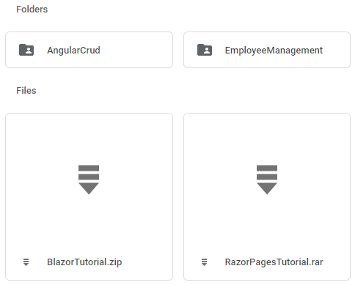

Extract all the files.

Double click on the solution file - BlazorTutorial.sln file. You will find this file in the BlazorTutorial folder.

Once you have the solution open. Execute the following command from Package Manager Console. Make sure EmployeeManagement.Web project is set as the Default project.

Update-Database

Copy

This will create the required asp.net core identity database tables.

Execute the Update-Database one more time. This time set EmployeeManagement.Api as the Default project. This migration creates the Employee database and the required tables.

Run the project using CTRL+F5

You can find all the videos, slides and notes in sequence on the following page.

[Blazor tutorial notes, slides and videos](https://www.pragimtech.com/courses/blazor-tutorial-for-beginners/)

If you have couple of minutes, please leave your rating and valuable feedback on our course page on the Feedback tab at the following URL.

[Submit your rating and review](https://www.pragimtech.com/courses/blazor-tutorial-for-beginners/)