Field Descriptions for Bat Survey Data Form
- Page__ of __: Fill in the first blank with the current page number and the second blank with the total number of pages used during the survey period (ex. Page 2 of 3).
- Date: The Day, Month, and 4 digit Year the survey was conducted (23 June 2005).
- Capture Location: The ‘common’ name of the site being surveyed (ex. Nirvana Pond or Selman’s Ranch House).
- County/State: The County and State in which the survey is being conducted (ex. Box Elder County, UT).
- Habitat/Site Description: Short, simple description of surroundings and dominant vegetation within one mile of survey site. Description should also include the characteristics that caused the site to be selected (ex. presence of a stock pond, mine shaft, roost, etc.)
- Photographs: Take one photograph in each cardinal direction (N,S,E,W) from the location the Coordinates were recorded (see #7). Note number of photograph if digital and applicable. Future photographs should always be taken from the same location to simplify historical comparisons.
- UTM Coordinates: Record easterly (6 digit) and northerly (7 digit) UTM coordinates of the survey site using a GPS unit set to collect data in the North American Datum 1927 (NAD27).
- Elevation (m): Use a GPS unit to record the Elevation at the same location the site’s Coordinates were taken (see #7). Record elevation in meters.
- Team Members: Record the first and last names of the individuals conducting the survey. Record professional affiliations if applicable (ex. USFWS, USFS, TNC, etc.)
- Recorder: Record the full name of the individual most often recording the data; insuring that questions about what was written can be directed to the right person.
- Methods Used: Mark Yes (Y) for all the methods that were used during the current survey and No (N) for those not used. If mist nets are being used, calculate and record their surface area in square meters [surface area = height (m) x sum length of all nets open (m)]. If a data logger is being used, note the type of data it is collecting (ex. temperature, humidity, barometric pressure) and the intervals to which it is set to collect data (ex. 5 min.). Use the Other category to record other methods employed during the survey period.
- Start; Hour 1…: The status of Fields 13-20 should be recorded at the Start of the survey period and each consecutive 60 minutes after until the end of the survey. Uneven starting or ending times of either the nets, data loggers, or ultrasonic detectors should be recorded in the Hour column closest to the event. The actual time for each event will be recorded in Field 13.
- Time: Actual time that the status of Fields 14 thru 20 are recorded.
- Net Status: Record whether nets are ‘Open’ or ‘Closed’ at time in Field 13.
- Detector Status: Recorded whether an ultrasonic detector is ‘Active’ or ‘Not Active’ at time in Field 13.
- Logger Status: Recorded whether a data logger is ‘Active’ or ‘Not Active’ at time in Field 13.
- Temp (°C): Record the temperature in degrees Celsius at time in Field 13.
- Wind: Use MPH categories as determined from the Beaufort Wind Scale. 1) 0-1 MPH: Calm; smoke rises vertically. 2) 1-3 MPH: Direction of wind shown by smoke drift, but not by wind vanes. 3) 4-7 MPH: Wind felt on face, leaves rustle, ordinary vane moved by wind. 4) 8-12 MPH: Leaves and small twigs in constant, gentle motion; wind extends light flag. 5) 13-18 MPH: Raises dust and loose paper; small branches are moved. In most situations winds in categories 3, 4,and 5 will not be conducive to operating mist nets.
- Weather: Record the dominant weather over the last hour: 1) Clear: 0-10% cloud cover. 2) Partly: 10%-50% cloud cover. 3) Cloudy: 50%-100% cloud cover. 4) Precip: some amount of precipitation fell during this hour.
- Moon: Record phase of moon as: 1) None: Either a new moon, or it hasn’t risen yet. 2) Crescent: 0-25% lit. 3) Half: 25-75% lit. 4) Full: 75-100% lit. 5) Obscured: Obscured by cloud cover.
- Bat No.: Number the bats as they are caught (ex. 1, 2,3 …).
- Time (24 hr): The time the bat was caught, not the time it was processed (ex. 2234).
- Temp (°C): The temperature in degrees Celsius when the bat was caught, not when it was being processed.
- Species: Use a dichotomous bat key for the area the survey is being conducted to help identify bats to species. It is likely that characters in addition to the Fields below will be needed for proper identification.
- FA (mm): The length of the forearm in millimeters. The forearm is defined as the length between the elbow and the distal side of the wrist (Figure 1).
- Ear (mm): The length of the ear in millimeters. The ear length is measured from the notch on the base of the ear to the ear’s tip (Figure 2).
- Tragus Shape: Note the shape of the tragus as either 1) Long and Pointed (Figure 3a) or 2) Short and Rounded (Figure 3b). Especially useful to determine identification of Pipestrelles.
- Keel: Note the 1) Presence or 2) Absence of a flap of skin hanging loose off the posterior edge of the calcar (Figure 4a & b).
- Sex: Record the sex of the bat as 1) Male or 2) Female. Evidence of sex is best obtained from the genitalia, with the males possessing a well developed penis.
- Reproductive Status: Record the reproductive status of the Males as either 1) Reproductive – one or both testes have descended or 2) Non-reproductive – neither testes are descended. For the Female note evidence of 1) Lactating – nipples are pink and enlarged, hair surrounding the nipple is worn. 2) Post-lactating – nipples wrinkly and dark hair has often grown back. 3) Pregnant – presence of unborn fetus evident. 4) Non-reproductive – nipples very small and well haired.
- Age: Record the age of the bat as either 1) Juvenile or 2) Adult based on the calcification of the phalangeal joints. Best observed by shining the joints from behind with a head lamp (Figure 5).
- Photo?: Record whether a photograph was taken of the bat with a Yes (Y) or (N). Note number of photograph if digital and applicable.
- Mark?: Record whether the animal was marked before release with a Yes (Y) or No (N). Note method of marking in the Notes (ex. Marker, band, tattoo, freeze brand, etc.)
- Weight: The total weight of the bat minus the weight of the bag in grams.
- Notes: To be used to record observations or actions of this particular bat not accounted for by the data sheet (ex. parasite load, marking method, injuries, capture method, etc.)
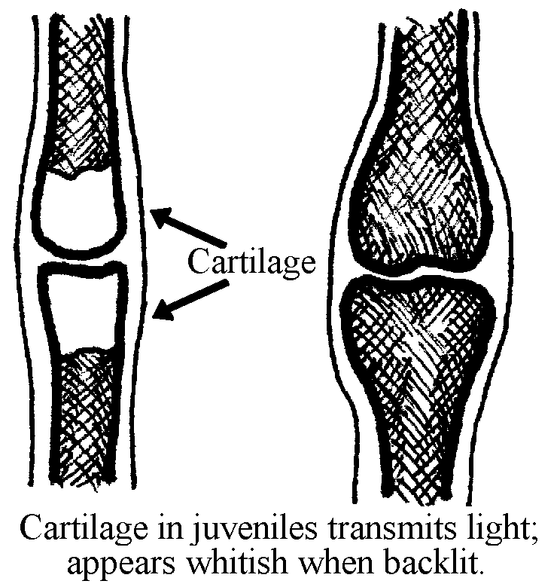
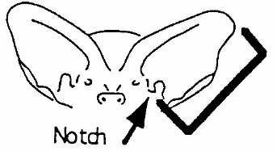
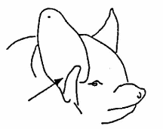
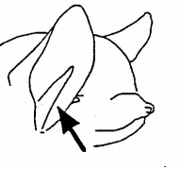
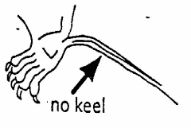
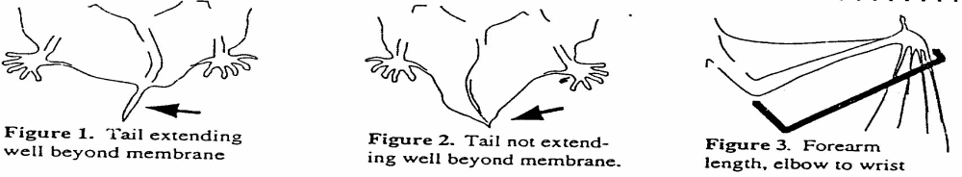
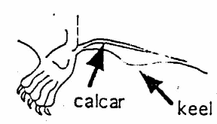
Figure 1:
Forearm =elbow to wrist
Figure 2:
Ear = notch bottom to tip
Figure 3: Tragus shape
a) long, pointed b) short, rounded
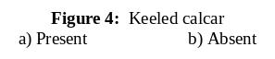
Figure 5: Age
a) Juvenile b) Adult

