^{FOR SALE}
Cement Bears, Logs, Benches & Fire Pits
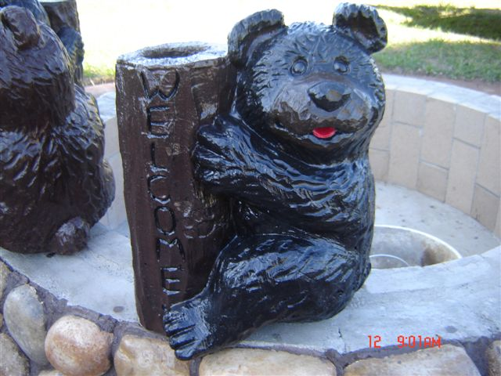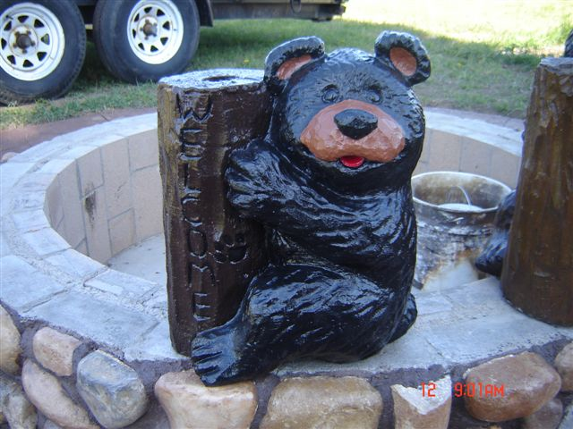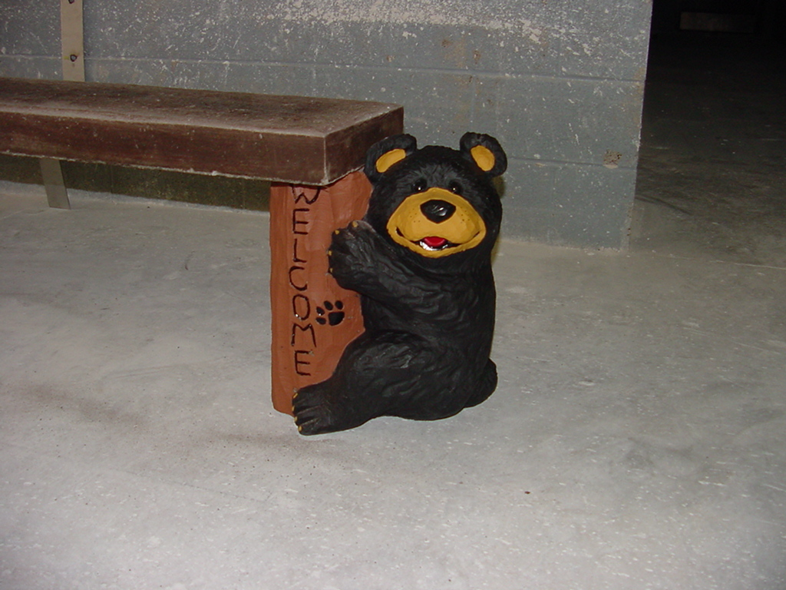
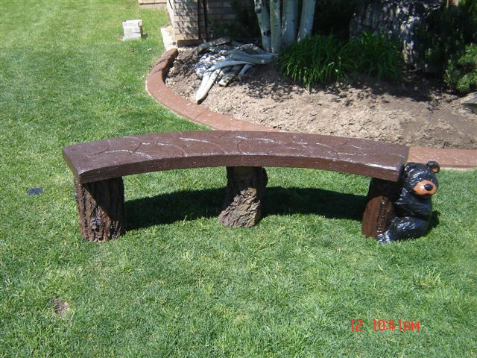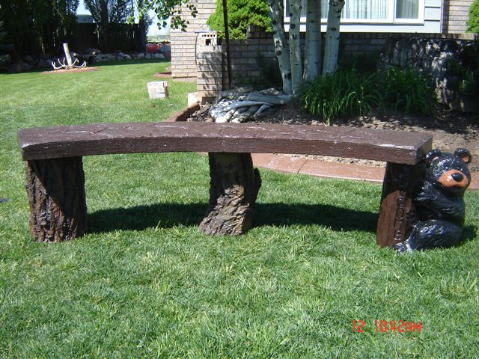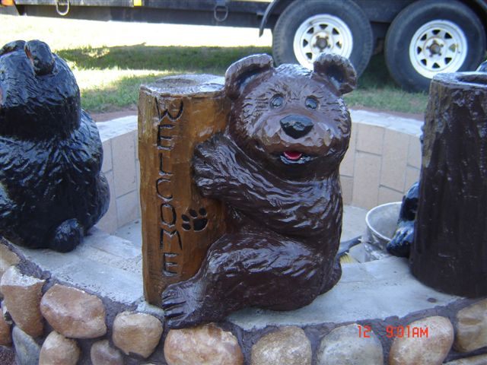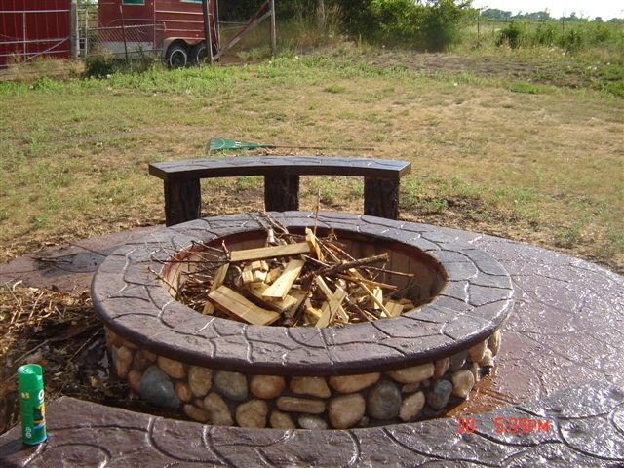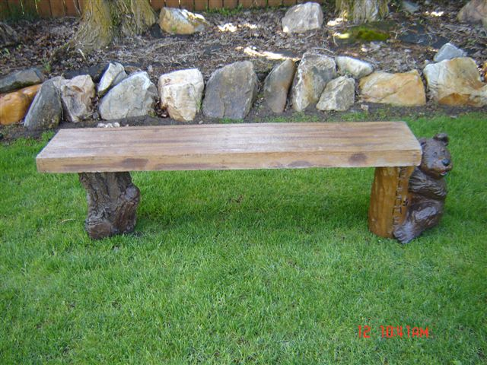
Custom made cement benches, cement logs, & cement bears. Can be used as planters, solar light holders, or yard decorations ect.. Bears $70, logs $40, Complete 4’Benches (1 log, 1 bear, and bench) $180. Bid on Fire pits available upon request. Contact Jeff @ 731-6112 or Rick @ 731-1808

