Freight Rate Prediction
Spotter ML Assessment

1. Problem
The task is to predict posted_rate in dollars for truckload freight. Each row is one load with origin, destination, equipment type, weight, distance, timing, and optional market signals. Training labels come from train_test.csv (Jan through Oct 2025). The holdout set is validation.csv (Nov through Dec 2025), which has no posted rates. I also had to fill predicted_rate for a fixed December lane file: Lexington to Fort Wayne, 360 miles, Dry Van, 32,000 lb, one row per day in December.

2. Data
Training has 48,000 loads and 14 columns. Validation has 12,000 loads and 13 columns (no target). Equipment is always Dry Van, Reefer, or Flatbed. There are 64 pickup cities and 64 delivery cities. Load volume runs about 4,700 to 5,000 per month across Jan to Oct.
posted_rate is right-skewed: mean about $2,374, median about $2,031. Distance correlates strongly with rate (roughly 0.91 in linear terms), but the scatter is wide at every mileage band. Same city pair can show more than one distance value, so origin and destination alone do not replace the distance column.
Data quality issues I handled:
Missing weight on about 300 train rows and 165 validation rows, plus negative weights treated as bad data.
Missing market_index on 374 train rows and 249 validation rows. quote_signal is complete.
No duplicate load_ids. No zero or negative distance or posted_rate in training.

3. Validation strategy
This is a time split, not a random shuffle. train_test.csv is Jan to Oct 2025. validation.csv is Nov to Dec 2025 with no date overlap. For development I held out Sep to Oct 2025 as dev validation (~9,500 rows) and trained on Jan to Aug (~38,500 rows). Model choice and error analysis used that Sep to Oct window. I did not tune on Nov to Dec.
I tried random splits early and they looked better on paper. That was misleading because future months leaked into training. The time split is slower to optimize against but matches what we are actually being scored on.
Metrics: MAE and RMSE in dollar space on dev validation (Sep to Oct).

4. EDA highlights
Equipment ordering by median rate: Reefer highest, then Flatbed, then Dry Van. Dry Van is the most common type. Average rate peaked around June 2025 and was lowest in January. market_index and quote_signal have weak linear correlation with rate on their own; I kept them anyway and tested them in models rather than dropping them from EDA.
Road distance is typically about 1.18 times straight-line miles between the given coordinates. Only 16 training rows match the December chart lane closely, so that file is a sanity check, not something the model can overfit to.

5. Feature engineering
All preprocessing lives in a single engineer_features() path so train, validation, and December rows see the same logic. Imputation stats for weight come from Jan to Aug dev train (median by equipment). Market imputation uses month-level medians from full labeled train, with a global median fallback.
Group | Features
Load | distance, log_distance, weight, log_weight, weight_missing
Market | market_index, market_index_missing, quote_signal
Geo | pickup/delivery lat/lon, mid_lat, mid_lon, bearing
Time | month, day_of_week, is_weekend, month_sin, month_cos
Categorical | equipment, pickup, delivery, lane (pickup -> delivery)

I did not use rate_per_mile as an input because it is built from the target. December rows have no market columns in the raw file; they get imputed values like everything else. Month 12 falls back to the overall train median for market_index, which limits how much daily variation the December chart can show.

6. Model comparison
Baselines and candidates on Sep to Oct dev validation (MAE / RMSE in USD):
Model | MAE | RMSE
Median by equipment | $1,145 | $1,562
Distance x median RPM | $257 | $684
Linear regression (full features) | $171 | $649
Random forest (full features) | $134 | $643
Hist gradient boosting (log target) | $127 | $639
Random forest (log target) | $137 | $644

Random forest beat linear regression by about $36 MAE, which told me lane and interaction effects matter. Adding market_index and quote_signal helped random forest by about $5 MAE. HistGradientBoosting with log1p(posted_rate) as the target did best at $127.22 MAE. Log target helped every model family because the rate distribution is skewed.

7. Final model
Selected model: HistGradientBoostingRegressor on log1p(posted_rate), predictions back-transformed with expm1 and clipped to stay positive. Hyperparameters: max_depth=10, learning_rate=0.08, max_iter=250. Categoricals go through OneHotEncoder (min_frequency=10); numerics through median imputation inside a sklearn Pipeline.
After selection I refit on all 48,000 Jan to Oct rows and used that pipeline for validation.csv and the December file. Reproducibility: artifacts in models/, regeneration via predict.py.

8. Error analysis
On Sep to Oct the model underpredicts on average (mean residual about +$93). About 79% of loads are underpredicted. RMSE is much higher than MAE because of a handful of extreme loads.
MAE by equipment: Dry Van about $120, Flatbed about $131, Reefer about $141. By distance decile, short hauls are easy (about $36 MAE on the shortest bucket). Long hauls are hard (about $258 MAE on the longest). The worst 20 errors are all huge underpredictions on cross-country Dry Van loads with posted rates around $17k to $20k while the model outputs $3.5k to $5.8k. Those are rare premium moves, not typical freight. The best predictions are essentially exact on normal loads.

9. Feature importance
Permutation importance on 2,000 training rows (grouped back to raw feature names). Shuffling distance raises MAE by about $0.72. Everything else is far smaller: equipment about $0.029, weight about $0.011, quote_signal about $0.007, month about $0.006. Pickup, delivery, and lane do not show up in the top 10 once distance is in the model.

10. Holdout predictions
validation_predictions.csv: 12,000 rows, all positive. Range about $211 to $6,457, mean about $2,350 (close to training mean). December lane file: 31 rows, about $850 to $853, mean about $852 ($2.36/mile on 360 miles, plausible for Dry Van). The daily curve is nearly flat because December inputs have no real market signal and month 12 uses the global imputed median.

11. December chart
From score.py after validating both submission files:
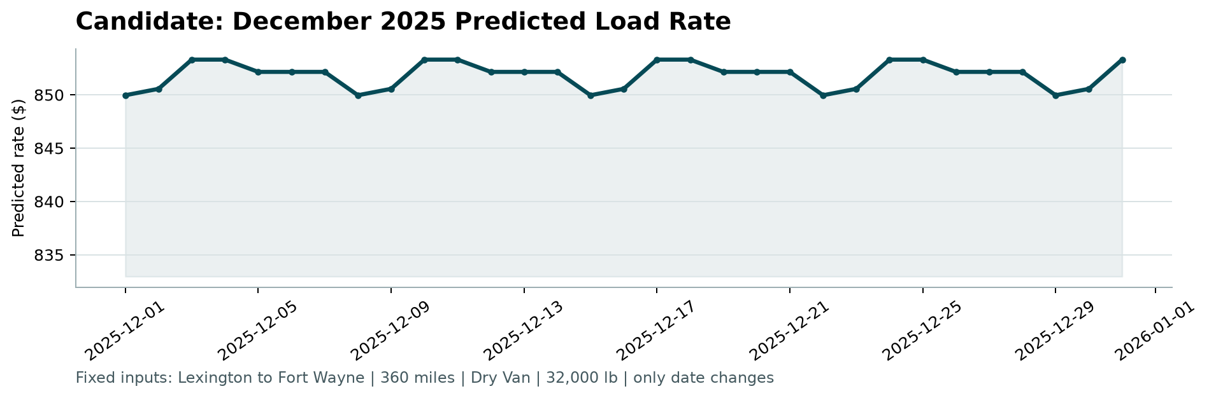
Small day-to-day wiggles come from calendar features (day of week, etc.). The band is tight because distance, equipment, weight, and lane are fixed and market inputs are imputed constants.

12. Limitations
Nov to Dec 2025 is out of sample in time. The model was tuned on Sep to Oct; drift into winter holdout is unknown until Spotter scores the file.
Rare high-rate long-haul outliers are the main failure mode. The model is strong on typical loads and weak on premium cross-country moves it has few examples of.
December chart inputs lack market_index and quote_signal. Predictions there reflect imputation, not a true forward market forecast.
City-pair categorical signal is mostly absorbed by distance in this model. A lane-heavy encoding or target encoding with careful time-aware CV might help on specific lanes but was not required to beat the baselines here.

Repository
GitHub: https://github.com/ttqureshi/spotter-freight-rate-ml
Notebook: notebooks/freight_rate_modeling.ipynb
Predict: python predict.py
Score: python score.py --predictions validation_predictions.csv --december-predictions data/december_chart_inputs.csv

