UNIVERSITY OF INFORMATION TECHNOLOGY
FACULTY OF COMPUTER ENGINEERING
--------------------------------



SOFTWARE TESTING FOR CURRENT CONSUMPTION TOOL

INTERNSHIP REPORT
Student Name: NGUYEN XUAN VIEN
Student ID: 13521027
Class: MTCL2013
Supervisor: TRAN NGOC DUC

Ho Chi Minh City – 2017

THANKING
The first, I would like to thank Renesas Design Vietnam Co., Ltd, where I intern,
During my internship at the company, I received a lot of enthusiastic support from friendly colleagues to finish my task. So, I would like to thank all
For the purpose of helping students be more familiar with the working environment in the company and know how to apply the theories which they have learnt in university into practice, internship is a very useful subject. During the ten-week internship at Renesas Design Vietnam Co., Ltd, I have received enthusiastic support from friendly colleagues in the company. Therefore, I would like to express the sincerest gratefulness to the company.
The next, I would like to thank all the teachers of the Faculty of Computer Engineering, who have given me a great deal of useful knowledge that has helped me a lot when we applied in real situation in this practicum. I also would like to thank my instructor Mr. Tran Ngoc Duc who have supported and guided me through this internship.
On the other hand, I would like to say thank you to the company’s Board of Directors who have facilitated me in order to help us make efforts as much as I can to complete the internship successfully.
Last but not least, I express gratitude to all of team Software Tool Solution who have given me much valuable experience in the job and made me feel my team like a family. I would like to say thank you.
Ho Chi Minh City, August 8th, 2016

Nguyễn Xuân Viễn

Table of contents
OVERVIEW OF THE INTERSHIP COMPANY 5
1. General Information 5
2. History of company 5
3. Scope of activities 7
4. Organizational Structure 7
5. The branch 8
6. Achievements 8
PRACTICE CONTENTS 9
1. Work schedule 9
2. Job description 10
3. Working method 10
4. Workflow and Result 11
4.1. Investigate relational document and prepare ITP 11
4.2. Execute integration test 12
4.3. Write user manual 13
4.4. Fix bug in code 13
ACHIEVEMENTS 16
1. Consolidated and improved knowledge: 16
2. Additional knowledge 16
3. Reality experiences 16
CONCLUSIONS 17
REFERENCES 17
INSTRUCTOR COMMENTS 18

OVERVIEW OF THE INTERSHIP COMPANY

General Information
Renesas Electronics Corporation, the world’s number one supplier of microcontrollers, is a premier supplier of advanced semiconductor solutions including microcontrollers, SoC solutions and a broad range of analog and power devices. The company's head office is located in Japan and this company currently has business activities in nearly 20 countries around the world.
Renesas Design Vietnam Co., Ltd. (RVC) belongs to Renesas Electronics Corporation, which is located in Ho Chi Minh City and has a function of designing and developing hardware, software for cars and digital equipment. RVC is nationally recognized as the first company in the field of semiconductor tech which was established in Vietnam.

History of company
Renesas Technology Corporation was founded in January 4/2003 by the union of the two fragments of the processor Hitachi, Ltd. and Mitsubishi Electric. In April of 2010, Renesas Technology Corporation combined with NEC Electronics Corporation and renamed to Renesas Electronics Corporation. It is a multinational company and has eight subsidiaries in Japan and 23 subsidiaries in nearly 20 countries around the world. Renesas Electronics Corporation is headquartered in Chiyoda district, Tokyo, Japan, with total employees of more than 27,000 people (8/2014). The company is one of the largest manufacturers of semiconductors in the world, which ranks first in the production of microcontrollers and ranks second place in the production of the application processors worldwide.
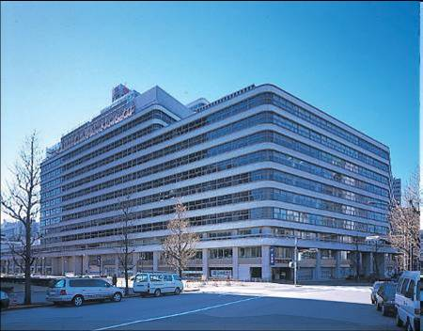
Figure 1: Renesas Electronics Corporation Headquarters in Japan
With 100% investment of Renesas Electronics Corporation (Renesas Technology Corporation at the time), Renesas Design Vietnam Co., Ltd. (RVC) was established on October 5, 2004, and is nationally recognized as the first company in the field of semiconductor technology in Vietnam. The role of the company is doing research, designing and developing hardware (IC) and functional software for semiconductor IC (integrated circuit).

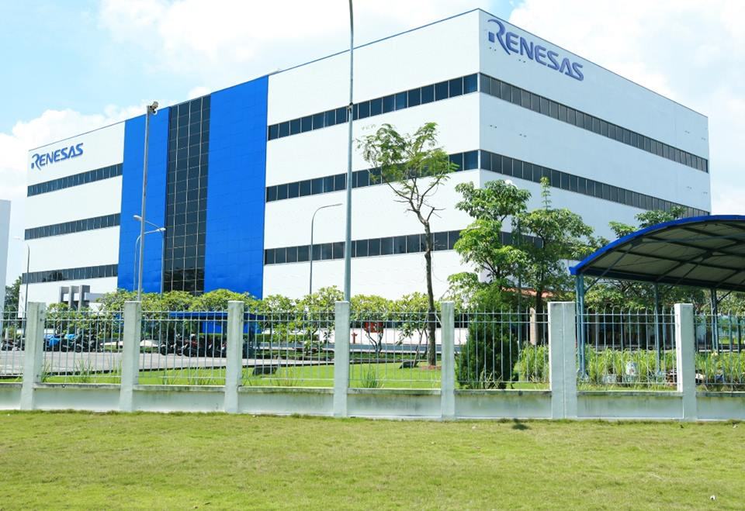
Figure 2: Renesas Design Vietnam

Scope of activities
Currently, the company's business activities consist of two main areas: hardware and software.
In terms of hardware, RVC makes a process on designing and developing advanced hardware, including RTL design, test (Verification), compile (Synthesis), placement and routing (Place & Route). Some research subjects in the field are microcontrollers, microprocessors and integrated circuits for systems of multimedia entertainment.
In terms of software, RVC designs and develops embedded software, as well as tests and evaluates software based on the reference system, develops and integrates software modules based on customers’ requirements.

Organizational Structure

Technology development department
Hardware
Software
Human Resources
Accounting department
IT
Facilities management
Figure 3: Structure of the RVC
The organizational structure of the company includes many parts and these parts are linked with each other. HR department is responsible for organizing, recruiting, and human resources management of the company. Accounting department analyzes business results of enterprises, and makes budget plans for the company. Facilities Management Department is responsible for managing the activities happening in the building of the company such as security, sanitation, food, electrical system maintenance...
The technology development department which develops hardware and software has an engineer team. IT department is responsible for maintaining the computer systems of the company intranet.

The branch
RVC now has only one branch in Vietnam, located in Lot 29-30-31a, Tan Thuan Street, Tan Thuan Export Processing Zone in District 7, Ho Chi Minh City.

Achievements
For nearly 10 years, RVC has made ​​important contributions to the development of the corporation as well as the outstanding contribution to the society, contributing to changing the face of Ho Chi Minh City in the area of ​​ semiconductors technology. The objective of RVC is always maximizing customers’ satisfaction with the most modern technology.
Being one of the most important designing centers in the world, RVC constantly improves the quality of a team of nearly 500 engineers and it is striving to reach 1,000 engineers in the coming years. With basic trainings, RVC ensures the available ability of new engineers. Moreover, for developing workforce, senior engineers of the RVC will have a chance to participate in the training session to enhance knowledge, project management skills, soft skills... In addition, thanks to professional modern working environment, the employees can catch up with the most advanced trends of technology available all over the world.
During its development, RVC has contributed to social and financial aspects of the country. Every year, the company has always had humanitarian blood donation, scholarships, gifts to troubled places ... The "Day for the community" is a typical example for a blood donation campaign.
Another achievement of RVC is the collaboration with universities in Ho Chi Minh City. By conducting seminars or the funded experiments, RVC has specialized knowledge of the students as well as the quality of the future workforce. RVC also has sponsored for the contest MCR (Micon Car Rally) and received a positive response as well as enthusiastic participation of the students in some universities such as University of Ho Chi Minh City University of Natural Sciences, HCMC. Through this contest, students will be able to understand more about advanced programming techniques and the relationship between theory and practice. RVC also holds annually practicum to help students understand the real working environment and helps them to have the opportunity to apply theory into work.
Because of the above achievements, the RVC has been awarded many awards recognizing its outstanding contribution to the development of the city.

PRACTICE CONTENTS

Work schedule
Employer of RVC work from Monday to Friday. But interns work part-time at least 2,5 days per week. I work three days per week. My detailed work schedule is specified in follow table:
 | Mon | Tue | Wed | Thu | Fri
Morning | x | x |  | x
Afternoon | x | x |  | x

Job description
In the time when I intern at RVC, I am a member of Software Tool Solution 2, the team is a part of Software Tool Solution group. My team develop the IDE e² studio. My task is preparing ITP (Integration test plan) for integration test, executing IT (Integration test), writing user manual, and fix bug in code. List of my task will be show in the follow table:

Task | Date start | Date end | Description
Prepare ITP | Mar 6 | Apr 26 | Writing test case for current consumption plug-in.
Write user manual | May 4 | May 11 | Writing user manual to produce the feature to user.
Execute integration test | May 11 | May 18 | The created test cases will be executed after reviewing.
Fix bug in code | May 22 | Jun 6 | Fixing the bug in code that was found after testing.

Working method
The student’s working method during the internship is mostly self-control. In the beginning, student usually investigates some documents which relate to project. After understanding the project, leader or mentor will assigns task to student. Student needs to estimate how long to finish the task and plan for task.
While doing the task, student must writes daily report to mentor and leader. On the last working day of week, student needs to report status of the task.
On every Friday, the group will have a meeting for leader to announce important news, and review what members have done in the past week, give suggestions and classify the job for members in the next week.

Workflow and Result

Investigate relational document and prepare ITP

- Duration: 3 days (investigate) + 10 days (prepare ITP) + 7 days (review and revise)
- Input: FS (functional specification), FD, ITP of another plug-in, ...
- Output: PCL (program check list).
- Task description:
- Investigate the documents to get knowledge about project.
- Create test cases in PCL document to execute integration test.
- Prepare review check list and write review minutes.
- Revise the wrong test case or add new test case after reviewing.
- Detail work:
- Phase 1: My mentor gives me some documents then I read and discuss with other interns to understand about the features of plug-in. Document contains: FS (functional specification), FD, ITP of another plug-in, …
- Phase 2: I create test cases (TCs) to test for each feature of the plug-in.
The TCs of each feature are stored by each sheet excel. Each test case contains numerical order, type of test case, test steps and expected. There are three type of test case: N (normal), A (abnormal), B (boundary).
+ N (normal case): Test case is examined with normal input as function specification. (System is not hang up or exception)
+ A (abnormal case): Test case is examined with abnormal inputs. Failure or Error occurs. In some cases, exception happens and caught.
+ B (boundary case): Test case is examined with boundary inputs. The inputs reach the minimum or maximum value of input range.
- Phase 3: After finishing the phase 1, project leader and experienced engineers will review created TCs. All of comments will be note in review minutes. I rely on the minutes to revise the wrong TCs.
- Result:
- Taking valuable knowledge about workflow to create test case for a software.
- Create more than 900 test cases.
- All the created TCs were approved by project leader to execute integration test.

Execute integration test

- Duration: 6 days
- Input: PCL
- Output: test report, bugs note.
- Task description:
- Tester rely on test steps and expected in PCL to execute the test.
- The bugs will be report to leader and all of developer by bugs note.
- Detail work:
- I execute all TCs in the latest version of IDE e² studio to find bug if any. When I find a bug, I will note it to bugs note. After I finish executing TCs, I will report the bugs note to my team. Developer will fix it then I test again. This process is repeated until the software is completed.

- Result:
- I founded some important bugs which effect to the feature of plug-in.
- All of bugs was fixed.

Write user manual
- Duration: 4 days
- Input: FS
- Output: user manual
- Task description:
- Refer FS to write user manual.
- Detail work:
- I write user manual to produce the features of plug-in to customer. After I finish the task. My leader will review it and comment. All of comments will be note in review minutes. I rely on the minutes to revise the wrong TCs.
- Result:
- With the support of my mentor, I finished writing user manual and submit to my leader.

Fix bug in code

- Duration: 2 days (investigate), 3 days (fix and implementation note), 2 days (FS + FD), 1 day (UT + IT).
- Input: bug report
- Output: fixed code, implementation note, FS, FD, UT (unit test), IT.
- Task description:
- The bug is assign to me and my partner to fix.
- We estimate the finish time and prepare a plan then report to leader.
- Detail work:
Learning java programming language:
- First, I compare java language with other programming language. I realize java language is the same C# language. Both are object-oriented programming (OOP) language.
- Next, I learn how to use variable, loop, operator in java. They are almost the same C programming language. But there are some differences:
Do while loop:
Do-while loop is similar to while loop, however there is a single difference between these two. Unlike while loop, do-while guarantees at-least one execution of block of statements. This happens because the do-while loop evaluates the boolean expression at the end of the loop’s body. Therefore the set of statements gets executed at-least once before the check of boolean expression.
Syntax:
do{
Statement(s);
}while(Boolean expression);
Java does not support pointers
The Java language does not support pointers, but how you can work without pointers? Java supports what it calls "references". References act a lot like pointers in C++ languages but you cannot perform arithmetic on pointers in Java. References have types, and they're type-safe. These references cannot be interpreted as raw address and unsafe conversion is not allowed.
Find exception automatically
Exception handling in Java is different because there are no destructors. Also, in Java, try/catch must be defined if the function declares that it may throw an exception.
Fix code:
- The first, I investigate the source code to find the bug codes.
- I investigate some document about java programming language. Because this is the first time I read java code, I have some problem to understand code. However, my partner support me to resolve this problem.
- Next, we note few lines of code can cause the bug. After we debug them to know how they run.
- We compare the result when debugging with FD.
- After we find the error codes, we will note them to implementation note and try to fix them until they run properly
- Result:
- The bugs were fixed.

ACHIEVEMENTS

Consolidated and improved knowledge:
During the internship, my work also researches about V-model development process. . It is an extension of the water fall, a traditional process. Instead of moving down in a linear way, the process steps are bent upwards after the coding phase, to form the typical V shape.
I also consolidate my knowledge about object-oriented programming. That help me to review my knowledge which I got in university. That is valuable knowledge for my project in university and my work in future.
When executed test trigger signal is inputted, I worked with C language. That help me to apply my experience in C language to my task.

Additional knowledge
This is the first time I use java programming language. The documents which I read have given me so many knowledges about java.
I also knew how to prepare a ITP, how to make sure a software can run perfectly without bugs.

Reality experiences
I spent a lot of time to learn how to prepare a ITP. That made me do everything more carefully.
In addition, my English skill was improved when I wrote user manual, and wrote some documents in English.
Next, I learned how to plan and work as planned.
Moreover, I also improved my teamwork skill because I always work with my partner, another trainee student.
Last, I learned how to hold a meeting, what things need to be prepared before each meeting.

CONCLUSIONS
After ten weeks of Internship at RVC, it has helped me not only to apply knowledge I have learnt at university into the job but also to know more specific knowledge which is very useful for my future career. In addition, working style and working disciplines in a professional environment such as RVC is the other important things that I was aware of.

REFERENCES

http://cs-fundamentals.com
https://vi.wikipedia.org
https://www.facebook.com/RenesasDesignVietnam
http://vietnam.renesas.com
https://www.renesas.com

INSTRUCTOR COMMENTS

Comments:
……………………………………………………………………………………………………………………………………………………………………………………………………………………………………………………………………………………………………………………………………………………………………………………………………………………………………………………………………………………………………………………………………………………………………………………………………………………………………………………………………………………………………………………………………………………………………………………………………………………………………………………………………………………

Mark:
Date: …………………………..
Instructor

