1. What is a POM?

POM (Project Object Model) is the fundamental unit of work in Mavan. It is an XML file that contains information about the project and configuration details used by Maven to build the project.

1. Structure of POM
   1. Overview

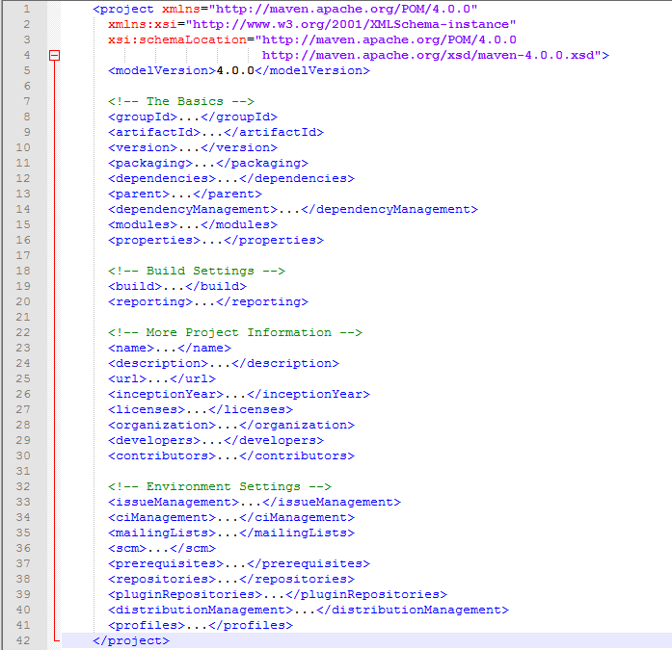

* 1. Basic POM (structure basic of POM)

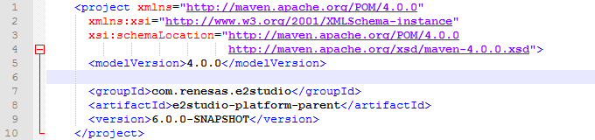With:

* modelVersion contains 4.0.0. That is currently the only supported POM version for both Maven 2 & 3
* groupId: the id of project’s group
* artifactId: the id of the artifact (project)
* version: the version of the artifact under the specified group

A POM requires that its groupId, artifactId and version be configured. These three values form the project’s fully qualified artifact name. This is in the form of <groupId>:<artifactId>:<version>.