PROGRESS REPORT

PREDICTION OF POTENTIAL DRUG-TARGET INTERACTIONS USING PROBABILISTIC MATRIX FACTORIZATION

INFSCI 2725 DATA ANALYTICS
JULY 21, 2019

GROUP MEMBERS:
PREM RAJGOPAL: PRR47@pitt.edu
TSHERING SHERPA: TTS12@pitt.edu
ZHENG HAN: ZHH41@pitt.edu

Problem Identification
We chose to study the unknown interactions between existing drugs and the well-known proteins in human or animals. This prediction will provide a guideline for the future drug discovery research and also help to explain the side effects of certain drugs.

Questions To Be Answered
Q1. For the currently reported interactions, find out the average number of targets for the drugs, and list the top 100 drugs according to the number of targets. Draw a histogram for the top 100 drugs in terms of the number of targets.
Q2. Predict the unknown interactions between drugs and targets. In other words, look for more drug-target pairs. Predict the interaction probability of each newly found drug-target pair.
Q3. The reported interactions serve as the positive samples. A certain number of negative samples need to be generated for training the model. The effect of the number of negative samples on the RMSE and AUC of the model will be studied.

What We Have Accomplished So Far
We have successfully answered Q1. For Q2 and Q3, we generated preliminary results with limited accuracy, and we are still trying to improve the accuracy.

Preliminary Results
Q1:
The original data set downloaded from DrugBank database was imported into a Jupyter Notebook and it looks like below:
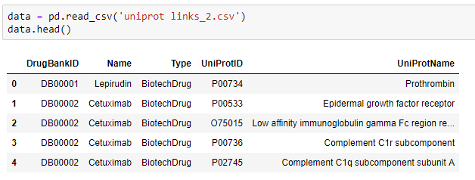
By using data.describe, we know that there are 7370 drugs represented by “DrugBankID” and 4763 proteins (targets) represented by “UniProtID” as shown below:
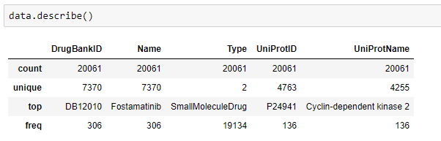
By grouping “DrugBankID”, we know how many targets for each drug. And then by using mean() function, we know the average number of targets for the drugs is about 2.72.
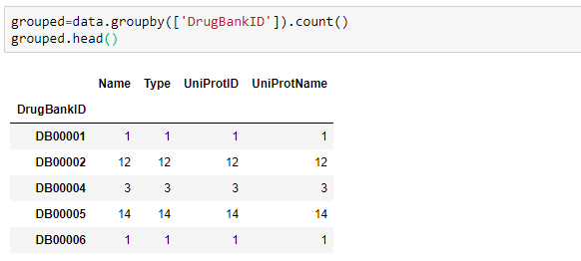
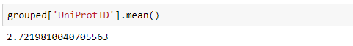
Then the drugs are sorted according to the number of targets and the top 100 drugs are displayed. A histogram is drawn to show the distribution of the number of targets.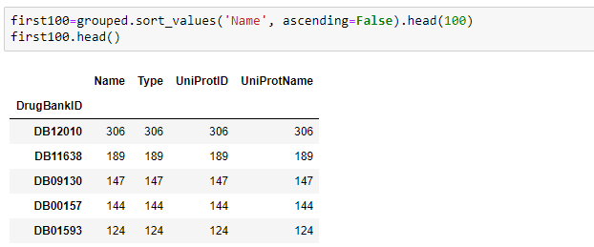
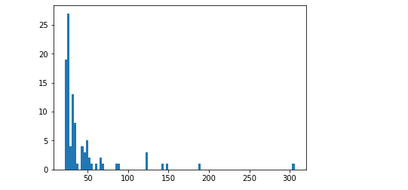
Q2:
The Probabilistic Matrix Factorization (PMF) model [1] is used for our prediction. We found the implementation of PMF from Github [2]. This author used PMF to predict the user’s rating on the movies that the user has not watched. The rating score ranges from 1 to 5 in his work. The prediction of drug and target interaction is similar to the prediction of user and movie relationship. But our scale is 0 to 1 with 0 indicating no interaction and 1 indicating interaction with a probability of 100%.
In order to use the PMF model, the drug ID, target ID and interaction scale have to be changed to integer. Below is what we did to change the labels.
All the DrugBankIDs are saved in a dictionary with the DrugBankID as the key and the integer value starting from 1 as the value:
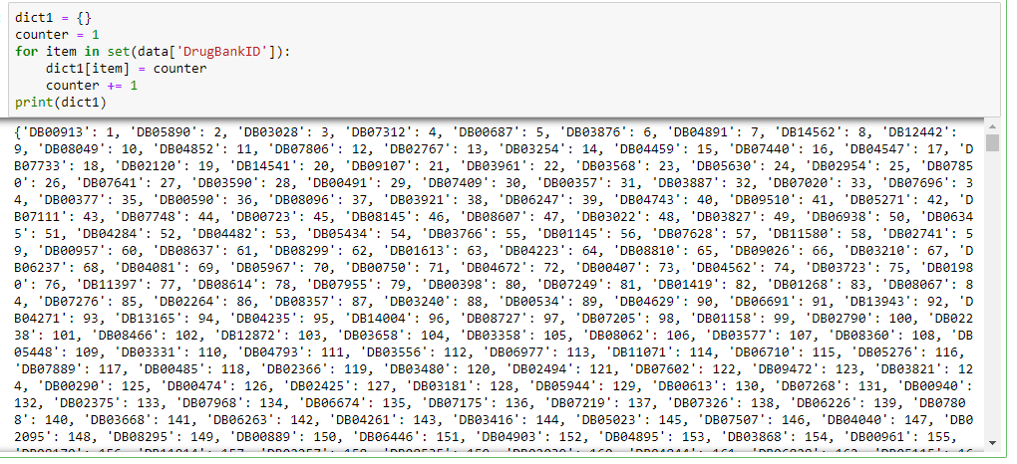
Then by using the map() function, a new column of “DrugBankIDLabel” can be generated and its values are integers.
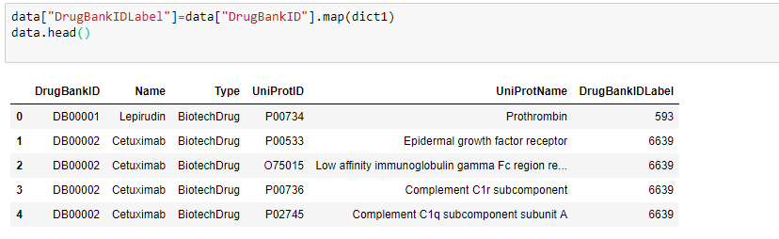
Similarly, a new column of “UniProtIDLabel” is generated and its values are integers.
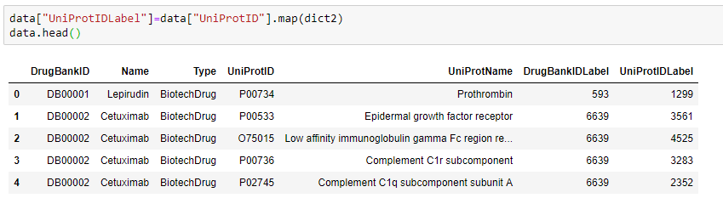
Because all the drug-target pairs from DrugBank are proved to be interacting with each other, the interaction probability is 100%. We generated another new column called “Interaction” and put 1 as the values for all these reported drug-target pairs. We call these positive samples. The data set with only positive samples looks like below (20061 rows × 3 columns):
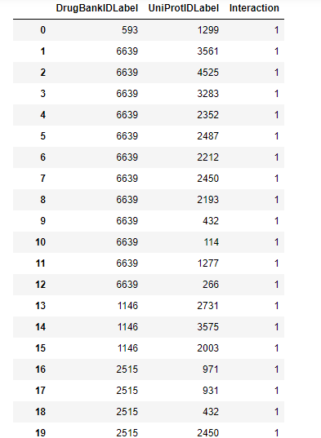
In order to train a good model, we have to generate negative samples. In our case, the negative sample means a drug-target pair with an interaction probability of 0. The Drugbank database only provides positive samples while there are no experimentally-validated negative samples. So we can only assume some drug-target pairs have 0 probability to be interacting with each other although they must not be real negative samples. The way we generate the negative samples is to randomly generate a drug-target pair and then verify if it exists in the positive sample set, if yes, then re-generate a new pair, if no, this pair is saved, and then go back the for loop to generate another pair until the loop ends. The below code iterates 30000 times and “data1” finally includes 20061 positive samples and 29992 negative samples.
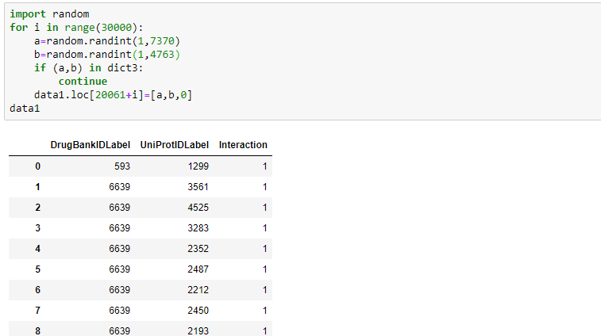
The above data set was split into train set and test set by:
(train, test) = train_test_split(data, train_size = 0.8)
We have to assign a value for the below parameters of the PMF model:

Parameter | Meaning
n_user | It is the total number of drugs in our case. The value is 7370.
n_item | It is the total number of targets in our case. The value is 4763.
n_feature | It tells how many features can uniquely describe a drug and a target. It composes an embedding vector for each drug and each target. Intrinsically, the inner product of the drug’s embedding vector and the target’s embedding vector gives the interaction probability of this drug and this target. We plan to run the PMF model a few times to find an optimal n_feature value.
n_iters | The number of iterations. The higher value of n_iters is supposed to give a better prediction but the running time will be increasing drastically.
max_rating | In our case, it is 1.
min_rating | In our case, it is 0.

We firstly tried this combination of parameters: n_user=7370, n_item=4763, n_feature=30, n_iters=10, max_rating=1, min_rating=0. And we obtained below results:
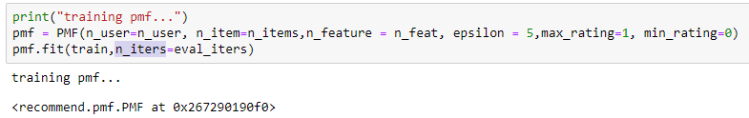
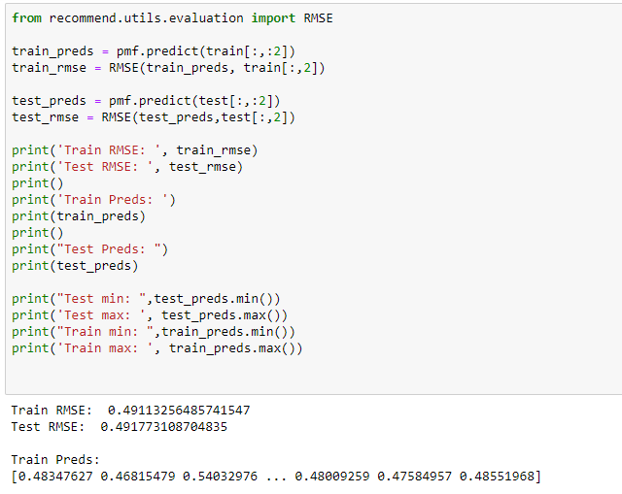
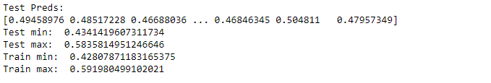
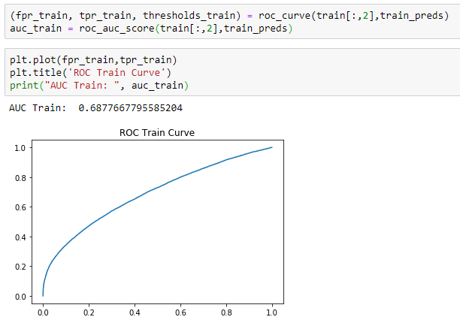
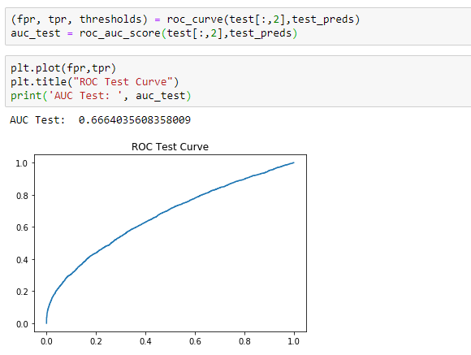
The results are summarized in below table:
Performance Indicator | Value
RMSE for train set | 0.4911
RMSE for test set | 0.4918
AUC score for train set | 0.6878
AUC score for test set | 0.6664
Results for: n_user=7370, n_item=4763, n_feature=30, n_iters=10, max_rating=1, min_rating=0
Similarly, we ran the model using different combinations of parameters and the results are listed below:
Performance Indicator | Value
RMSE for train set | 0.5119
RMSE for test set | 0.5155
AUC score for train set | 0.7331
AUC score for test set | 0.6875
Results for: n_user=7370, n_item=4763, n_feature=70, n_iters=10, max_rating=1, min_rating=0

Performance Indicator | Value
RMSE for train set | 0.4643
RMSE for test set | 0.4703
AUC score for train set | 0.8773
AUC score for test set | 0.7966
Results for: n_user=7370, n_item=4763, n_feature=30, n_iters=50, max_rating=1, min_rating=0

Performance Indicator | Value
RMSE for train set | 0.4443
RMSE for test set | 0.4585
AUC score for train set | 0.9078
AUC score for test set | 0.8010
Results for: n_user=7370, n_item=4763, n_feature=30, n_iters=100, max_rating=1, min_rating=0

Comparing the above four results, the current optimal result occurred at n_feature=30, n_iters=100. The predicted data was exported to “PMF Generated data_30000_fea30_ite100.csv”. The current model can be used to predict the interaction probability for any drug-target pair but with limited accuracy. Taking DrugBankIDLabel #1 for example, we paired it with all the 4763 targets and predicted the interaction probability of all these pairs. Below is the screenshot of the result:
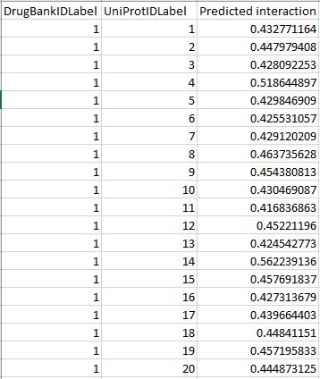
Q3:
It has been reported that the quality of the negative data set affects the prediction results [3]. The chemical and structural similarity has been incorporated into the procedure of generating the negative data set [2]. In our study, we did randomly pairing of the drug and the target and assume their interaction probability to be 0. And we varied the number of negative samples to form different data sets aiming to see how the number of negative samples affects the prediction performance.
We generated another data set with 20061 positive samples and 79955 negative samples. We split the data set by using “(train, test) = train_test_split(data, train_size = 0.8) and used n_feature=30, n_iters=100 to fit the PMF model on the train data. The results are summarized as below:
Performance Indicator | Value
RMSE for train set | 0.3692
RMSE for test set | 0.3771
AUC score for train set | 0.8760
AUC score for test set | 0.8054
Results for: n_user=7370, n_item=4763, n_feature=30, n_iters=100, max_rating=1, min_rating=0
The ROC curves as below:
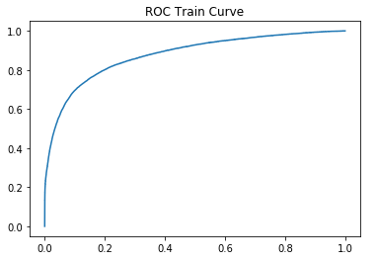
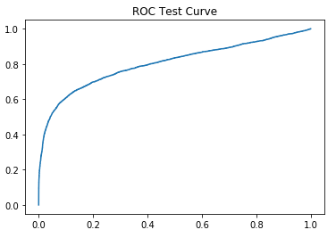
We can see that when the number of the negative samples increases from 29992 to 79955, the RMSE is lowered by about 17.8% and the AUC score almost stays the same. The reduction in RMSE might be because more negative samples bring more zero(s) into the calculation. So it looks to us that there is no improvement in the prediction accuracy when there are more negative samples.

Problem Report
The predicted interaction probability for the positive samples is supposed to be very close to 1 but it is actually much smaller than 1 as shown below. And as we have seen in the tables above, the RMSE and AUC score still have some room to improve. The future work will have to take the chemical similarity into consideration when generating the negative samples. For example, given a known interaction of drug i and target j, for a drug k, the more difference between drug i and drug k, the less possibility that drug k interacts target j. We expect to see improved prediction accuracy after the chemical similarity is taken into account.
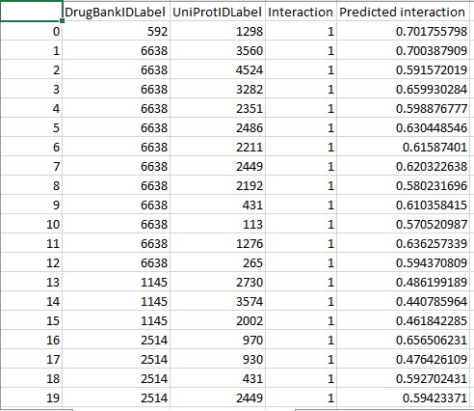
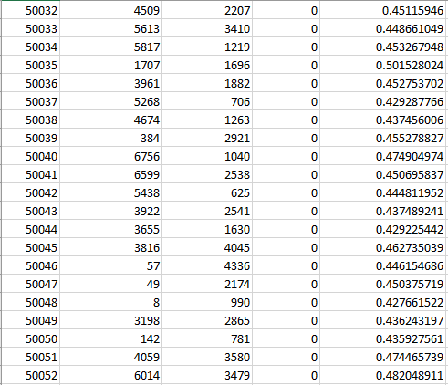
Screenshots of the partial prediction results for the data set with 29992 negative samples and n_feature=30, n_iters=100.

References

Ruslan Salakhutdinov and Andriy Mnih. Probabilistic matrix factorization. In Advances in Neural Information Processing Systems; NIPS, 2007 20: 1257-1264

Implementation of PMF: https://github.com/chyikwei/recommend/tree/master/recommend

Zhanzhan Cheng, Kai Huang, Yang Wang, Hui Liu, Jihong Guan and Shuigeng Zhou. Selecting high-quality negative samples for effectively predicting protein-RNA interactions. BMC Systems Biology. 2017 11 (Suppl 2) :9

