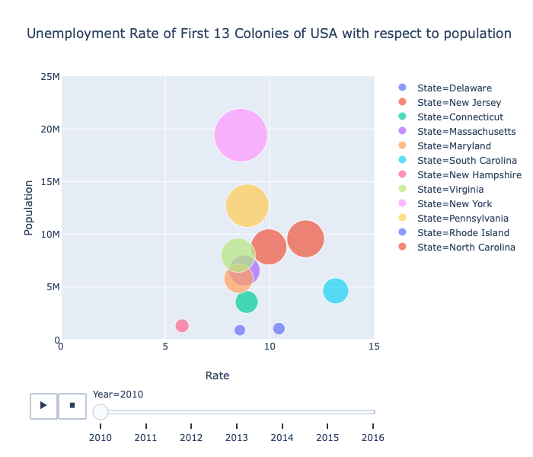

LEGEND:

The above graph is animated graph and representation of unemployment rate of First 13 Colonies of United States of America with respect to Population from 2010 to 2016. I got the dataset from Kaggle and US Census. For the unemployment rate I use the dataset from this link: <https://www.kaggle.com/jayrav13/unemployment-by-county-us>. This is a dataset that 'Jay Ravaliya' built by scraping the United States Department of Labor's Bureau of Labor Statistics. The dataset has a data of unemployment rate from all of the county of United States. For the population dataset I use this link: [https://www.census.gov/data/tables/time-series/demo/popest/2010s-state-total.html#par\_textimage.](https://www.census.gov/data/tables/time-series/demo/popest/2010s-state-total.html" \l "par_textimage.) This assignment is ongoing work for my final project. I used the data and work from my assignment 1 and continued it for this assignment. I was curious about the first 13 colonies of United States since it was one of the questions that was asked by interviewer for my naturalization. I wanted to know how it changed throughout the year. Since the data was large, I sliced the data to the first 13 colonies of USA. Comparing to seaborn and plotly, I found plotly much better since it is interactive visualization and tells us a bit of information while hovering at the graph. Also, I was amazed that we can use animated visualization from plotly and thus I used ploty package so that I can explore and learn to use it. I combined the data of unemployment and population so as to find out the relation between them. For my final project I am planning to add more data and information as well as some machine learning algorithm to get future information. For the above graph I used plotly for the plot, ‘Rate’ for x axis, ‘Population’ for y axis, ‘State’ as a color, ‘Population’ for the size of the plot and 'Year' as an animation frame. Here every component has a purpose in the animation. From this diagram I can tell that the rate is decreasing each year. From my analysis, just looking at the above diagram, the rate of unemployment will continue to decrease but with such a small data it is very hard to tell it will be true. There is a saying that "Little knowledge is a dangerous thing" therefore I cannot be sure of my analysis. I found it interesting that even though the population of "New York" has been the highest, the unemployment rate remained average out of these states whereas "New Hampshire" has always the lowest unemployment rate throughout the year from 2010 to 2016. Also, after looking at the diagram I found that my first data is missing entire information/values about the State "Georgia". I wish I have bigger data so that I can be more confident in my results and can come up with better visualization.