Homework 1

- (10 points) Using the program shown below, explain what the output will be at LINE A.

#include <sys/types.h>
#include <stdio.h>
#include <unistd.h>
int value = 10;
int main()
{
pid_t pid;
pid = fork();

if (pid == 0) { /* child process */
value += 15;
return 0;
}
else if (pid > 0) { /* parent process */
wait(NULL);
printf("PARENT: value = %d",value); /* LINE A */
return 0;
}
}

The output of the line A is 10. It is because the child process has its own memory space and doesn’t affect or shares memory with the parent process.

- (10 points) Explain the circumstances under which the line of code marked printf(“LINE J”) in the program below will be reached.

#include <sys/types.h>
#include <stdio.h>
#include <unistd.h>

int main()
{
/* fork a child process */
pid_t pid = fork();
if (pid < 0) { /* error occurred */
fprintf(stderr, "Fork Failed");
return 1;
}
else if (pid == 0) { /* child process */
execlp("/bin/ls","ls",NULL);
printf("LINE J");
}
else { /* parent process */
/* parent will wait for the child to complete */
wait(NULL);
printf("Child Complete");
}
return 0;
}

Answer: Line J will reach only if the execlp() function fails to execute.

- (10 points) Including the initial parent process, how many processes are created by the program shown below:

#include <stdio.h>
#include <unistd.h>

int main()
{
/* fork a child process */
fork();
/* fork another child process */
fork();
/* and fork another */
fork();
return 0;
}

It will create a total of 8 processes.

- (10 points) Using the program shown below, explain what the output will be at lines X and Y.

#include <sys/types.h>
#include <stdio.h>
#include <unistd.h>

#define SIZE 5
int nums[SIZE] = {0,1,2,3,4};

int main()
{
pid_t pid = fork();

if (pid == 0) {
for (int i = 0; i < SIZE; i++) {
nums[i] *= -i;
printf("CHILD: %d ",nums[i]); /* LINE X */
}
}
else if (pid > 0) {
wait(NULL);
for (i = 0; i lt; SIZE; i++)
printf("PARENT: %d ",nums[i]); /* LINE Y */
}
return 0;
}

For line x:
CHILD: 0 CHILD: -1 CHILD: -4 CHILD: -9 CHILD: -16

For line Y:
PARENT: 0 PARENT: 1 PARENT: 2 PARENT: 3 PARENT: 4

The above output is because Parent is not sharing it memory space with child.

- Consider the following set of processes, with the length of the CPU burst time given in milliseconds:

Process | Burst Time | Priority | Arrive Time
P₁ | 2 | 2 | 3
P₂ | 1 | 1 | 0
P₃ | 8 | 4 | 2
P₄ | 4 | 2 | 7
P₅ | 5 | 3 | 5

The processes are assumed to have arrived in the order P₁, P₂, P₃, P₄, P₅, all at time 0.

- (40 points) Draw four Gantt charts that illustrate the execution of these processes using the following scheduling algorithms: FCFS, SJF, non-preemptive Priority (a larger priority number implies a higher priority), and RR (quantum = 2).

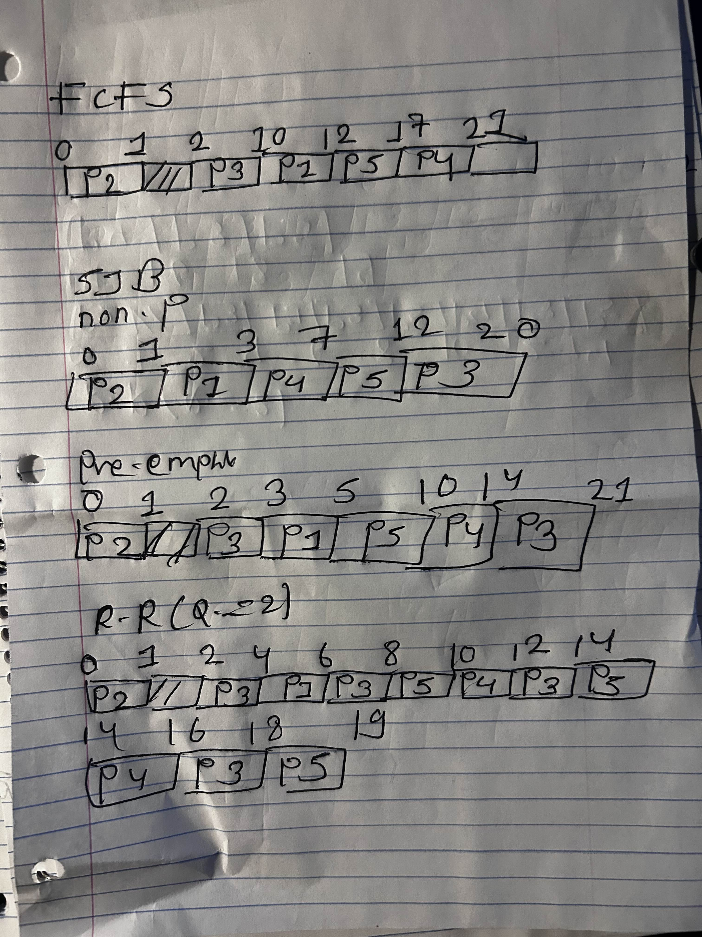

- (5 points) What is the turnaround time of each process for each of the scheduling algorithms in part a.?

c. (5 points) What is the waiting time of each process for each of these scheduling algorithms?

FCFS:

Process ID | Completion Time | Turnaround Time | Waiting Time
P1 | 12 | 9 | 7
P2 | 1 | 1 | 0
P3 | 10 | 8 | 0
P4 | 21 | 14 | 10
P5 | 17 | 12 | 7

SJF:
non-preemptive:
Turnaround = completion-arrival
Process | Waiting Time | Turn-around Time
P1 | 1 | 3-3=0
P2 | 0 | 1
P3 | 12 | 20-2=18
P4 | 3 | 7-7=0
P5 | 7 | 12-5=7

preemptive:
Process | Waiting Time | Turnaround Time
P1 | 0 | 5-3=2
P2 | 0 | 1
P3 | 11 | 19
P4 | 3 | 7
P5 | 0 | 5

non-preemptive Priority (a larger priority number implies a higher priority):

Process | Completion time | Turnaround Time | Waiting Time
P1 | 17 | 17-3=14 | 14-2=12
P2 | 1 | 1-0=1 | 1-1=0
P3 | 10 | 10-2=8 | 8-8=0
P4 | 21 | 21-7=14 | 14-4=10
P5 | 15 | 15-5=10 | 10-5=5

Round-Robin (Quantum=2)

Process | Completion Time | Turnaround Time | Waiting Time
P1 | 6 | 6-3=3 | 3-2=1
P2 | 1 | 1-0=1 | 1-1=0
P3 | 18 | 18-2=16 | 16-8=8
P4 | 16 | 16-7=9 | 9-4=5
P5 | 19 | 19-5=12 | 12-5=7

- (10 points) Which of the algorithms results in the minimum average waiting time (over all processes)?

FCFS: Average waiting time: 4.8 units

SJF:
Non-pre-emtive: Average waiting Time:4.6 units
Preemptive: Average waiting Time: 3.25 units

Priority:
Average Turnaround time: 11.75
Average Waiting time= 23.25

RR:
Average Turnaround time: 11
Average Waiting time= 5.25

