Name=Sudarshan Tiwari

1. Write a prediction for the four experiments performed in la

Experiment 1. Diffusion in agar. (1 pt)

Prediction: Potassium permanganate should diffuse the fastest because it has a lower molecular mass (158 g/mole) compared to malachite green (365 g/mole). The speed of diffusion is inversely proportional to the square root of the molecular mass therefore lighter molecules diffuses faster.

Experiment 2. Diffusion in gas. (2 pts)

Which gas should diffuse the fastest?

Ammonia gas (NH3) should diffuse faster because it has a lower molecular mass (17.031 g/mole) compared to chlorine gas (Cl2), which has a molecular mass of 70.900 g/mole. According to Graham's Law, lighter gases diffuse faster.

Diffusion in agar vs. gas: In which type of media should diffusion occur the fastest? Why?

Diffusion should occur faster in gas because the molecules are further apart, allowing them to travel longer distances between collisions compared to a liquid or solid medium like agar. In a solid, molecular movement is more restricted.

Experiment 3. Effects of salt on turgor pressure. (1 pt)

As the salt concentration increases, the leaf's consistency will become less rigid and eventually wilt. This is because in a hypertonic solution, water will move out of the plant cells, leading to a loss of turgor pressure, causing the cells to shrink and the leaves to lose rigidity.

Experiment 4. Osmosis across a semipermeable membrane. (2 pts)

Bags placed in a hypertonic solution should decrease in weight because water will move out of the bags toward the higher solute concentration outside.

Bags placed in a hypotonic solution should increase in weight as water moves into the bag, following the concentration gradient.

Bags placed in an isotonic solution should remain the same in weight because there is no net movement of water.

2. Figure 4-1. Graph for % initial weight vs. time for osmosis in model cells experiment (Exp. 4).
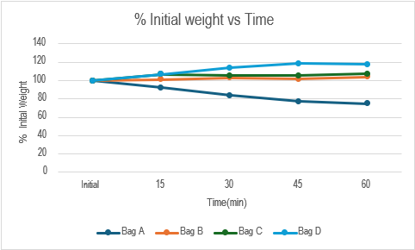

Describe what happened in each bag in terms of hypertonic, hypotonic, or isotonic environments. Is this what you expected? Why or why not?

Bags A is in a hypertonic environment lose weight due to water moving out.

Bags C(gained slowly due to less concentration) and D in a hypotonic environment gained weight as water entered.

Bags B is in an isotonic environment and stayed the same in weight.

Yes, this is what I expected because osmosis causes water to move from areas of low solute concentration to areas of high solute concentration.

Why is there a difference between the results of bags C and D?

There is a difference in bags C and D because of different solute concentrations. Bag C has less concentrations than the Bag D which is 25% and 50% respectively causing slower movement of water inside the Bag C than Bag D.

3. Table 4-1. Table for gas and agar diffusion.
Compound | Molecular Mass (g/mole) | Media | Time(s) | Distance(mm) | Rate (mm/s)
Potassium Permanganate | 158 | Agar | 2460 | 9 | 0.003
Malachite Green | 365 | Agar | 2460 | 5 | 0.002
Ammonia (NH3) | 17.031 | Gas | 836 | 56.5 | 0.676
Chlorine (Cl2) | 70.900 | Gas | 836 | 50 | 0.598

Which compound had the fastest rate of diffusion? Is this what you expected? Why or why not?
Ammonia had the fastest rate of diffusion, which is expected because of its lower molecular mass, as predicted by Graham's Law of diffusion.

Compare the diffusion rate of substances in gas versus those in agar and explain the difference.

Diffusion is significantly faster in gas than in agar because gases have molecules that are further apart, allowing for more freedom of movement and faster diffusion compared to the more compact structure of agar.

4. Results from the lettuce experiment (Exp. 3). (1.5 pts)

Describe what happened in reference to hypertonic, isotonic, or hypotonic environments for each bowl of lettuce.

Hypertonic environment: The lettuce leaves lost water, became limp, and wilted due to water moving out of the cells.

Isotonic environment: The lettuce leaves remained firm as there was no net movement of water in or out of the cells.

Hypotonic environment: The lettuce leaves became more turgid (stiff) as water entered the cells, increasing turgor pressure.

Describe what is happening per cell in each bowl.

In the hypertonic environment, water is leaving the cells, causing them to shrink and lose turgor pressure.

In the isotonic environment, there is no net movement of water, so the cell size and turgor pressure remain constant.

In the hypotonic environment, water enters the cells, causing them to swell and increase turgor pressure.

