Supplementary Materials to KNU-DTI: KNowledge United Drug-Target Interaction prediction
Ryong Heo^{1,3}, Dahyeon Lee², Byunju Kim³, Sangmin Seo⁴, Sanghyun Park⁴ and Chihyun Park^{1,2,3,5}*
¹Interdisciplinary Graduate Program in Medical Bigdata Convergence, Kangwon National University, Chuncheon-si, 24341, Gangwon-do, Republic of Korea, ²Department of Data Science, Kangwon National University, ³UBLBio Corporation, Yeongtong-ro 237, Suwon, 16679, Gyeonggi-do, Republic of Korea, ⁴Department of Computer Science, Yonsei University, Yonsei-ro 50, Seodaemun-gu, 03722, Seoul, Republic of Korea, ⁵Department of Computer Science and Engineering, Kangwon National University
∗ Corresponding author
1. Generation Structural Property Sequence (SPS) task
If you want to make your own SPS, you need SCRATCH-1D[1] tool. This tool is available for download here: https://download.igb.uci.edu/
We used (2021, Ubuntu Only, 1.4 GB) version of it. We provide some jupyter notebook files to run SCRATCH-1D tool on your dataset. The overall process as follows:
1. Get unique protein sequences from your Drug-Target Protein pair dataset.
2. To create an SPS, divide it into appropriate sizes and save it as a FASTA file. (Recommendation: up to 200 proteins per fasta)
3. Using the FASTA file as input for the SCRATCH-1D tool, obtains .acc and .ss3 files.
4. Use grouping method from DeepAffinity [2], for .acc, .ss3, and FASTA files to obtain the final SPS.
5. Repeat steps 2 to 4 to obtain the SPS for all unique proteins.

Detailed user guide and codes for running are available on our GitHub page: https://github.com/DBpackage/SPS

2. Conducted environments and Hyperparameters
All experiments were conducted on a desktop computer with the following environments, NVIDIA GeForce GTX 3090 with 24.00 GB of memory, Intel(R) Xeon(R) W-2255 CPU @ 3.70GHz and 256GB RAM. We used all default hyperparameters for comparing models except for training epochs. We set all 100 train epochs for comparing models except for GraphDTA [3] which used 500 train epochs. Other changes were only for loss functions and/or sigmoid activation function of last layer to apply both classification and regressions task. KNU-DTI has many hyperparameters since we made it based on the Chemprop D-MPNN [4] and PercieverCPI [5]. However, we only used the hyperparameters in below Table S1. All hyperparameters were determined empirically, and hyperparameter optimization experiments were conducted using a dataset reduced to 1/10 of its original size. The general hyperparameters, D-MPNN, Gated CNN block, and regularization terms were inherited from existing Chemprop and PerceiverCPI models and were not modified, except for the training epochs. For the baseline model, a transformer module was constructed, and optimization was performed to determine the most suitable hyperparameters for its components. Proper adjustment of the input sequence's maximum length was essential: the sequence length for proteins was set to the maximum protein length, while SPS and SMILES lengths were set to their respective maximum lengths. Under the specified settings, the model consisted of 5,095,441 parameters and required approximately 3 minutes per epoch for training. Training for 120 epochs took about 6 hours. Using a batch size of 50, the GPU memory consumption was approximately 3.4 GB.
Table S1 Hyperparameters used in our experiment
Hyperparameter |  | setting | Search Range
General hyperparameters | dropout | 0.1
 | optimizer | Adam | [Adam, Lamb [6]]
 | lr | 0.0001
 | Activation function | ReLU
 | epochs | 120 | [100, 120, 150]
 | batch size | 50
Transformer block | transfrmer_d_model | 64 | [64, 128, 256]
 | transformer_d_ff | 512 | [256, 512, 1024]
 | transformer_nlayers | 2 | [2, 4]
 | transformer_nheads | 4 | [4, 8]
MAX_SEQ_LEN | sequence_length | 500 | [500, 1000]
 | sps_length | 70 | [50, 70, 100]
 | smiles_length | 50 | [50, 100]
D-MPNN block | depth | 3
Gated CNN block | sps_1d_out | 64
 | sps_hidden_size | 128
 | sps_1dcnn_numlayers | 3
 | kernel_size | 7
United vector size | hidden_size | 300 | [100, 300]
weighting term  (applied only to regression task) | tau | 2.0, 5.0 | [[2.0, 5.0],  [4.0, 9.0]]
 | alpha | 0.5
 | beta | 5.0

3. Weighting method for regression task
In PerceiverCPI, a weighting method was adopted to address the issue of label skewness in the Davis [7] and KIBA [8] datasets by assigning higher weights to samples with underrepresented labels. Specifically, the hyperparameter tau defines the label range to which differentiated weighting is applied. For samples with labels within the range of tau, the loss used for gradient updates is scaled by a factor of alpha, while samples with labels outside this range are scaled by beta. For instance, if tau = [4.0, 9.0], alpha = 0.5, and beta = 5.0, the loss values for samples with labels in the range of 4.0–9.0 are multiplied by 0.5, whereas the loss for samples outside this range is multiplied by 5.0. Although PerceiverCPI effectively addressed the label skewness in Davis and KIBA through this weighting method, the BindingDB [9] dataset used in this study exhibits no significant label skewness, following a normal distribution. Therefore, we adopted two distinct weighting strategies in our study:
- A weighting strategy similar to PerceiverCPI, designed to promote uniform learning across all label ranges by emphasizing underrepresented samples.
- A task-specific weighting strategy that prioritizes the identification of protein-compound pairs with stronger binding affinities.
In this study, we observed that the second approach yielded superior performance and thus adopted it as the primary weighting method. Specifically, we defined tau = [2.0, 5.0], alpha = 0.5, and beta = 5.0. For samples with labels in the range of 2.0–5.0 (indicating binding affinities weaker than 10 µM), the loss values were scaled by 0.5 to smooth the learning process. In contrast, for samples with labels above 5.0 (indicating binding affinities stronger than 10 µM), the loss values were scaled by 5.0, thereby focusing the model’s learning on these more relevant samples.

4. Additional results
Although not included in the main manuscript, we conducted additional comparative tests with DeepAffinity, TransformerCPI [10], and GraphDTA variants. DeepAffinity, which utilizes SPS, was considered as a comparative model; however, its performance was not competitive compared to other models, and thus we did not repeat tests with this approach. Similarly, TransformerCPI was excluded from the main results table as it exhibited limitations in handling regression tasks effectively. Detailed results for these models are provided in Table S2, with results not included in the main table highlighted in bold. Table S3 shows classification results on Davis dataset.
Table S2 Results on BindingDB regression.
Model |  | RMSE ( ↓ ) | CI ( ↑ )
DeepAffinity |  | 0.9349 | .
TransfomrerCPI |  | 1.4389 (0.008) | 0.7446 (0.000)
HyperAttentionDTI |  | 0.8220 (0.005) | 0.8309 (0.001)
GraphDTA | GAT_GCN | 0.8103 (0.009) | 0.8328 (0.002)
 | GATNet | 1.2558 (0.008) | 0.6942 (0.003)
 | GCNNet | 0.8312 (0.009) | 0.8273 (0.003)
 | GINConvNet | 0.8279 (0.004) | 0.8273 (0.001)
Moltrans |  | 1.008 (0.025) | 0.7895 (0.010)
ELECTRA_DTA |  | 0.8062 | 0.8370 (0.002)
perceriverCPI |  | 0.8702 (0.011) | 0.8193 (0.003)
KNU-DTI | Full, ENSEMBLE1 | 0.7804 (0.002) | 0.8410 (0.000)
 | Full, ENSEMBLE3 | 0.7443 (0.004) | 0.8505 (0.000)
 | Baseline | 0.9594 (0.004) | 0.7956 (0.001)

Table S3 Classification results on the Davis dataset
Model |  | AUROC | AUPRC | ACC | Recall | Precision
TransfomrerCPI |  | 0.8691 (0.004) | 0.6243 (0.023) | 0.7866 (0.026) | 0.7949 (0.046) | 0.4040 (0.027)
HyperAttentionDTI |  | 0.9193 (0.005) | 0.7335 (0.018) | 0.8955 (0.004) | 0.6890 (0.018) | 0.6720 (0.010)
GraphDTA | GINConvNet | 0.8986 (0.007) | 0.6900 (0.018) | 0.8875 (0.004) | 0.5380 (0.030) | 0.6858 (0.004)
Moltrans |  | 0.8857 (0.008) | 0.6531 (0.016) | 0.7640 (0.028) | 0.8689 (0.021) | 0.3968 (0.023)
perceriverCPI |  | 0.8559 (0.005) | 0.6005 (0.012) | 0.8733 (0.006) | 0.3977 (0.046) | 0.6888 (0.031)
KNU-DTI | Full, ENSEMBLE1 | 0.9101 (0.003) | 0.7146 (0.015) | 0.8431 (0.012) | 0.8210 (0.027) | 0.5100 (0.029)
 | Full, ENSEMBLE3 | 0.9221 (0.003) | 0.7467 (0.017) | 0.8533 (0.018) | 0.8412 (0.025) | 0.5316 (0.040)
 | Baseline | 0.9008 (0.006) | 0.6875 (0.019) | 0.8275 (0.005) | 0.8193 (0.020) | 0.4798 (0.013)

5. Data imbalance and redundancy in Davis dataset
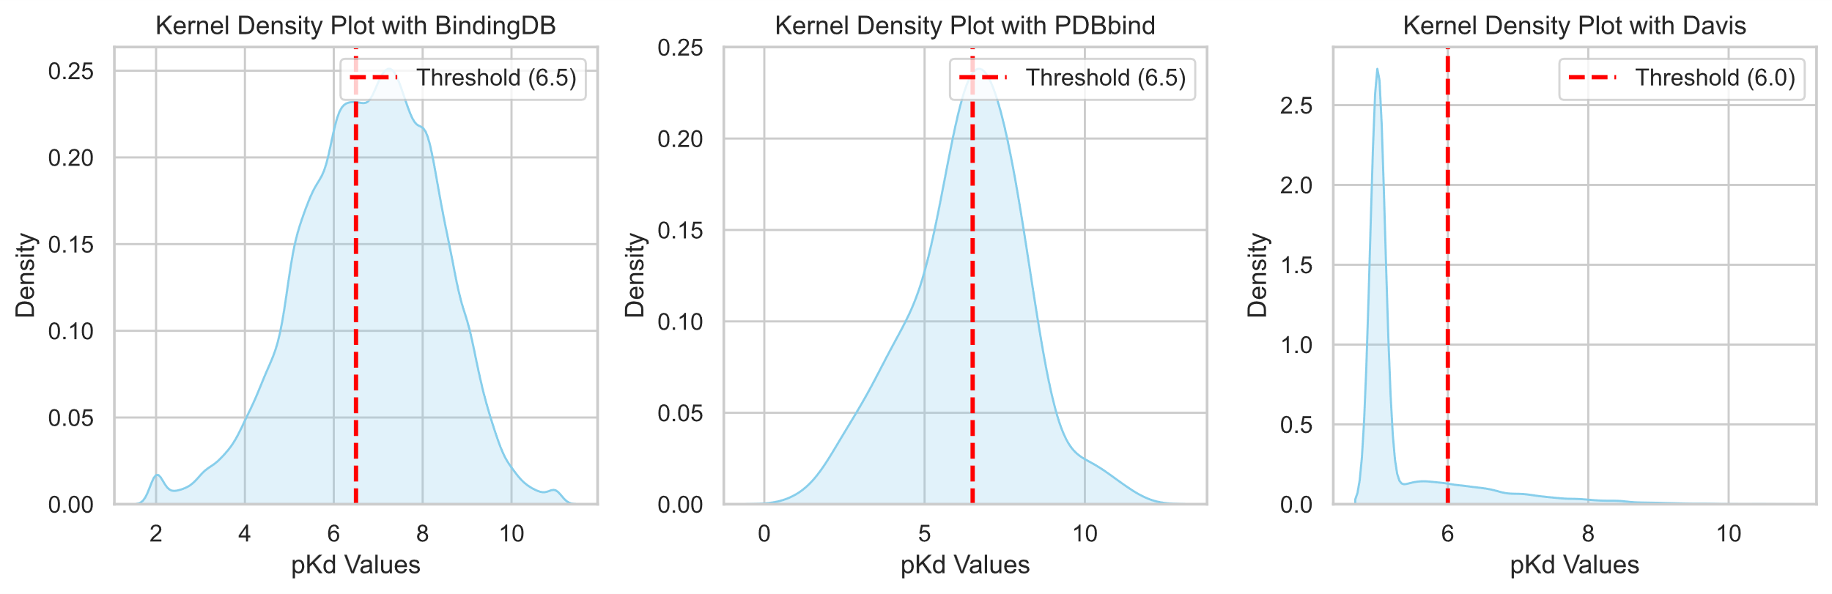
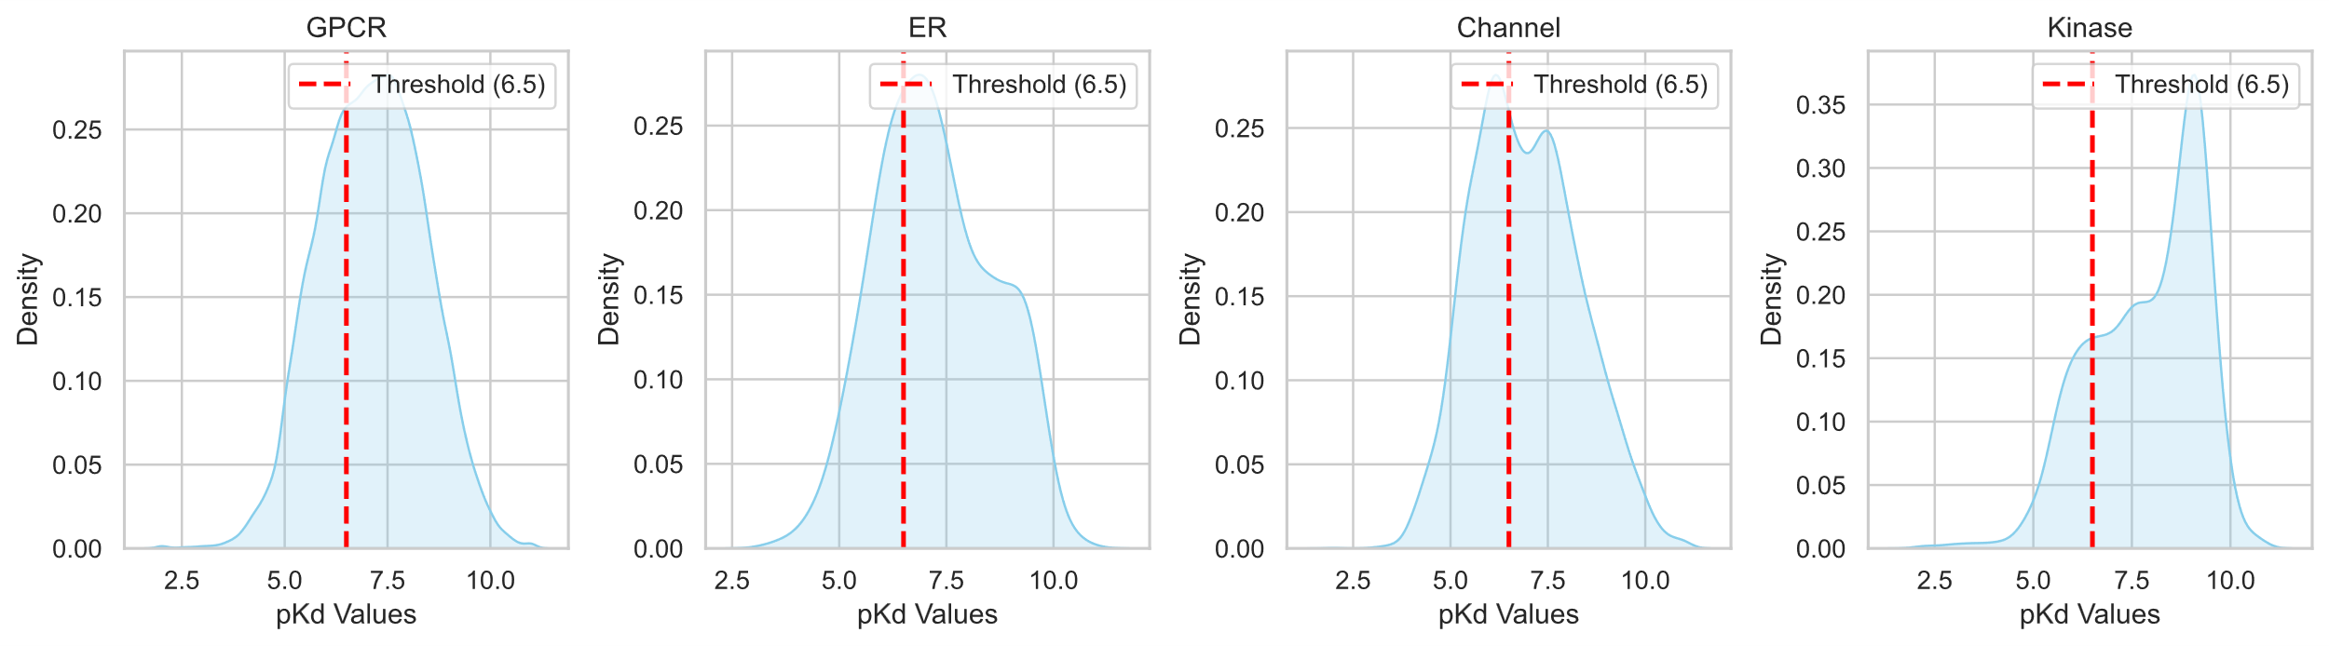
Given the variety of datasets utilized in our study, we conducted an analysis of the label distributions for each dataset. As highlighted in the main manuscript, KNI-DTI does not achieve the highest performance on the Davis [7] dataset. However, as illustrated in Figure S1, the label distribution of the Davis dataset is highly right-skewed, with a significant concentration around a value of 5.0. It is worth noting that building models capable of learning effectively from skewed datasets represents a significant challenge that warrants discussion in the field of deep learning. However, in the case of the Davis dataset, the issue arises from the fact that its skewness is a result of incorrect assumptions made during the dataset's construction process. According to AS Rifaioglu [11] et al. In this dataset, about 70% of the bioactivity values (20,931 out of 30,056) are recorded as 10 uM, which converted into label value of 5.0. These binding affinity values indicate compound–target protein pairs for which no binding was observed in the primary screen, where the authors screened ligands against the panel at a single concentration of 10 uM. As a result, these bioactivity records are not the true bioactivity values between the corresponding compound–target protein pairs. Therefore, it is not suitable to use these data points in a regression-based prediction system, since incorporating these data points into the training dataset may cause biased predictive models and misleading performance results. Furthermore, according to J. Sun et al. [12], the Davis dataset exhibits a high redundancy rate of 18.3%, with 5,508 out of 30,056 entries being duplicated. This issue is not unique to Davis; datasets documenting biological experimental results, such as BindingDB, frequently include repeated measurements for the same protein-compound pairs. While the presence of redundant results does not necessarily indicate a low-quality dataset, a high redundancy rate relative to the total dataset size reduces the number of unique patterns available for model training. For instance, in the case of BindingDB, the dataset initially curated by DeepAffinity contained 144,525 entries, of which 15,416 were redundant, resulting in a redundancy rate of approximately 10.6%. After removing redundancies, BindingDB dataset still retained 129,109 unique entries. In contrast, the Davis dataset, with 30,056 entries, has a higher redundancy rate of 18.3%, leaving only 25,772 unique entries after duplicates are removed. This not only demonstrates a higher redundancy rate compared to BindingDB but also highlights the relatively small number of unique data points available in Davis, which is insufficient given the vast search space of protein and compound sequences. These instabilities of Davis dataset can negatively impact the training of predictive models and make it difficult to ensure reliability in performance comparison evaluations.
Figure S1 Label distribution on various datasets.
6. Average length of raw protein sequence Compared to SPS
We suppose that SPS can help achieve better model performance since it concentrated on deriving additional structural information from raw protein sequences. However, since the length of the raw protein sequence we used is around 1000, we suppose that a long SPS sequence length could have a negative impact on space and time complexity. Additionally, we aimed to use Gated Convolution Neural Network [13] to obtain information from SPS, we assume that shorter sequences would be advantageous considering the small kernel sizes of CNN. Thus, we investigate the length of the original protein sequences and the average length of SPS sequences for each dataset and find that there are significant (>10 times) decreases of sequence length between them. Figure S2 shows the result.
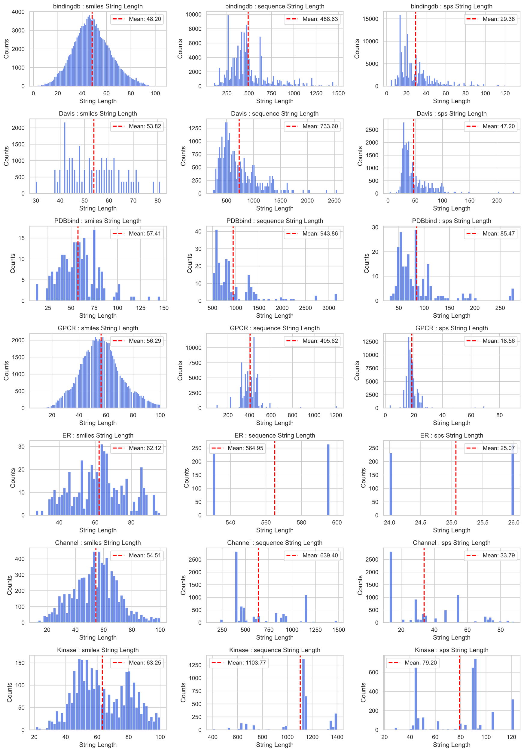
Figure S2 SMILES, protein and SPS length distributions for each dataset.
7. Analysis of model performance across varying dataset sizes
To evaluate the performance of the KNU-DTA model across varying dataset sizes, we conducted experiments using BindingDB ranging from 10% (12,910 samples) to full dataset size. To demonstrate that the labels of the partitioned data do not introduce any bias that could hinder learning, we presented the label distribution for each volume in Figure S3. The results are summarized in Table S4 and visualized in Figure S4. The RMSE consistently decreased and the CI increased as the dataset size grew. Notably, when 30% of the dataset (approximately 40,000 samples) was used, the RMSE dropped below 1.0 (0.96), suggesting that this data threshold is sufficient to achieve stable and reliable performance.
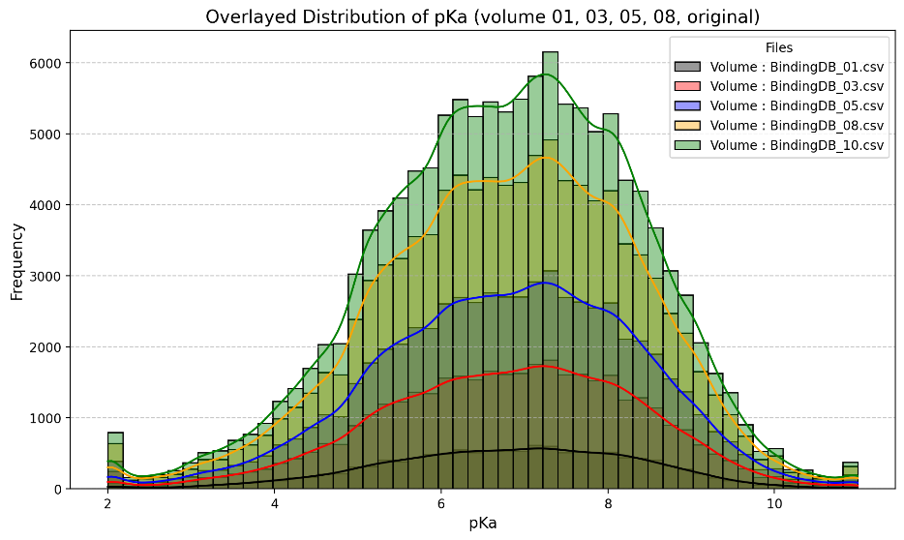
Figure S3 Label distribution for each split dataset
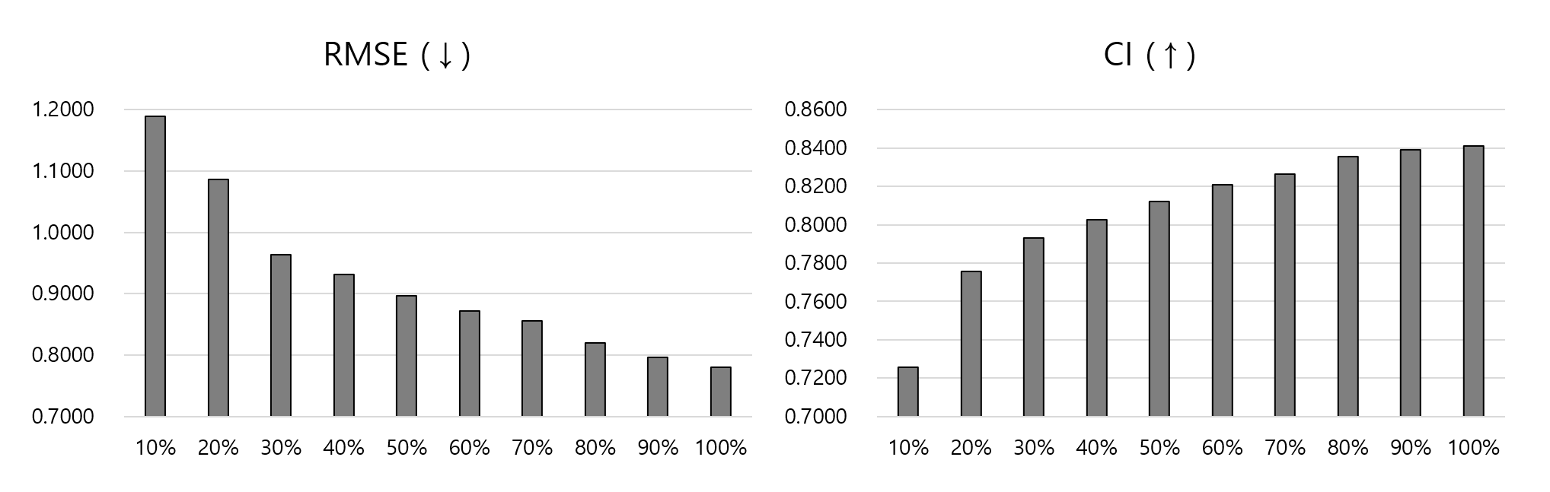
Figure S4 Visualized results for analysis of Model Performance Across Varying Dataset Sizes
Table S4 Analysis of Model Performance Across Varying Dataset Sizes
Model | Volume of dataset | RMSE (↓) | CI (↑)
KNU-DTA | 10% | 1.1893 | 0.7255
 | 20% | 1.0868 | 0.7757
 | 30% | 0.9633 | 0.7932
 | 40% | 0.9312 | 0.8027
 | 50% | 0.8969 | 0.8120
 | 60% | 0.8725 | 0.8209
 | 70% | 0.8557 | 0.8264
 | 80% | 0.8195 | 0.8355
 | 90% | 0.7965 | 0.8391
 | 100% | 0.7804 | 0.8410
 | 300% | 0.7199 | 0.8474

8. Visual representation of results.
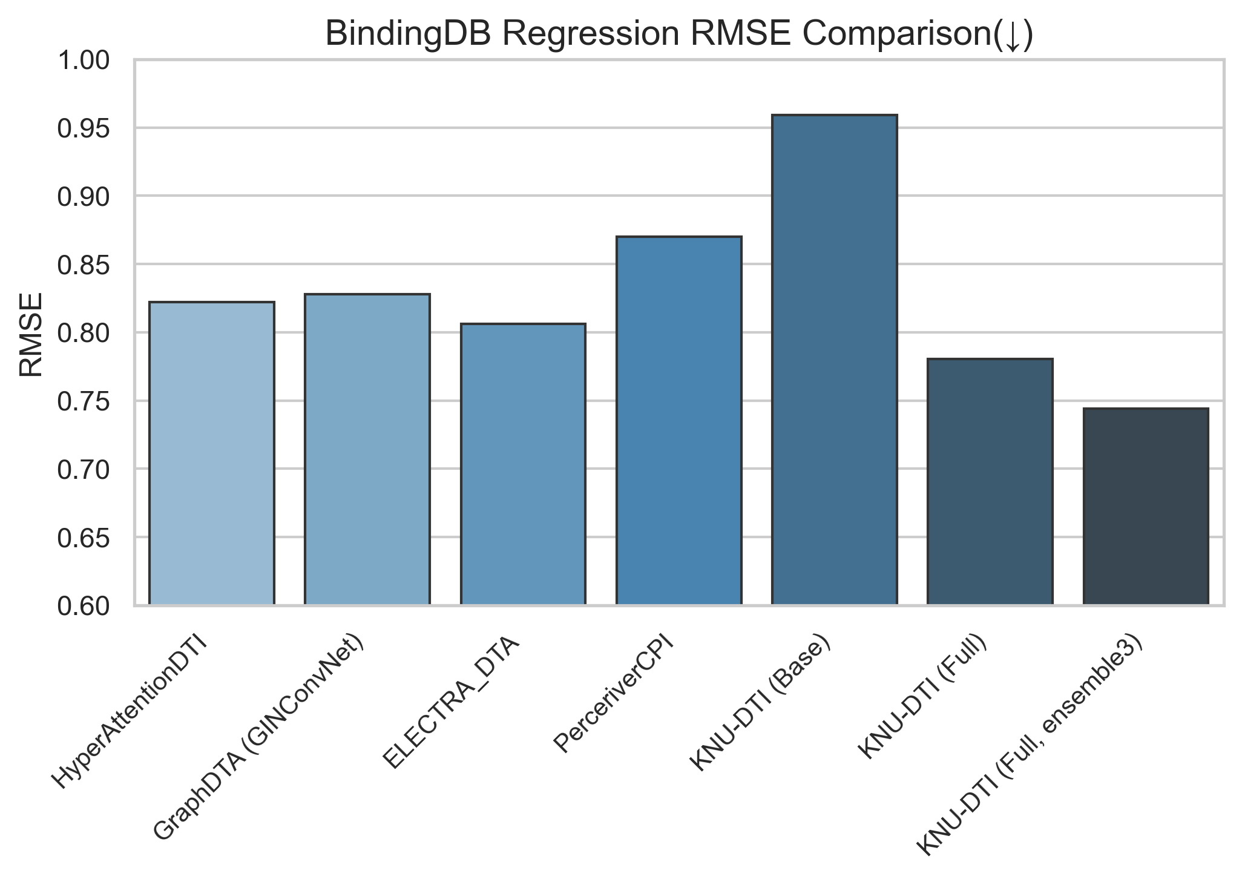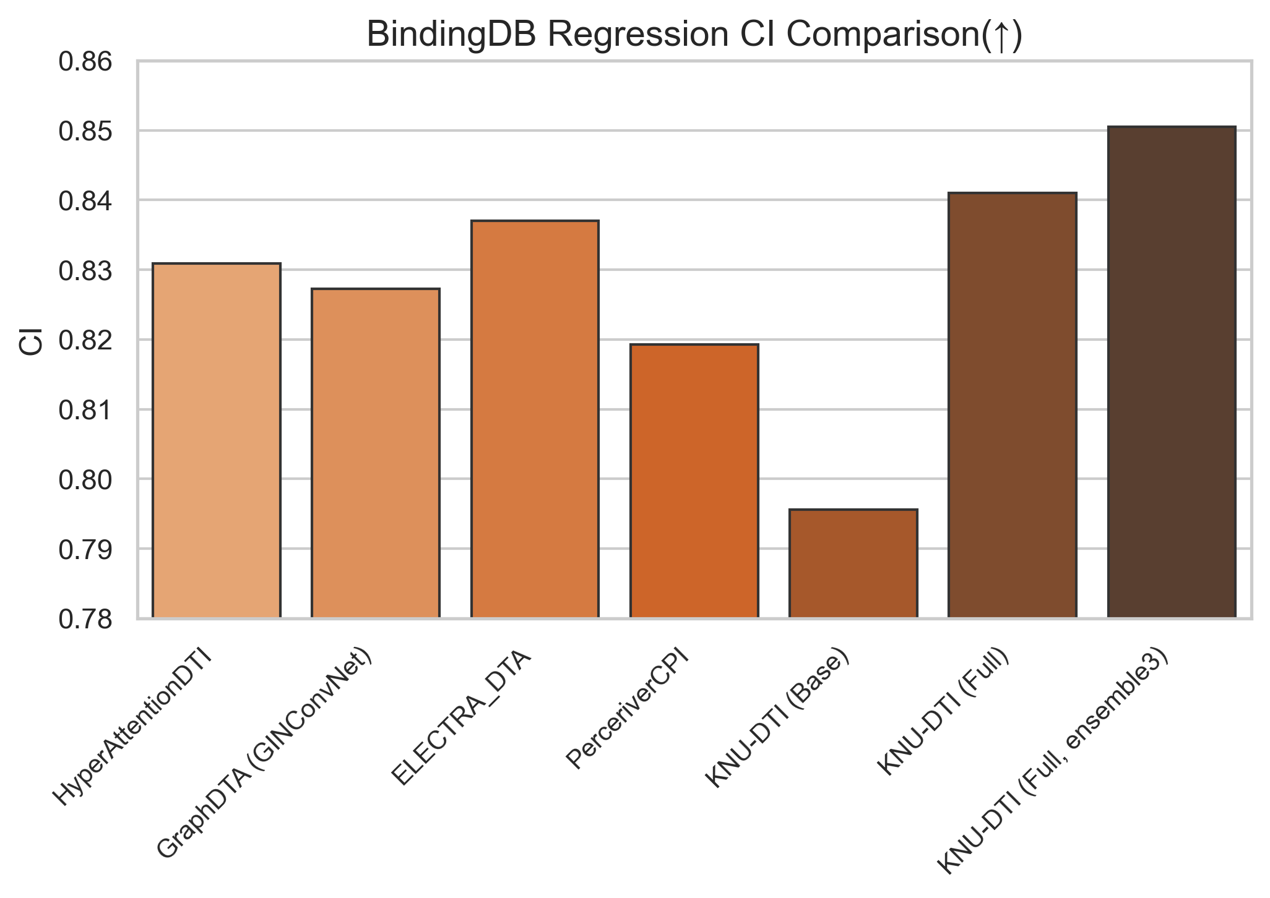
Figure S5 Visualized result of BindingDB regression

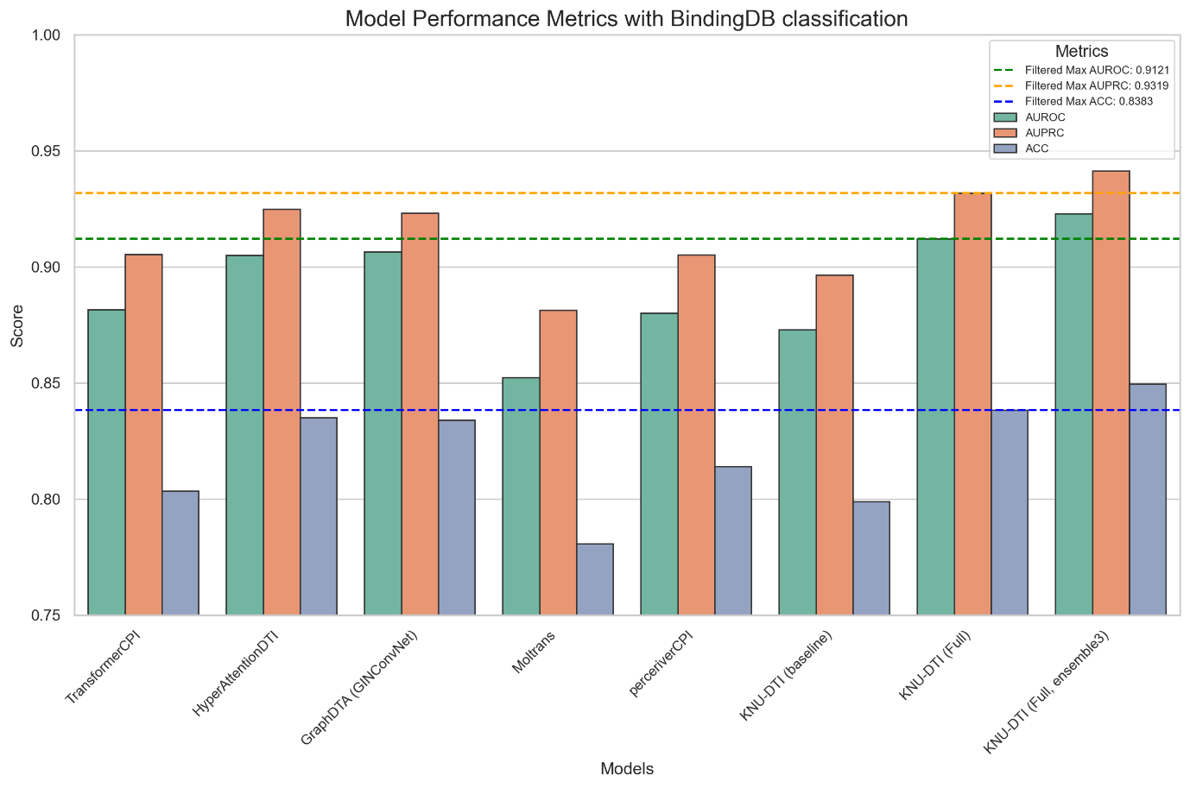
Figure S6 Visualized result of BindingDB classification
The horizontal line was drawn based on the best-performing model among those excluding the KNU-DTI ensemble3 model, to ensure fairness.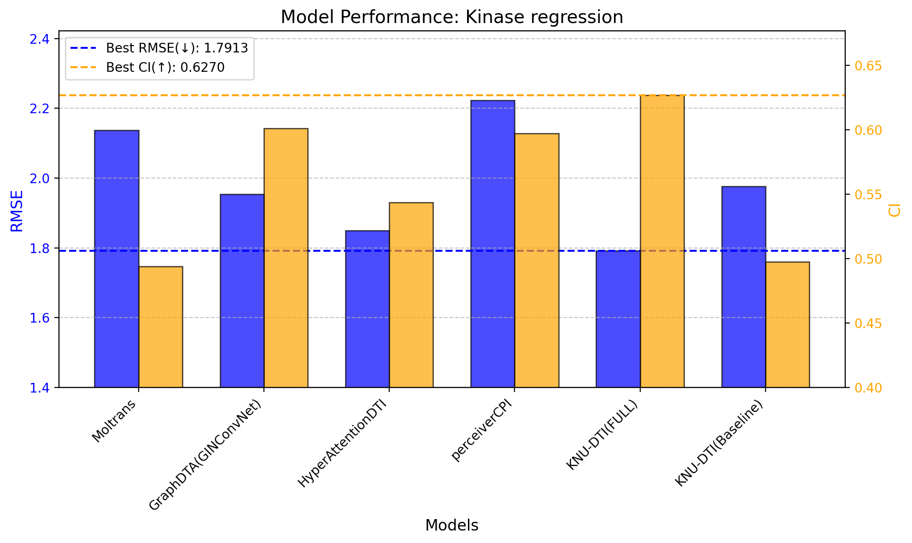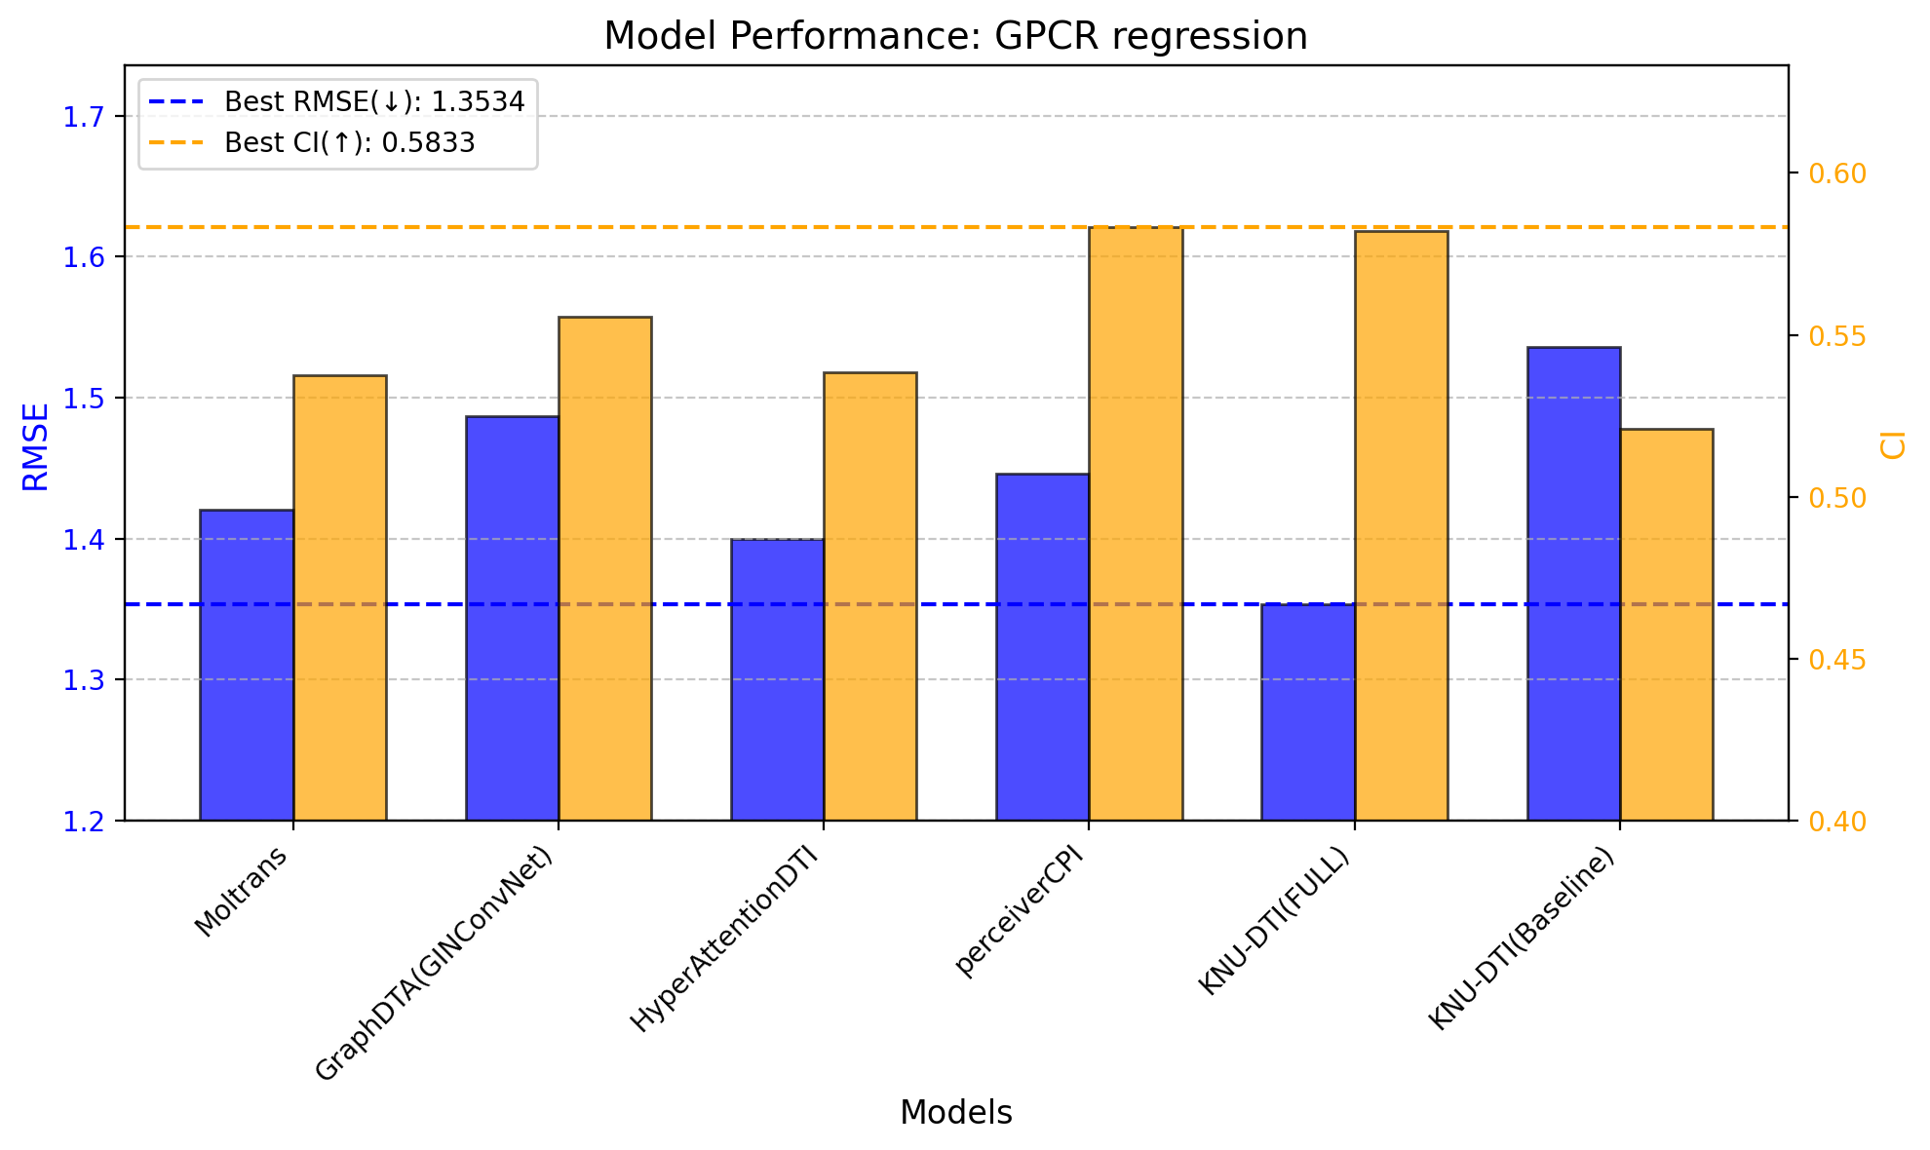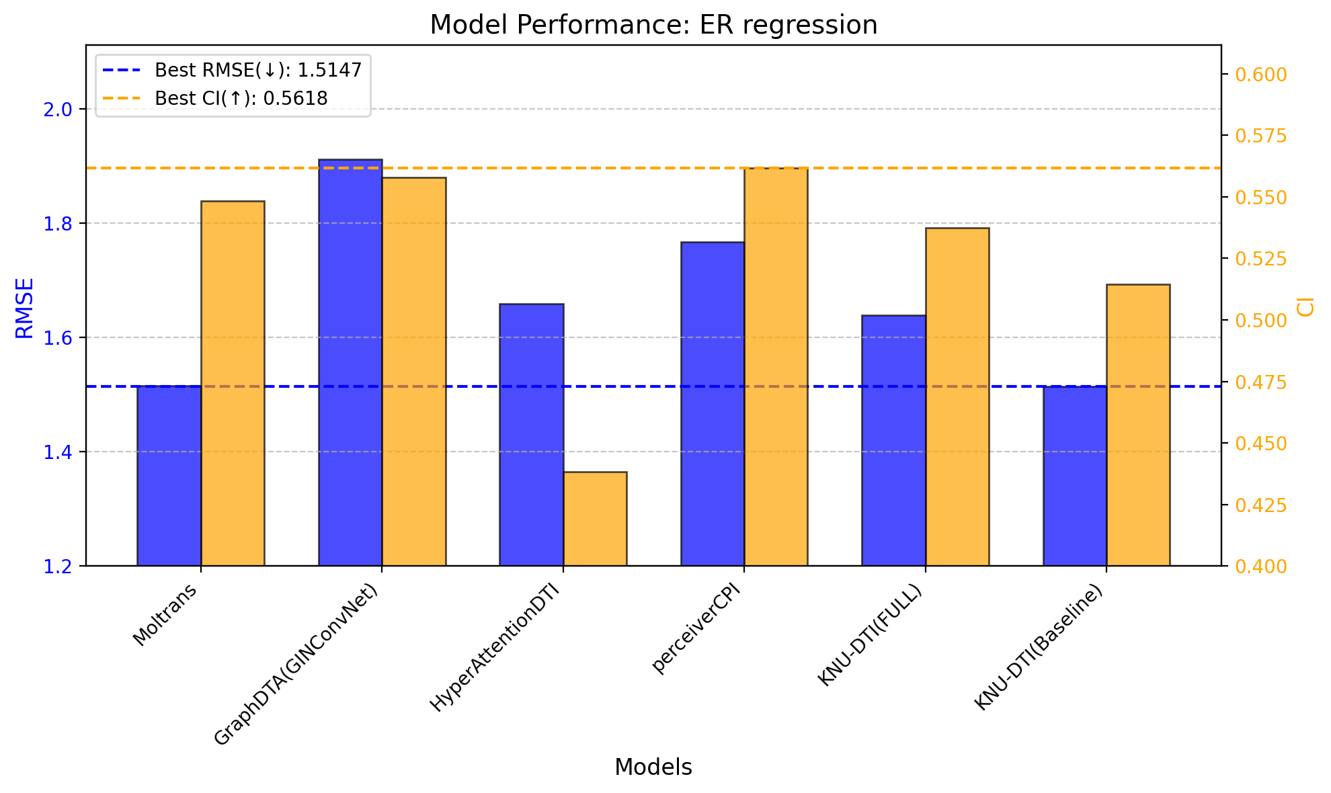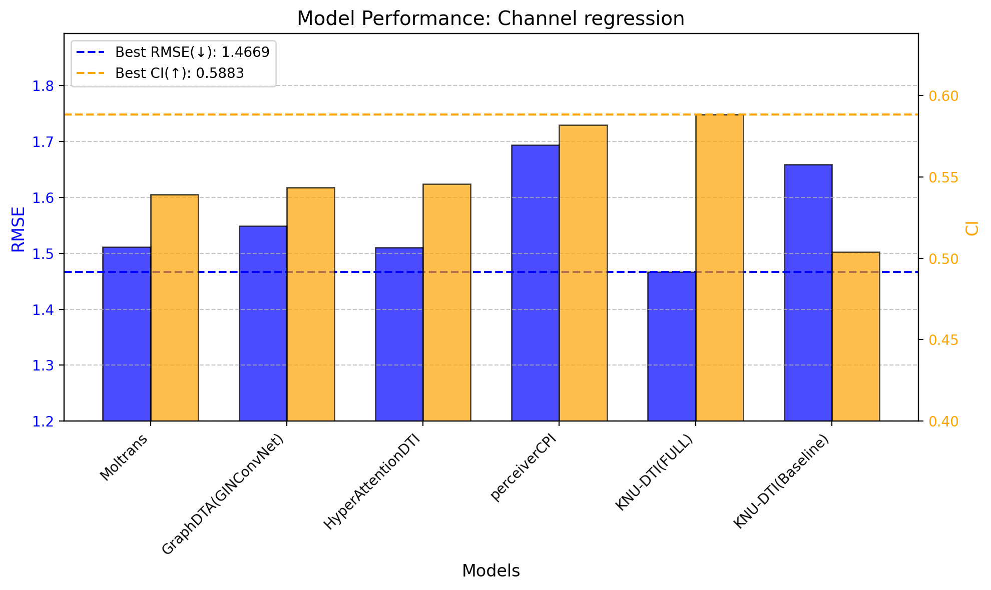
Figure S7 Visualized results of protein class dependent regression

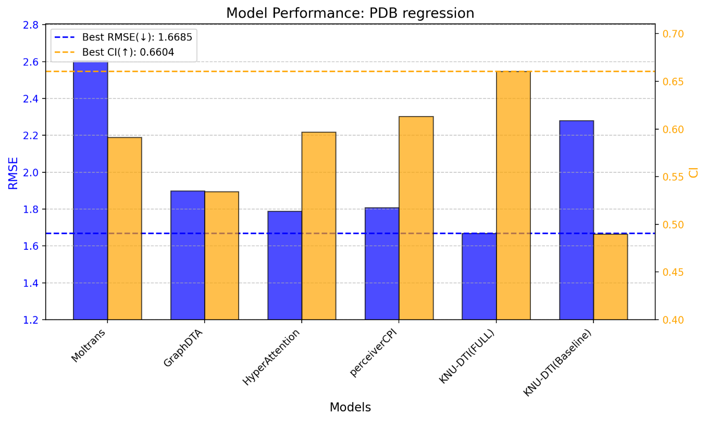
Figure S8 Visualized result of PDB regression

9. Further experiments for robustness and generalizability verification
9.1 Regression and classification test on DUD-E dataset
To further evaluate the robustness and generalization performance of the proposed model, we conducted additional experiments using the DUD-E [14] dataset. This dataset, designed for virtual screening tasks, includes active compounds that interact with 102 target proteins and decoys that share similar physicochemical properties but lack biological activity. These decoys challenge the model to distinguish between compounds with similar features but differing interaction behaviors, effectively simulating scenarios where input data may be perturbed or noisy. For these experiments, we randomly selected 40 active and 40 decoy compounds for each target protein. During preprocessing, certain data points were dropped due to SMILES invalidity, and target proteins with an active-to-decoy ratio disrupted to 8:2 or higher (e.g., COMT, FA7, TRY1, UROK and FGFR1) were excluded. After preprocessing, the final dataset consisted of 6,849 compound pairs (3,374 actives and 3,475 decoys) across 97 target proteins. The predictions were made using a model trained on the BindingDB dataset, with the DUD-E dataset serving as an unseen dataset. This setup allows us to evaluate the model's robustness and generalizability by assessing its predictive performance on previously unseen data. Interaction (active or decoy) were predicted and standard classification metrics—including accuracy, recall, precision, and F1-score—were calculated. These metrics provided insights into the model’s ability to generalize and maintain predictive accuracy when evaluated on perturbed samples. Furthermore, the DUD-E dataset is entirely independent of the BindingDB dataset used for training, ensuring that the evaluation reflects the model’s generalizability on unseen data. The results shown in Table S5 demonstrate that the proposed model can effectively generalize knowledge learned from the BindingDB dataset to a different dataset with distinct characteristics. Genes with an accuracy of 0.7 or higher are considered successfully learned entries and highlighted in bold. Out of a total of 97 proteins, 24 proteins (24.7%) were found to have an accuracy of 0.7 or higher. This outcome highlights the model’s robustness and generalization capability, providing confidence in its potential to handle new and challenging datasets. Figure S9 presents a plot of the experimental results conducted to validate the outcomes shown in Table S5 through a regression test. 29 target proteins were tested, and since the data obtained from DUD-E only includes class labels, docking simulations were performed for each protein-compound pair to generate a total of 2,320 continuous pseudo-labels. In the docking simulations, a smaller negative docking score indicates stronger binding, while in the prediction model, a larger positive value suggests stronger binding. Therefore, the presence of a negative correlation between the two values demonstrates consistency between the prediction model's output and the docking simulator's calculated results. For the ACES gene, the Pearson Correlation Coefficient (PCC) was measured at -0.56, indicating a significant negative correlation. Additionally, other genes, such as AA2AR, ABL1, and ADA17, were observed to have negative correlations close to -0.4, further supporting the model's alignment with the docking simulations. These additional experiments conducted using DUD-E demonstrate the model's robustness and generalizability.
Table S5 DUD-E classification result
Gene | Accuracy | Precision | Recall | F1-score | Active | Decoy
AA2AR | 0.7568 | 0.6964 | 0.9750 | 0.8125 | 40 | 34
ABL1 | 0.6974 | 0.6207 | 0.9730 | 0.7579 | 37 | 39
ACE | 0.5325 | 0.6111 | 0.2750 | 0.3793 | 40 | 37
ACES | 0.6364 | 0.5806 | 0.7200 | 0.6429 | 25 | 30
ADA | 0.7761 | 0.7419 | 0.7667 | 0.7541 | 30 | 37
ADA17 | 0.6709 | 0.6167 | 0.9250 | 0.7400 | 40 | 39
ADRB1 | 0.6667 | 0.7333 | 0.5641 | 0.6377 | 39 | 36
ADRB2 | 0.5694 | 0.6000 | 0.6154 | 0.6076 | 39 | 33
AKT1 | 0.5769 | 0.5625 | 0.6923 | 0.6207 | 39 | 39
AKT2 | 0.6000 | 0.5932 | 0.8974 | 0.7143 | 39 | 31
ALDR | 0.3889 | 0.2857 | 0.1053 | 0.1538 | 38 | 34
AMPC | 0.5067 | 0.0000 | 0.0000 | 0.0000 | 37 | 38
ANDR | 0.7397 | 1.0000 | 0.4412 | 0.6122 | 34 | 39
AOFB | 0.5072 | 0.4667 | 0.2121 | 0.2917 | 33 | 36
BACE1 | 0.5441 | 0.4848 | 0.5333 | 0.5079 | 30 | 38
BRAF | 0.6714 | 0.6122 | 0.8824 | 0.7229 | 34 | 36
CAH2 | 0.5556 | 0.4681 | 0.8800 | 0.6111 | 25 | 38
CASP3 | 0.5270 | 0.5667 | 0.4359 | 0.4928 | 39 | 35
CDK2 | 0.7143 | 0.7586 | 0.6286 | 0.6875 | 35 | 35
CP2C9 | 0.6081 | 0.6000 | 0.5143 | 0.5538 | 35 | 39
CP3A4 | 0.6429 | 0.7500 | 0.3636 | 0.4898 | 33 | 37
CSF1R | 0.6393 | 0.6000 | 0.7241 | 0.6563 | 29 | 32
CXCR4 | 0.6071 | 0.3571 | 0.7143 | 0.4762 | 7 | 21
DEF | 0.5325 | 0.8333 | 0.1250 | 0.2174 | 40 | 37
DHI1 | 0.4865 | 0.5833 | 0.1750 | 0.2692 | 40 | 34
DPP4 | 0.6000 | 0.7143 | 0.5000 | 0.5882 | 40 | 30
DRD3 | 0.6712 | 0.6596 | 0.7949 | 0.7209 | 39 | 34
DYR | 0.8148 | 0.8462 | 0.5789 | 0.6875 | 19 | 35
EGFR | 0.5479 | 0.5625 | 0.4865 | 0.5217 | 37 | 36
ESR1 | 0.7468 | 0.7500 | 0.7500 | 0.7500 | 40 | 39
ESR2 | 0.7125 | 0.6735 | 0.8250 | 0.7416 | 40 | 40
FA10 | 0.5472 | 0.3784 | 0.9333 | 0.5385 | 15 | 38
FABP4 | 0.5694 | 0.5333 | 0.2500 | 0.3404 | 32 | 40
FAK1 | 0.7368 | 0.8378 | 0.7750 | 0.8052 | 40 | 17
FKB1A | 0.7632 | 0.7619 | 0.8000 | 0.7805 | 40 | 36
FNTA | 0.6714 | 0.7241 | 0.5833 | 0.6462 | 36 | 34
FPPS | 0.5211 | 0.0000 | 0.0000 | 0.0000 | 34 | 37
GCR | 0.6750 | 0.6346 | 0.8250 | 0.7174 | 40 | 40
GLCM | 0.5634 | 0.5714 | 0.3529 | 0.4364 | 34 | 37
GRIA2 | 0.5600 | 0.5714 | 0.1739 | 0.2667 | 23 | 27
GRIK1 | 0.5323 | 0.5000 | 0.0345 | 0.0645 | 29 | 33
HDAC2 | 0.5325 | 0.5882 | 0.2564 | 0.3571 | 39 | 38
HDAC8 | 0.5758 | 0.5000 | 0.5357 | 0.5172 | 28 | 38
HIVINT | 0.4267 | 0.3704 | 0.2778 | 0.3175 | 36 | 39
HIVPR | 0.8108 | 0.7805 | 0.8649 | 0.8205 | 37 | 37
HIVRT | 0.5600 | 0.5532 | 0.6842 | 0.6118 | 38 | 37
HMDH | 0.6364 | 0.7368 | 0.3784 | 0.5000 | 37 | 40
HS90A | 0.6494 | 0.6140 | 0.8750 | 0.7216 | 40 | 37
HXK4 | 0.3889 | 0.1667 | 0.0250 | 0.0435 | 40 | 32
IGF1R | 0.5857 | 0.5593 | 0.9167 | 0.6947 | 36 | 34
INHA | 0.4933 | 0.4815 | 0.7222 | 0.5778 | 36 | 39
ITAL | 0.8400 | 0.8529 | 0.8056 | 0.8286 | 36 | 39
JAK2 | 0.7429 | 0.7568 | 0.7568 | 0.7568 | 37 | 33
KIF11 | 0.5256 | 0.6000 | 0.1538 | 0.2449 | 39 | 39
KIT | 0.6833 | 0.5600 | 0.6364 | 0.5957 | 22 | 38
KITH | 0.4000 | 0.3462 | 0.2250 | 0.2727 | 40 | 40
KPCB | 0.4306 | 0.4576 | 0.7500 | 0.5684 | 36 | 36
LCK | 0.8030 | 0.7576 | 0.8333 | 0.7937 | 30 | 36
LKHA4 | 0.4324 | 0.4400 | 0.6111 | 0.5116 | 36 | 38
MAPK2 | 0.4857 | 0.4375 | 0.2059 | 0.2800 | 34 | 36
MCR | 0.5195 | 1.0000 | 0.0513 | 0.0976 | 39 | 38
MET | 0.7455 | 0.6842 | 0.9286 | 0.7879 | 28 | 27
MK01 | 0.7105 | 0.6471 | 0.8919 | 0.7500 | 37 | 39
MK10 | 0.6250 | 0.6098 | 0.6944 | 0.6494 | 36 | 36
MK14 | 0.7273 | 0.7021 | 0.8250 | 0.7586 | 40 | 37
MMP13 | 0.6711 | 0.6744 | 0.7250 | 0.6988 | 40 | 36
MP2K1 | 0.6029 | 0.6364 | 0.2333 | 0.3415 | 30 | 38
NOS1 | 0.7500 | 0.5556 | 0.3846 | 0.4545 | 13 | 35
NRAM | 0.5634 | 0.5263 | 0.3125 | 0.3922 | 32 | 39
PA2GA | 0.4156 | 0.3529 | 0.1500 | 0.2105 | 40 | 37
PARP1 | 0.5455 | 0.6923 | 0.2250 | 0.3396 | 40 | 37
PDE5A | 0.7091 | 0.7727 | 0.6071 | 0.6800 | 28 | 27
PGH1 | 0.4935 | 0.0000 | 0.0000 | 0.0000 | 39 | 38
PGH2 | 0.6364 | 0.6410 | 0.6410 | 0.6410 | 39 | 38
PLK1 | 0.7538 | 0.8276 | 0.6857 | 0.7500 | 35 | 30
PNPH | 0.7297 | 0.8077 | 0.5833 | 0.6774 | 36 | 38
PPARA | 0.6456 | 0.6500 | 0.6500 | 0.6500 | 40 | 39
PPARD | 0.7089 | 0.6545 | 0.9000 | 0.7579 | 40 | 39
PPARG | 0.5972 | 0.6410 | 0.6250 | 0.6329 | 40 | 32
PRGR | 0.6324 | 0.5625 | 0.6207 | 0.5902 | 29 | 39
PTN1 | 0.5641 | 0.6316 | 0.3077 | 0.4138 | 39 | 39
PUR2 | 0.6533 | 0.8421 | 0.4103 | 0.5517 | 39 | 36
PYGM | 0.5811 | 0.5455 | 0.6857 | 0.6076 | 35 | 39
PYRD | 0.5063 | 0.6667 | 0.0500 | 0.0930 | 40 | 39
RENI | 0.5513 | 0.5882 | 0.2632 | 0.3636 | 38 | 40
ROCK1 | 0.7576 | 0.8000 | 0.7059 | 0.7500 | 34 | 32
RXRA | 0.5362 | 0.6154 | 0.4211 | 0.5000 | 38 | 31
SAHH | 0.6933 | 0.7500 | 0.6154 | 0.6761 | 39 | 36
SRC | 0.7183 | 0.6327 | 0.9394 | 0.7561 | 33 | 38
TGFR1 | 0.4605 | 0.4211 | 0.2105 | 0.2807 | 38 | 38
THB | 0.6494 | 0.6078 | 0.8158 | 0.6966 | 38 | 39
THRB | 0.7455 | 0.6667 | 0.6667 | 0.6667 | 21 | 34
TRYB1 | 0.5741 | 0.5000 | 0.2174 | 0.3030 | 23 | 31
TYSY | 0.6970 | 0.7619 | 0.5161 | 0.6154 | 31 | 35
VGFR2 | 0.6197 | 0.5800 | 0.8286 | 0.6824 | 35 | 36
WEE1 | 0.5875 | 0.6296 | 0.4250 | 0.5075 | 40 | 40
XIAP | 0.4714 | 0.6154 | 0.2000 | 0.3019 | 40 | 30
OVERALL | 0.6113 | 0.6228 | 0.5350 | 0.5756 | 3374 | 3475

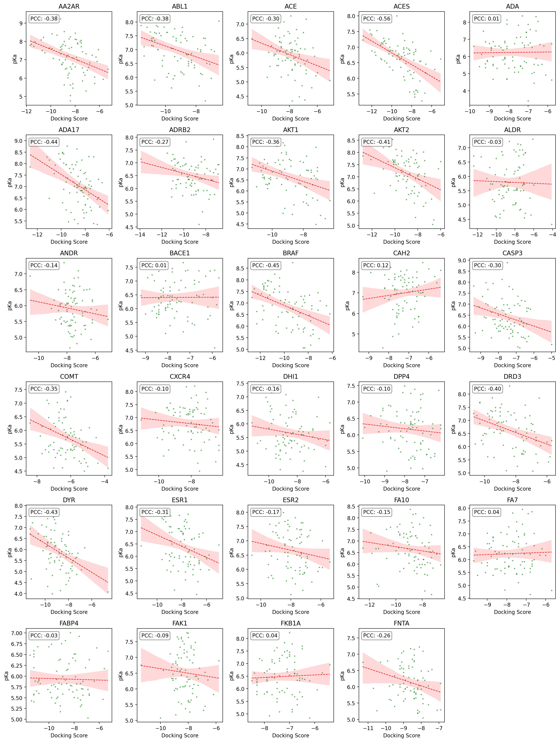
Figure S9 Scatter plot and PCC values between docking scores and prediction model outputs on the DUD-E dataset

9.2 Regression test on newly generated SMILES
We additionally evaluated the predictive accuracy on limited data. For this, we prepared 27 newly generated virtual compounds using an internally developed Variational AutoEncoder (VAE) [15] based SMILES generation model. As the generation model is still under development and not yet published, we are unable to disclose its detailed mechanism. However, we assessed the generated SMILES to ensure they exhibit pharmacological properties of existing drugs and are structurally stable by calculating the QED score [16] (a measure of drug-likeness) and the Synthetic Accessibility score (SAs) [17] (an indicator of synthetic feasibility). Only SMILES with a QED score of 0.9 or higher and an SAs value of 3.0 or lower were selected. To further validate the generated SMILES structures, we applied the RDKit sanitize exception filter during the selection process. This approach allowed us to identify and exclude SMILES strings that failed sanitization checks, such as invalid valence or chemical inconsistencies. Finally, the filtered SMILES were searched using the PubChem compound searching API, which contains 119 million SMILES entries. Only SMILES without any identical compounds and with fewer than 1,000 similar compounds in the search results were retained for further analysis. Figure S10 presents the 2D images of the final 27 generated SMILES for this study. Next, we selected 10 proteins from BindingDB and combined them with the generated SMILES to construct a total of 270 novel protein-compound pairs. Since these data do not contain any label values, Similar to the experiment described in Section 9.1, we used Gibbs free energy values obtained from docking simulations as pseudo-labels. Empirically, we used Gibbs free energy of -7.0 as the threshold for interaction. Pairs with a Gibbs free energy less than -7.0 were considered active (Docking(+)), while those with values greater than or equal to -7.0 were classified as inactive (Docking(-)). For the prediction model, as mentioned in the manuscript, an affinity value greater than 6.0 was classified as active (DTA(+)), and values of 6.0 or below were classified as inactive (DTA(-)). Based on this, we created a scatter plot, the results of which are shown in Figure S11. The four areas represent the following:
- docking(+)/DTA(+)
- docking(-)/DTA(+)
- docking(+)/DTA(-)
- docking(-)/DTA(-)

Out of the 270 novel pairs, 173 pairs were successfully predicted (64.1%). These results show a performance that is partially comparable to the accuracy observed in the DUD-E classification task described in section 9.1. Considering that the SMILES used in this experiment were entirely newly generated and were not part of the training data, these results partially demonstrate that the model can achieve a certain level of predictive performance even for newly generated or less common compounds.
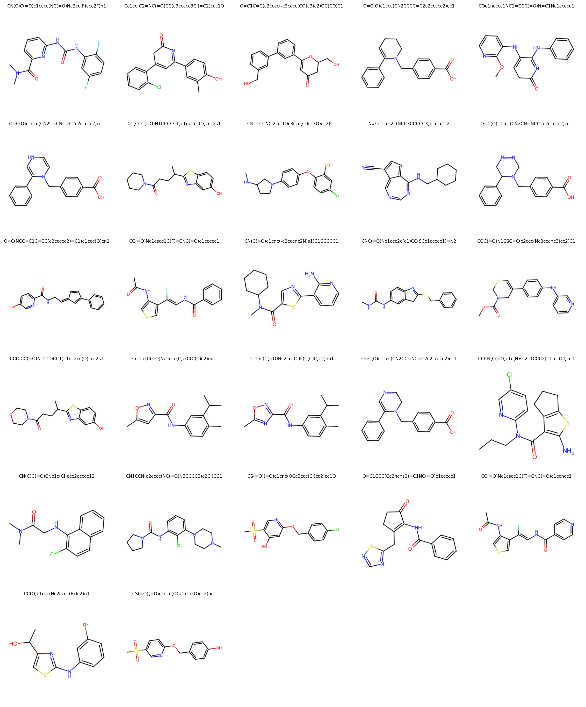
Figure S10 2D Images of 27 newly generated SMILES
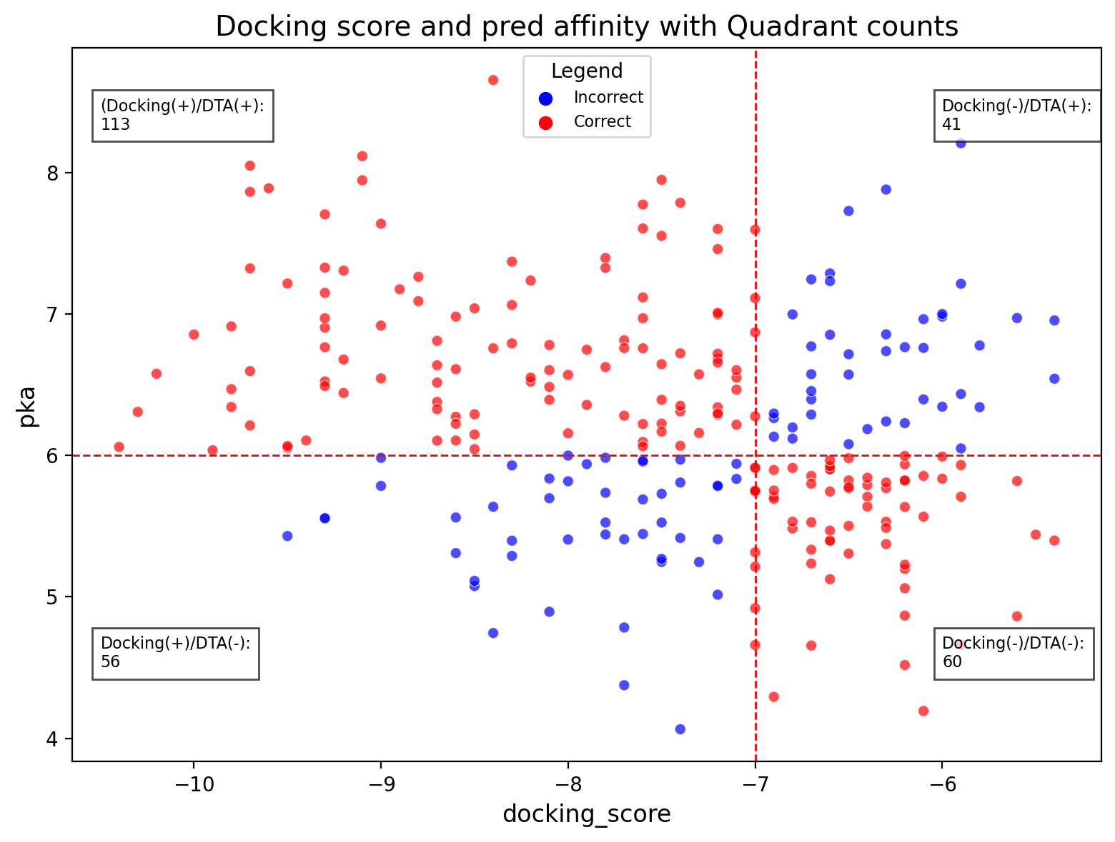
Figure S11 Regression task on newly generated samples
The red vertical dashed line represents the decision boundary for determining active/inactive status based on docking results, while the horizontal dashed line represents the decision boundary for active/inactive classification by the affinity prediction model. The red dots indicate pairs where the predictions from docking and the affinity prediction model are consistent, whereas the blue dots represent pairs with differing predictions. Among the 270 newly generated pairs, 173 points showed consistent prediction results.

1. Cheng J, Randall AZ, Sweredoski MJ, Baldi P. SCRATCH: a protein structure and structural feature prediction server. Nucleic acids research. 2005;33(suppl_2):W72-W6.
2. Karimi M, Wu D, Wang Z, Shen Y. DeepAffinity: interpretable deep learning of compound–protein affinity through unified recurrent and convolutional neural networks. Bioinformatics. 2019;35(18);doi: 10.1093/bioinformatics/btz111.
3. Nguyen T, Le H, Quinn TP, Nguyen T, Le TD, Venkatesh S. GraphDTA: Predicting drug–target binding affinity with graph neural networks. Bioinformatics. 2021;37(8):1140-7.
4. Gilmer J, Schoenholz SS, Riley PF, Vinyals O, Dahl GE, editors. Neural message passing for quantum chemistry. International conference on machine learning; 2017: PMLR.
5. Nguyen N-Q, Jang G, Kim H, Kang J. Perceiver CPI: a nested cross-attention network for compound–protein interaction prediction. Bioinformatics. 2023;39(1):btac731.
6. You Y, Li J, Reddi S, Hseu J, Kumar S, Bhojanapalli S, et al. Large batch optimization for deep learning: Training bert in 76 minutes. arXiv preprint arXiv:190400962. 2019.
7. Davis MI, Hunt JP, Herrgard S, Ciceri P, Wodicka LM, Pallares G, et al. Comprehensive analysis of kinase inhibitor selectivity. Nature biotechnology. 2011;29(11):1046-51.
8. Tang J, Szwajda A, Shakyawar S, Xu T, Hintsanen P, Wennerberg K, et al. Making sense of large-scale kinase inhibitor bioactivity data sets: a comparative and integrative analysis. Journal of Chemical Information and Modeling. 2014;54(3):735-43.
9. Liu T, Lin Y, Wen X, Jorissen RN, Gilson MK. BindingDB: a web-accessible database of experimentally determined protein–ligand binding affinities. Nucleic acids research. 2007;35(suppl_1):D198-D201.
10. Chen L, Tan X, Wang D, Zhong F, Liu X, Yang T, et al. TransformerCPI: improving compound–protein interaction prediction by sequence-based deep learning with self-attention mechanism and label reversal experiments. Bioinformatics. 2020;36(16):4406-14.
11. Rifaioglu AS, Cetin Atalay R, Cansen Kahraman D, Doğan T, Martin M, Atalay V. MDeePred: novel multi-channel protein featurization for deep learning-based binding affinity prediction in drug discovery. Bioinformatics. 2021;37(5):693-704.
12. Sun J, Wang H, Mi J, Wan J, Gao J. MTAF–DTA: multi-type attention fusion network for drug–target affinity prediction. BMC bioinformatics. 2024;25(1):1-21.
13. Dauphin YN, Fan A, Auli M, Grangier D, editors. Language modeling with gated convolutional networks. International conference on machine learning; 2017: PMLR.
14. Mysinger MM, Carchia M, Irwin JJ, Shoichet BK. Directory of useful decoys, enhanced (DUD-E): better ligands and decoys for better benchmarking. Journal of medicinal chemistry. 2012;55(14):6582-94.
15. Kingma DP. Auto-encoding variational bayes. arXiv preprint arXiv:13126114. 2013.
16. Bickerton GR, Paolini GV, Besnard J, Muresan S, Hopkins AL. Quantifying the chemical beauty of drugs. Nature chemistry. 2012;4(2):90-8.
17. Ertl P, Schuffenhauer A. Estimation of synthetic accessibility score of drug-like molecules based on molecular complexity and fragment contributions. Journal of cheminformatics. 2009;1:1-11.

