LAB 5

Connect from SQL Server Database to Java Application (Query)

# Lab Task

## Using the above guide, design and replicate the GUI form as in the Figure below.

* 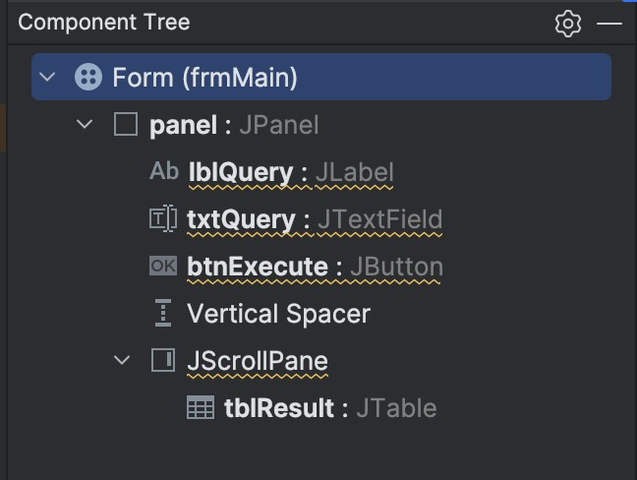**Hint:** The component tree should look like this, with the name following your choice.

## Complete the Java code to build the application. Then, test the database connection and the application code.

1. **Perform these tasks by writing your query and showing the result, given the ERD of this database.**

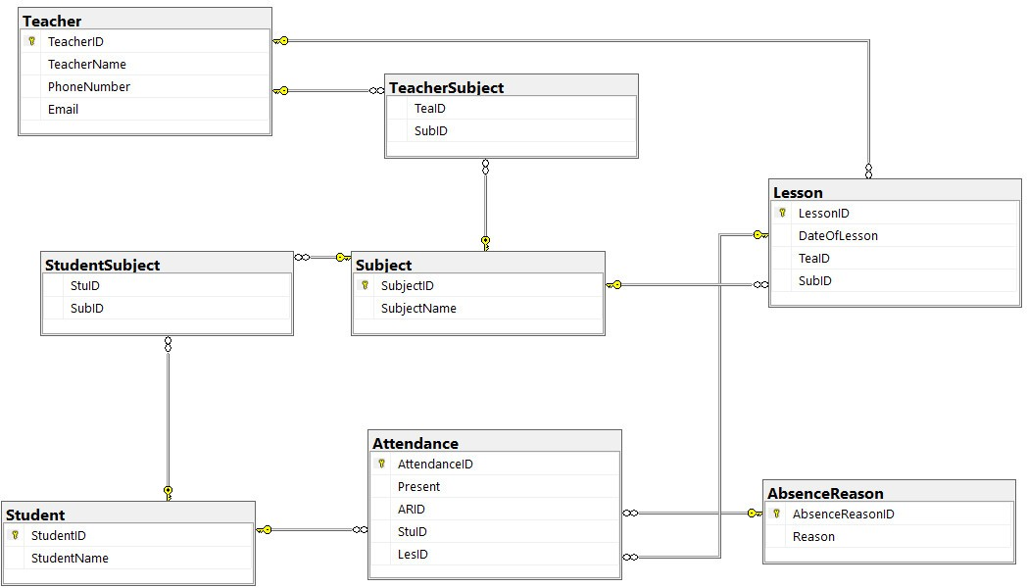

* Retrieve the subject names taught by a specific teacher with the ID 3.
* Retrieve students' attendance status (present or absent) for a specific lesson with ID 2.
* Retrieve the total number of students enrolled in each subject.
* Retrieve the average length of lessons (in days) for each teacher.
* Retrieve the total number of lessons conducted for each subject.
* Retrieve the maximum and minimum number of students in a lesson across all subjects.
* Retrieve the average number of students absent for each subject across all lessons.

USE PDM_Lab5

GO

DROP TABLE IF EXISTS STUDENT

CREATE TABLE STUDENT

(

StudentID NVARCHAR(30) PRIMARY KEY,

StudentName VARCHAR(50) NOT NULL,

)

DROP TABLE IF EXISTS ABSENCEREASON

CREATE TABLE ABSENCEREASON

(

AbsenceReasonID NVARCHAR(30) PRIMARY KEY,

Reason VARCHAR(300),

)

DROP TABLE IF EXISTS SUBJECT

CREATE TABLE SUBJECT

(

SubjectID NVARCHAR(30) PRIMARY KEY,

SubjectName VARCHAR(50),

)

DROP TABLE IF EXISTS TEACHER

CREATE TABLE TEACHER

(

TeacherID NVARCHAR(30) PRIMARY KEY,

TeacherName VARCHAR(50),

PhoneNumber VARCHAR(50),

Email VARCHAR(30),

)

DROP TABLE IF EXISTS LESSON

CREATE TABLE LESSON

(

LessonID NVARCHAR(30) PRIMARY KEY,

DateOfLesson DATE ,

TeaID NVARCHAR(30) FOREIGN KEY REFERENCES TEACHER(TeacherID),

SubID NVARCHAR(30) FOREIGN KEY REFERENCES SUBJECT(SubjectID),

)

DROP TABLE IF EXISTS ATTENDANCE

CREATE TABLE ATTENDANCE

(

AttendanceID NVARCHAR(30) PRIMARY KEY,

Present BIT NOT NULL,

ARID NVARCHAR(30) FOREIGN KEY REFERENCES ABSENCEREASON(AbsenceReasonID),

StuID NVARCHAR(30) FOREIGN KEY REFERENCES STUDENT(StudentID),

LesID NVARCHAR(30) FOREIGN KEY REFERENCES LESSON(LessonID),

)

DROP TABLE IF EXISTS STUDENTSUBJECT

CREATE TABLE STUDENTSUBJECT

(

StuID NVARCHAR(30) FOREIGN KEY REFERENCES STUDENT(StudentID),

SubID NVARCHAR(30) FOREIGN KEY REFERENCES SUBJECT(SubjectID),

)

DROP TABLE IF EXISTS TEACHERSUBJECT

CREATE TABLE TEACHERSUBJECT

(

TeaID NVARCHAR(30) FOREIGN KEY REFERENCES TEACHER(TeacherID),

SubID NVARCHAR(30) FOREIGN KEY REFERENCES SUBJECT(SubjectID),

)

-- Populate data for STUDENT table

INSERT INTO STUDENT (StudentID, StudentName) VALUES

('S001', 'John Doe'),

('S002', 'Jane Smith'),

('S003', 'Michael Johnson');

-- Populate data for ABSENCEREASON table

INSERT INTO ABSENCEREASON (AbsenceReasonID, Reason) VALUES

('AR001', 'Sickness'),

('AR002', 'Family emergency'),

('AR003', 'Personal reasons');

-- Populate data for SUBJECT table

INSERT INTO SUBJECT (SubjectID, SubjectName) VALUES

('SUB001', 'Mathematics'),

('SUB002', 'Science'),

('SUB003', 'History');

-- Populate data for TEACHER table

INSERT INTO TEACHER (TeacherID, TeacherName, PhoneNumber, Email) VALUES

('T001', 'Mr. Smith', '123-456-7890', 'smith@example.com'),

('T002', 'Ms. Johnson', '987-654-3210', 'johnson@example.com');

-- Populate data for LESSON table

INSERT INTO LESSON (LessonID, DateOfLesson, TeaID, SubID) VALUES

('L001', '2024-05-15', 'T001', 'SUB001'),

('L002', '2024-05-16', 'T002', 'SUB002'),

('L003', '2024-05-17', 'T001', 'SUB003');

-- Populate data for ATTENDANCE table

INSERT INTO ATTENDANCE (AttendanceID, Present, ARID, StuID, LesID) VALUES

('A001', 1, NULL, 'S001', 'L001'),

('A002', 0, 'AR001', 'S002', 'L001'),

('A003', 1, NULL, 'S001', 'L002'),

('A004', 1, NULL, 'S002', 'L002'),

('A005', 0, 'AR002', 'S003', 'L002');

-- Populate data for STUDENTSUBJECT table

INSERT INTO STUDENTSUBJECT (StuID, SubID) VALUES

('S001', 'SUB001'),

('S001', 'SUB002'),

('S002', 'SUB002'),

('S003', 'SUB003');

-- Populate data for TEACHERSUBJECT table

INSERT INTO TEACHERSUBJECT (TeaID, SubID) VALUES

('T001', 'SUB001'),

('T002', 'SUB002'),

('T001', 'SUB003');