Exercise 2:

Exercise 3:

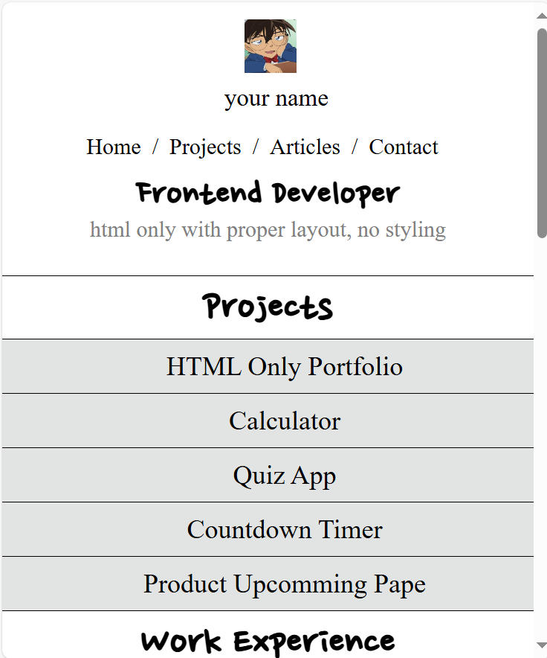

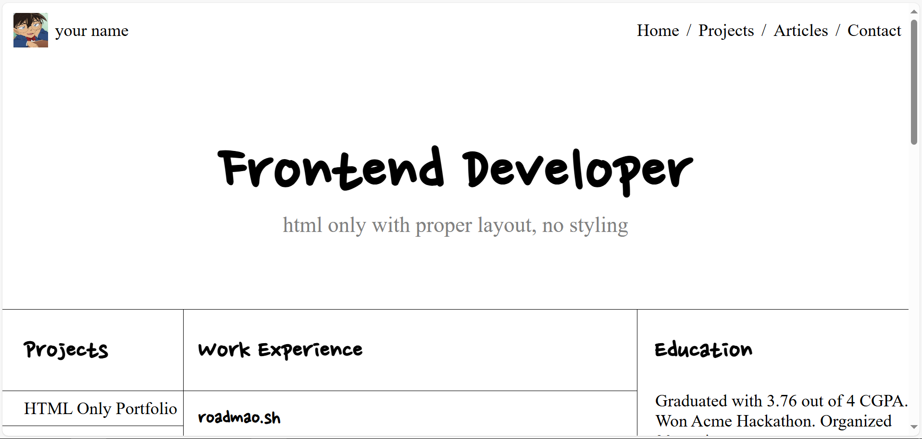

Exercise 4:

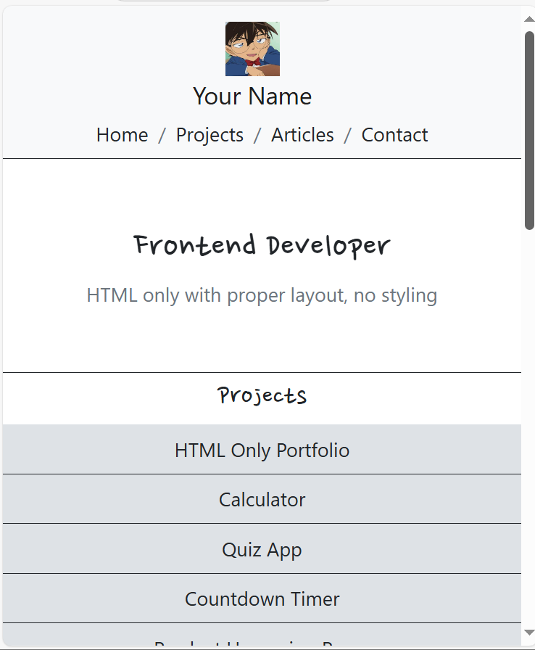

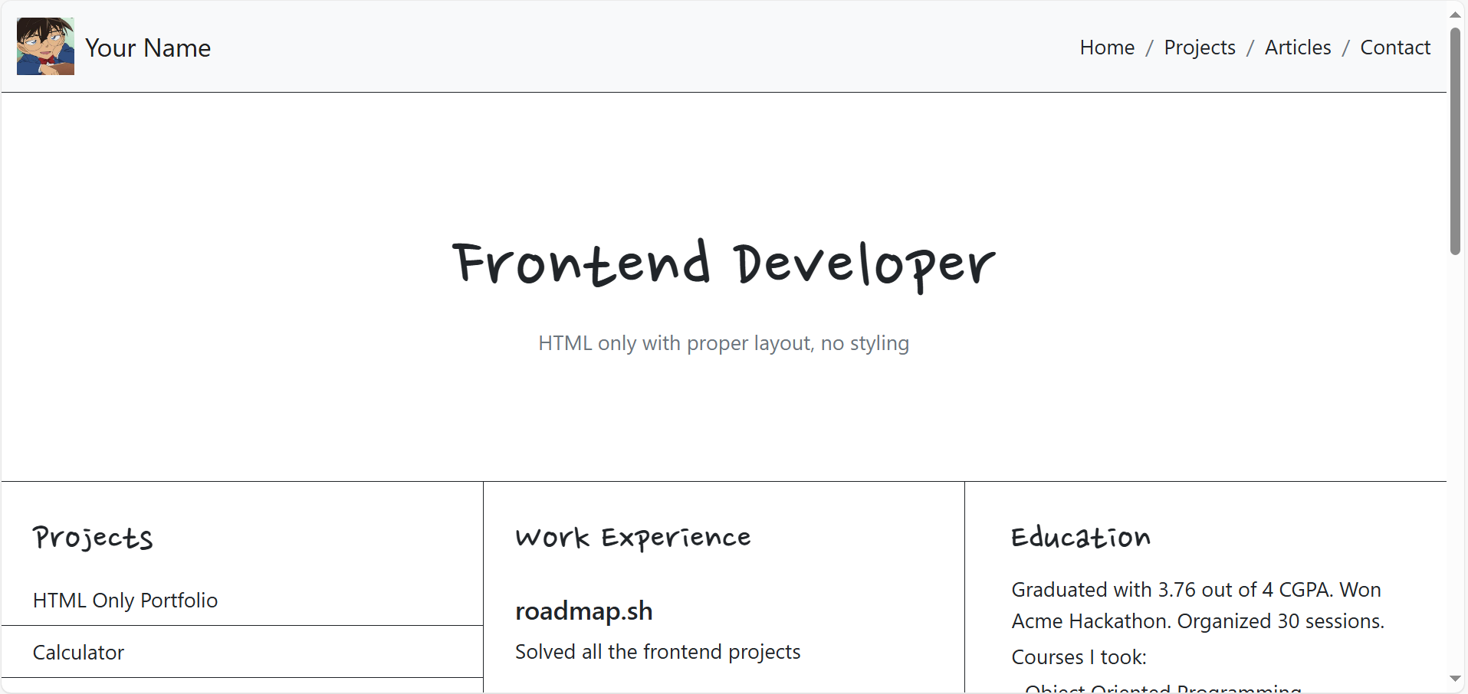

[Document (tttduong.github.io)](https://tttduong.github.io/TaThiThuyDuong.github.io/): https://tttduong.github.io/TaThiThuyDuong.github.io/