1

Lab

**BÁO CÁO BÀI THỰC HÀNH SỐ 1**

**Classical Cryptography**

**Môn học: Thuật toán và tiến trình trong an toàn máy tính**

**Lớp: CS4243.P11.CTTT**

|  |  |
| --- | --- |
| **Giảng viên hướng dẫn** | Nguyễn Xuân Hà |
| **Sinh viên thực hiện** | Lê Nguyễn Gia Hưng (21520890) |
| Nguyễn Thanh Quỳnh Tiên (21521531) |
| Nguyễn Thiện Bảo Châu (21521886) |
| **Mức độ hoàn thành** | Hoàn thành |
| **Thời gian thực hiện** | 20/09/2024 – 27/09/2024 |
| **Tự chấm điểm** | 10/10 |

1. **Kick off: Crack the code**
2. The answer is 182

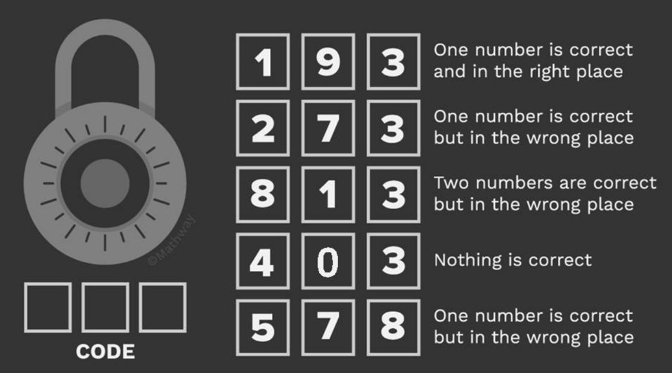

***Explanation:***

* Firstly, we look at all 5 hints and notice that the 4th hints ***403 Nothing is correct***. We directly discard all three numbers in that hints.
* In the 1st hint, we can conclude that 1 or 9 is the correct number.
* Now we look for the number 1 or 9 in all 5 hints and realize that in the 3rd hint, we can conclude **8 and 1 is the right number** which are **both in the wrong position**. Combining with the 1st hint, we can state that **the first number is 1**.
* Combining the 3rd hint and the 5th hint, we conclude **8 is right and in the second position**
* We come to the 2nd hint, we can observe that 2 or 7 may be the right number but in the wrong position. However, in the 5th hint, we just knew that number 8 is concluded as the right number so we discard the number 5 and number 7. Therefore, the number 2 is the right number and it is in the last position (due to the fact that 1 is in the first and 8 is in the second position).
* Finally, **the found number is 182.**

1. The answer is

|  |  |  |  |  |
| --- | --- | --- | --- | --- |
|  |  |  |  |  |
|  |  |  |  |  |
|  |  |  |  |  |
|  |  |  |  |  |
|  |  |  |  |  |

1. **Caesar cipher**

The answer is:

* The key: 19.
* The sentence: *The UIT is a leading institution under VNU-HCM, specializing in the field of information technology. Established with a mission to foster innovation and excellence in IT education and research, UIT offers a wide range of undergraduate and postgraduate programs aimed at producing highly skilled professionals. The university is recognized for its cutting-edge research in areas like cybersecurity, artificial intelligence, and software engineering. With state-of-the-art facilities and a strong emphasis on collaboration with industry, UIT equips students with both theoretical knowledge and practical skills to thrive in the rapidly evolving tech industry.*
* The key refers to our school’s age. Happy birthday 19th UIT <3.

***Explanation:*** The Caesar cipher is one of the methods to encrypt and decrypt messages. This technique involves shifting the letters of the alphabet by a fixed number *key* of places. For example, if the shift is 3, then the letter A would be replaced by the letter D, B would become E, C would become F, and so on. The alphabet is wrapped around so that after Z, it starts back at A. We implement the Caesar cipher algorithm in C++. The code is in the attached file.