Threshold：

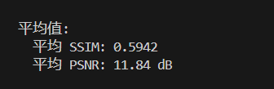  
threshold=0.1

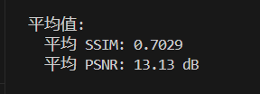

Threshold = 0.2

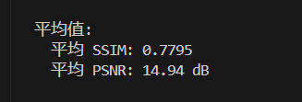

Threshold=0.3

Threshold =0.4

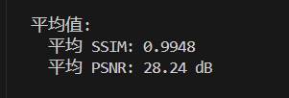  
threshold=0.5

Renderdoc记录  
motionVector: 0.233ms

minmaxMipmap: 7.286 + 2.918 + 0.0348 + 0.0245 + 0.0194 + 0.0174 + 0.0184 + 0.0174 + 0.0174 + 0.0194 = 10.3727ms

backwardSearch: 8.265ms

generateYMaps: 0.189 + 0.047 + 0.024 + 0.039 + 0.030 + 0.027 + 0.025 + 0.026 + 0.035 + 0.046 = 0.488ms

cull: 272.410ms

298.4947

Nsight记录：

GetMotionVector：232.45 us

GenerateMinMaxMipmap：171.01 + 8.19 + 4.10 + 3.07 + 3.07 + 2.05 + 2.05 + 2.05 + 2.05 + 2.05 = 199.69us

BackwardSearch：840.70us

GenerateYMaps：12.29 + 4.10 + 2.05 + 8.19 + 4.10 + 4.10 + 4.10 + 3.07 + 3.07 + 3.07 = 48.14us

Cull：10.70us

All：1331.68us