**Teevision**

1. **Input size and price:**

Goto Admin tool -> edit product.

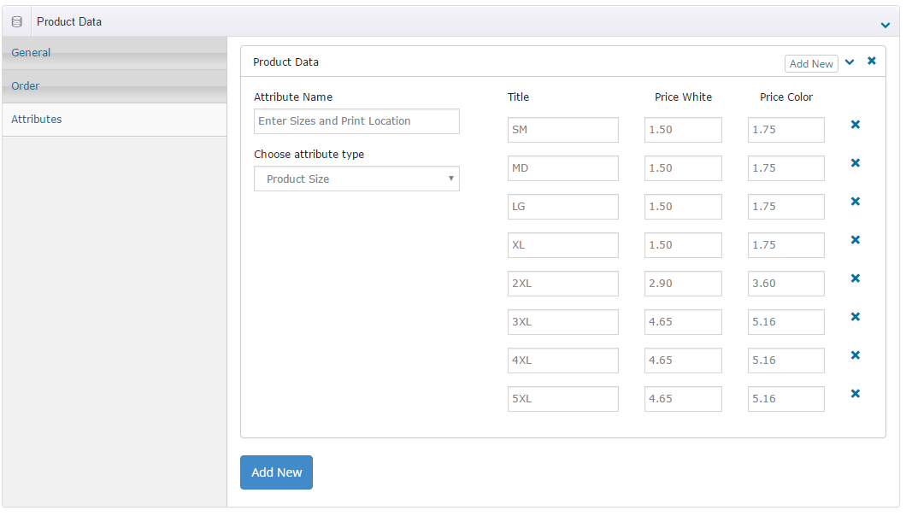

Note:

* Price white: Base price of 1 white shirt
* Price color: Base price of 2 color shirt

1. **Edit Screen printing and Shipping price per box:**

Goto admin tool -> Setting menu -> configuration -> select Your price tab

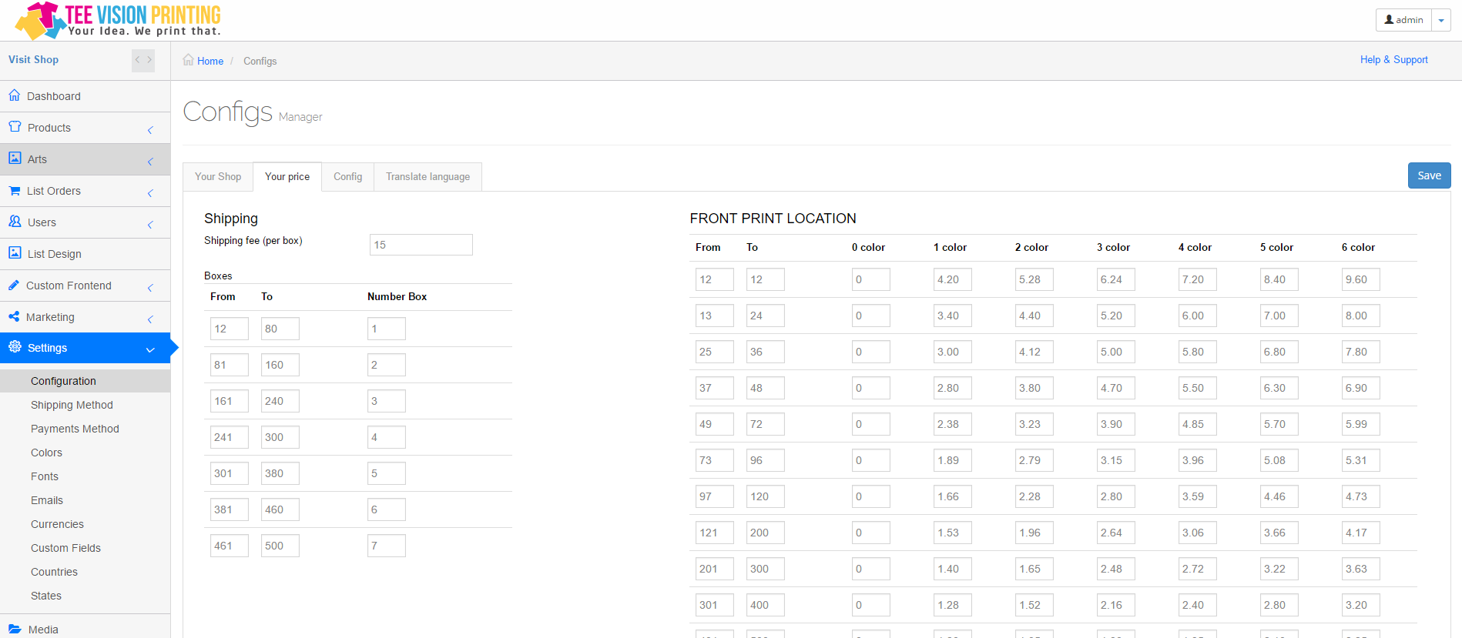

Note:

* Green box:
  + Settup the shipping fee per box
  + Define your number of box
* Red box:
  + Define your print location price table

1. **Price fomular:**

**Shirt price = Base price x Number of Items**

**Print price = Number of Items x ( Front location price + Back location price )**

**Setup Charge = Number of color * $20**

**Tax : 8%**

**Shipping fee**

**Total price = (Shirt price + Print price + Setup Charge ) + 8% + Shipping fee**