BUGS – ROUND 1

UPLOADING

When you upload an image and add a name/number the prices reset and disappear.

Step 1: add front price $116.95

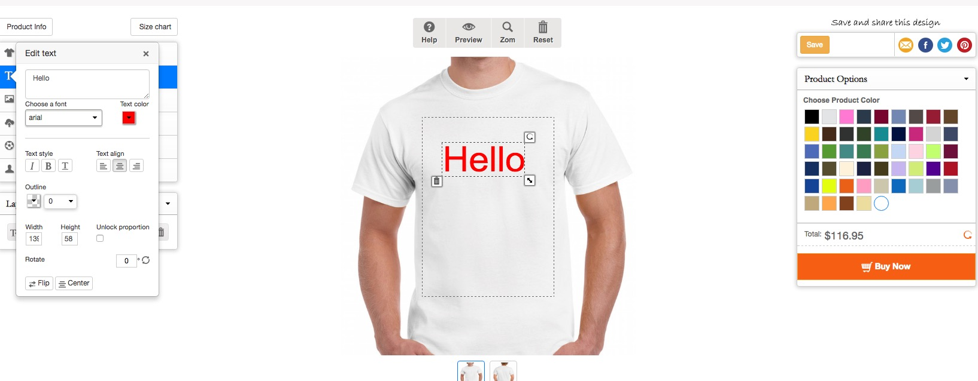

step 2 : add name price $152.55

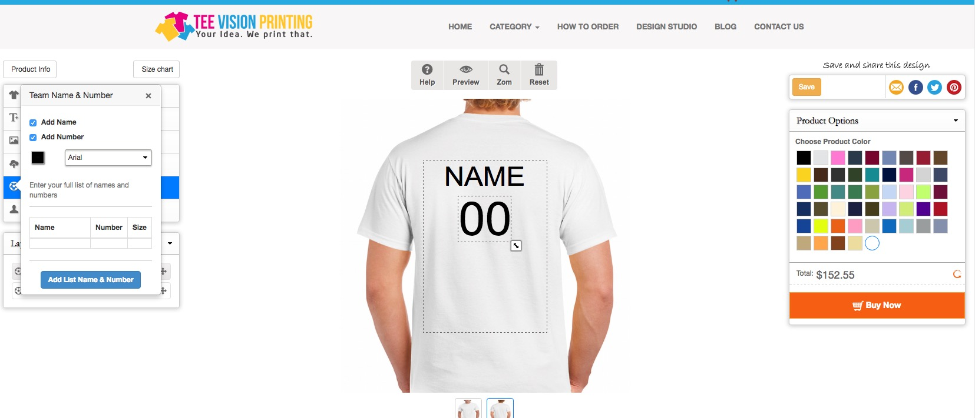

step 3: remove name and number , This is where it resets the prices

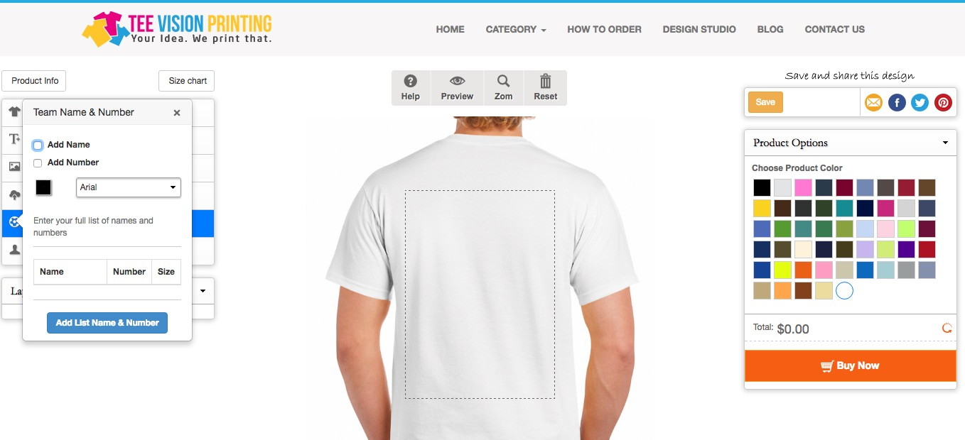

**ADD ON (this is a function we need to add on to the design studio. Please let me know how much it will cost.)**

**---- When only the name is clicked and user clicks add list & number the cell for number comes up. That should be removed. It should be the same with the number.**

**-----We need new prices to be added on. The names are not part of the pricing but are set prices. Name is $5 for name and $4 for number.**

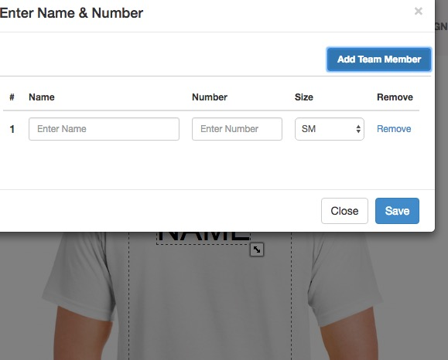

MULTI COLOR

----changing colors issue when the image is uploaded or art is on the shirt. It does not recognize the black outline or black color and it will not change the black color if there is more than 1 color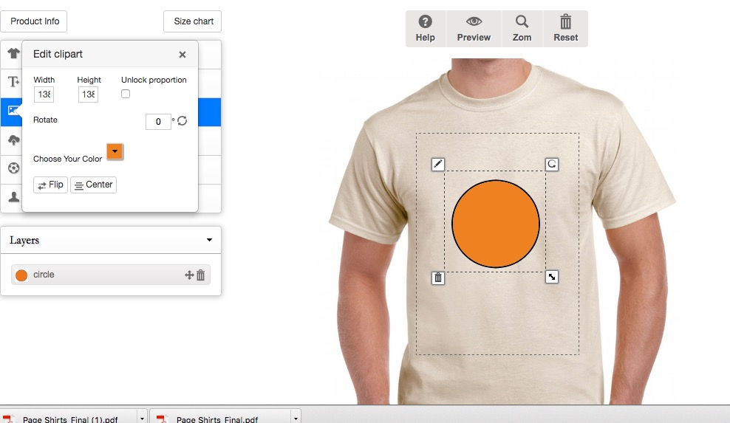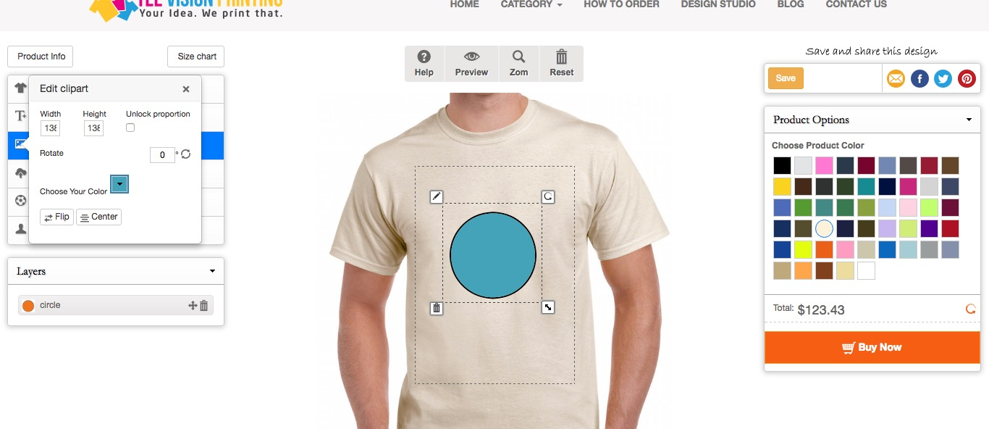

My Design

-----When logging in, after it logs in a new password is required. I do not want user However when you add a new password a 404 Page opens (error)

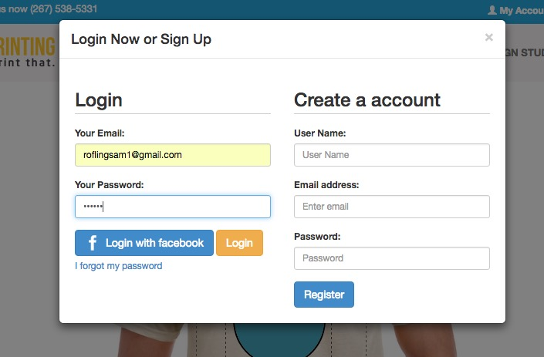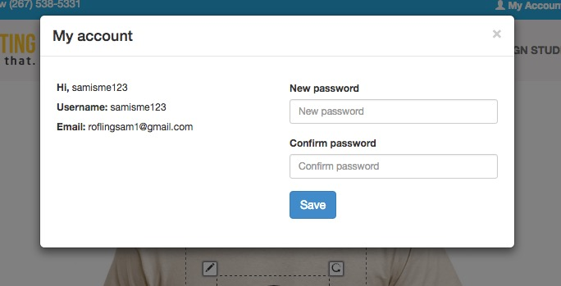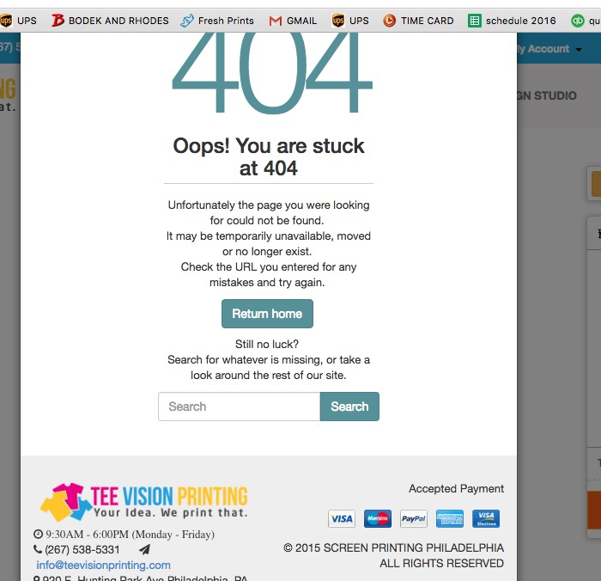

Choose product

----when you click a product on the next screen the change product button is too low and cannot be seen without scrolling down

--Add Design a price needs to be removed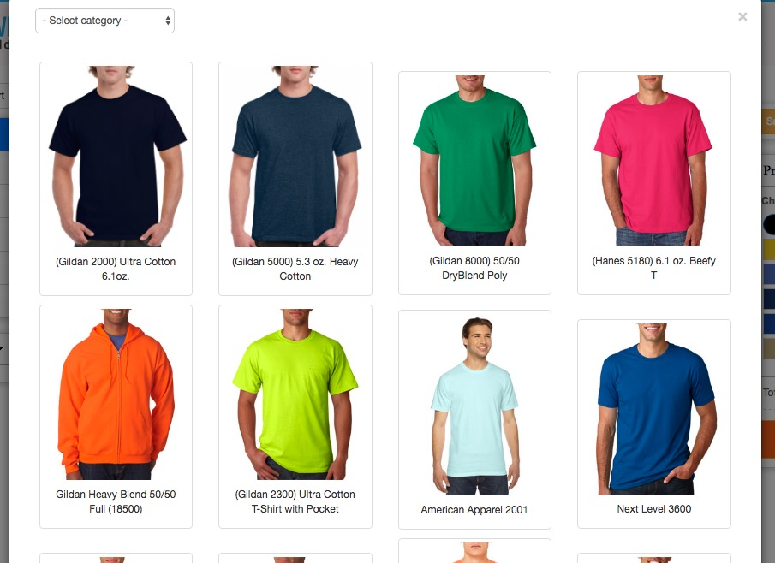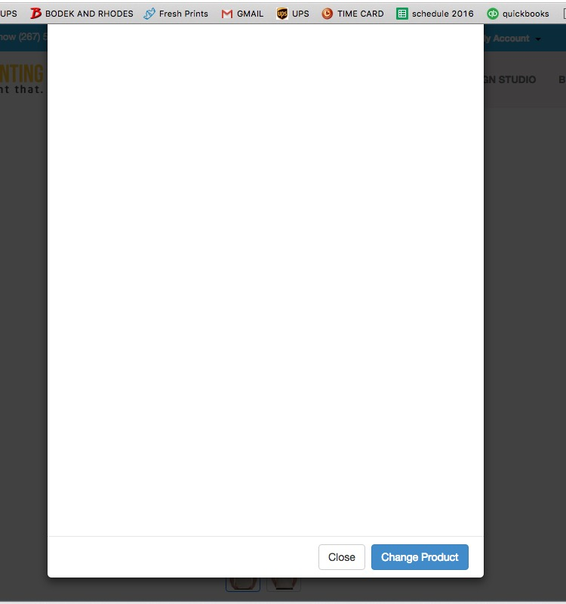

((ADDITIONAL ADD ONS))let me know the price---Please be able to add PSD, PDF, and AI files in the upload images. Also, Please let customer to have option to write a comment