1. In the header, Change category to Products. Change Design Studio to Design Online. Remove Blog.
2. Under the Slider, I wish to have 4 dates.

* Free Shipping 2 weeks (auto dates set to 2 weeks from Todays date) For example: Today is August 15, so It would say Guaranteed by Aug 29 (Thurs)
* Rush Shipping Option 7 Days. Date set to 7 days from current date.
* Super Rush option 3-5 Days
* Save option. “Not in a hurry? Option to save if you don’t require the shirts within 2 weeks. Button that says “learn more”

Something similar to this. 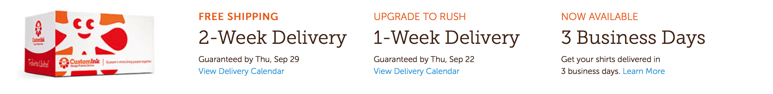

1. Slide screen button to go to Either, design online page
2. Able to add PDF, AI, OR EPS FILES on design studio.
3. Clipart date base… (if not I will try to find a company that has it.
4. Name and number. When customer clicks name or on it automatically puts it on the BACK of the shirt at a certain place. Name Top of the back shirt and number underneath.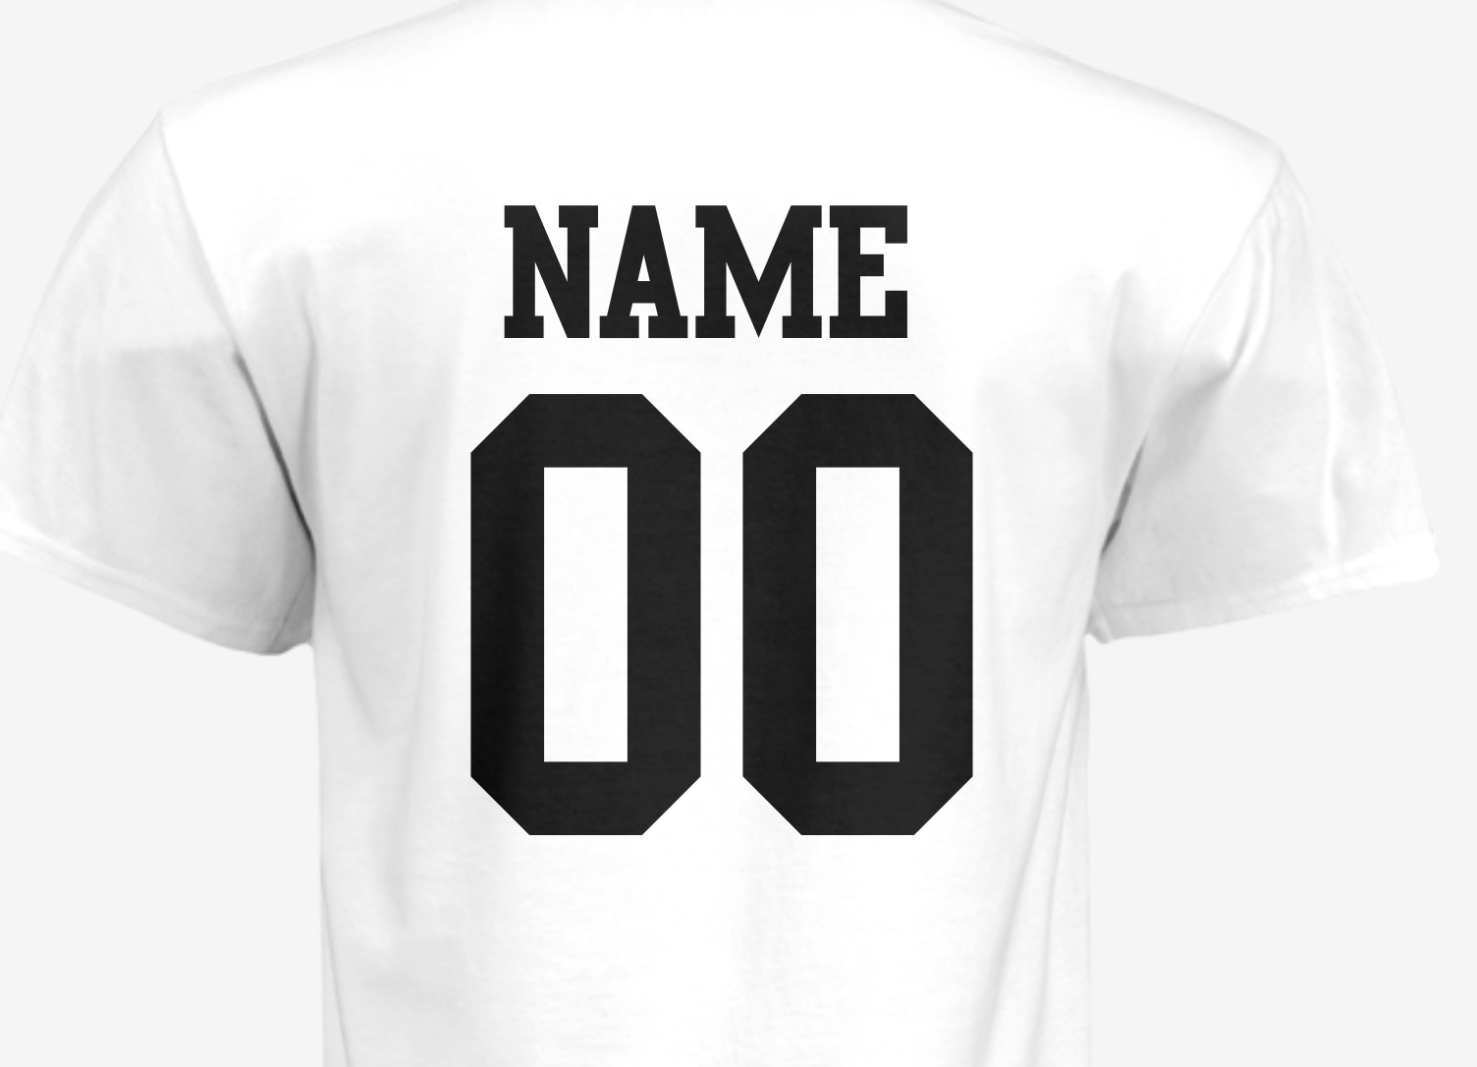
5. Removing white background in upload does not work. If a user adds a image and it has background color. Click that button should remove the background color…
6. Add order description in artwork and proof page (so we know which order we are changing)
7. when buying, have option button for customer to SAVE Or SHARE under BUY NOW. Customer must register to save their logo. An email of their logo with designer key should be emailed to them. Share button (must be registered) and gives option to email other friends the logo (Cannot change design)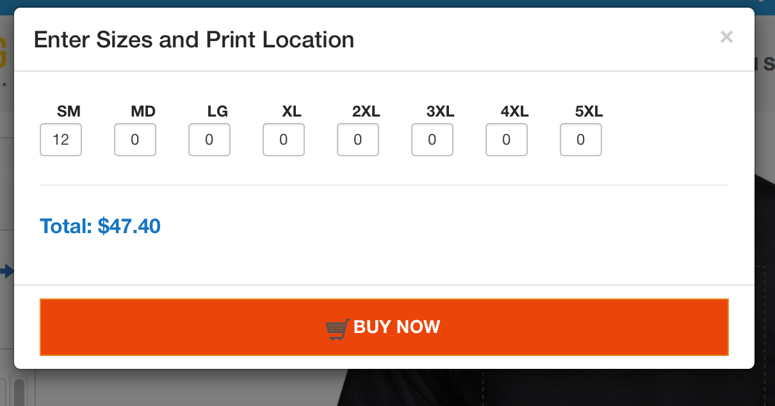
8. when checking out above the total cost, I want it to say the UNIT cost per shirt. Above that I want it to say the TOTAL amount of shirts they are ordering. Also, Standard Shipping Free (2 weeks) with live date, and rush date as well. 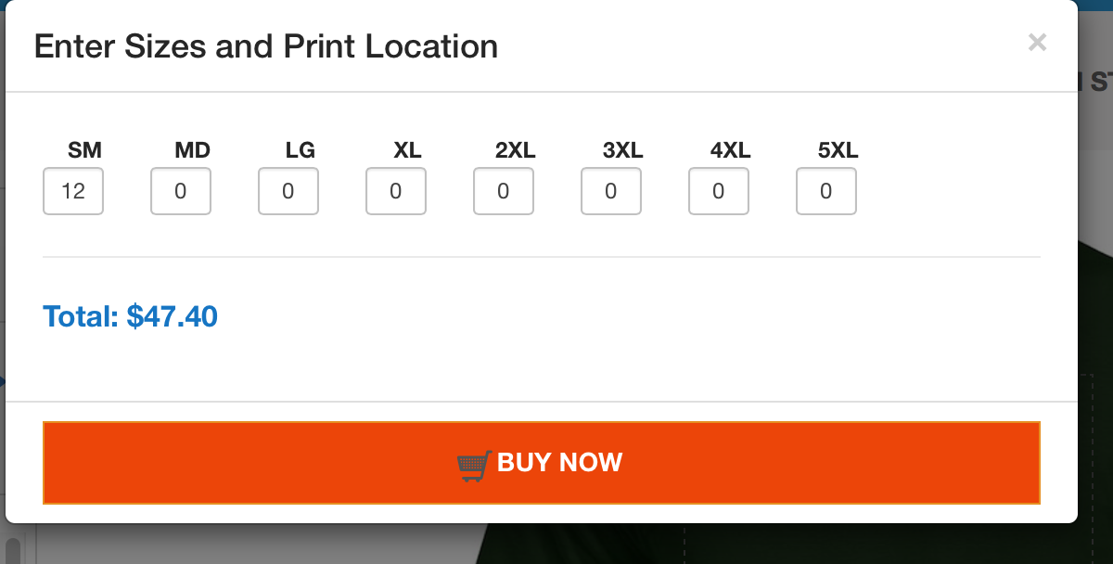

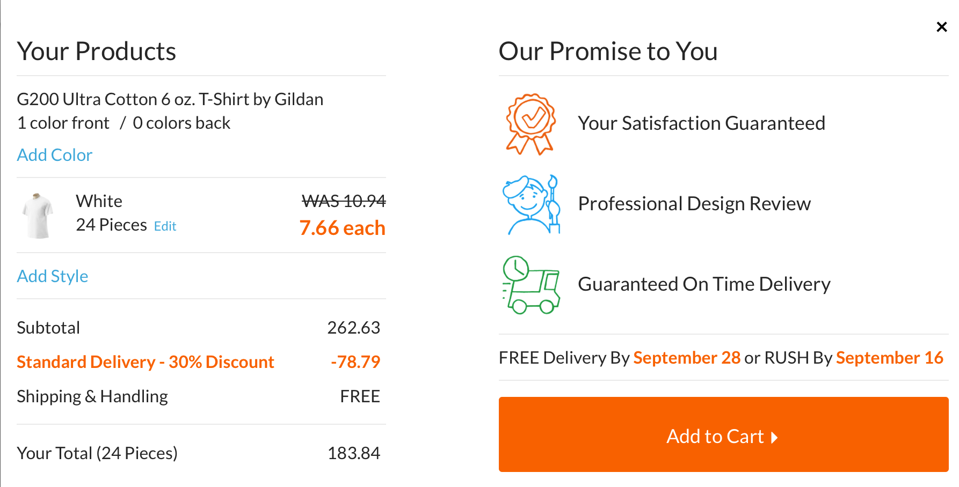

1. Home page footer

* Your Saved Designs ( clicking that will login customers page with saved designs by email)
* Services (which will be the blog)
* Contact us

**Estimate time**

|  |  |  |  |
| --- | --- | --- | --- |
| **NO.** | **Detail** | **Time (h)** | **Note** |
| 1 | - Change category to Products.  - Change Design Studio to Design Online.  - Remove Blog. | 2 |  |
| 2 | - Add 4 bloc shipping date under the Slider | 8 |  |
| 3 | - Edit link in slider | 2 |  |
| 4 | - Able to add PDF, AI, OR EPS FILES on design studio. | 30 | This function need time to research and implement |
| 5 | - Clip art base | 0 |  |
| 6 | - Relocated name and number | 10 |  |
| 7 | - Removing white background in upload | 0 | Design bug |
| 8 | - Add order description in artwork and proof page | 8 |  |
| 9 | - Redisplay SAVE or SHARE under BUY NOW | 0 | Design bug |
| 10 | - UNIT cost per shirt | 1 |  |
|  | - Add Standard Shipping Free (2 weeks) with live date, and rush date. | 4 |  |
| 11 | - Fix bug price when add number and name | 0 | Bug |
| 12 | - Add callback function tracking user paid for order or not. | 15 |  |
| 13 | - Fix search order by orderNo, date… | 0 | Bug |
| 14 | - We did not get issue when register new user and login. Please give us more information or step by step issue occur | 0 | Bug |
| **Total** | | **80** |  |