

SNM / CNF Project Report

Documentation of the Practical Project Conducted as Part of the CNSM Course

Submitted by

First name, last name | First name, last name | First name, last name
gabriel.crisan1601@stud.acs.upb.ro | Email | Email
UNSTPB, Faculty of Automatic Control and Computer Science | UNSTPB, Faculty of Automatic Control and Computer Science | Affiliated University, Department Name
65 | Matriculation Nr. / Student ID | Matriculation Nr. / Student ID
Home Address  (for vhb and DECAMP students) | Home Address  (for vhb and DECAMP students) | Home Address  (for vhb and DECAMP students)

Submitted to

Examiner: | Prof. Dr. Alexandru Soceanu
Advisor: | Maximilian Schmitz
Submission Date: | 18.01.2026

Statutory declaration
I hereby declare that I have composed this project report independently and without using any sources or aids other than those explicitly cited. Sentences or parts of sentences quoted verbatim are marked as such, and all other references to statements and their scope are provided with full details of the respective publications. This report has not been submitted in the same or similar form to any examination body and has not been published. It has not been used, in whole or in part, in any other examination or as coursework.

Additionally, I declare that any use of Artificial Intelligence (AI) in the preparation of this report has been explicitly noted. If AI-based tools or technologies were employed, their use is clearly indicated to avoid any potential issues with plagiarism or AI detection checks.

Place, Date Signature

Place, Date Signature

List of abbreviations
(Should be listed in ascending order in respect to their lexicographical order)
#: | Abbreviation: | Description:
1 | ACL | Access Control List
2 | … | …
Table 1 List of abbreviations

Abstract/Summary
The final project of the Secure Network Management course consists of designing and simulating a secure virtual infrastructure, where we will conduct a set of controlled cyber-attacks in order to observe and analyse the real-time traffic between components, resulting in valuable information which helps us reinforce protection rules and mitigate potential threats.
To ensure the successful implementation and testing of our network, the following objectives and phases were established:
- Topology sketch and design – defining the network architecture, placement of the pfSense firewall, hosts and other components

- Attacks planning – brainstorming the flow of each attack and how it should be performed within our topology

- Component configuration – from connectivity testing to firewall rules, we checked and configured each section of our virtual network

- Attacks implementation – creating custom Python scripts for each attack

- Putting everything together – assembling the whole environment and making sure that Snort and Wireshark are able to capture traffic between components

- Testing and results – launching each attack and monitoring the outcomes to see if they all are as expected
Regarding the project’s constraints and technical boundaries, we had to work within the 192.168.40.0 – 255 pool range, which we subnetted to organize our virtual environment. The central point of the project is the pfSense firewall (DMZ1) that runs Snort as an IDS/IPS, forwarding all logs to a Splunk SIEM in order to have an organised monitoring. The attacks our team simulated are 2 Reconnaissance Attacks, 2 Denial of Service Attacks and 1 extra RIP Attack.
The main expectation of the project was to prove that our firewall and Snort rules could successfully detect the Scapy attacks. We used Splunk and Wireshark captures to visualise the real-time impact of the attacks on our environment, which ultimately helped us validate that our configuration does indeed mitigate the effects of these threats.
Table of Contents
- Introduction 1
- Analysis/Result Section 2
- Conclusion and Recommendations 3
- Bibliography 4
  - Appendix A 5
    - Python Code Fragments 5
    - Wireshark Excerpts 5
    - Other important Excerpts 5

Introduction
- Topology overview
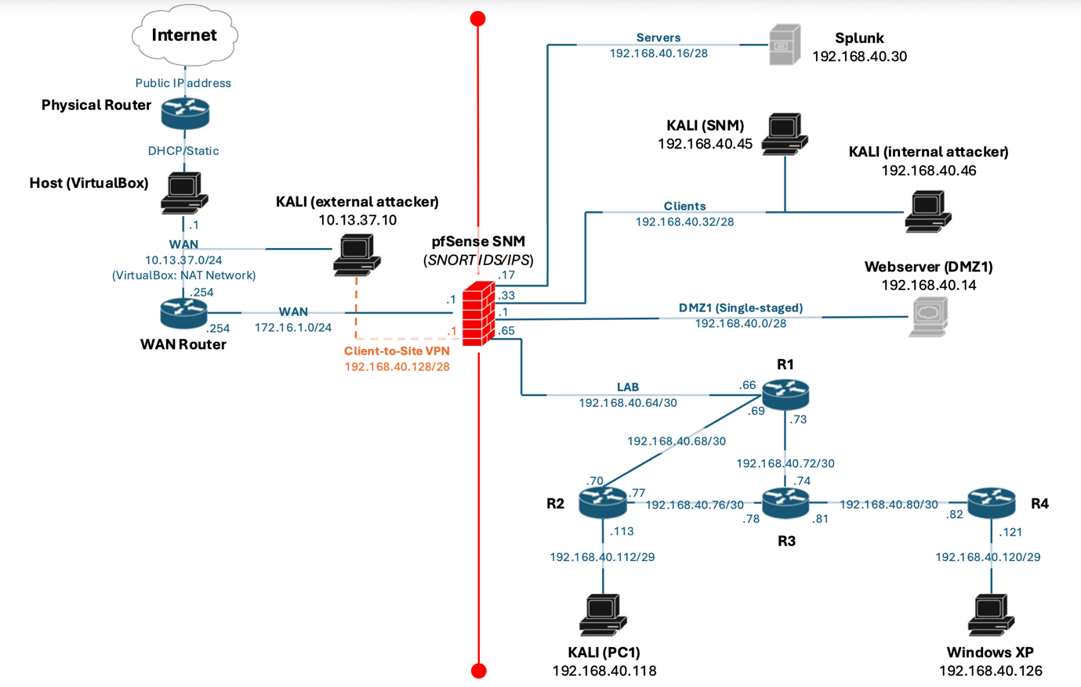

The network is segmented into multiple security zones:
- DMZ (single–stagged) – Webserver
- Servers – SIEM from Splunk
- Clients – Kali (SNM) & Kali (Internal Attacker)
- LAB (routing domain) – R1-R4 & Kali (PC1) & Windows XP

pfSensese acts as the central firewall and routing boundary. The lab zone contains 4 VyOS routers (R1 – R4) interconnected using RIPv2. All internal networks are allocated within the pool range 192.168.40.0 – 255.

- Addressing plan

- Endpoint addressing table

Endpoint name | Role | Interface | IP address | Subnet | Gateway
pfSense | Firewall / Router | DMZ | 192.168.40.1 | 192.168.40.0/28 | -
pfSense | Firewall / Router | Servers | 192.168.40.17 | 192.168.40.0/28 | -
pfSense | Firewall / Router | Clients | 192.168.40.33 | 192.168.40.32/28 | -
pfSense | Firewall / Router | LAB | 192.168.40.65 | 192.168.40.64/30 | -
Webserver | DMZ | Eth0.10  (VLAN 10) | 192.168.40.14 | 192.168.40.0/28 | 192.168.40.1
Splunk | SIEM Server | Eth0 | 192.168.40.30 | 192.168.40.16/28 | 192.168.40.17
Kali SNM | Management / Admin | Eth0 | 192.168.40.45 | 192.168.40.32/28 | 192.168.40.33
Kali Internal Attacker |  | Eth0 | 192.168.40.46 | 192.168.40.32/28 | 192.168.40.33
Kali PC1 | LAB Host | Eth0 | 192.168.40.118 | 192.168.40.112/29 | 192.168.40.113
Windows XP | LAB Host (Victim) | Eth0 | 192.168.40.126 | 192.168.40.120/29 | 192.168.40.121

Note: Due to the limitation of available physical network adapters on the pfSense machine, VLAN tagging is used to multiplex multiple zones over a single physical interface.

- LAB subnet & Router Link table

Subnet | Mask | Link Description | Device A | Device B
192.168.40.64 | /30 | pfSense ↔ R1  (VLAN 20) | 192.168.40.c5  (em3.20) | 1S2.1c8.40.cc  (eth0.20)
192.168.40.68 | /30 | R1 ↔ R2 | 192.168.40.cS | 1S2.1c8.40.70
192.168.40.72 | /30 | R1 ↔ R3 | 192.168.40.73 | 1S2.1c8.40.74
192.168.40.76 | /30 | R2 ↔ R3 | 192.168.40.77 | 1S2.1c8.40.78
192.168.40.80 | /30 | R3 ↔ R4 | 192.168.40.81 | 1S2.1c8.40.82
192.168.40.112 | /29 | R2 ↔ Kali PC1 | 192.168.40.113 | 1S2.1c8.40.118
192.168.40.120 | /29 | R4 ↔ Windows XP | 192.168.40.121 | 1S2.1c8.40.12c

- External network & VPM Allocation

Component | Network | IP (Range) | Note
VirtualBox NAT (WAN) | 10.13.37.0/24 | 10.13.37.1 | Used to simulate Internet
WAN Router | 172.16.1.0/24 | 172.16.1.254 | Upstream gateway for pfSense
pfSense WAN | 172.16.1.0/24 | 172.16.1.1 | Internet-facing interface
Client-to-Site VPN | 192.168.40.128/28 | 192.168.40.129-142 | Pool of IP addresses to assign  to VPN clients
Kali (External Attacker) | 10.13.37.0/24 | 10.13.37.10 | Becomes internal attacker

- Phase 1 – Base addressing & basic connectivity

Objective

The objective of Phase 1 is to configure static IP addressing on all devices and verify basic, local connectivity.

At the end of Phase 1:
- all interfaces have correct IP addresses;
- hosts can reach their default gateway only;
- no dynamic routing is enabled;
- LAB routers do not exchange routes.

- pfSense configuration

Interface and VLAN Setup

Because pfSense has a limited number of physical adapters, we are using VLANs.
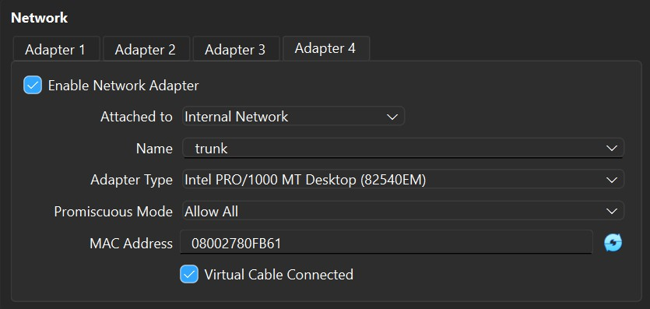

VLAN ID | Zone | pfSense interface
10 | DMZ | Em3.10
20 | LAB | Em3.20

The physical interface em3 acts as an 802.1Ǫ trunk (Promiscuous mode: Allow All; name : trunk).

Interface IP Configuration

To configure interfaces directly using GUI, inside Kali SNM, the pfSense Clients interface, acting as gateway for endpoints inside the Clients subnet, must be configured using pfSense CLI. After being able to successfully ping 192.168.40.33 from Kali SNM, pfSense can be accessed using its GUI. Remaining interfaces can be configured from Interfaces → [Interface Name].
Because of the limited number of adapters, VLANs must be created from Interfaces → Assignments → VLANs → Add. These VLANs interfaces must be assigned to DMZ (em3.10) and LAB (em3.20).

Temporary Firewall Rules

These rules are temporary and are used only to simplify connectivity testing. They will be replaced in later phases.
On each interface (DMZ, Servers, Clients, LAB):
- Action: PASS
- Protocol: IPv4 Any
- Source: Interface net
- Destination: Any

- Endpoint configuration

View Appendix A.1. Phase 1 – Endpoint configuration

- VyOS Routers (no RIP)

View Appendix A.2. Phase 1 – VyOS Routers

- Expected results
By the end of the first configuration phase, this is the expected behaviour of the topology:
• hosts can ping their gateway
• hosts can reach other subnets (Clients cannot reach LAB)
• LAB hosts cannot reach Clients

- Phase 2 – Dynamic routing with RIP

- Objective

Phase 2 introduces RIP v2 inside the LAB routing domain and ensures bidirectional connectivity between firewall-managed networks and LAB hosts.

- Enable RIP

View Appendix A.3. Phase 2 – Enable RIP
- Static route injection
pfSense does not run RIP, so R1 must inject firewall-side networks. Configurations that will be shown in this section are specifically for R1, which means that the remanining routers will maintain current configuration and no other commands will be added.

Static Route on R1:

set protocols static route 192.168.40.32/28 next-hop 192.168.40.65

Redistribute Static Routes into RIP:

set protocols rip redistribute static

- pfSense: Static route addition

Create gateway

System → Routing → Gateways → Add

- Interface: LAB
- Gateway IP: 192.168.40.66
- Name: GW_LAB_R1
- disable monitoring (Important!)

Add static route

System → Routing → Static Routes → Add

- Destination: 192.168.40.0/24
- Gateway: GW_LAB_R1

- Expected Results

By the end of the second configuration phase, this is the expected behavior of the topology:

- Fully routed (RIP Routes should appear marked with R; static route with S)
- Intentionally insecure (all communication between subnets is allowed)
- Reproducible

- Phase 3 – Firewall rules & Snort configuration

- pfSense: Alias definitions

Objective: In this step, we created aliases to group network addresses and port numbers in order to make the firewall configuration clearer and easier to manage. By using these aliases, the rules become more readable and better organized, which helped us with understanding their purpose.

IP Address & Network Aliases were created for the main segments of the topology and specific hosts:
CLIENTS_Network
- Type: Network
- Value: 192.168.40.32/28
- Description: Represents the client zone (users + internal attacker)
DMZ_Network
- Type: Network
- Value: 192.168.40.0/28
- Description: DMZ zone, containing the Webserver
SERVERS_Network
- Type: Network
- Value: 192.168.40.16/28
- Description: Internal servers zone, containing the Splunk SIEM
LAB_HOSTS_Networks
- Type: Networks
- Values: 192.168.40.112/29 & 192.168.40.120/29
- Description: LAB networks for hosts, containing the Kali (PC1) and Windows XP end devices
Individual Host Aliases:
- HOST_KALI_SNM: 192.168.40.45 (Management workstation in the clients subnet)
- HOST_Splunk: 192.168.40.30 (Splunk SIEM Server for log collection)
- HOST_WEBSERVER_DMZ: 192.168.40.14 (The target web server in DMZ1)
Port Aliases:
- PORT_HTTP_HTTPS: 80, 443 (http/https web services)
- PORT_SPLUNK_INGEST: 9997 (TCP port used by Splunk to send logs)
- PORT_SPLUNK_WEB: 8000 (Port for Splunk Web UI)
- PORT_SSH: 22 (Secure Shell management)
- pfSense: Firewall rules configuration
We implemented the following firewall rules to limit network access to only what is necessary for the system to function correctly. The rules are organized based on interface zones to make the configuration easier to understand and to clearly define what type of traffic is permitted in each zone:

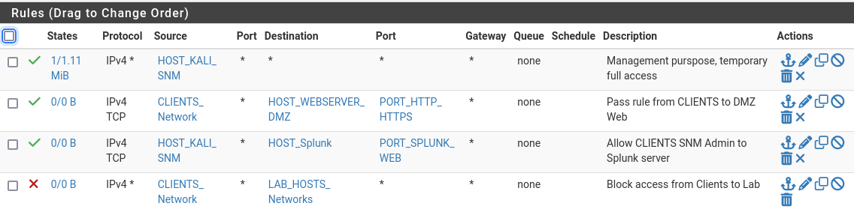
Figure 1: Clients zone firewall rules

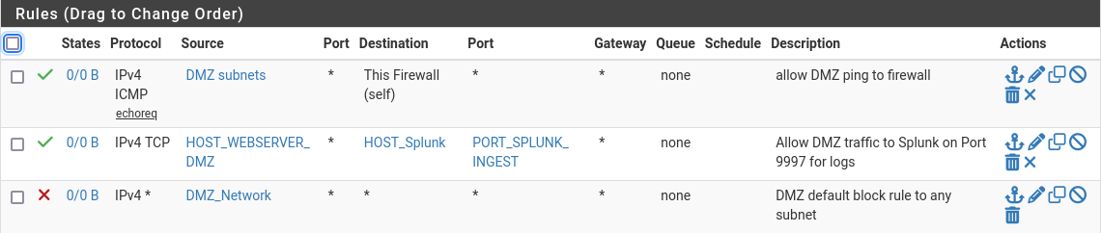
Figure 2: DMZ zone firewall rules

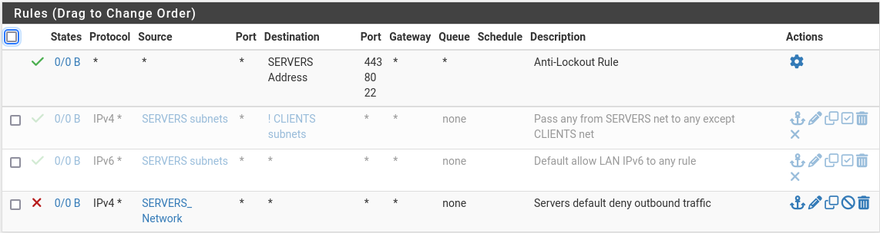

Figure 3: Servers zone firewall rules
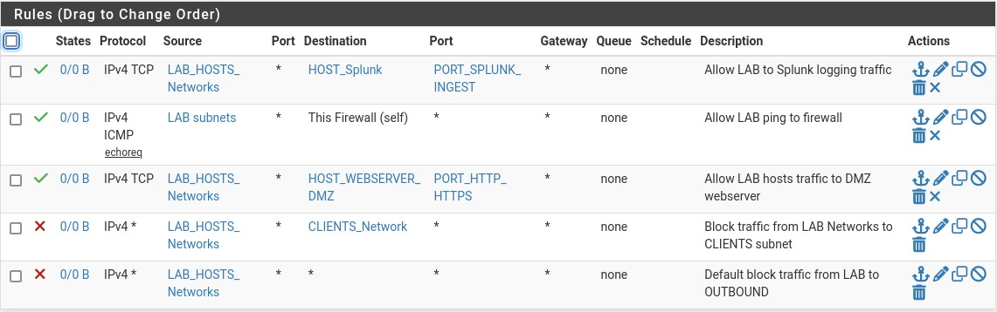
Figure 4: LAB zone firewall rules

- Snort IDS/IPS configuration
While our firewall rules check traffic using IP addresses and ports, we also used Snort to spot malicious activity or scanning attempts that the firewall by itself might miss.
- Rule sets & Interface assignment
To establish a layer of security we downloaded and enabled the GPLv2 Community Rules package. We also configured Snort interfaces to monitor critical network segments:
- WAN (em0): Configured to detect external attacks targeting the infrastructure
- CLIENTS (em2): Configured to detect internal threats or compromised hosts
- Custom rules definitions
We also configured specific custom rules to monitor unusual traffic behaviors such as RIP routing updates, DMZ access and specific scan types:
Rule 1: ICMP Reconnaissance detection
- Purpose: It detects ping sweeps and checks to see which devices on the internal network can be reached
- Syntax: alert icmp any any -> $HOME_NET any (msg:"ICMP Recon Detected"; sid:1000001; rev:1;)
Rule 2: TCP SYN Scan detection
- Purpose: Identifies port scanning attempts used to discover open ports
- Syntax: alert tcp any any -> $HOME_NET any (flags:S; msg:"TCP SYN Scan Detected"; sid:1000002; rev:1;)

Rule 3: Webserver monitoring
- Purpose: Logs specific HTTP traffic directed towards the DMZ Webserver (192.168.40.14) to monitor how frequent it is accessed
- Syntax: alert tcp any any -> 192.168.40.14 80 (msg:"HTTP Access to DMZ Webserver"; sid:1000003; rev:1;)
Rule 4: RIP Protocol monitoring
- Purpose: Detects RIPv2 routing updates
- Syntax: alert udp any any -> any 520 (msg:"RIP Routing Update Detected"; sid:1000004; rev:1;)
Rule 5: DoS protection (SYN Flood)
- Purpose: Detects potential Denial of Service attacks by tracking the rate of SYN packets. It triggers if a source sends more than 20 SYN packets in 10 seconds.
- Syntax: alert tcp any any -> $HOME_NET any (flags:S; threshold:type both, track by_src, count 20, seconds 10; msg:"Potential SYN Flood"; sid:1000005; rev:1;)

- Splunk configuration

Analysis/Result Section

In the Analysis/Results section, you should explain what you did within the virtual environment, including any experiments, programs, tools, and other practical applications you implemented. It may be helpful to include a before- and-after comparison to highlight the effects of your work. However, you must clearly present the outcomes of your actions, whether they involve experiments or other activities [1].
It may also be useful to include network-related diagrams, tables, and summaries, especially when dealing with network packets and needing to explain them. These visual aids can help clarify your findings and provide a clearer understanding of the network's performance and behavior.
If it makes the presentation clearer, feel free to break down this chapter into further sub-sections. This can help in organizing the information logically and making it easier for readers to follow your analysis.

Conclusion and Recommendations
Summarize the important conclusions of the project depending on the context
  - explanation of how your analysis (based on measured traffic) support your conclusions. [1]
  - recommendations for putting your conclusions into practice. [1]
  - suggestions for further investigation of the subject [1]

Bibliography

[1] | Prof. Dr. Alexandru Soceanu, "Project report guideline," [Online].  Available: https://moodle.hm.edu. [Accessed 10 08 2024].

Appendix A

Phase 1 – Endpoint configuration

WEBSERVER (DMZ)
sudo nano /etc/network/interfaces

Edit network configuration:
auto lo
iface lo inet loopback
netmask 255.255.255.240
gateway 192.168.40.1
dns-nameservers 8.8.8.8

Apply:
sudo reboot

Verification:
ping 192.168.40.1

Note: The Webserver adapter must be named exactly as pfSense last adapter was
named (trunk) and Promiscuous mode must be set to Allow all.

SPLUNK SERVER

sudo nano /etc/netplan/00-netcfg.yaml

Edit network configuration:
network:
version: 2
ethernets:
eth0:
addresses:
- 192.168.40.30/28
gateway4: 192.168.40.17
nameservers:
addresses:
- 8.8.8.8

Apply:
sudo netplan apply

Verification:
ping 192.168.40.17
KALI (SNM)

sudo nano /etc/network/interfaces

Edit network configuration:
auto lo
iface lo inet loopback
auto eth0
iface eth0 inet static
address 192.168.40.45
netmask 255.255.255.240
gateway 192.168.40.33
dns-nameservers 8.8.8.8

Apply:
sudo systemctl restart networking

Note: Similar configurations will be assigned to Kali (Internal Attacker), Kali (PC1), Windows XP (modify the ID properly, gateway as well, netmask might change between configurations).

End hosts must not have VLAN subinterfaces!

Phase 1 – VyOS Routers
R1
configure
set interfaces ethernet eth0 vif 20 address 192.168.40.66/30
set interfaces ethernet eth1 address 192.168.40.69/30
set interfaces ethernet eth2 address 192.168.40.73/30
delete interfaces ethernet eth0 address
commit
save
exit

Note: Similar configurations will be assigned to R2, R3, R4. (we need to make sure that every router has as many adapters as interfaces). The only distinction is that R1 must have the adapter responsible for eth0 (Adapter 1) named exactly as pfSense adapter was named (trunk) and Promiscuous mode must be set to Allow all.

Phase 2 – Enable RIP
R1

configure
set protocols rip interface eth0
set protocols rip interface eth1
set protocols rip interface eth2
set protocols rip network 192.168.40.0/24
commit
save
exit

Note: Similar configurations will be assigned to R2, R3, R4.

Python Code Fragments
def say() -> void:
print(“Hello World”)
Table 2 Code fragment for hello world function

Wireshark Excerpts

List of figures
Figure 1 Example for a flow diagram 2

List of tables
Table 1 List of abbreviations II
Table 2 Code fragment for hello world function 5

