**Free Fall Detector Application**

Can detect free fall of the device and send notification. Store all free fall events

And display the free fall events in a list view. It supports two languages **English** and **German**

1. Launch the app.

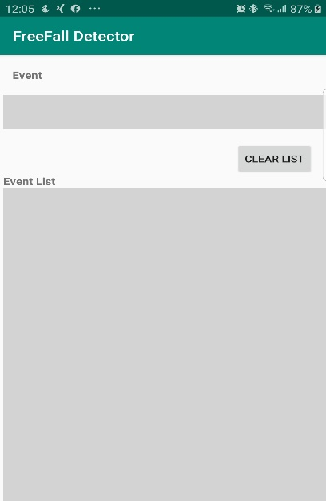

1. If there are past events, that will be displayed in the list view in the bottom of the display

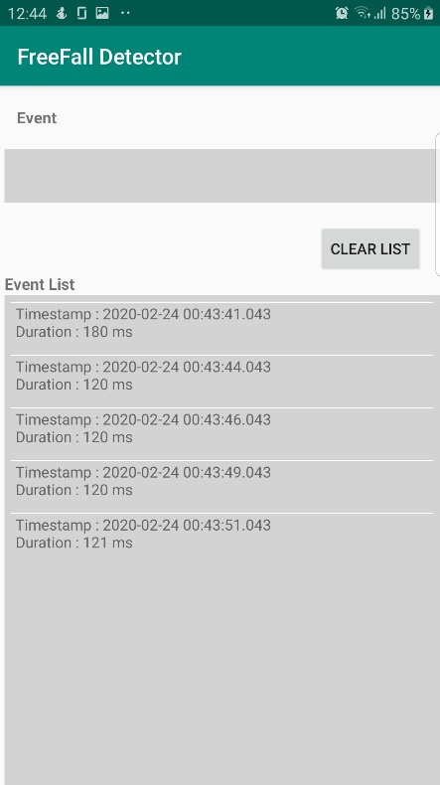

1. Fall your device to the ground from a height

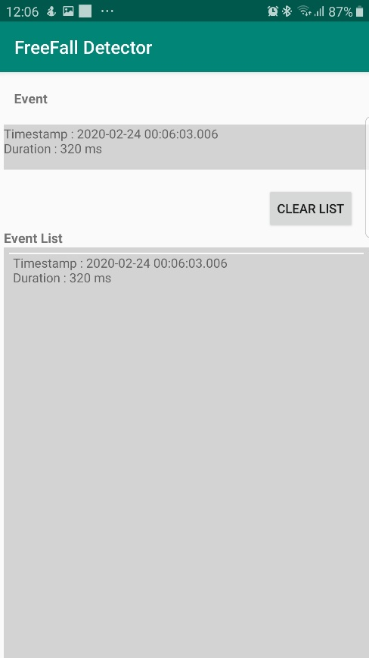

6

5

4

1. Event information will be displayed in the display view
2. Event list will be updated in the bottom of the display.
3. Previous events can be erased by pressing CLEAR LIST button.
4. Notification will be send to notification bar

