Trần Thanh Tùng
demo bài tập:
Trang dashboard
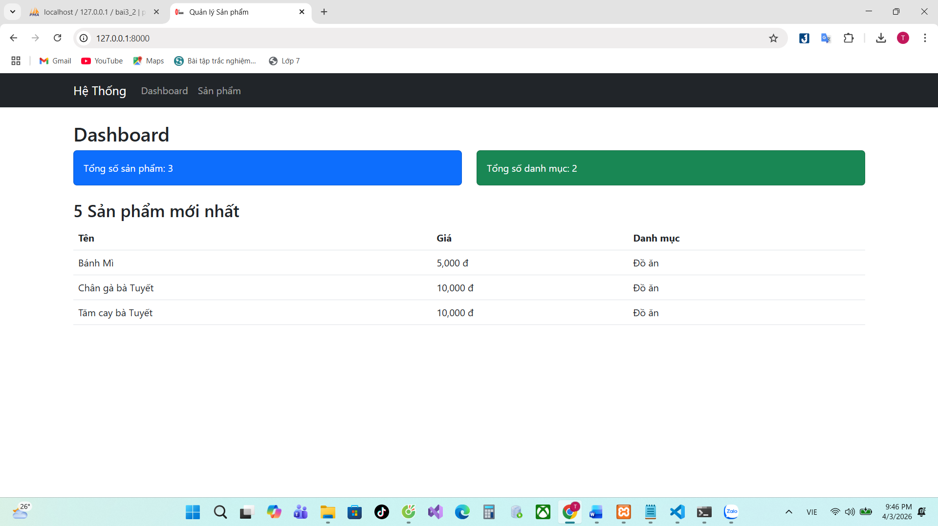
Trang danh sách sản phẩm:
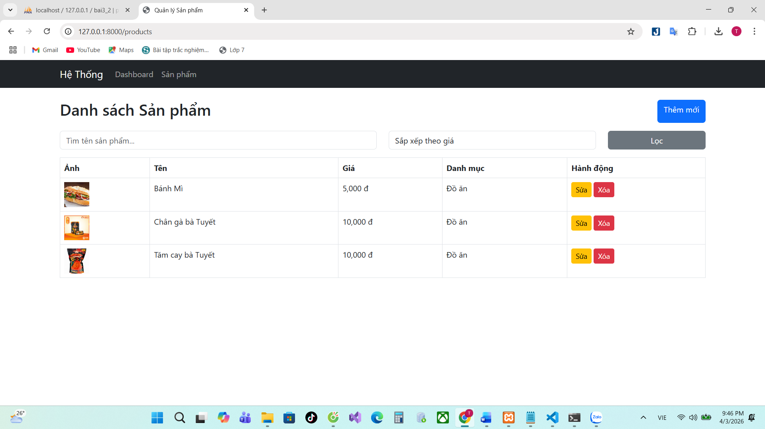

Trang thêm sản phẩm:
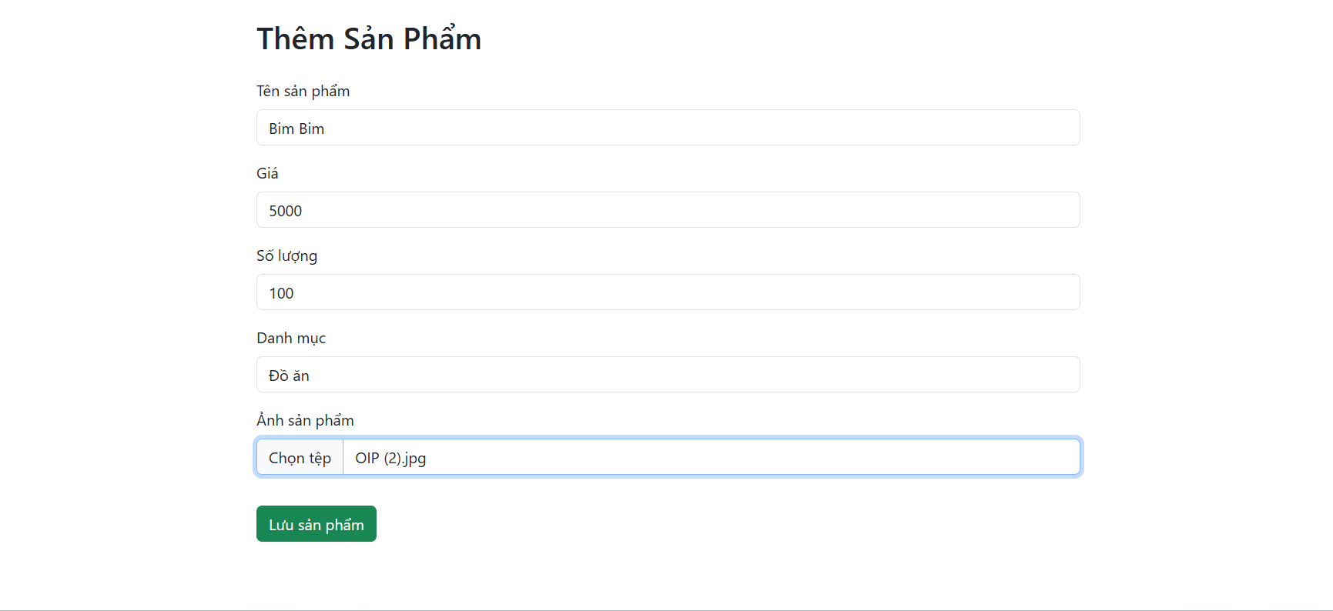
Trang sửa sản phẩm:
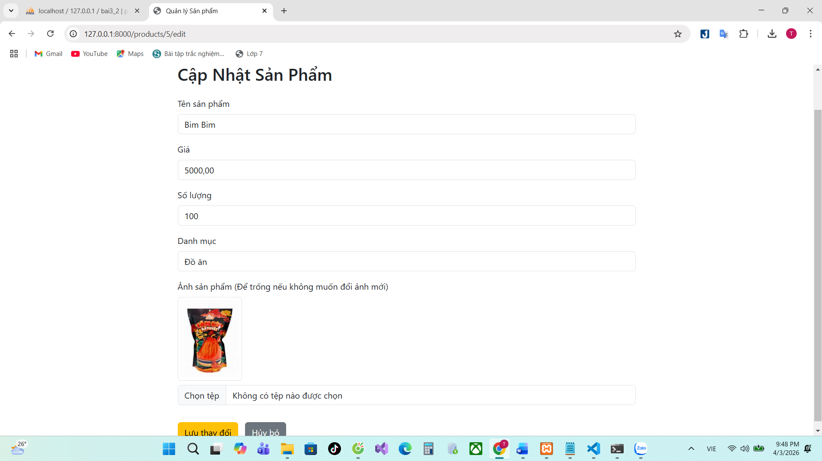
Xóa sản phẩm:
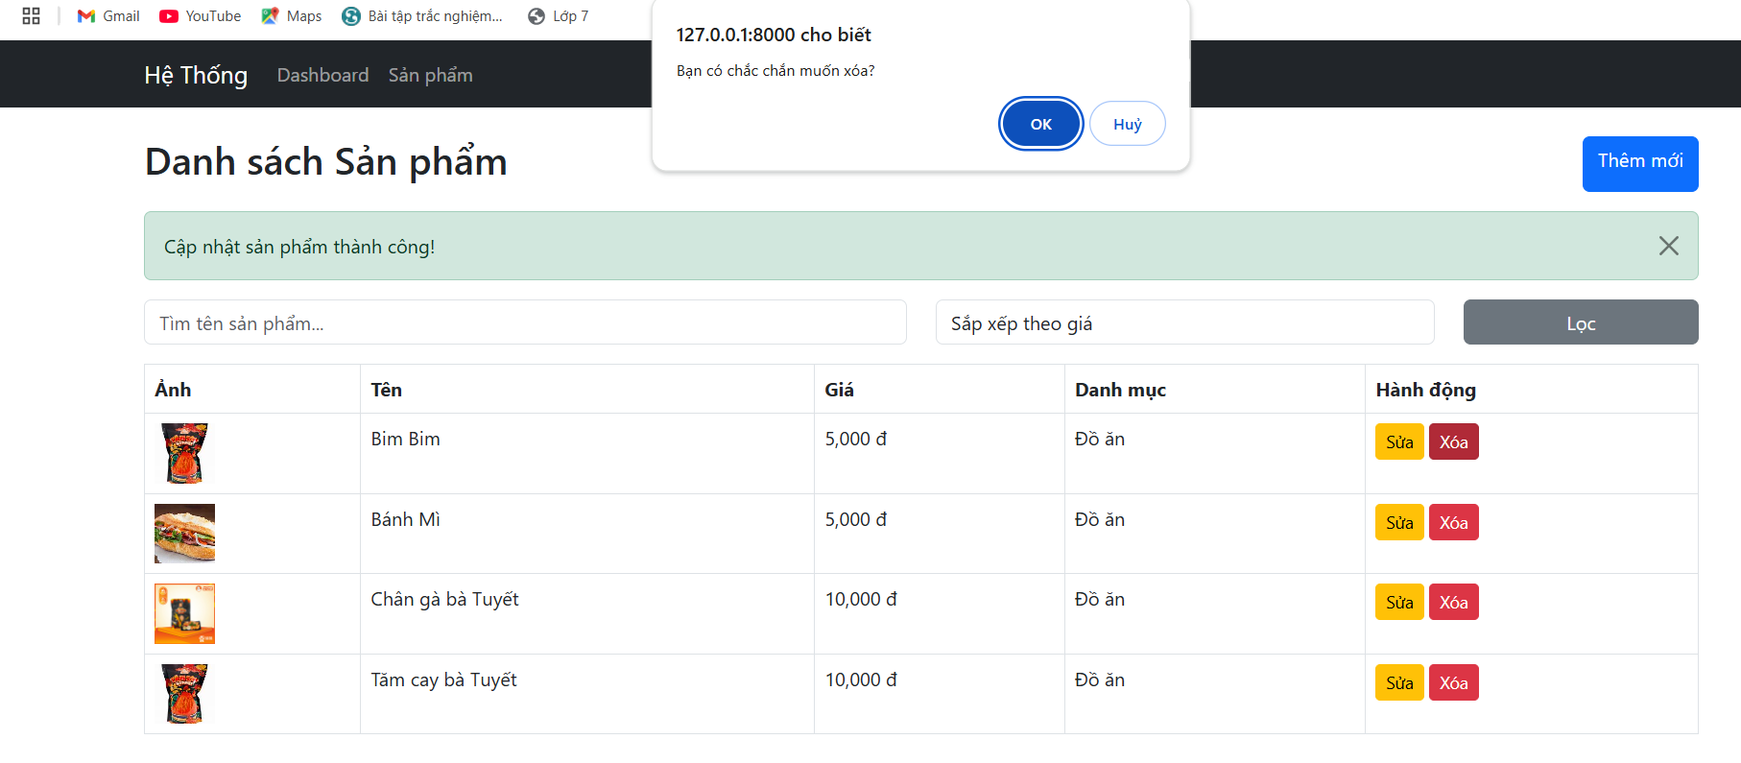
Tìm kiểm sản phẩm:
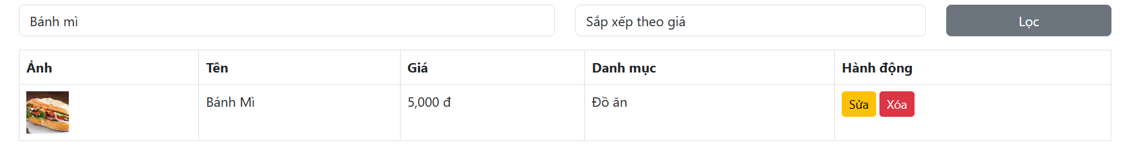
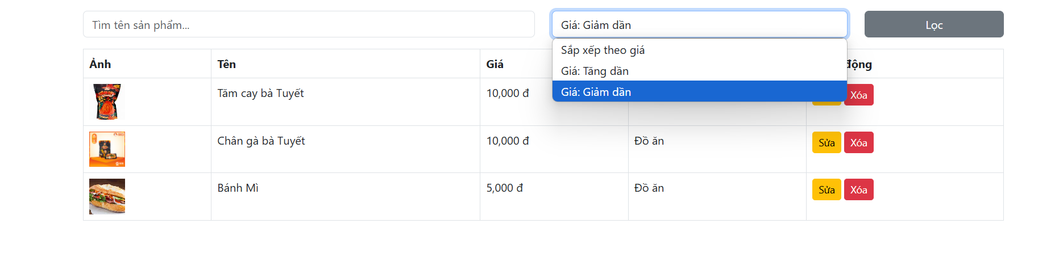
Code web.php:
<?php

use Illuminate\Support\Facades\Route;
use App\Http\Controllers\ProductController;

Route::get('/', [ProductController::class, 'dashboard'])->name('dashboard');
Route::resource('products', ProductController::class);
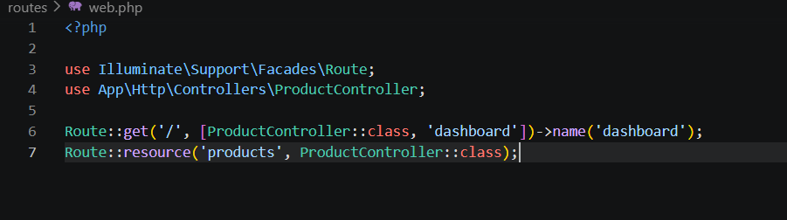
Code:2026_04_03_134736_create_categories_table.php
<?php

use Illuminate\Database\Migrations\Migration;
use Illuminate\Database\Schema\Blueprint;
use Illuminate\Support\Facades\Schema;

return new class extends Migration
{

public function up()
{
Schema::create('categories', function (Blueprint $table) {
$table->id();
$table->string('name');
$table->timestamps();
});
}

public function down(): void
{
Schema::dropIfExists('categories');
}
};

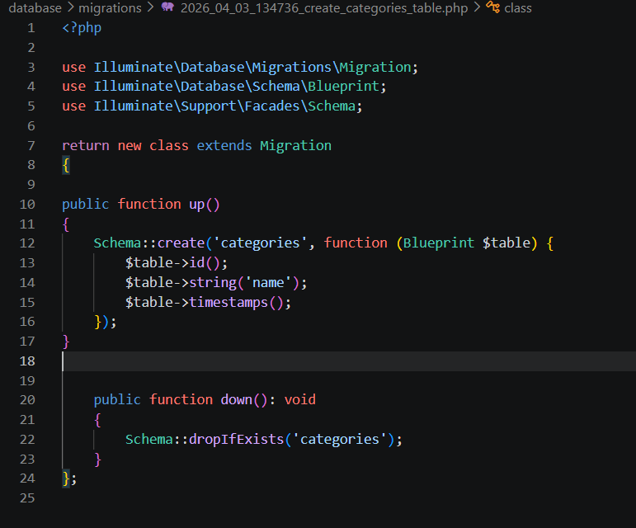
Code Category.php:
<?php
namespace App\Models;

use Illuminate\Database\Eloquent\Factories\HasFactory;
use Illuminate\Database\Eloquent\Model;

class Category extends Model
{
use HasFactory;
protected $fillable = ['name'];

public function products()
{
return $this->hasMany(Product::class);
}
}

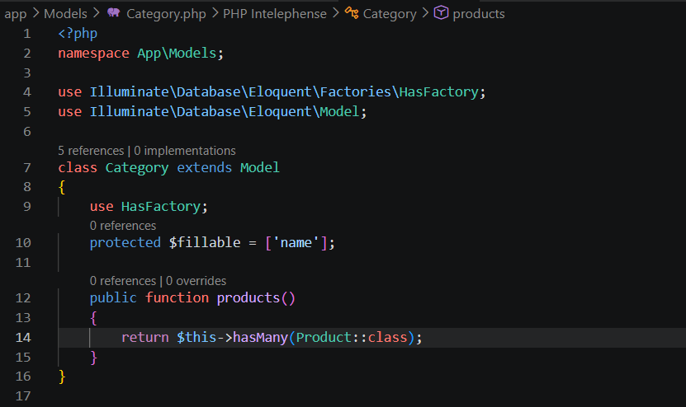
Code Product.php:
<?php
namespace App\Models;

use Illuminate\Database\Eloquent\Factories\HasFactory;
use Illuminate\Database\Eloquent\Model;

class Product extends Model
{
use HasFactory;
protected $fillable = ['name', 'price', 'quantity', 'category_id', 'image'];

public function category()
{
return $this->belongsTo(Category::class);
}
}
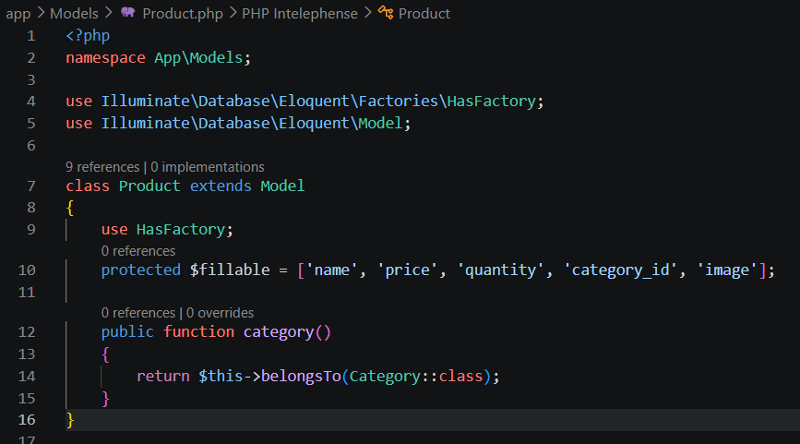
Code ProductController.php:
<?php
namespace App\Http\Controllers;

use App\Models\Product;
use App\Models\Category;
use Illuminate\Http\Request;
use Illuminate\Support\Facades\Storage;

class ProductController extends Controller
{
// Dashboard
public function dashboard()
{
$totalProducts = Product::count(); // Tổng số sản phẩm
$totalCategories = Category::count(); // Tổng số danh mục
$latestProducts = Product::with('category')->latest()->take(5)->get(); // 5 sản phẩm mới nhất

return view('dashboard', compact('totalProducts', 'totalCategories', 'latestProducts'));
}

//Hiển thị danh sách, Search, Sort, Eager Loading
public function index(Request $request)
{
// Sử dụng with() để tránh N+1 query
$query = Product::with('category');

// Tìm kiếm theo tên
if ($request->has('search') && $request->search != '') {
$query->where('name', 'like', '%' . $request->search . '%');
}

// Sắp xếp theo giá
if ($request->has('sort')) {
$direction = $request->sort == 'desc' ? 'desc' : 'asc'; // Giảm dần hoặc Tăng dần
$query->orderBy('price', $direction);
} else {
$query->latest(); // Mặc định hiển thị mới nhất
}

// Phân trang
$products = $query->paginate(10);

return view('products.index', compact('products'));
}

// Thêm sản phẩm
public function create()
{
// Lấy toàn bộ danh mục từ database
$categories = \App\Models\Category::all();

// Truyền biến $categories sang view create
return view('products.create', compact('categories'));
}

public function store(Request $request)
{
$data = $request->validate([
'name' => 'required|string|max:255',
'price' => 'required|numeric',
'quantity' => 'required|integer',
'category_id' => 'required|exists:categories,id',
'image' => 'nullable|image|mimes:jpeg,png,jpg|max:2048',
]);

// Upload ảnh vào storage
if ($request->hasFile('image')) {
$data['image'] = $request->file('image')->store('products', 'public');
}

Product::create($data);

return redirect()->route('products.index')->with('success', 'Thêm sản phẩm thành công!'); // Thông báo
}

//Cập nhật sản phẩm
public function edit(Product $product)
{
$categories = Category::all();
return view('products.edit', compact('product', 'categories'));
}

public function update(Request $request, Product $product)
{
$data = $request->validate([
'name' => 'required|string|max:255',
'price' => 'required|numeric',
'quantity' => 'required|integer',
'category_id' => 'required|exists:categories,id',
'image' => 'nullable|image|mimes:jpeg,png,jpg|max:2048',
]);

if ($request->hasFile('image')) {
// Xóa ảnh cũ nếu có
if ($product->image) {
Storage::disk('public')->delete($product->image);
}
$data['image'] = $request->file('image')->store('products', 'public');
}

$product->update($data);

return redirect()->route('products.index')->with('success', 'Cập nhật sản phẩm thành công!'); //Thông báo
}

//Xóa sản phẩm
public function destroy(Product $product)
{
if ($product->image) {
Storage::disk('public')->delete($product->image);
}
$product->delete();

return redirect()->route('products.index')->with('success', 'Xóa sản phẩm thành công!');
}
}

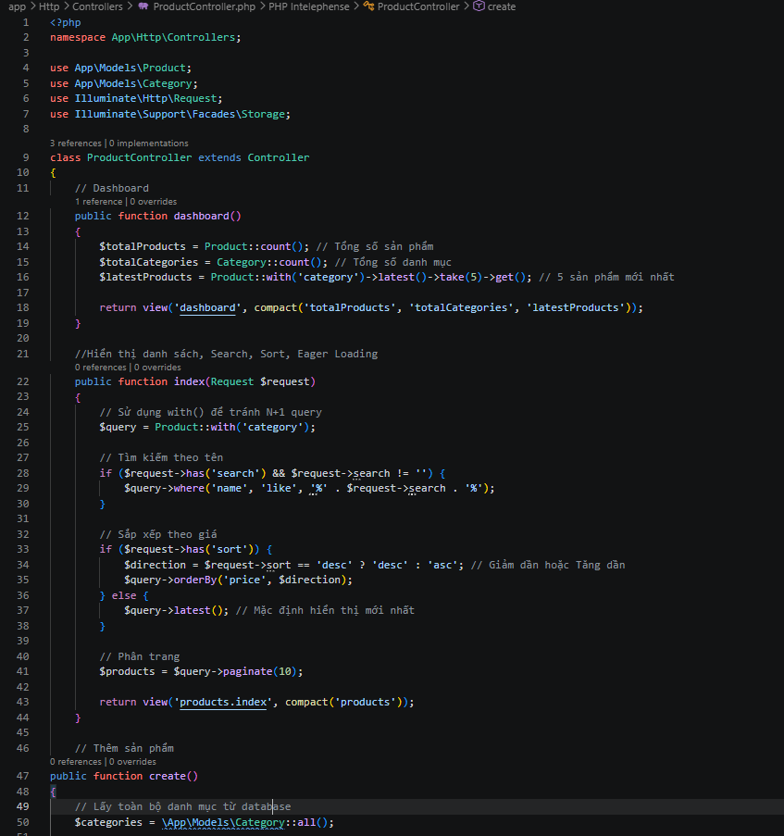
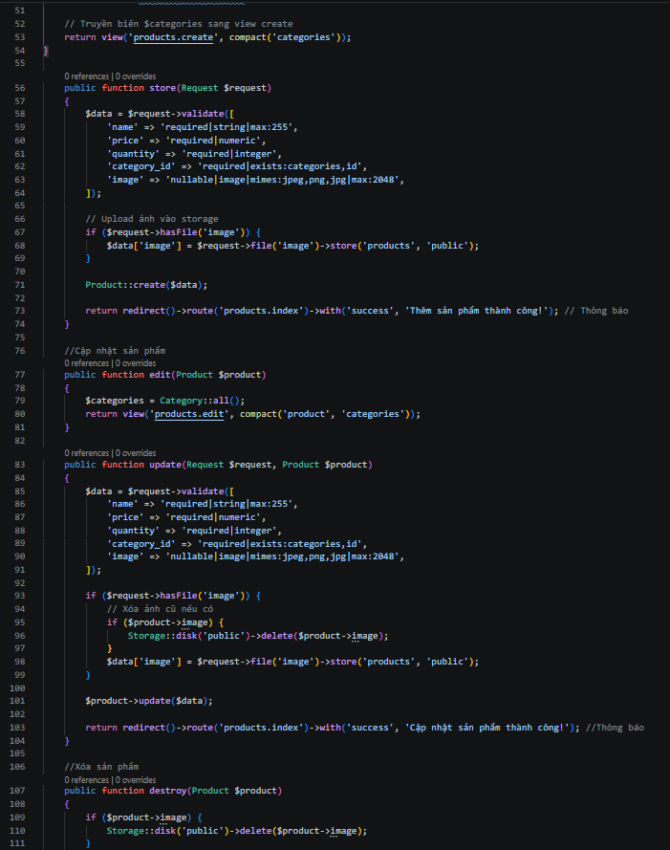
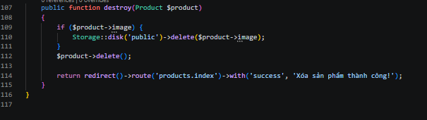
Code file:master.blade.php
<!DOCTYPE html>
<html lang="vi">
<head>
<meta charset="UTF-8">
<meta name="viewport" content="width=device-width, initial-scale=1.0">
<title>Quản lý Sản phẩm</title>
<link href="https://cdn.jsdelivr.net/npm/bootstrap@5.3.0/dist/css/bootstrap.min.css" rel="stylesheet">
</head>
<body>
<nav class="navbar navbar-expand-lg navbar-dark bg-dark mb-4">
<div class="container">
<a class="navbar-brand" href="{{ route('dashboard') }}">Hệ Thống</a>
<div class="collapse navbar-collapse">
<ul class="navbar-nav">
<li class="nav-item"><a class="nav-link" href="{{ route('dashboard') }}">Dashboard</a></li>
<li class="nav-item"><a class="nav-link" href="{{ route('products.index') }}">Sản phẩm</a></li>
</ul>
</div>
</div>
</nav>

<div class="container">
@yield('content')
</div>
</body>
</html>

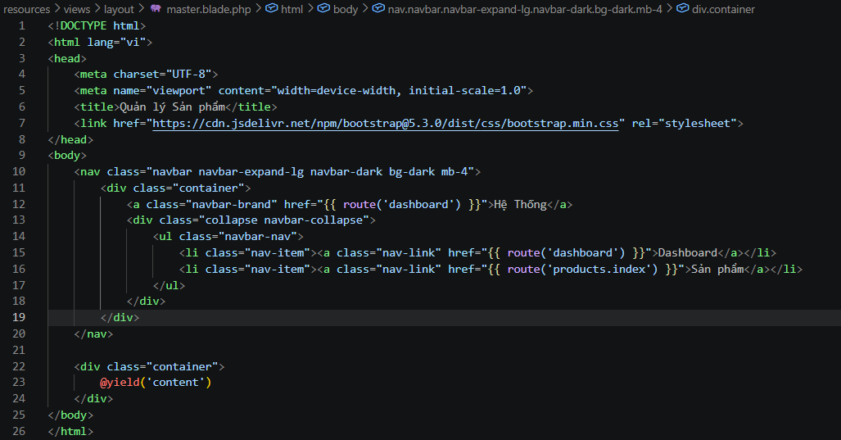
Code alert.blade.php:
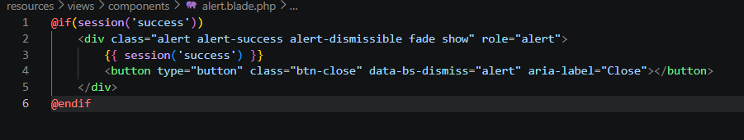
@if(session('success'))
<div class="alert alert-success alert-dismissible fade show" role="alert">
{{ session('success') }}
<button type="button" class="btn-close" data-bs-dismiss="alert" aria-label="Close"></button>
</div>
@endif

Code dashboard.blade.php:
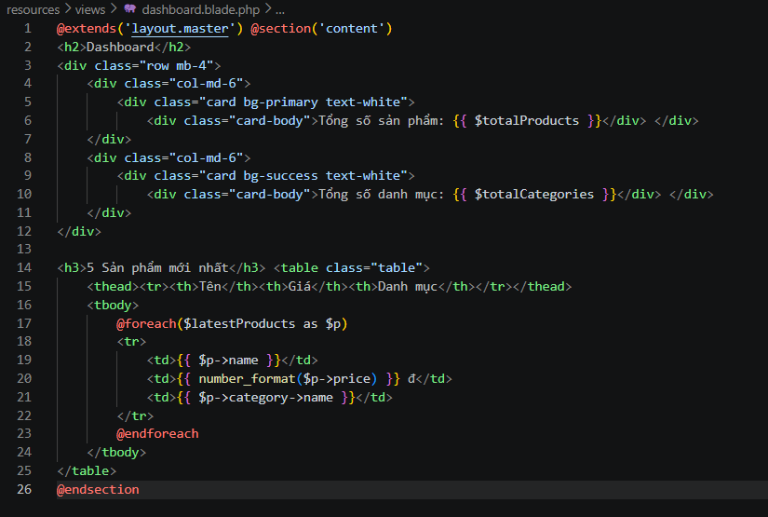
@extends('layout.master') @section('content')
<h2>Dashboard</h2>
<div class="row mb-4">
<div class="col-md-6">
<div class="card bg-primary text-white">
<div class="card-body">Tổng số sản phẩm: {{ $totalProducts }}</div> </div>
</div>
<div class="col-md-6">
<div class="card bg-success text-white">
<div class="card-body">Tổng số danh mục: {{ $totalCategories }}</div> </div>
</div>
</div>

<h3>5 Sản phẩm mới nhất</h3> <table class="table">
<thead><tr><th>Tên</th><th>Giá</th><th>Danh mục</th></tr></thead>
<tbody>
@foreach($latestProducts as $p)
<tr>
<td>{{ $p->name }}</td>
<td>{{ number_format($p->price) }} đ</td>
<td>{{ $p->category->name }}</td>
</tr>
@endforeach
</tbody>
</table>
@endsection

Code index.blade.php:
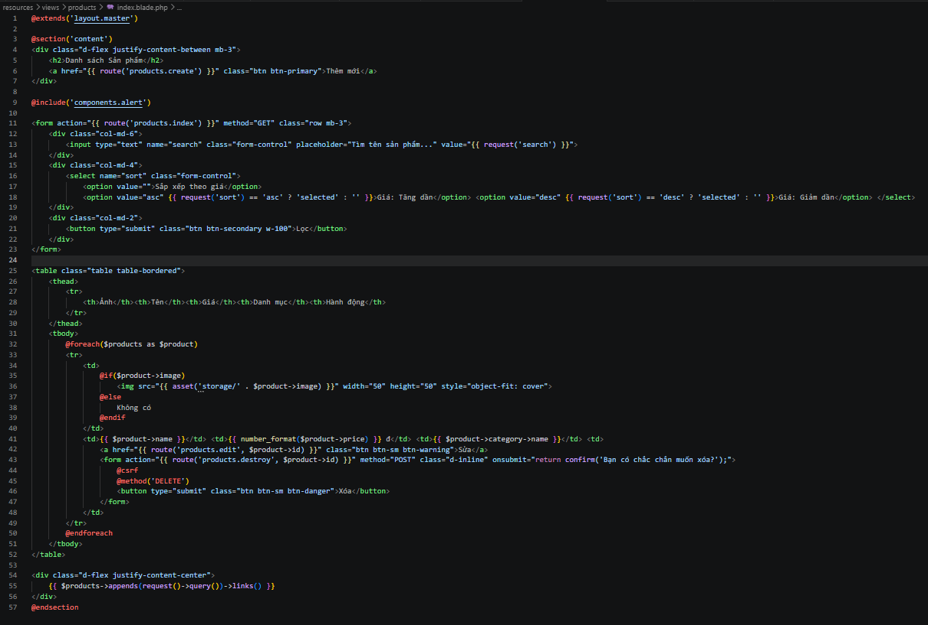
@extends('layout.master')

@section('content')
<div class="d-flex justify-content-between mb-3">
<h2>Danh sách Sản phẩm</h2>
<a href="{{ route('products.create') }}" class="btn btn-primary">Thêm mới</a>
</div>

@include('components.alert')

<form action="{{ route('products.index') }}" method="GET" class="row mb-3">
<div class="col-md-6">
<input type="text" name="search" class="form-control" placeholder="Tìm tên sản phẩm..." value="{{ request('search') }}">
</div>
<div class="col-md-4">
<select name="sort" class="form-control">
<option value="">Sắp xếp theo giá</option>
<option value="asc" {{ request('sort') == 'asc' ? 'selected' : '' }}>Giá: Tăng dần</option> <option value="desc" {{ request('sort') == 'desc' ? 'selected' : '' }}>Giá: Giảm dần</option> </select>
</div>
<div class="col-md-2">
<button type="submit" class="btn btn-secondary w-100">Lọc</button>
</div>
</form>

<table class="table table-bordered">
<thead>
<tr>
<th>Ảnh</th><th>Tên</th><th>Giá</th><th>Danh mục</th><th>Hành động</th>
</tr>
</thead>
<tbody>
@foreach($products as $product)
<tr>
<td>
@if($product->image)
<img src="{{ asset('storage/' . $product->image) }}" width="50" height="50" style="object-fit: cover">
@else
Không có
@endif
</td>
<td>{{ $product->name }}</td> <td>{{ number_format($product->price) }} đ</td> <td>{{ $product->category->name }}</td> <td>
<a href="{{ route('products.edit', $product->id) }}" class="btn btn-sm btn-warning">Sửa</a>
<form action="{{ route('products.destroy', $product->id) }}" method="POST" class="d-inline" onsubmit="return confirm('Bạn có chắc chắn muốn xóa?');">
@csrf
@method('DELETE')
<button type="submit" class="btn btn-sm btn-danger">Xóa</button>
</form>
</td>
</tr>
@endforeach
</tbody>
</table>

<div class="d-flex justify-content-center">
{{ $products->appends(request()->query())->links() }}
</div>
@endsection
Code create.blade.php:
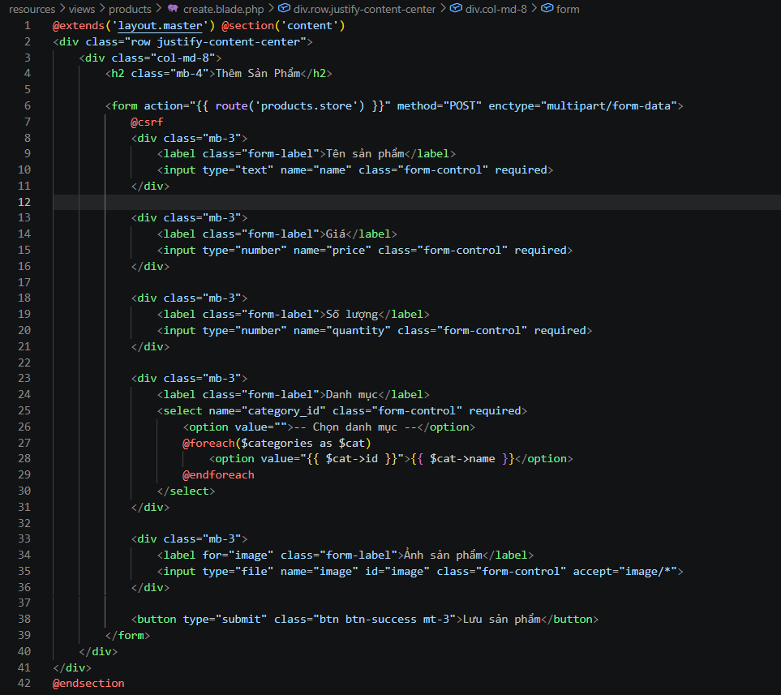
@extends('layout.master') @section('content')
<div class="row justify-content-center">
<div class="col-md-8">
<h2 class="mb-4">Thêm Sản Phẩm</h2>

<form action="{{ route('products.store') }}" method="POST" enctype="multipart/form-data">
@csrf
<div class="mb-3">
<label class="form-label">Tên sản phẩm</label>
<input type="text" name="name" class="form-control" required>
</div>

<div class="mb-3">
<label class="form-label">Giá</label>
<input type="number" name="price" class="form-control" required>
</div>

<div class="mb-3">
<label class="form-label">Số lượng</label>
<input type="number" name="quantity" class="form-control" required>
</div>

<div class="mb-3">
<label class="form-label">Danh mục</label>
<select name="category_id" class="form-control" required>
<option value="">-- Chọn danh mục --</option>
@foreach($categories as $cat)
<option value="{{ $cat->id }}">{{ $cat->name }}</option>
@endforeach
</select>
</div>

<div class="mb-3">
<label for="image" class="form-label">Ảnh sản phẩm</label>
<input type="file" name="image" id="image" class="form-control" accept="image/*">
</div>

<button type="submit" class="btn btn-success mt-3">Lưu sản phẩm</button>
</form>
</div>
</div>
@endsection

Code edit.blade.php:
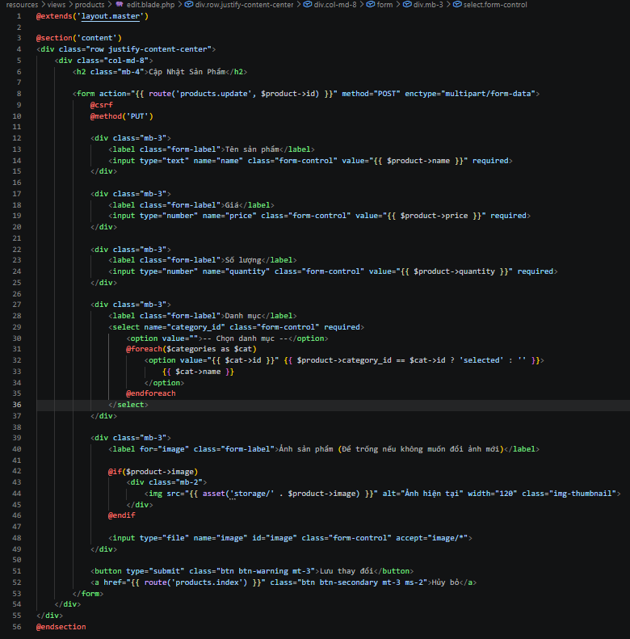
@extends('layout.master')

@section('content')
<div class="row justify-content-center">
<div class="col-md-8">
<h2 class="mb-4">Cập Nhật Sản Phẩm</h2>

<form action="{{ route('products.update', $product->id) }}" method="POST" enctype="multipart/form-data">
@csrf
@method('PUT')

<div class="mb-3">
<label class="form-label">Tên sản phẩm</label>
<input type="text" name="name" class="form-control" value="{{ $product->name }}" required>
</div>

<div class="mb-3">
<label class="form-label">Giá</label>
<input type="number" name="price" class="form-control" value="{{ $product->price }}" required>
</div>

<div class="mb-3">
<label class="form-label">Số lượng</label>
<input type="number" name="quantity" class="form-control" value="{{ $product->quantity }}" required>
</div>

<div class="mb-3">
<label class="form-label">Danh mục</label>
<select name="category_id" class="form-control" required>
<option value="">-- Chọn danh mục --</option>
@foreach($categories as $cat)
<option value="{{ $cat->id }}" {{ $product->category_id == $cat->id ? 'selected' : '' }}>
{{ $cat->name }}
</option>
@endforeach
</select>
</div>

<div class="mb-3">
<label for="image" class="form-label">Ảnh sản phẩm (Để trống nếu không muốn đổi ảnh mới)</label>

@if($product->image)
<div class="mb-2">
<img src="{{ asset('storage/' . $product->image) }}" alt="Ảnh hiện tại" width="120" class="img-thumbnail">
</div>
@endif

<input type="file" name="image" id="image" class="form-control" accept="image/*">
</div>

<button type="submit" class="btn btn-warning mt-3">Lưu thay đổi</button>
<a href="{{ route('products.index') }}" class="btn btn-secondary mt-3 ms-2">Hủy bỏ</a>
</form>
</div>
</div>
@endsection
Code 2026_04_03_134746_create_products_table.php:
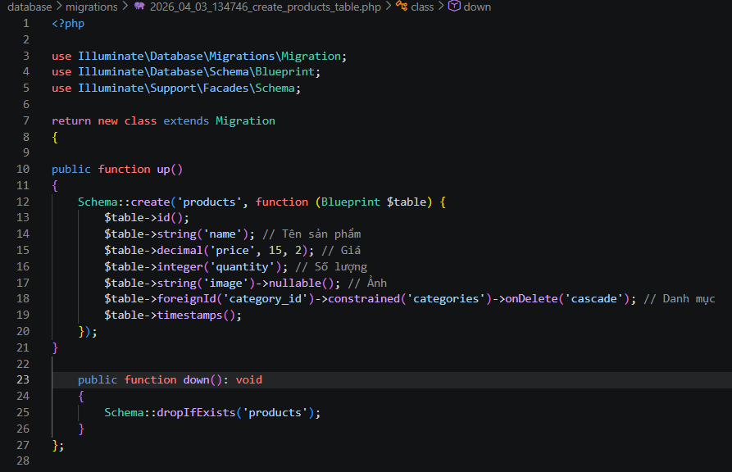
<?php

use Illuminate\Database\Migrations\Migration;
use Illuminate\Database\Schema\Blueprint;
use Illuminate\Support\Facades\Schema;

return new class extends Migration
{

public function up()
{
Schema::create('products', function (Blueprint $table) {
$table->id();
$table->string('name'); // Tên sản phẩm
$table->decimal('price', 15, 2); // Giá
$table->integer('quantity'); // Số lượng
$table->string('image')->nullable(); // Ảnh
$table->foreignId('category_id')->constrained('categories')->onDelete('cascade'); // Danh mục
$table->timestamps();
});
}

public function down(): void
{
Schema::dropIfExists('products');
}
};

File .env
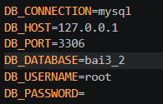
Github:https://github.com/ttung20044-ctrl/bai-tap-cd1

