

BỘ CÔNG THƯƠNG

TRƯỜNG ĐẠI HỌC CÔNG NGHIỆP THÀNH PHỐ HỒ CHÍ MINH

**KHOA CÔNG NGHỆ THÔNG TIN**

-----🙞🙜🕮🙞🙜-----



**BÁO CÁO GIỮA KÌ PHÂN TÍCH DỮ LIỆU 2**

***ĐỀ TÀI:***

**DEVELOP A DECENTRALIZED APPLICATION FOR CROWDFUNDING**

**Giáo viên hướng dẫn :** ThS. Huỳnh Nam

**Nhóm thực hiện :** Nhóm 03

**Lớp học phần :** DHHTTT16C - 420300233003

Thành phố Hồ Chí Minh, tháng 04 năm 2023

Table of Contents

I. ABSTRACT 3

II. INTRODUCE 3

III. RELATED WORK 4

IV. METHODOLOGY 4

1) Choose a suitable blockchain: First, you need to choose a suitable blockchain to build your dApp. Ethereum is the most popular blockchain platform for building dApps, as it supports programming through smart contracts. 4

2) Smart contract design: Smart contracts are an important part of building a complete fundraising dApp. You need to design and implement a smart contract on the blockchain, which records user fundraising transactions. 4

3) User interface design: After you have defined the smart contract, you need to design the user interface for your dApp. The interface should provide information about the project, describe its functions, and explain how users can contribute to the fund. 4

4) Develop a fundraising function: Next, you need to develop the fundraising function of the dApp. This function should provide users with information about the project, the level of completion and how to contribute to the fund. 4

5) Related function development: Includes delete, transaction, accumulation functions,.. . 4

6) Testing and testing: After you finish building the dApp, you need to test and test its features. Make sure that your project works properly and that there are no security vulnerabilities. 4

7) Deployment and promotion: Finally, you need to deploy your dApp on the blockchain and start promoting to attract users. You can use online advertising tools, like Google Ads or Facebook Ads, to introduce your dApp to more users. 4

V. IMPLEMENTATION 4

VI. RESULT & CONCLUSION 5

VII. REFERENCE 6

VIII. GITHUB LINKS 6

**Develop a Decentralized Application For Crowdfunding**

Võ Nguyễn Thanh Tú  
*Information Technology*   
*Industrial University of Ho Chi Minh City*Ho Chi Minh city, Viet Nam   
thanhtu612222@gmail.com

Trần Thị Minh Huyền  
*Information Technology  
Industrial University of Ho Chi Minh City*  
Ho Chi Minh city, Viet Nam   
minhuyen1111@gmail.com

Lê Thị Ngọc Mai  
*Information Technology  
Industrial University of Ho Chi Minh City*  
Ho Chi Minh city, Viet Nam   
lethingocmai15022002@gmail.com

Đỗ Quốc Tuấn  
*Information Technology  
Industrial University of Ho Chi Minh City*  
Ho Chi Minh city, Viet Nam   
dot048209@gmail.com

Võ Quốc Thịnh  
*Information Technology  
Industrial University of Ho Chi Minh City*  
Ho Chi Minh city, Viet Nam   
thinhvo18112002@gmail.com

Nguyễn Hoàng Thái  
*Information Technology  
Industrial University of Ho Chi Minh City*  
Ho Chi Minh city, Viet Nam   
thaidp2002@gmail.com

# ABSTRACT

Blockchain technology has the potential to revolutionize crowdfunding by creating a transparent and secure environment for fundraising. Our proposed platform leverages smart contracts and incentivizes backers with tokens, making it easier for entrepreneurs, small business owners, and investors to participate in the crowdfunding process. By using the Ethereum blockchain, our platform provides greater transparency, security, and efficiency. All transactions are recorded on a public ledger, making it easy to track cash flows and ensure they are being used as intended. This increased transparency builds trust among entrepreneurs and investors, a key factor in the success of crowdfunding campaigns. Our platform also provides enhanced security through the use of smart contracts and encryption. This minimizes the risk of fraud and protects both entrepreneurs and investors. Finally, our platform incentivizes backers with tokens, creates a sense of community, and encourages investors to be more involved in the success of the projects they are backing. Overall, we believe blockchain-based crowdfunding has the potential to transform the crowdfunding landscape. Our platform can help entrepreneurs and small business owners raise funds more efficiently and efficiently, while reducing costs and increasing transparency and accountability.

# INTRODUCE

Our preferred platform leverages smart contracts and uses tokens to incentivize backers, making it easy for entrepreneurs, small business owners, and investors to participate in the crowdfunding process. By using the Ethereum blockchain, our platform improves transparency, security, and efficiency. All transactions are recorded on a public ledger, making it easier to track the flow of money and ensure that it is spent as intended. This increased transparency helps build trust among entrepreneurs and investors. This is an important component of a successful crowdfunding campaign.

Our platform also enhances security by using smart contracts and cryptography. This reduces the risk of fraud and protects entrepreneurs and investors. Finally, our platform will incentivize our supporters with tokens to create a sense of community and encourage investors to be more involved in the success of the projects they support. Overall, we believe blockchain-based crowdfunding has the potential to change the crowdfunding landscape.

Our platform helps entrepreneurs and small business owners raise capital more efficiently, while reducing costs and increasing transparency and accountability.

Detailed Review of blockchain-based crowdfunding platforms Blockchain-based crowdfunding platforms are becoming increasingly popular and offer many benefits over traditional crowdfunding platforms. Here are some detailed reviews of popular blockchain-based crowdfunding platforms:

Kickstarter: is one of the largest online crowdfunding platforms in the world, focusing on innovative projects and unique products. However, Kickstarter doesn't use blockchain to record transactions, so it can't provide the best transparency and security for investors.

Indiegogo: is one of the largest online crowdfunding platforms in the world, mainly focusing on creative projects and electronics. Indiegogo is exploring the use of blockchain to enhance the security and transparency of transactions.

Giveth: is an open-source, non-profit crowdfunding platform that allows users to raise funds for charity projects and social networks. Giveth uses the Ethereum blockchain to ensure the transparency and security of transactions.

Swarm: is a crowdfunding platform for blockchain and cryptocurrency projects. Swarm provides tools and services for startups to access venture capital through blockchain.

KICKICO: is a crowdfunding platform for blockchain projects, especially applications and services for cryptocurrencies. KICKICO uses blockchain to record transactions, ensuring transparency and security of transactions.

In conclusion, blockchain-based crowdfunding platforms are gaining popularity and bringing many benefits to startups and investors. However, each platform has its own advantages and disadvantages, so businesses should carefully consider their options before choosing one.

# RELATED WORK

To solve problems associated with traditional charity fundraising, DApps (decentralized applications) for charity fundraising can be designed and implemented. Some of the characteristics of a charitable fundraising DApp include:

* Use blockchain: Charitable fundraising DApps use blockchain to increase transparency and safety during fundraising and fund management.
* Use of tokens: Charitable fundraising DApps use a private token to raise funds and manage funds.
* Process Automation: Charity fundraising DApps are designed to automate processes, minimize human intervention, and increase transparency.

To work effectively, charitable fundraising DApps must be properly designed and implemented. Jobs related to charitable fundraising DApps include:

* DApp design and implementation: This is the first stage of the process. DApps need to be designed and implemented to engage users and raise funds for charity. In this phase, the designer must define the DApp's goals, users, and features.
* Fundraising Management: After a DApp is implemented, managers must manage funds raised carefully and transparently. They must ensure that money is used properly and not wasted. The management of fundraising money includes planning, monitoring and reporting.
* Create an app: Managers need to create an app to engage users and allow them to contribute money to charity through a DApp. App creation involves developing and testing features and integrating technologies such as blockchain and tokens.
* User acquisition: To raise funds effectively, DApps need to attract many users. Managers need to advertise

# METHODOLOGY

To build a complete fundraising dApp (Decentralized Application), you can perform the following steps:

### Choose a suitable blockchain: First, you need to choose a suitable blockchain to build your dApp. Ethereum is the most popular blockchain platform for building dApps, as it supports programming through smart contracts.

### Smart contract design: Smart contracts are an important part of building a complete fundraising dApp. You need to design and implement a smart contract on the blockchain, which records user fundraising transactions.

### User interface design: After you have defined the smart contract, you need to design the user interface for your dApp. The interface should provide information about the project, describe its functions, and explain how users can contribute to the fund.

### Develop a fundraising function: Next, you need to develop the fundraising function of the dApp. This function should provide users with information about the project, the level of completion and how to contribute to the fund.

### Related function development: Includes delete, transaction, accumulation functions,.. .

### Testing and testing: After you finish building the dApp, you need to test and test its features. Make sure that your project works properly and that there are no security vulnerabilities.

### Deployment and promotion: Finally, you need to deploy your dApp on the blockchain and start promoting to attract users. You can use online advertising tools, like Google Ads or Facebook Ads, to introduce your dApp to more users.

# IMPLEMENTATION

Functions and Files:

UI/UX design: use reactJS and javascripts to process.

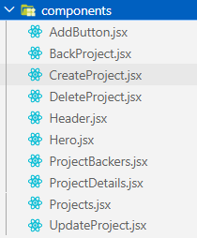 Pic 1. components

File hardhat.js and deploy.js

This is a configuration file for the Hardhat development environment, which is a popular tool for building, testing, and deploying smart contracts on the Ethereum blockchain. Imports the Hardhat Waffle plugin, which adds support for the Waffle testing library. Loads environment variables from a .env file, which is used to store sensitive information such as private keys and API endpoints. sets the default network to use for running tasks and tests to be the local Ethereum network running on the developer's machine.

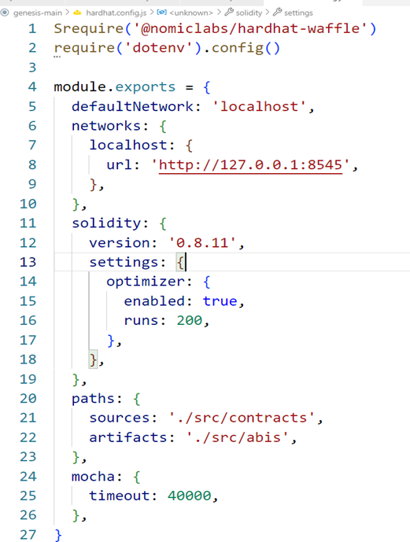Pic 2. File hardhat.js

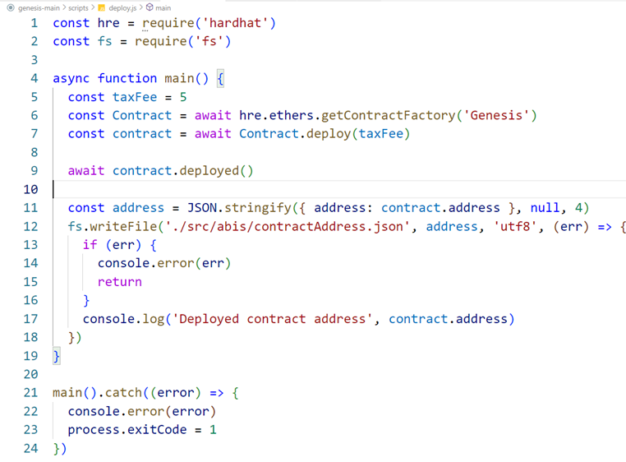

Pic 3. File deploy.js

Service:

This code is a JavaScript program that connects to a smart contract deployed on the Ethereum blockchain using the web3.js library. It uses the Metamask browser extension to connect to the Ethereum network, retrieve accounts, and sign transactions.

The program imports the smart contract's ABI (Application Binary Interface) and contract address from JSON files. It also imports functions to get and set global state and the ethers.js library, which is a more user-friendly API for interacting with the Ethereum blockchain.

The program defines several functions to interact with the smart contract, such as creating a new project, updating a project, deleting a project, and backing a project. It also defines functions to load information about projects, including their statistics and backers.

 Pic 4. File blockchain.jsx

Views:

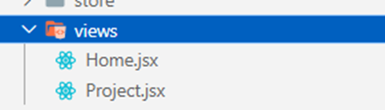 Pic 5. views

It imports several modules, including React's useEffect, useState, useParams hook, several custom components (AddButton, CreateProject, Hero, and Projects), and two functions from other files: "loadProjects" from '../services/blockchain' and "useGlobalState" from '../store'. Using the "useGlobalState" hook to allows the component to access the state of the global store, which may be managed by a library such as Redux or MobX. The "useEffect" hook is then used to asynchronously load project data from the blockchain service when the component mounts. The empty array passed as the second argument to "useEffect" indicates that the effect should only run once on mount.

# RESULT & CONCLUSION

Pic 1: Home

Pic 2: Create Campaign

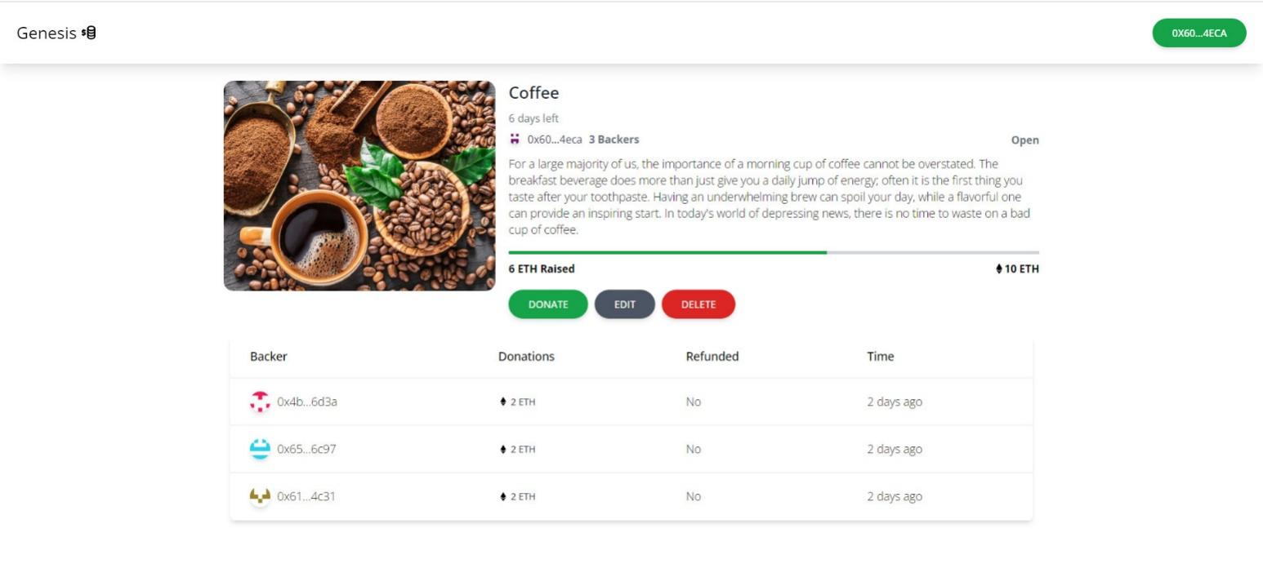

Pic 3: CampaignDetails

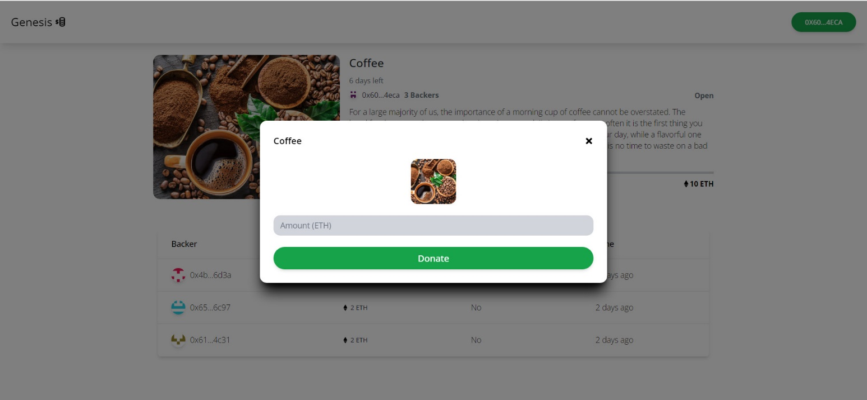

Pic 4: Donate

# REFERENCE

* Building DApps for Beginners: A Step-by-Step Guide: Author: Coursetro
* Ethereum Whitepaper: Author: Vitalik Buterin.
* Solidity Documentation: Author: Solidity Team
* OpenZeppelin Documentation: Author: OpenZeppelin Team

# GITHUB LINKS

https://github.com/Tuan2110/Nhom3_LTPTDL2_CK

# DEMO REAL PRODUCT