Key observations so far
- The data of the public leaderboard has a very different distribution compared to the training data.
- The test data is not quite contiguous after a careful analysis of the gaps. Most likely, there is a small random gap between test chunks. => Gap analysis will not solve the test chunk ordering problem.
- There are 8 test-chunks with the same particular gap-pattern – could these be starts of earthquakes?
- Mini quakes `reset` the experiment and make this a challenging regression problem.

Minor observations
- It seems impossible to model if two chunks are sequential or come from the same earthquake
- There is no pattern repetition in the end and beginning of test data chunks
- Conclusion: we need a statistical chunk-based solution instead of a test chunk ordering approach.

Test data distribution
- Are the data from p4677? Yes!
  - Arxiv paper – see figure 1 for best alignment of train and experiment train data
=> 16 earthquakes in the train data, 8 full earthquake cycles in the test data and an incomplete one at the beginning of the measurements. The experiment ends with TTF 0. TLDR: 9 quakes but only 8 full cycles in test.
xdotool getmouselocation - Train data is approx (1108-602) = 506 pixels, test data approx (1432-1108) = 324 pixels
=> Train data should be of size 2624*506/324 ~= 4100 chunks but actually it is ~= 4200.
Maybe the first part of the test data (~3-4 s) is excluded from the leaderboard (test)?

  - Other source behind a paywall
  - deepdetect p4677 google search results in very interesting plots
  - Assuming that the test data contains 8 resets of the ttf, derivation of average test prediction:
    - Train data is ~= 163.0 s based on kaggle data => test data is 163*2624/4184 ~= 102.2 s with 8 resets
    - Based on plots, the cycles are of length
      - Test cycle 1: 9.8 s (total cycle of 11.6)
      - Test cycle 2: 12
      - Test cycle 3: 11.6
      - Test cycle 4: 7
      - Test cycle 5: 11.6
      - Test cycle 6: 16 – End of this cycle is most likely part of the public LB
      - Test cycle 7: 9.7 – This cycle is most likely entirely part of the public LB
      - Test cycle 8: 12.5
      - Test cycle 9: 17
    - Sum: 107.2; Possible explanations:
      - Incorrect estimate of test cycle lengths – verify by estimating the train cycle lengths
        - Train cycle 1: 1.5
        - Train cycle 2: 11.6 (True: 11.6)
        - Train cycle 3: 14 (True: 14.2)
        - Train cycle 4: 8.5 (True: 8.9)
        - Train cycle 5: 12.5 (True: 12.7)
        - Train cycle 6: 16 (True: 8+7 = 15)
        - Train cycle 7: 16 (True: 16.1)
        - Train cycle 8: 7.5 (True: 7.9)
        - Train cycle 9: 8.5 (True: 9.6)
        - Train cycle 10: 11.6 (True: 11.4)
        - Train cycle 11: 11 (True: 11)
        - Train cycle 12: 7.5 (True: 8.8)
        - Train cycle 13: 8 (True: 8.6)
        - Train cycle 14: 15 (True: 14.7)
        - Train cycle 15: 9.5 (True: 9.5)
        - Train cycle 16: 1.8
        - Total sum: 160.5, underestimate by 2%
      - Part of the test data is excluded from the competition – This would affect the envisioned approach to match the predicted and expected first moment. If missing, it would be at the start of the first test cycle since 9 massive shocks are present in the data.
      - The gaps between the test chunks could be part of the remaining gap
      - => The average test (private + public) prediction should be:
(9.8^2+12^2+11.6^2+7^2+11.6^2+16^2+9.5^2+12.5^2+17^2)/(2*107) ~= 6.307
      - Assuming the first part of the test data is missing, this number doesn’t change much:
(6.8^2+12^2+11.6^2+7^2+11.6^2+16^2+9.5^2+12.5^2+17^2)/(2*104) ~= 6.249
      - The test mean of the first submission was 5.356 => room for improvement!
      - => The average public LB prediction should be:
(4^2+9.7^2)/(2*(4+9.7) ~= 4.017

What data to train on to have good generalization to test distribution
- There is a gradual shift in the data distribution => only use the last part of the train data, specifically the last 3/4 earthquakes of which the last one is incomplete (only contains 15% of the earthquake cycle data).
- Motivation: frequency based VAE:
Plot of earthquake ids in latent space, zoom in on full eq 2 and full eq 15 (last full train cycle)
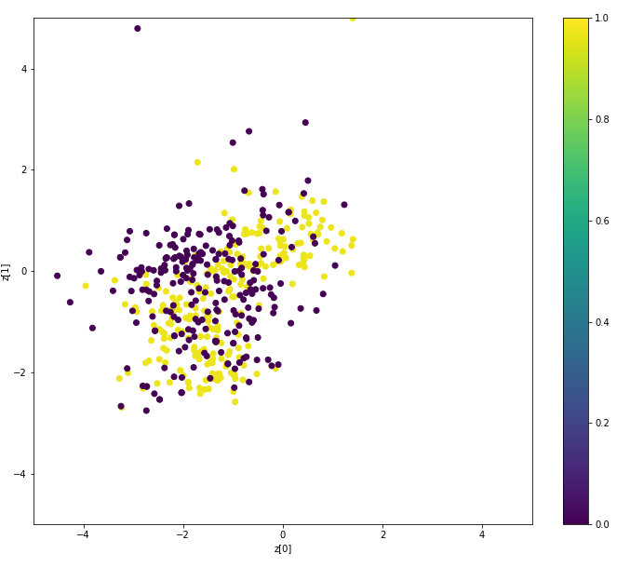
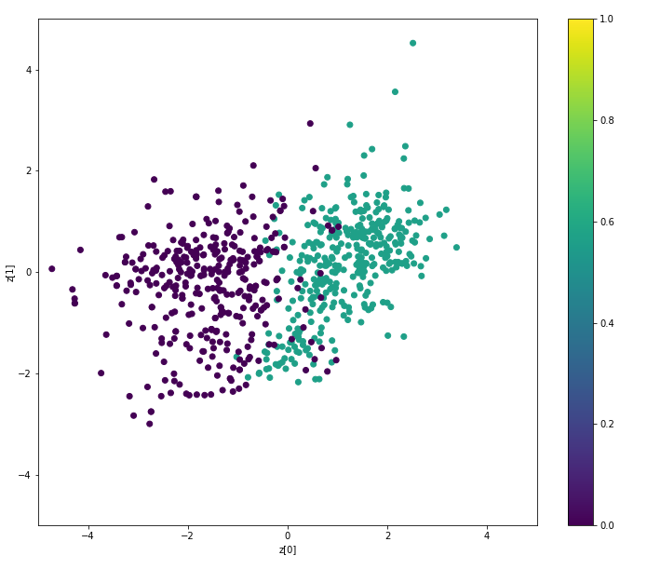
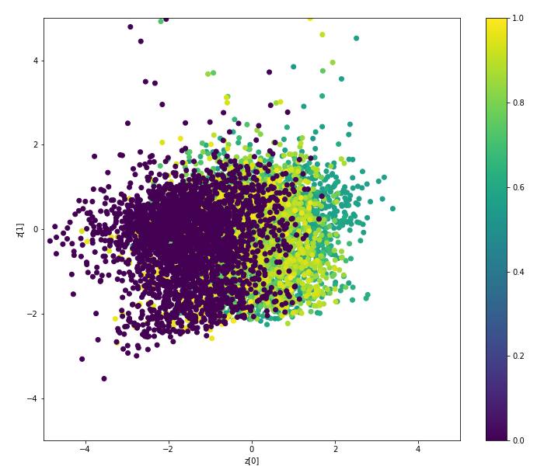

Selected features
- Decide on what features to use for each sub-chunk. Select from:
  - FFT (10)
  - Mean (1), std (1) and quantile (5) statistics
  - CPC encodings (only for neural net since they are defined at the sub-chunk level)

Consider alternative problem formulation
- Model the quantile of the chunk within an earthquake and predict (1-quantile)*median earthquake cycle length (repeated by earthquake cycle length!)

Median cycle length for test derivation– ignore the 9.5 cycle from the public leaderboard:
np.median(np.hstack([np.repeat(11.6, 98), np.repeat(12, 120), np.repeat(11.6, 116), np.repeat(7, 70), np.repeat(11.6, 116), np.repeat(16, 160), np.repeat(9.5, 95), np.repeat(12.5, 125), np.repeat(17, 170)]))
=> np.median(np.hstack([np.repeat(11.6, 98), np.repeat(12, 120), np.repeat(11.6, 116), np.repeat(7, 70), np.repeat(11.6, 116), np.repeat(16, 160), np.repeat(12.5, 125), np.repeat(17, 170)]))
Both have length 12.0 s

Fit lightGBM
- train_valid_test_lightgbm_sequential.py
- Train on train_features_scaled_keep_incomplete_target_quantile.csv (chunk based features)
- Main changes:
  - Train/validation split generation – Drop splits and only validate on future data
  - Add normalization in the validation prediction
  - Add visualization of the predictions vs the ground truth for validation data
  - Sweep over
    - TARGET_QUANTILE
    - TRAIN_ALL_PREVIOUS
    - LGB hyperpars
    - NUM_FOLDS
Best settings:
    - 2000 trees
    - Learning rate: 0.02
    - 14 leaves
    - Max depth: 12
    - Feature fraction: 0.8
    - Subsample: 0.9
    - Min data in leaf: 10
  - Submit test with median cycle test length of 9.7 using the best hyperparameter settings – 1.53 public LB (worse than first submission of 1.52)
  - Submission to probe the public LB
Try to submit with a median cycle length < 9.7. Conjecture: that would likely result in a better score since the first cycle is at the end of a quake and is typically an overestimate.
Public LB score with median_test_cyle_length of 8.0: 1.771 – Interesting!

Fit Neural net
- Merge encodings for incomplete earthquakes
- Train on train_main_cpc_encodings_and_features.csv (subchunk based features with cpc encodings)

Submission strategy
- Blend lightGBM with neural net
- Maybe drop the first fold since it seems to have a different distribution compared to the other folds
- 2 submissions, select from
  - 1 submission using 3 or 4 train cycles (2 or complete ones) – 6 or 5 folds
  - 1 submission using all train cycles (or maybe drop the first fold)
  - 1 submission using all train cycles with the first mini quake in the data

Planned actions May 31
- Make sense of public leaderboard
- Select best LightGBM model/blend
- Train neural network on quantile formulation, considering all previous data
  - Verify quality of the encoder
  - Merge CPC encodings with subchunk based features
  - Modify train_valid_test_rnn.py to train_valid_test_rnn_sequential.py
    - Make sure that the notrain features are not included in the model
  - Tune hyperparameters to avoid overfitting – Add encoding dropout
  - Sweep over
    - Including CPC encodings or not
    - Neural net hyperpars

Public leaderboard analysis
- Public data most likely comes from a continuous segment
- Max between 9 and 10
- 2 peaks (log_var > 9)
  - Either 2 incomplete (at extemes) and 1 complete cycle with the last one 4s ttf
  - Or 1 incomplete followed by one full cycle
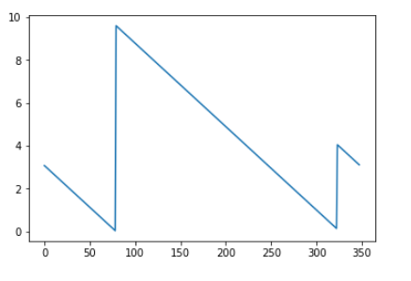
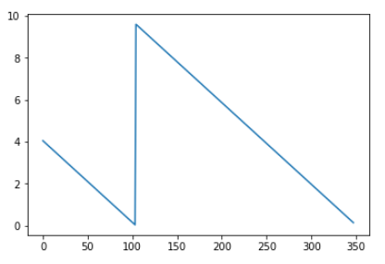

- Overall leaderboard assumptions:
  - 9 quakes of durations 9.8 (11.6) – 12 – 11.6 – 7 – 11.6 – 16 – 9.5 – 12.5 – 17
  - 8 full cycles (first one is incomplete)
- Most likely hypothesis:
Public leaderboard contains the 6th full leaderboard cycle and the end of the fifth
- Conclusion: the optimal public leaderboard median_test_cyle_length should be 9.X.
- Maybe there is a tradeoff with the very long preceding cycle of 16 that could result in a better public LB score with a higher median_test_cyle_length – This should not be the case in expectation since 9.5*9.5 > 4*16

Submission summary
Submission date | Score | Summary
5th March, 2019 | 1.522 | Initial LightGBM baseline
30th May, 2019 | 1.530 | LightGBM – Quantile – Median_test_cyle_length 9.7
30th May, 2019 | 1.771 | LightGBM – Quantile – Median_test_cyle_length 8.0
31st May, 2019 | 1.517 | LightGBM – Quantile – Median_test_cyle_length 11
31st May, 2019 | 1.662 | LightGBM – Quantile – Median_test_cyle_length 12
1st June, 2019 | 4.523 | NeuralNet – Quantile – Train all prev - Median_test_cyle_length 11
2nd June, 2019 | 1.485 | NeuralNet – Quantile – Train all prev - Median_test_cyle_length 11 – NO CPC
2nd June, 2019 | 1.482 | Average blend submissions 4 and 8 (yellow)

Actions June 01
- Evaluate on a fixed range to determine if the median cycle quantile prediction drifts
  - train_all_previous set to False
  - valid_eq_ids = np.arange(14, 17) and use train_val_split[4][7] instead of train_val_split[fold][7]
  - Also try valid_eq_ids = np.arange(11, 17) and use train_val_split[3][7] instead of train_val_split[fold][7]
Conclusion: no obvious prediction drift
- Train neural net with target_quantile set to False (CV 2.085 with train_all_previous = True, CV 2.166 with train_all_previous = False)
- Better results with target_quantile True and train_all_previous False (CV 2.022) => include train_all_previous in the next sweep
- Select best hyperparameters of the target quantile neural net with train_all_previous = True (CV 2.054) and submit with Median_test_cyle_length 11. This will give a comparison point with respect to LightGBM.
  - Flakiness: test predictions are variable with the same inputs unless if we call K.clear_session() but for some reason this messes up the train/validation accuracy :S. Avoid calling K.clear_session() in test or validate. Hypothesis: this switches from test to train model and updates the model.
  - The chunk prediction is the median of all models where each model prediction is the average of 20*2 reps of the test features. Reason for averaging: the model is stochastic.

- Debug RNN predictions – strong negative correlation with LightGBM predictions so there is probably some subtle bug. The bug was due to the CPC features that resulted in a leak of the validation predictions.

Actions June 02
- Determine optimal hyperparameters NN
- Add Scirpus inspired features

- Debug NN all same predictions – Sub_frac_greater_1000 was ocasionally nan after normalization
- Hyperpar sweep NN
- Select best NN hyperparameters
- NN submission comparable to LightGBM best submission - median_test_cyle_length=11
- NN LightGBM blend submission, both with median_test_cyle_length=11
- Launch hyperpar sweep LightGBM

Actions June 03
- Select best NN hyperparameters (consider the correct sweep)
- Select best LightGBM hyperparameters

- Determine submission strategy
  - Both submissions should be an average blend of the LightGBM and NN models
  - Use 10 random seeds for each model-data pair
    - Models: LightGBM and NN
    - Data:
      - One single model trained on the last 6 complete cycles
      - One median model blend trained on all previous, discarding the first model of 6 folds (not enough data to get accurate median predictons)
- Converge on the magic median_test_cyle_length constant
- Generate predictions using different seeds for LightGBM and NN

- Blend LightGBM and NN predictions for each data type and submit to Kaggle and FLAG AS SUBMISSIONS

Discussion
Title: 11th place with 11 submissions

Many congratulations to the winners, The Zoo, you truly stood out on the private leaderboard! Also congratulations to all teams that survived the private earthquake or learned something during the competition. @Keita (+4024 to claim a gold with 2 submissions) is a great example that we should sometimes focus less on the public leaderboard even though we all know we should :-).

Special thanks go to all forum contributors. People like @CPMP, @mykper, @scirpus, @Abhishek and several others are what make Kaggle great and I am deeply grateful for your contributions.

Let’s start with what didn’t end up in the final submission. My efforts during this competition were mostly wasted on modeling the gaps (every 4095/4096 observations) in the data. The assumption was that if one could detect these gaps, it would be possible to order the test chunks, making the test prediction problem trivial. This model worked perfectly on the validation data but it didn’t on the test data. I am actually certain that the test data is not contiguous and is divided into 150,000 observation chunks with random gaps in between. It is a bit sad that the organizers ignored many good questions about the data distribution in the “Additional info” topic, requiring the competitors to make many assumptions.

The second biggest chunk of my time was spent on unsupervised learning of features using the raw high frequency data with recurrent networks. The code was inspired by David Tellez his implementation of Contrastive Predictive Coding (https://arxiv.org/pdf/1807.03748.pdf). The hope was that this would lead to robust features for training and testing. I embedded each chunk of 1,500 observations to a shared embedding of size 32 and defined the following loss heads:
- Predict if one embedding directly follows (with some small random gap) another embedding
- Predict if a pair of embeddings comes from the same data chunk of 150,000 observations
- Predict if an embedding comes from the train or test data
- Predict if a pair of embeddings comes from the same earthquake
- Predict Time To Failure (TTF)
The first three losses are trained for both the train and test data of which the third one is trained using domain adversarial training (https://arxiv.org/pdf/1505.07818.pdf). The last two losses can only be trained for the train data. Even though I ended up not using any of these models, it became clear that it was very hard to distinguish if raw observations come from the same earthquake. That led me to redefine the learning objective in the final approach.

An alternative way to specify the learning objective is the following: predict the quantile ttf of an earthquake, meaning that the target is 0 at the beginning of an earthquake cycle and 1 for the last 150,000 observation chunk of each earthquake. Assuming that this model is perfect, what should each (1-prediction) then be scaled by to minimize the MAE? The median of [the earthquake lengths, repeated by the earthquake lengths]! For example, if the test data consisted of earthquake lengths 6, 3 and 2 this would result in median(6, 6, 6, 6, 6, 6, 3, 3, 3, 2, 2) = 6 * (1-quantile_pred) as the optimal predicted time to failure. The nice thing about this reformulation is that we can use the data from the P4677 experiment (I estimated the test median earthquake ttf to be 12) without having to break your head over what earthquake cycles to train on.

The models themselves use basic FFT and quantile features for each 150,000 observation chunks and 100 1,500 observation subchunks. This resulted in 41*100 = 4040 features which were fed into LightGBM (feature fraction of 0.003) and neural networks. The first final submissions averages the LightGBM and neural network predictions starting from the last 6 complete earthquake cycles. The second submission uses all data except for the first incomplete earthquake cycle (given that the cycle length is unknown we can’t determine it’s quantile). A nice property of this approach is that the predictions don’t change much when training on different folds so in hindsight it would have been better to submit with different estimated median private test earthquake times.

I look forward to hear your thoughts!

