**REPORT ON THE PROJECT IN COMPUTER SCIENCE**

**PROJECT’S TOPIC: COURSE REGISTRATION SYSTEM**

**Group 7**

Students: Trần Tuấn Việt

Phạm Vũ Minh Giang

Trần Thúc Minh Trí

Đỗ Vương Quốc Thịnh

1. **General Introduction**

This is our project in CS162: A Course Registration System. This is the system for the staff to create a new schoolyear, create a new class, manage students and manage courses for students to enroll their courses and also view the scoreboard of the student. Moreover, in our system, the student can login to view their profile, enroll courses when new semester is coming and view their score of their course. That is the general introduction about our system and now let’s go on detail of our project.

1. **The List Function Of System**

* Login to the system (Staff + Student)
* View user profile (Staff + Student)
* Change password (Staff + Student)
* Log out (Staff + Student)
* Staff
  + Create a new school year
  + Create several classes for 1st year students
  + Add new 1st year students to 1st-year classes.
    - By manual
    - By CSV
  + Import Student into class from CSV file
  + Create a new semester
  + Create a course registration session
  + Add a course to this semester
    - By manual
    - By CSV
  + View the list of courses.
  + Update course information.
  + Delete a course.
  + View a list of classes.
  + View a list of students in a class.
  + View a list of courses.
  + View a list of students in a course
  + Export a list of students in a course to a CSV file
  + Import the scoreboard of a course.
    - By manual
    - By CSV
  + View the scoreboard of a course.
  + Update a student result.
  + View the Scoreboard of a class include total mark and GPA
* Student
  + Enroll in a course. If 2 sessions of the new course are conflicted with existing enrolled course sessions, he/she can not enroll in it. He/she can enroll in at most 5 courses in a semester.
  + View a list of enrolled courses.
  + Remove a course from the enrolled list.
  + View his/her scoreboard.

1. **How to use the system**

**1. Login System**

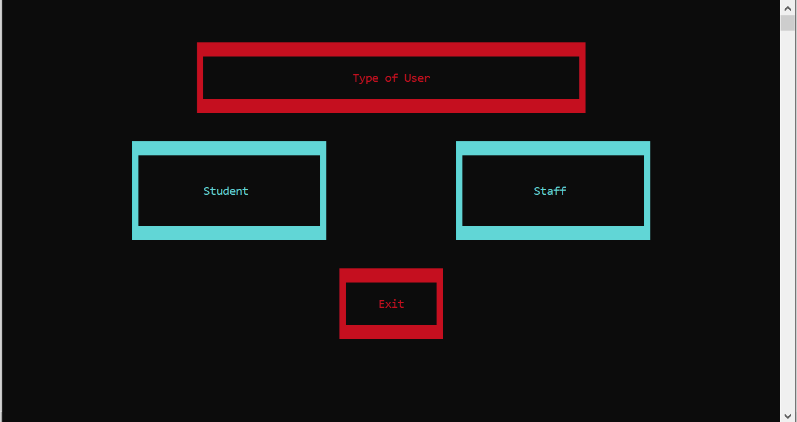

* Here is the login system which consists 3 buttons as the picture below:
  + Student Button: click the left mouse on its button to login as a student.
  + Staff Button: click the left mouse on its button to login as a staff.
  + Exit Button: clcick the left mouse on its button to quit the system.
* If we click on Student Button or Staff Button, there will have the login rectangle with username and password for the user to enter their account to login. In detail if you go on the Staff Button, you will login with staff account and if you click on the Student Button, you will login as a student with student account.
* 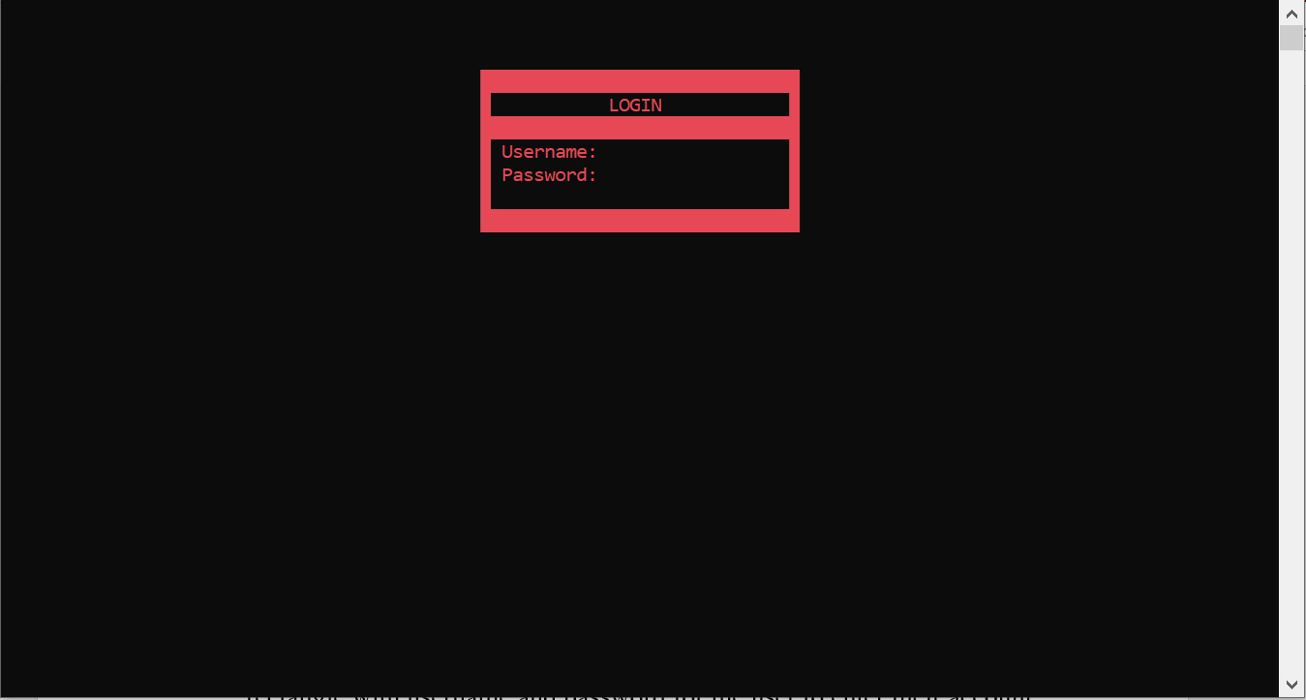There are 2 cases whenever you press enter in the login
  + 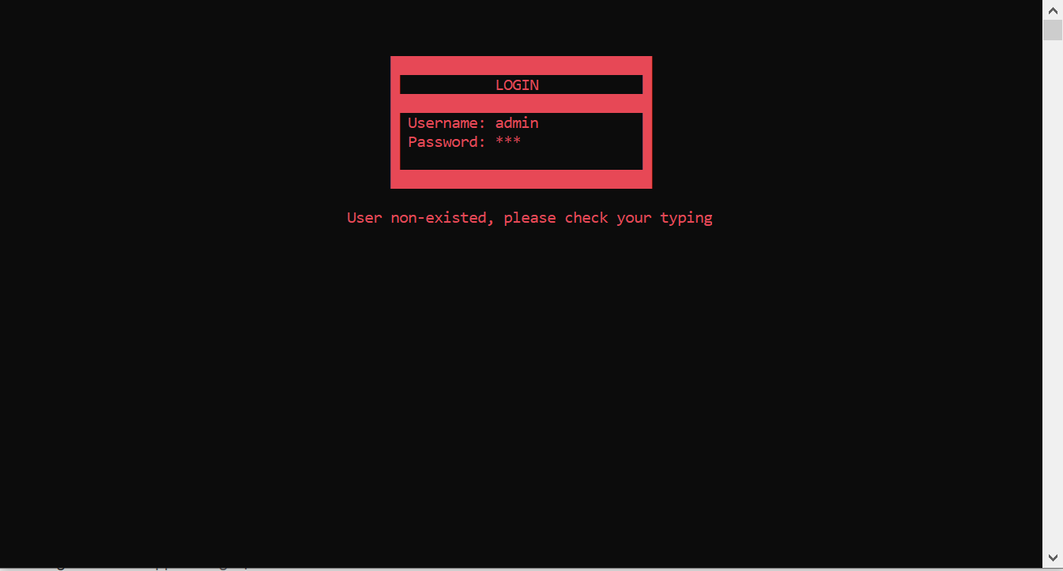The first case is our username or your password is incorrect.
  + The second case is that you have login successfully.

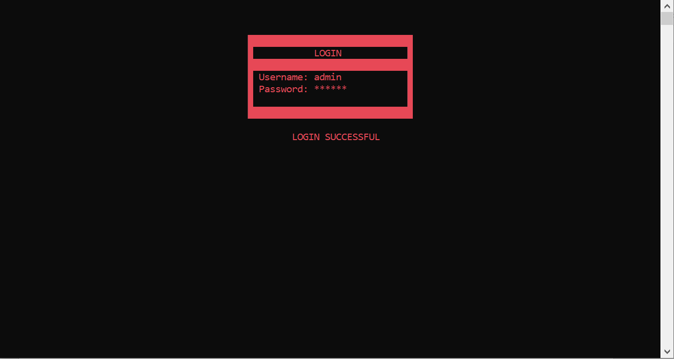

* After loginning successfully, we will continue with the first type of users: **STAFF**

**2. Staff System**

* This is the menu interface when you login as a staff with:
  + The profile button: to view the staff’s profile
  + Manage student button: to create a new school year, create classes or load old classes, manage student, …. Let’s see its function later.
  + Manage courses button: to create a new semester, view semester info, create a course registration, and manage courses by adding a new courses or modify it, ….
  + Change password button: to change to password of the user’s account.
  + Log out button: to log out the current account.
  + Welcome …: to welcome the user to our system.

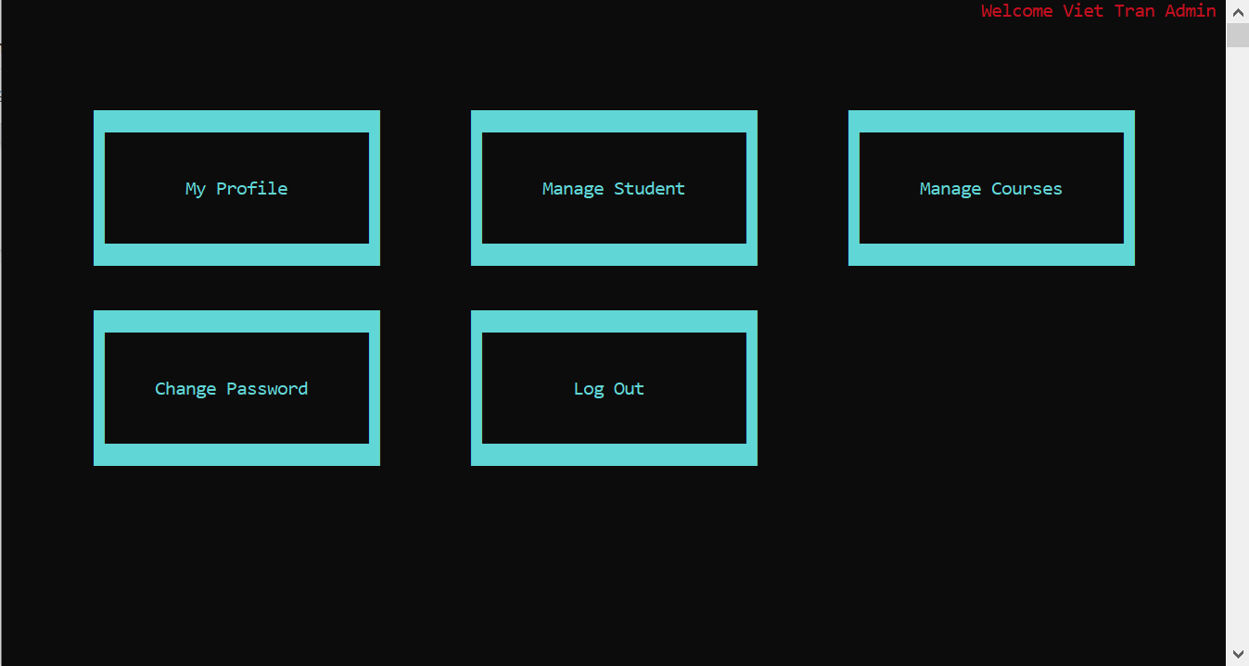

* Here is **MY PROFILE** window which show the user’s information such as ID, First name, Last Name, Gender and Date of Birth.
* 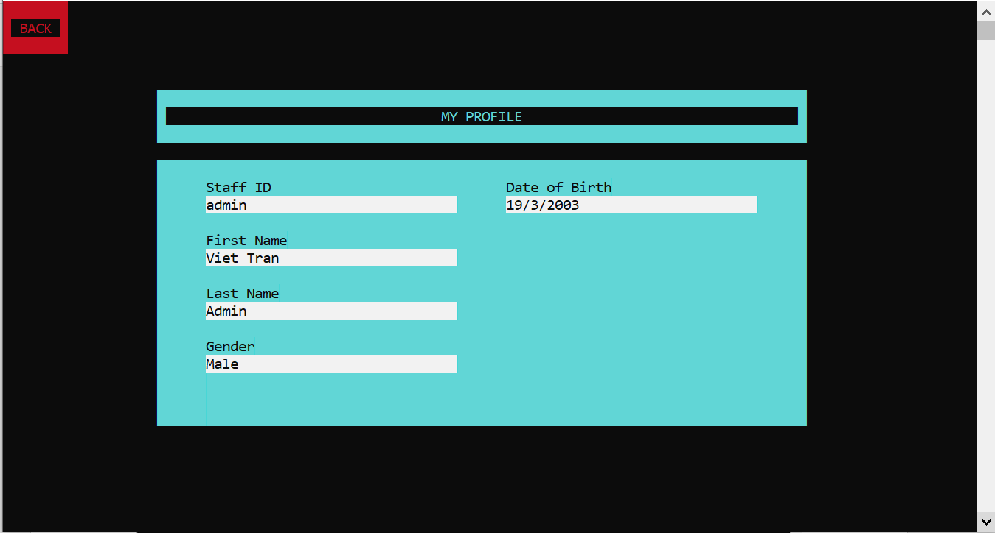After viewing the information, click back to return to the menu
* Here is the **Manage Student** window concludes:
  + Create a new school year
  + School year Information: to show the current school year information
  + Manage classes: to do some operations with classes and students
  + List of Class: to view list of classes, list of students in the class and also their total score and GPA.

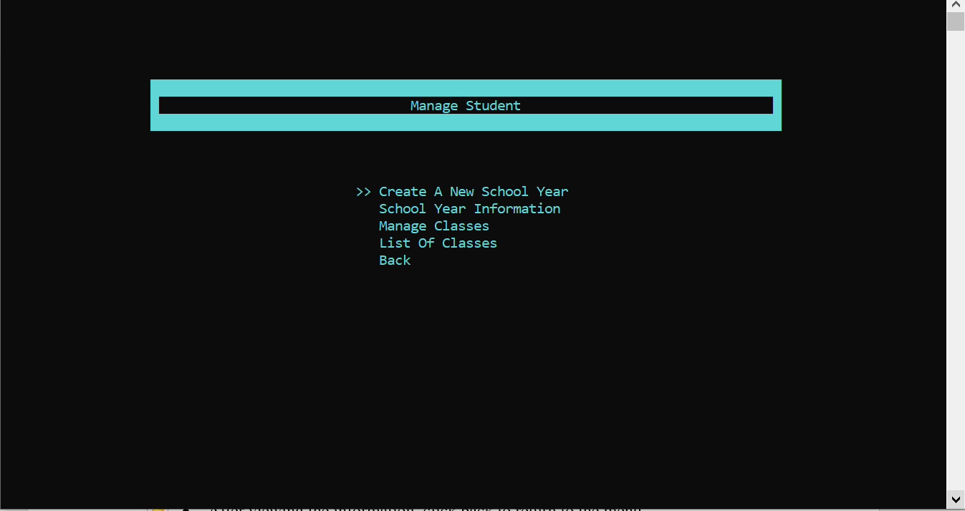

* In **Manage Student,** if you select **Create A New School Year**, there will create the gap for you to input the new school year information.

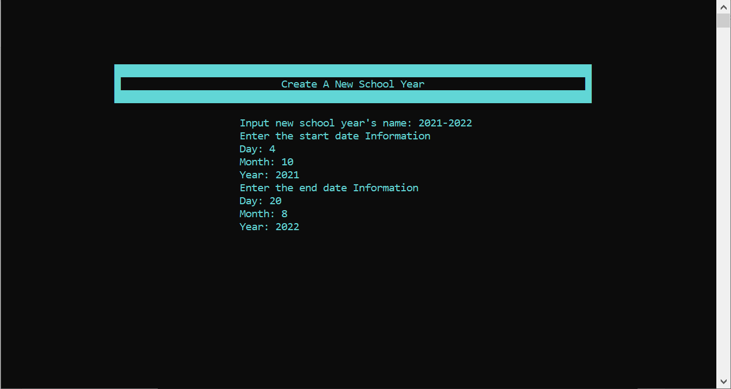

* In **Manage Student,** if you select **School Year Information**, the system will show the school year’s information with the name, start date and end date of the school year.

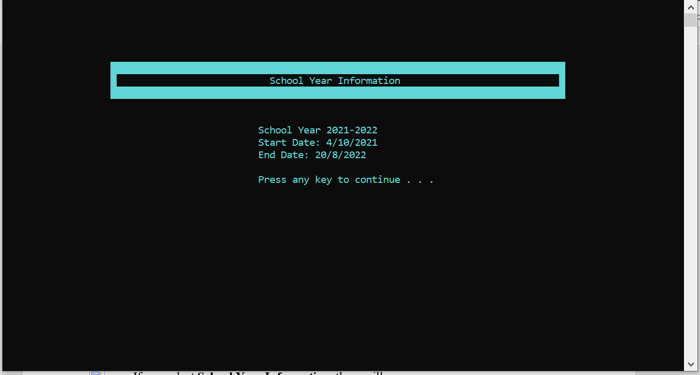

* In **Manage Student,** if you select **Create Classes**, the new window will be created with 5 functions:
  + Create A New Class
  + Load Old Class
  + Add Students Into Class
  + Add Students Into Class From CSV File
  + Back

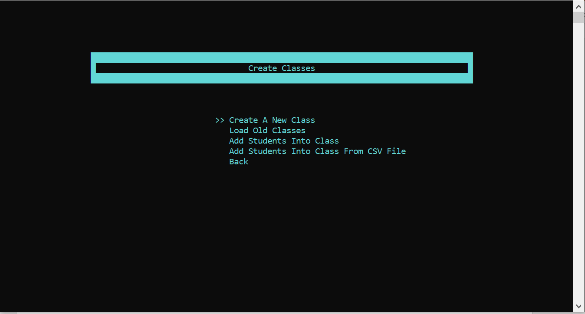

* + In **Create Classes,** if you select **Create A New Class,** it will appear a window for you to enter the new class
  + 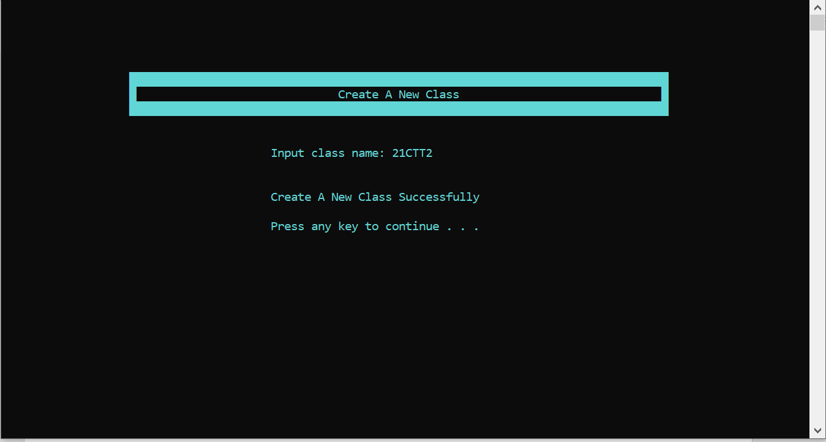In **Create Class,** if you select **Load Old Class,** it will load the old class from the school year before.
  + In **Create Class**, if you select **Add Student Into Class,** first you will enter the class you want to add student, then the number students and finally the student’s inforamtion
  + 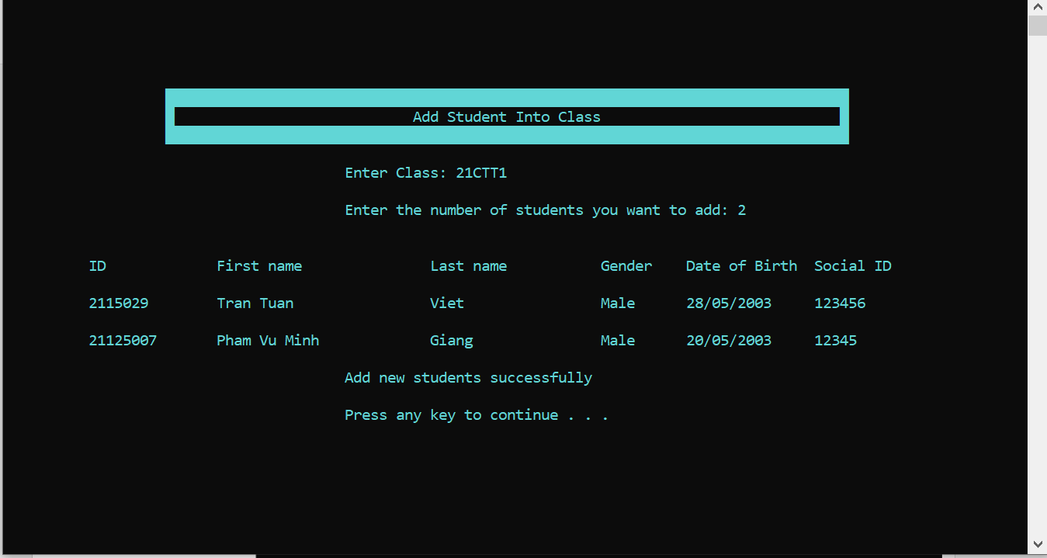In **Create Class,** if you select **Add Student Into Class From CSV File,** the system will find the CSV file of the class you input to to load student

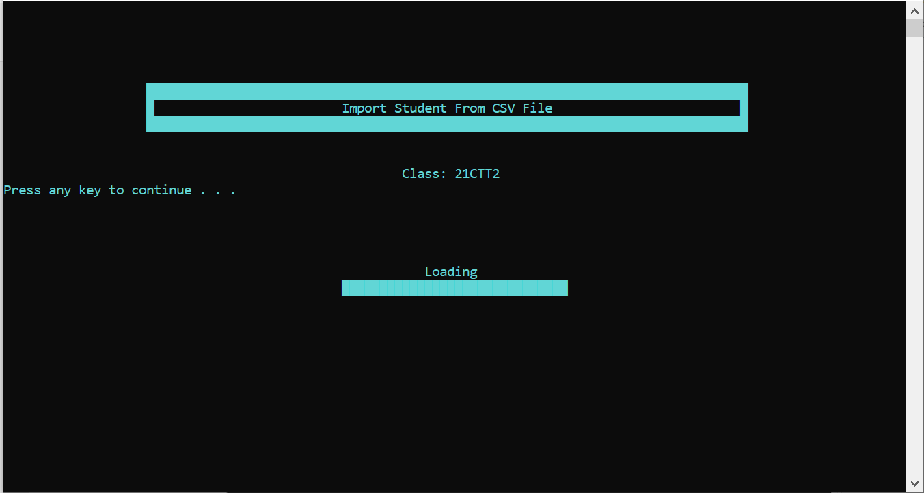

* Now let’s go with **List Of Classes** in **Manage Student** as the image below
  + 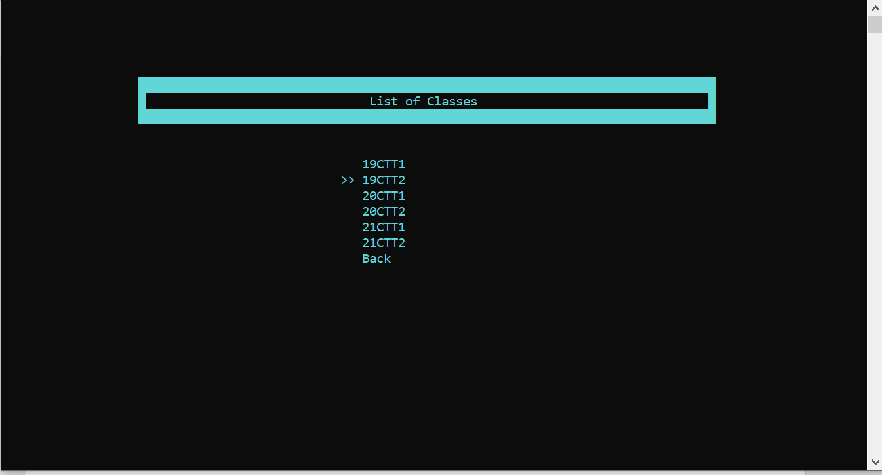If you press enter to any class, it will have 2 kinds of operations:
    - List of Students: to view list of students in the class
    - View Scoreboard: to view the scoreboard of the students in the class

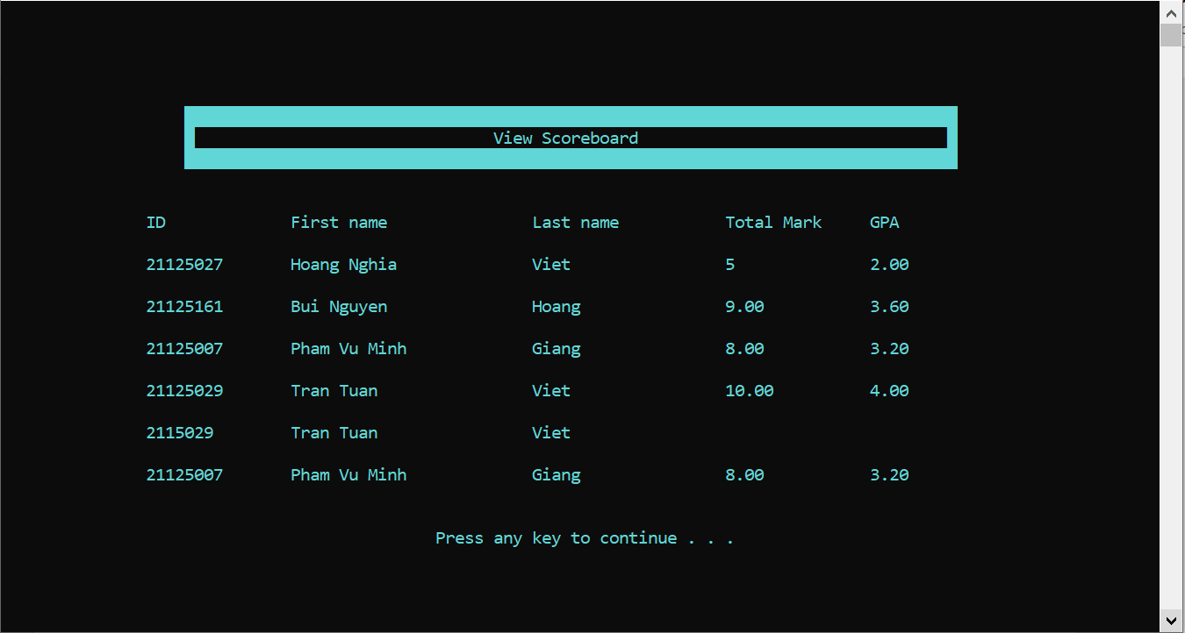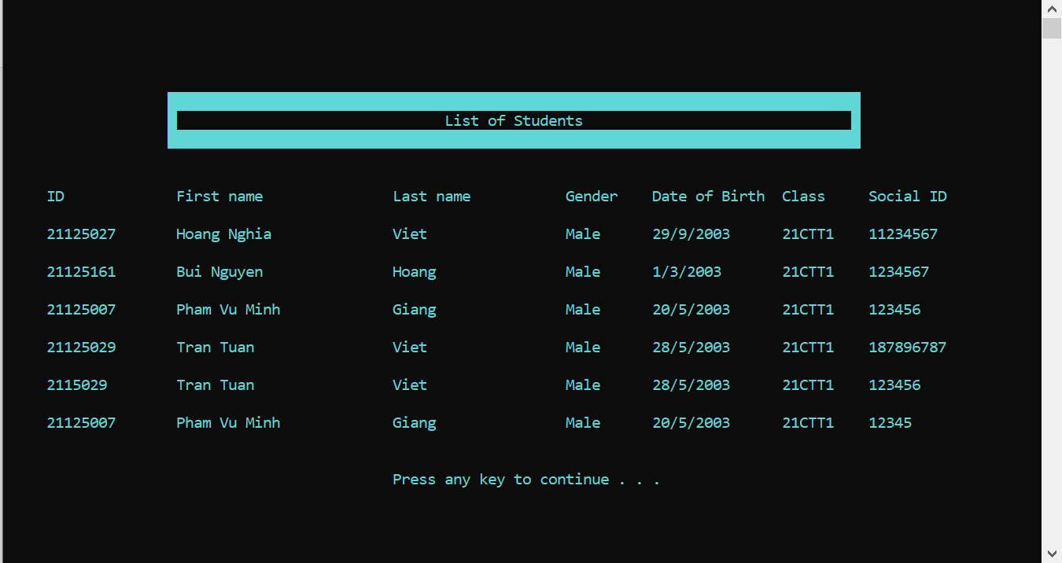

* That is all functions in **Manage Student** button, now let’s continue with **Manage Courses** button
* If you click left mouse button in **Manage Courses** button, there will be 7 kinds of operations:
  + Create A New Semester
  + Semester Information
  + Create Registration Session
  + Course Registration Information
  + Add Courses
  + List Of Courses
  + Back

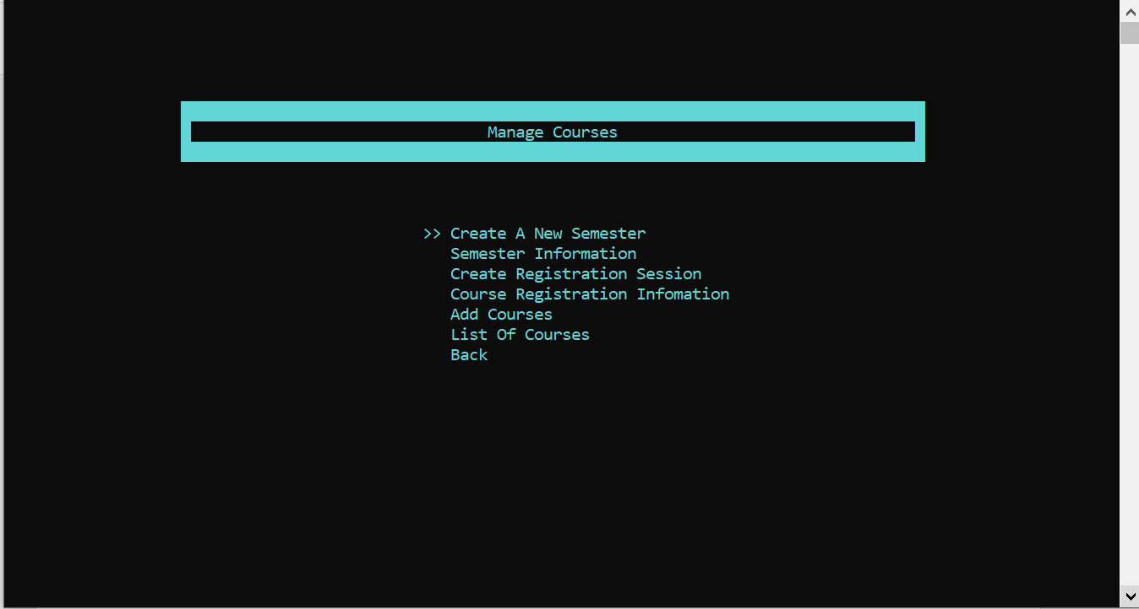

* If you select **Create A New Semester,** there will be the window for user to create a new semester by enter all semester information as this image
* 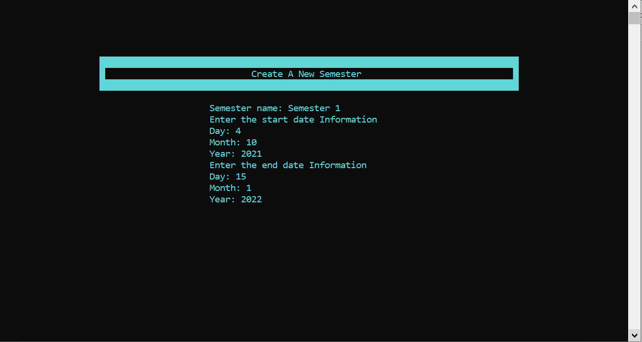After creating a new semester, you can view the semester information by selecting **Semester Information.**
* 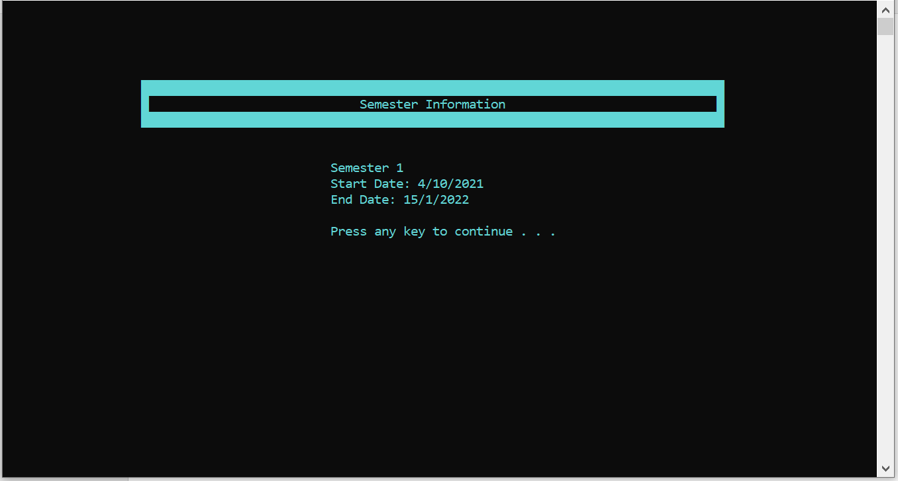Similarly, select **Create Registration Session** to create a new registration session or select **Course Registration Information** to show its information

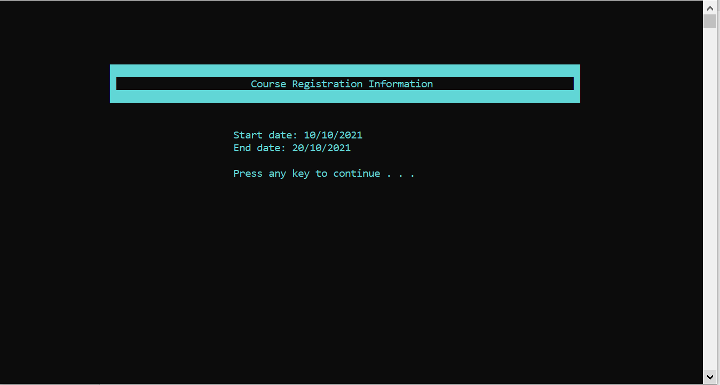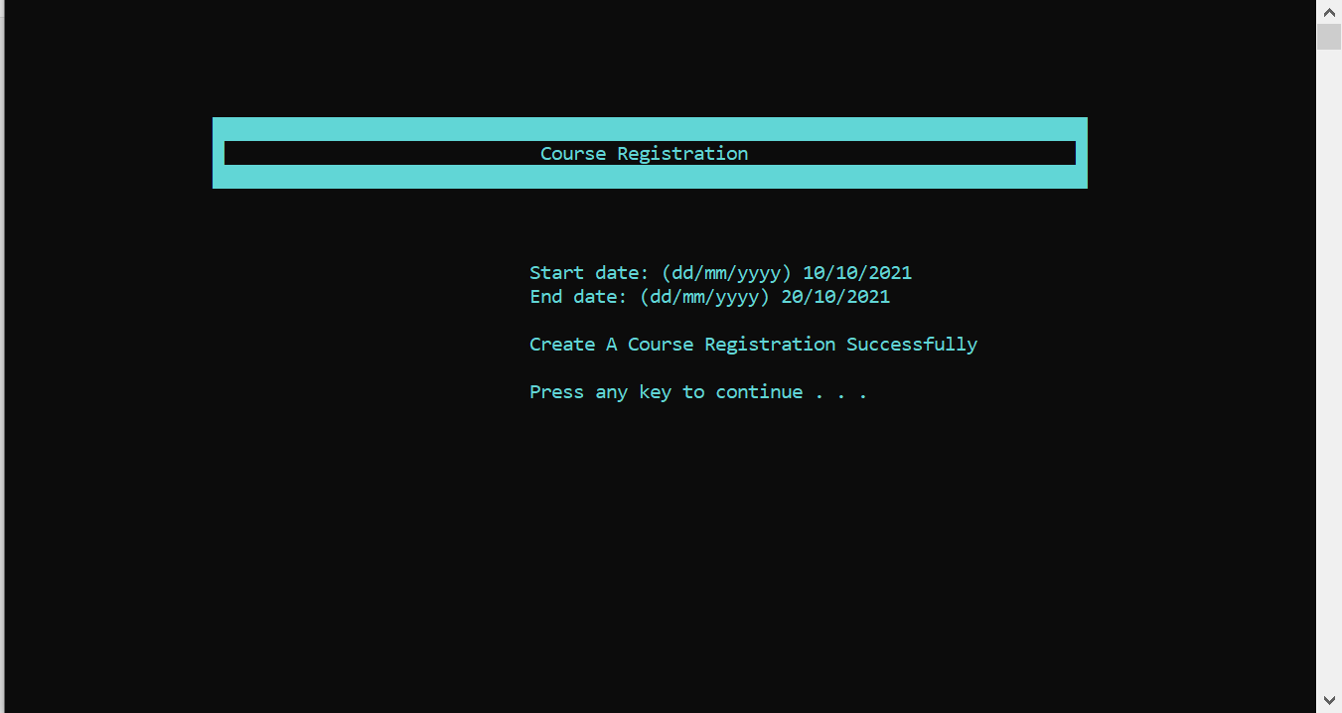

* In **Manage Courses**, if you select **Add Courses,** there are 2 ways to add new courses:
  + By Manual by select **Add Courses**
  + By CSV file by select **Add Courses From CSV File**

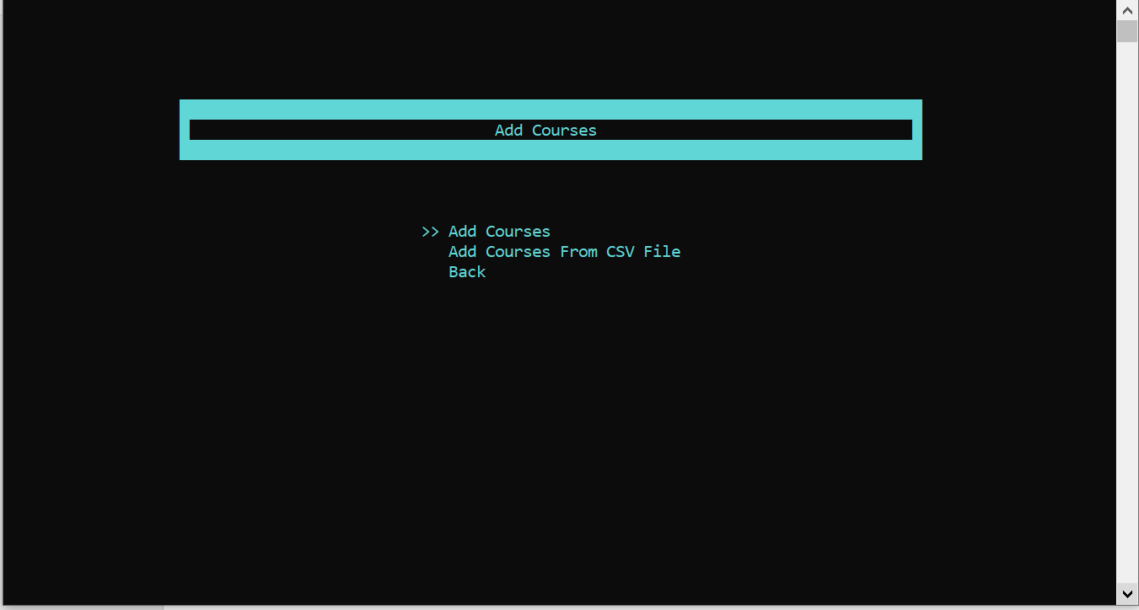

* If you select **Add Courses**, you need to enter the class for the course and the course’s information
* 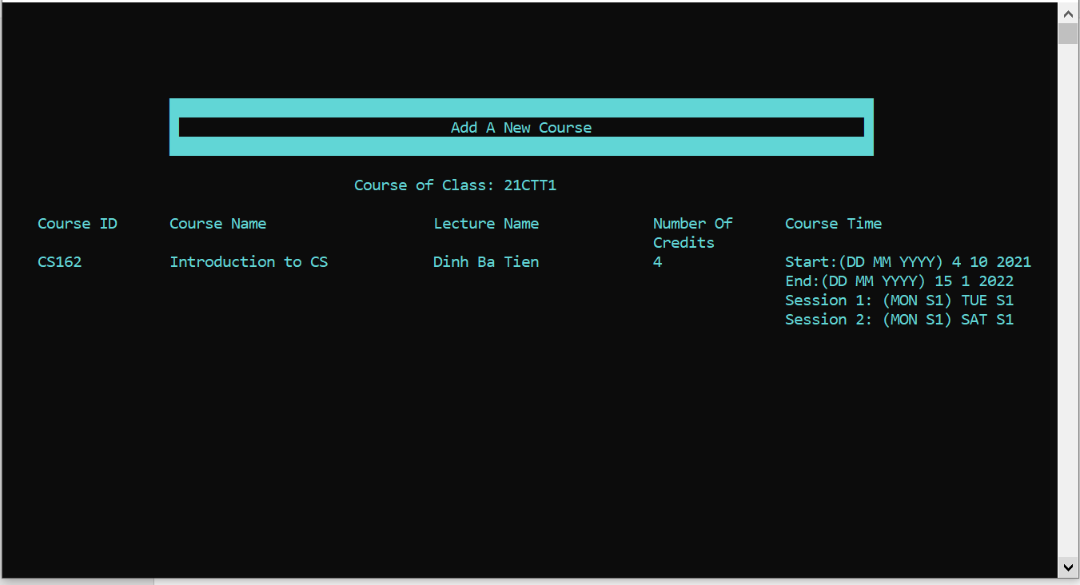If you select **Add Courses By CSV,** it will appear the window for you to enter the class of courses and then the system will find the course’s CSV file to load.

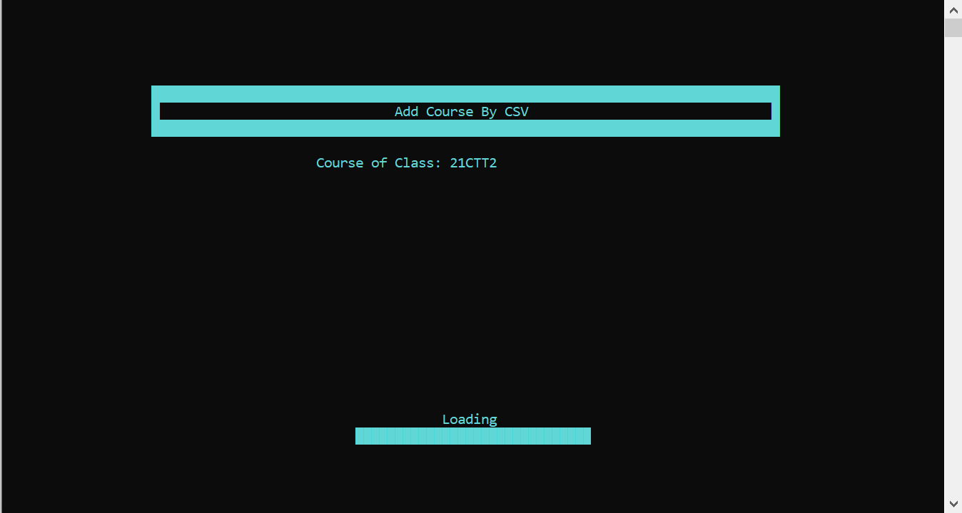

* In **Manage Course,** select **List Of Courses** to view all list of courses

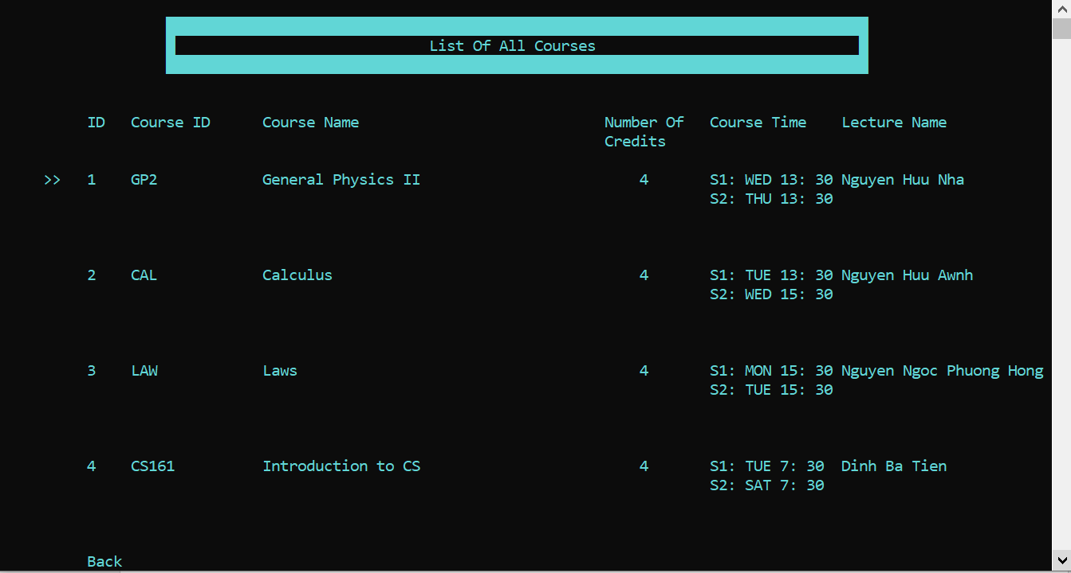

* + If you select a arbitrary courses, there will be:
    - The current course’s information
    - Modify the current course
    - Delete the current course
    - View list of Students in the current course
    - Import Course’s Scoreboard
    - View ScoreBoard
    - Back

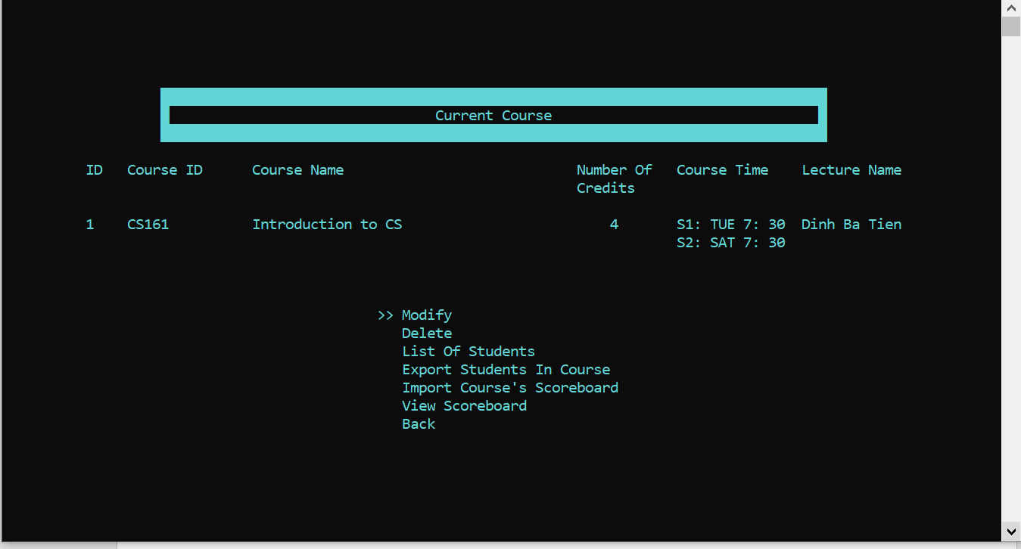

* When you select **Modify,** you will modify the current course’s information

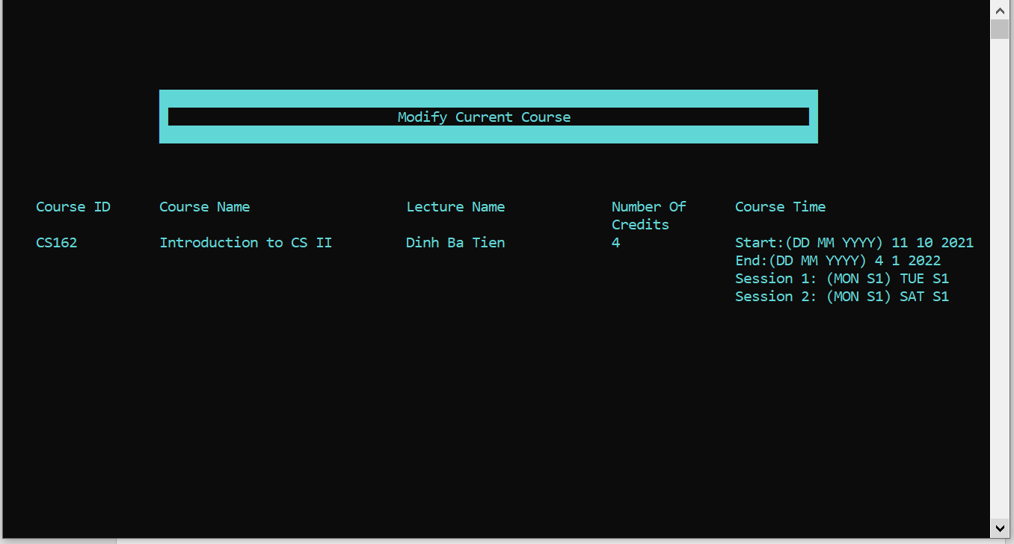

* When you select **Delete**, you will have 2 options to delete the current course or not

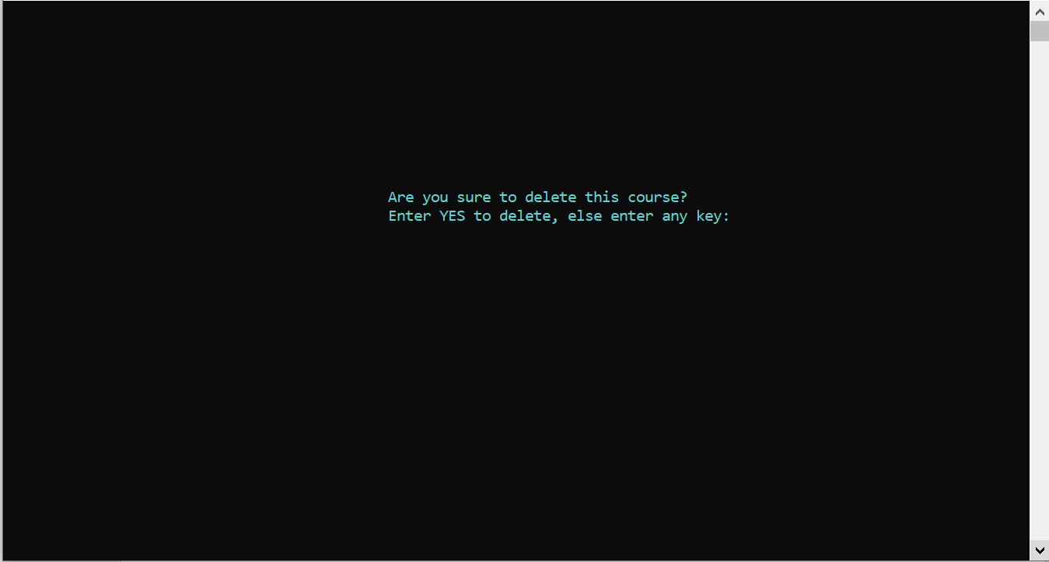

* Select **Lisf Of Student** to view the student enroll this course
* 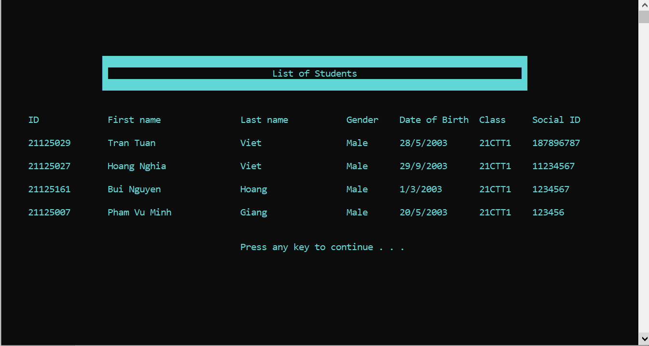Select **Export Students In Course** to export the list students in this course to CSV file in a few second



* Select **Import Course’s Scoreboard** to
* 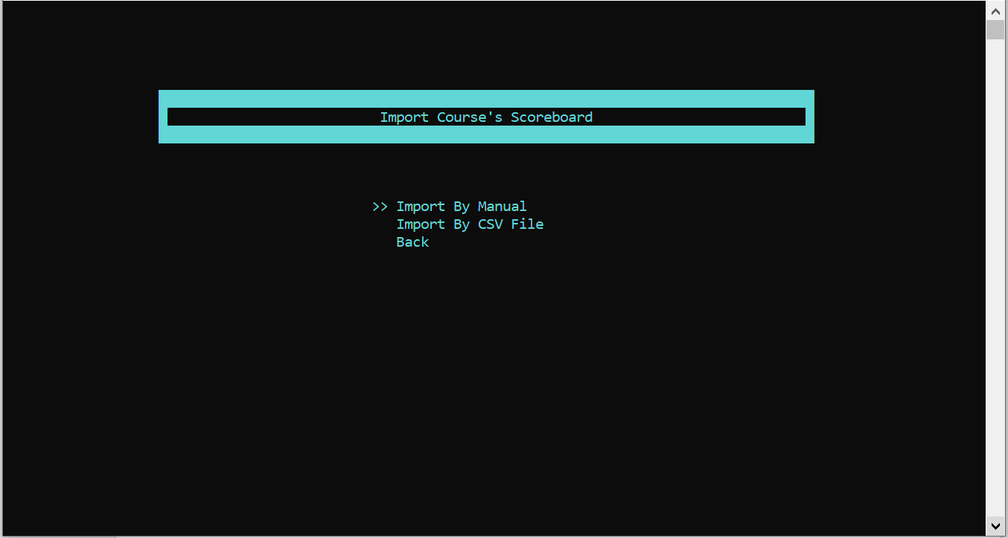Import the scoreboard by manual

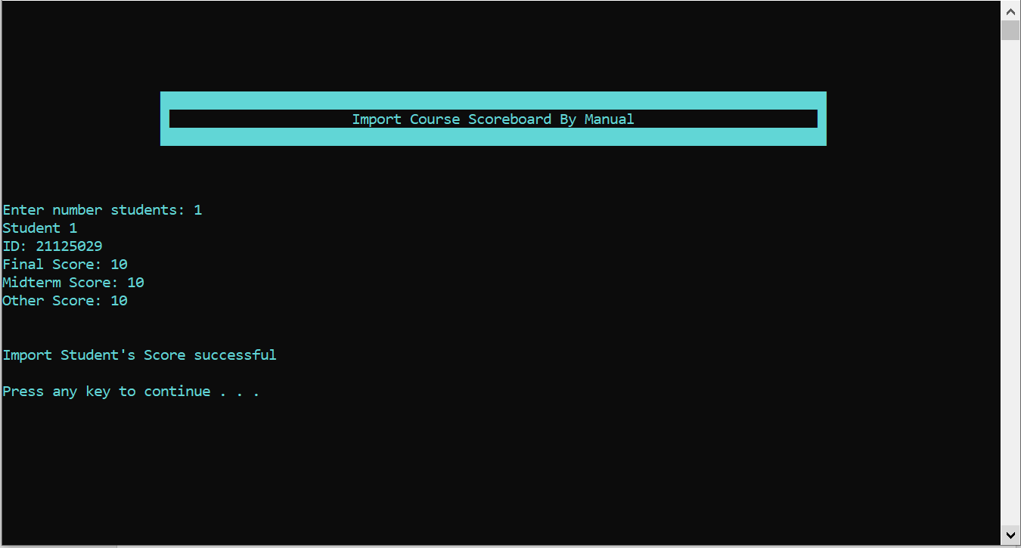

* Import the scoreboard by CSV
* Select **View Scoreboard** to view the student’s score of the current course

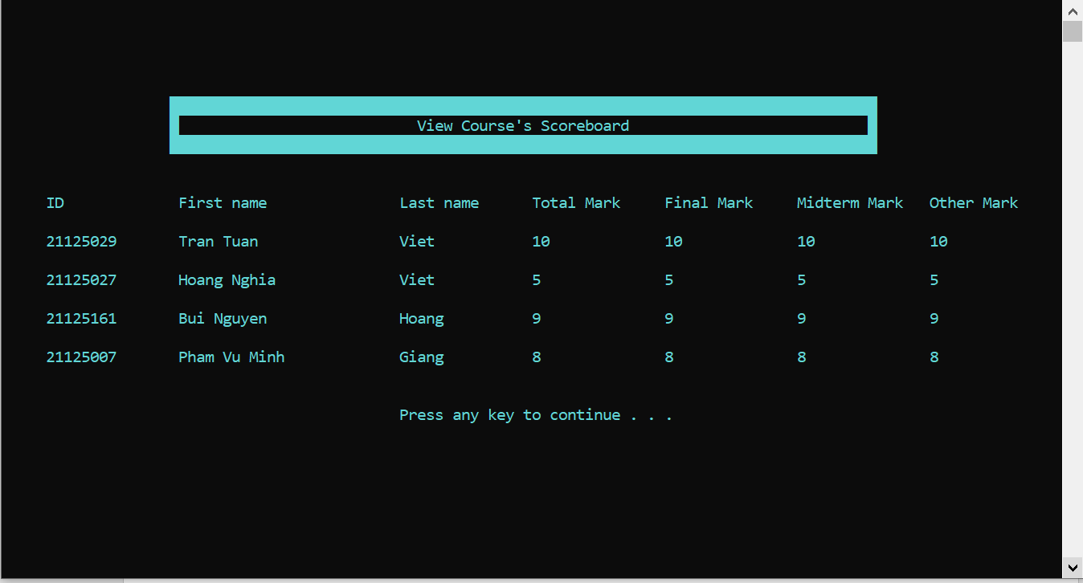

* That is all function of **Manage Courses** button
* If you select **Change Password** button, you will change your current account’s password

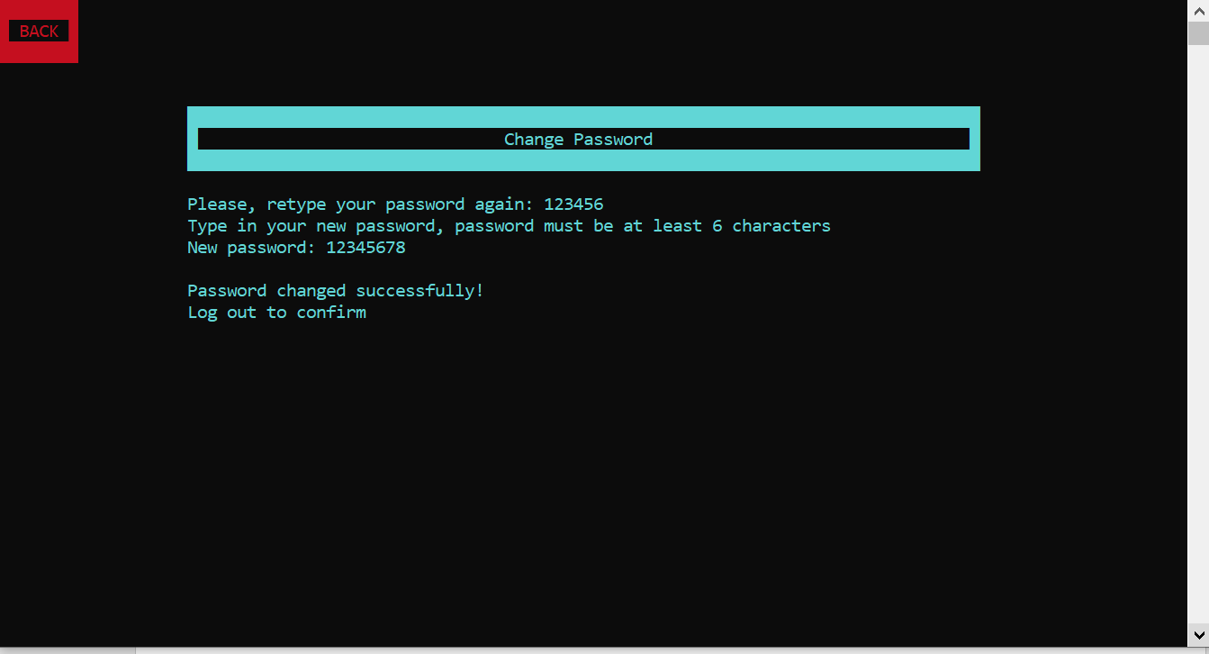

* If you select **Log Out**, you will return to the Login System.

**3. Student System**

* After you login as a student, it will appear the menu interface of a student
* 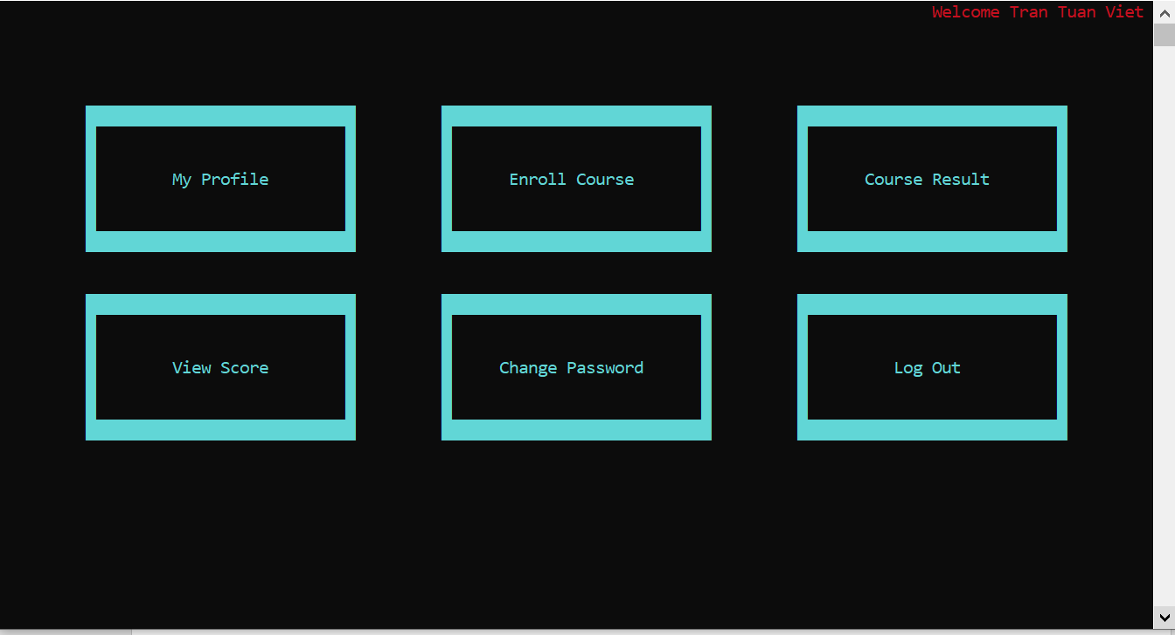If you click left mouse button on **My Profile** button, you will view your profile

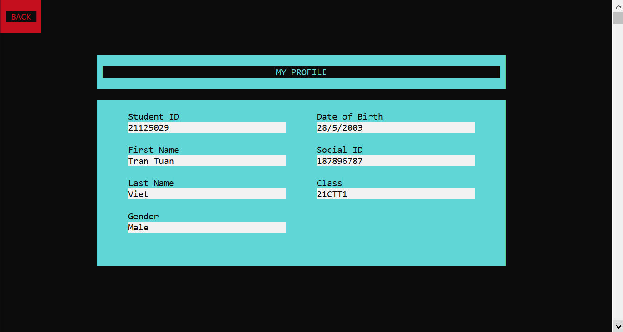

* If you click on **Enroll Course,** it will view all of the courses that student can enroll this semester. The student press enter to any courses, it will create a small red rectangle corresponding with that student will enroll this course, and press again to cancel.
* 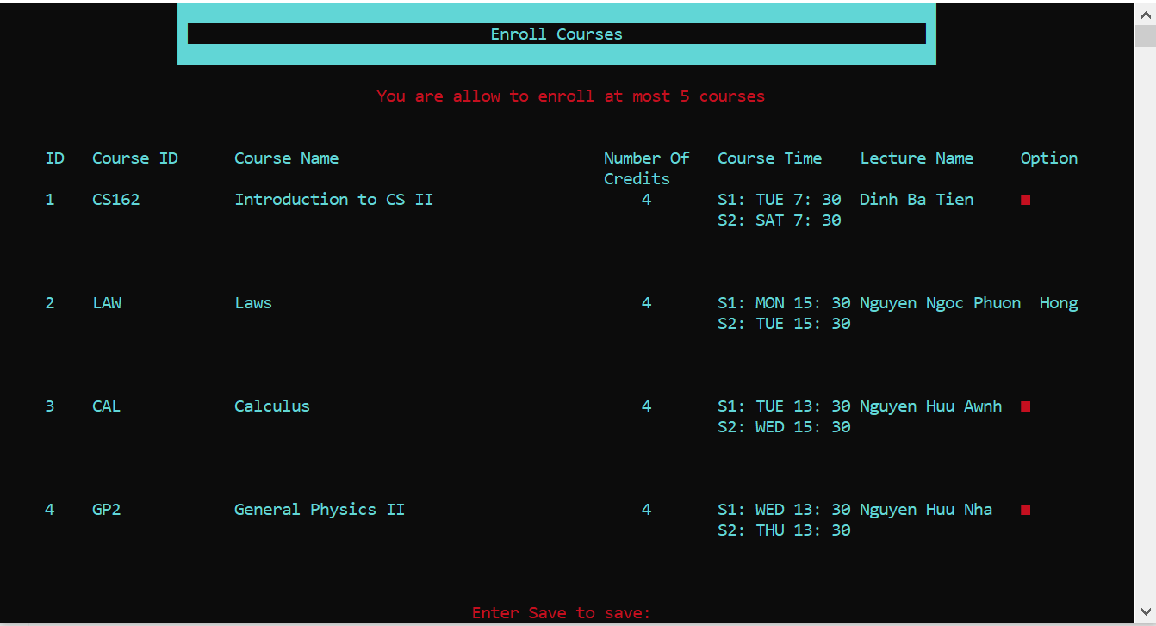If you click on **Course Result**, it will show all courses that student have registrated

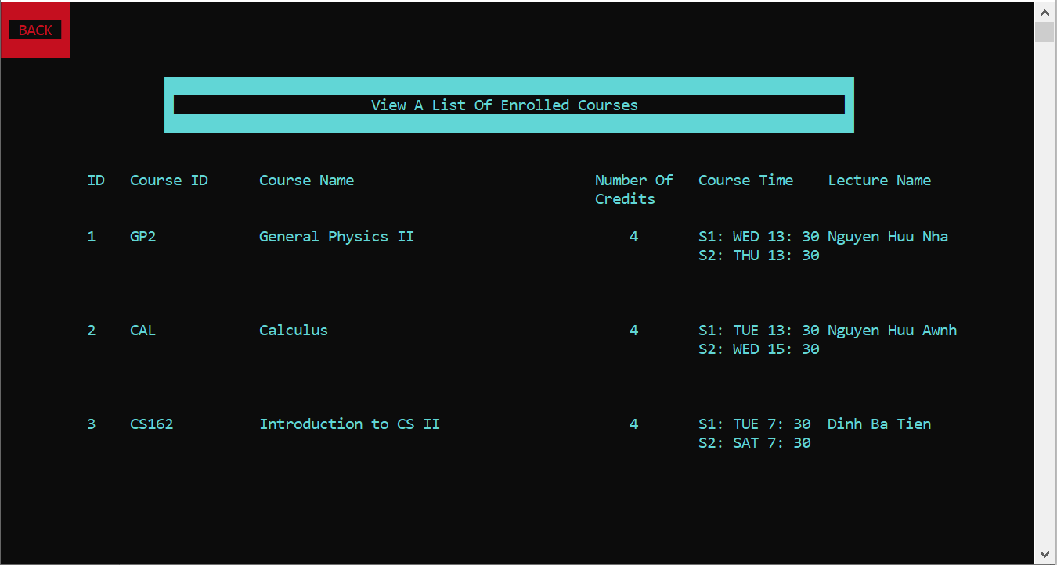

* If you click on **View Scoreboard**, it will show your score of some courses
* 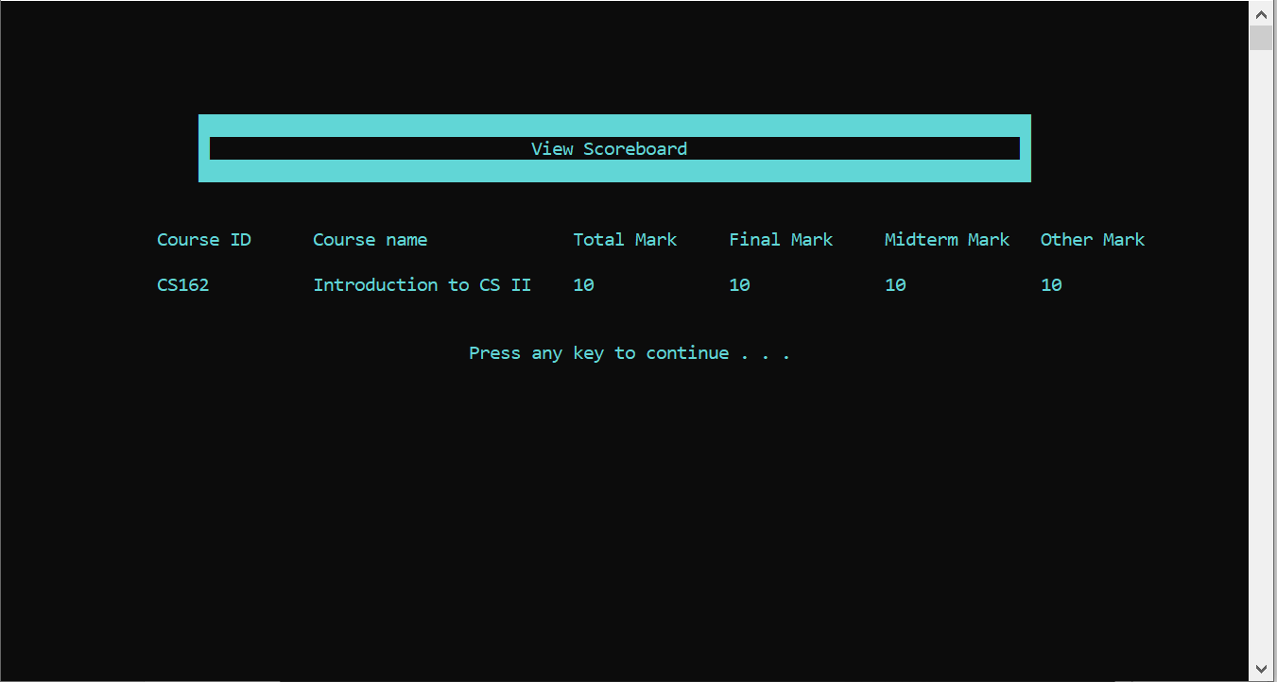If you click on the **Change Password** or **Log Out** button, it will be the same as the staff.
* That is all functions of the Student Users.

1. **List Tasks Done By My Team**

* **Trần Tuấn Việt:**
* Create Staff Class for doing Staff operations
* Do staff function
  + Create a new school year
  + Create several classes for 1st year students
  + Add new 1st year students to 1st-year classes.
    - By manual
    - By CSV
  + Import Student into class from CSV file
  + Create a new semester
  + Create a course registration session
  + Add a course to this semester
    - By manual
    - By CSV
  + View the list of courses.
  + Update course information.
  + Delete a course.
  + View a list of classes.
  + View a list of students in a class.
  + View a list of courses.
  + View a list of students in a course
  + Export a list of students in a course to a CSV file
  + Import the scoreboard of a course.
    - By manual
    - By CSV
  + View the scoreboard of a course.
  + Update a student result.
  + View the Scoreboard of a class include total mark and GPA
* Design the interface(front end) for the project.

**Đỗ Vương Quốc Thịnh**

* Login/Logout function:

o Login system with student user

o Login system with staff user

o View staff profile

o View student profile

o Change staff’s password

o Change student’s password

o Log out student user

o Log out staff user

**Phạm Vũ Minh Giang**

Design struct and write functions for: class, course, student

* Class: saving a class information, adding a student into a class, adding a course into a class, showing all students information of a class, showing all courses information of a class, loading last class’s data.
* Course: showing a course’s information, updating a course’s information, adding a new student into a course (for registration and class’s scoreboard), removing a student from a course, saving a course’s data and adding a course, showing course’s scoreboard, loading last course’s data.
* Student: showing student’s information, enrolling a course, showing all enrolled courses’s information, saving a student’s information, deleting course from a list of enrolled courses, loading last student’s data.

*All functions above are working with the database.

**Trần Thúc Minh Trí**

* Check the Notepad files to make sure that the Course names, teacher names and course codes are spelled correctly.
* Perform some final checks to test if the program is running as planned.