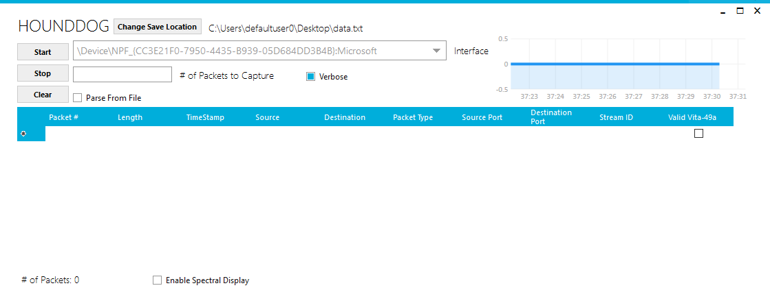

This is the main window of HOUNDDOG.

The arrows are pointing to the key features of HOUNDDOG on the main menu.

**Green Arrow:** This is the start button, use this to begin the packet capture and parsing.

**Red Arrow:** This is the stop button, use this to stop the packet capture and parsing.

**Gray Arrow:** This is the clear button, it will clear out the data table referenced by the light blue arrow.

**Dark Blue Arrow:** Change the save location of the parsed packet output.

**Dark Green Arrow:** Limit how many packets you capture, up to 1 million. If no value is entered, it won’t stop capturing packets until you hit stop or close HOUNDDOG.

**Pink Arrow:** Allows you to parse through a pcap file.

**Yellow Arrow:** Changes the verbosity of the parsed output file.

**Black Arrow:** Use this to select an interface to capture packets from.

**Dark Purple Arrow:** To enable the spectral display.

**Orange Arrow:** Live Packet Capture chart. Y axis is # of packets, and X axis is time. It updates every 500 ms.

**Light Blue Arrow:** Live Data Table, updates as packets are captured and parsed.

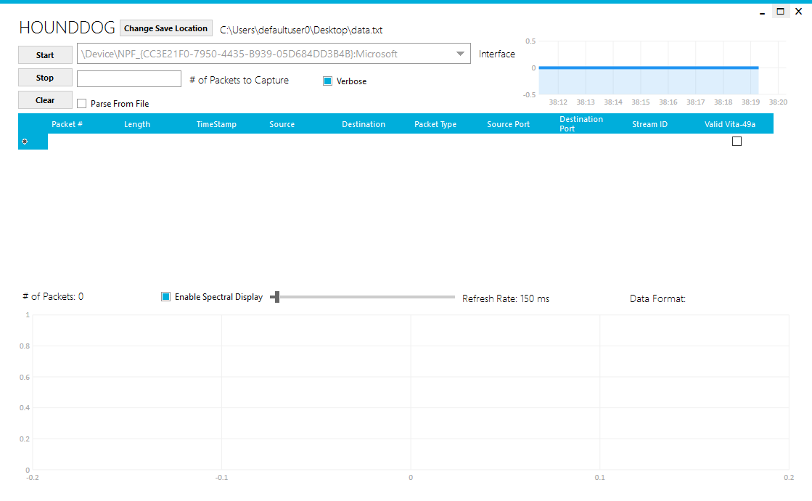

This is HOUNDDOG with the Spectral Display enabled. When the Spectral Display is enabled, it unlocks the refresh rate for the chart and the Data Format Field.

**Dark Blue Arrow:** Refresh Rate slider, you can set it anywhere from 1ms up to 5000 ms (5 seconds)

**Green Arrow:** Tells you if the data is Real, Complex Cartesian, or Complex Polar

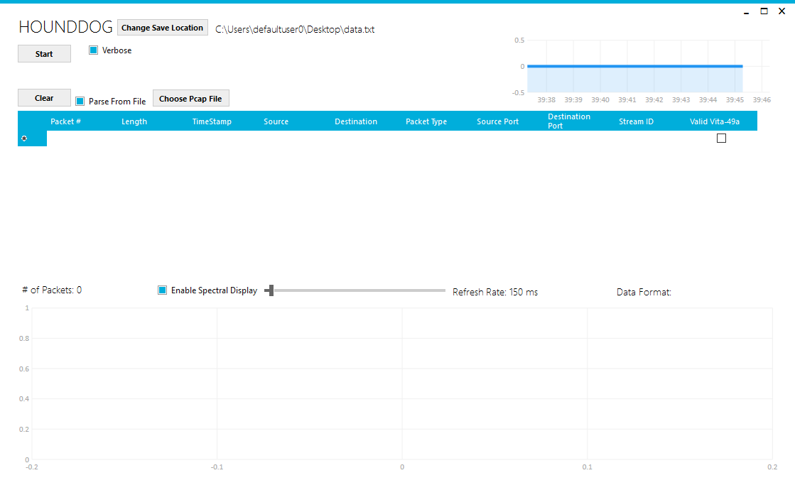

This is HOUNDDOG in File Parsing Mode with the Spectral Display Enabled.

**Purple Arrow:** This button allows you to choose a pcap file to parse through.

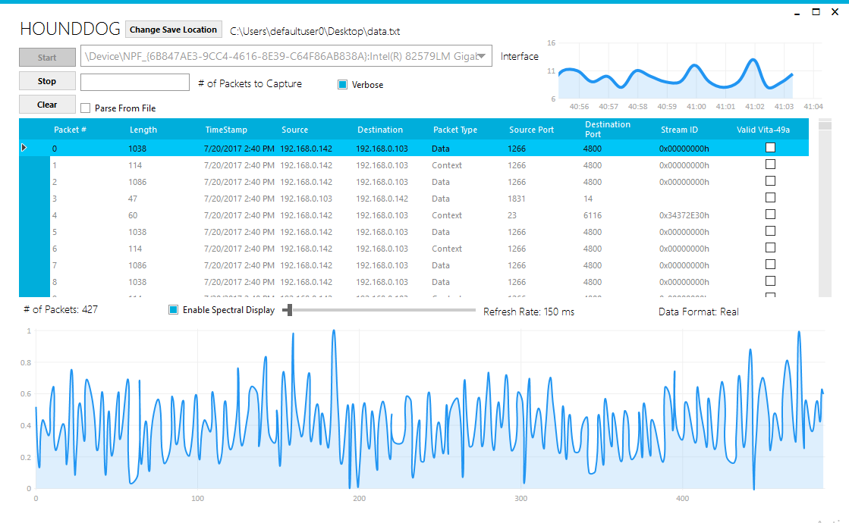

An example of HOUNDDOG in action. This is from a live capture of a MMS.

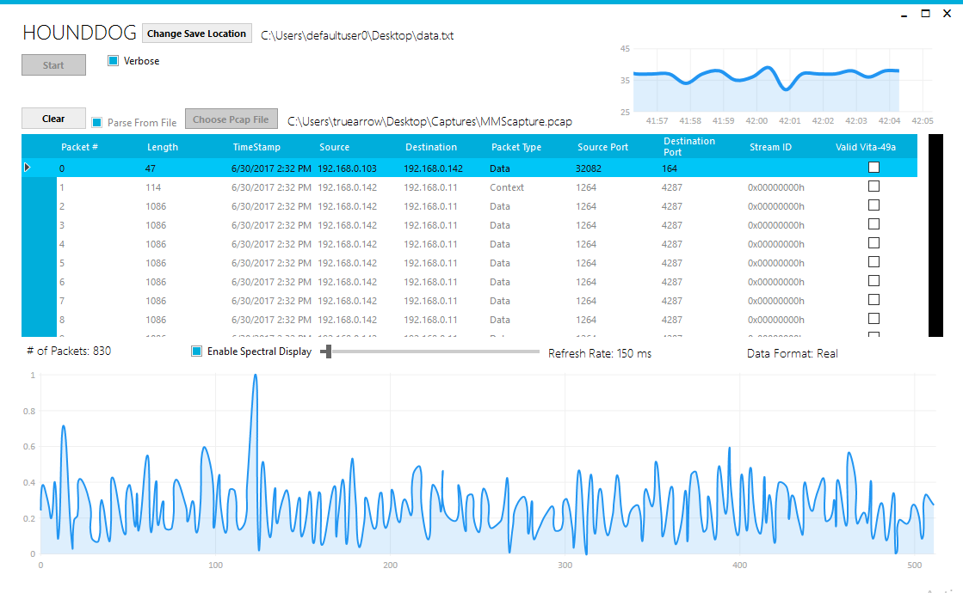Another example of HOUNDDOG in action. This is from a pcap file being loaded and parsed.