 | Laboratory Assignment Number 8 for ME 218b  Due by 5:00 pm on February 5, 2026
Part 1: A Simple Mobile Platform
Assignment:
You are to design and build a mobile platform that will be able to begin in a random orientation at position A. There will be a beacon placed approximately as shown in the diagram below. The beacon will pulse infrared light at a frequency of 1427Hz. Your droid should query the Command Generator over SPI (protocol and command descriptions in Appendix A) and follow the commands to position itself. Get a sign-off from a TA/Ed/lab coach after demonstrating your completed vehicle.
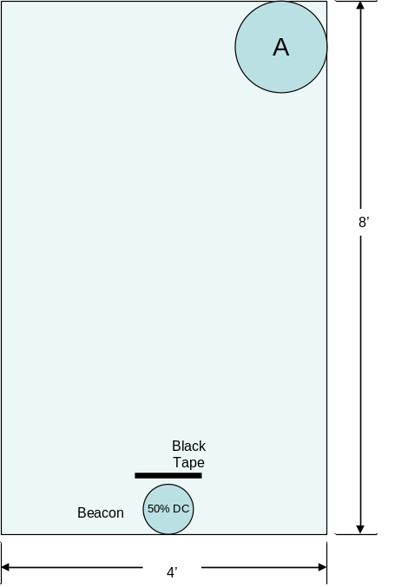
❑ | 1.1) | Your vehicle must be constructed from scratch using the motors and wheels provided and carry the PIC32, Command Generator and other electronics of your choosing. It should use a tether to supply power and may connect to the PC to display debugging messages. The motors and wheels may not be modified and must be returned in good working order at the end of the lab. Note1: the motor leads are somewhat fragile. Please be sure to strain-relieve them to prevent fatiguing the motor connections.
In the report:
The report should include a description of the mechanical hardware design, electrical hardware design (schematics and design calculations), along with state charts and pseudo-code for the software. Additionally, include a narrative description of the hardware and software (brief and to the point, max. 1 page each), and a Highlighted listing of the final software that was implemented. When copying your code into your report, please use the Highlight program to prepare an RTF file using the “bright” color theme. You can then open the RTF file in Word and copy and paste the code into your report and it will maintain the color highlighting. Look at the code that you paste into your report. If the indenting is messed up anywhere, it means that you had tab characters in your source files. If the indenting is messed up, clean this up before running Highlight again and submitting your report.

Table of Pins

Motor Output (OC, PWM)
Controlled Motor | Pin# on PIC32 | Port on PIC32 | PWM Channel PIC32 | Pin# on L293NE | Port on L293NE
M1+ | 11 | RB4 | 1 | 2 | 1A
M1- | 14 | RB5 | 2 | 7 | 2A
M2+ | 18 | RB9 | 3 | 10 | 3A
M2- | 24 | RB13 | 4 | 15 | 4A

Input Capture (IR Sensor)
Pin# on PIC32 | Port on PIC32 | # of IC
6 | RB2 | 1

Design Calculations

