Database Performance Dashboard
CS5226 Database Tuning Project
Present By
Gu Yang A0040661R
Lu Fangjian A0040740W
Yang Zhaoyu A0040953J
Zhang Haojun A0032586A
2013/04/09

Project Admin
S/N | Task | Member*
1 | 3 levels of breakdown for each database parameter being monitored. | Gu Yang  Lu Fangjian  Yang Zhaoyu  Zhang Haojun
2 | Provide a configuration page(s) to define the various thresholds used to determine whether a specific database parameter is healthy, not so healthy or need DBA attention. | Gu Yang  Lu Fangjian
3 | For each of the performance issue identified that is in the “red” area, the application should provide information on the parameter in init.ora that should be modified in order to solve the performance issue. | Gu Yang  Zhang Haojun
4 | On-demand reports – where the users can specify the date ranges for the database parameters being monitored. | Lu Fangjian
5 | A Debug interface – Allow the user to issue SQL commands to the database. The results should be displayed neatly on the webpage. | Zhang Haojun
6 | README.txt | Gu Yang
7 | Database Setup Scripts | Gu Yang
8 | Configure the web development framework (Spring 3.2.0). Setup the project on google code. | Lu Fangjian
9 | UI design and modification. | Lu Fangjian  Yang Zhaoyu
10 | Configure connection parameters to dbtune server. | Lu Fangjian  Yang Zhaoyu
11 | Structure design and implement of the background program to query the database and calculate results. | Lu Fangjian  Yang Zhaoyu
12 | Configure database for testing. | Yang Zhaoyu
13 | Project Report writing. | Gu Yang  Lu Fangjian  Yang Zhaoyu  Zhang Haojun
*Members are listed in alphabetic order
Part 1. System Designs and Architecture
1.1 The overall architecture and design of the application
The web application uses the pre-installed Oracle database in dbtune server to perform its main activities, which is to monitor a set of database parameters, and to query database through debug window. The database is also acted as permanent storage for the configuration data.
The development of the web interface follows the popular Model-View-Controller (MVC) approach using Spring Framework 3.2.0. The various application layers are separated distinctly in different classes. The detailed relations are illustrated below.

Class | Folder | Role
*TO.java | domain | Transfer objects are data carriers which are used in Presentation layer (web interface), Service layer and DAO layer.
*.jsp | view | Views are web pages which receive transfer objects from controller and display them to user. They also allow user to send inputs to controller for processing.
*Controller.java | controller | Controllers fetch the transfer objects and send them to the view for display. They also receive user inputs and send them to service layer for analysis.
*Service.java | service | Services are implemented with business logics to perform analysis. They may also fetch transfer objects from DAO layer during the process.
*Dao.java | dao | Data access objects retrieve data from permanent storages such as database, put them into transfer objects and send them to service layer for analysis.
*Util.java | util | Constants and static variables/methods which can be utilized to perform certain functions.
Part 2. Database Design, Statistics Computation and SQL Commands
2.1. Database Support for the Dashboard
The dashboard requires some thresholds parameters to be stored in the database. These thresholds parameters determine the status of database, whether it is HEALTHY, MODERATE or ATTENTION. To store the thresholds parameters, we build a single table and populate it with some default values that can be modified later through our web application. The SQL scripts are setup.sql and data.sql (which are in the subfolder /Scripts):

Filename: setup.sql
DROP TABLE THRESHOLD_PARAM;

CREATE TABLE THRESHOLD_CONFIG
(
PARAM_NAME VARCHAR2(100 BYTE),
PARAM_WARNING NUMBER(10, 2),
PARAM_CRITICAL NUMBER(10, 2)
);

Filename: data.sql
delete from THRESHOLD_CONFIG;
insert into THRESHOLD_CONFIG(PARAM_NAME, PARAM_WARNING, PARAM_CRITICAL) values ('Shared Pool',40,60);
insert into THRESHOLD_CONFIG(PARAM_NAME, PARAM_WARNING, PARAM_CRITICAL) values ('Buffer Cache',80,60);
insert into THRESHOLD_CONFIG(PARAM_NAME, PARAM_WARNING, PARAM_CRITICAL) values ('Redo Log Buffer',30,40);
insert into THRESHOLD_CONFIG(PARAM_NAME, PARAM_WARNING, PARAM_CRITICAL) values ('Memory Area Used For Sorting',50,20);
insert into THRESHOLD_CONFIG(PARAM_NAME, PARAM_WARNING, PARAM_CRITICAL) values ('Redo Log Files',1000,9000);
commit;

We will monitor following statistics: “Share Pool Free %” for “Shared Pool”, “Buffer Cache Hit Ratio” for “Buffer Cache”, “Redo Allocation Hit Ratio” for “Redo Log Buffer”, “Memory Sorts Ratio” for “Memory Area Used For Sorting”, and “Redo Log Files Total Waits” for “Redo Log Files”.
Each of them will have two thresholds: PARAM_WARNING and PARAM_CRITICAL. If the value monitored becomes greater than PARAM_CRITICAL, ATTENTION is alarmed. If the value monitored is between PARAM_WARNING and PARAM_CRITICAL, MODERATE is displayed. Otherwise the database is HEALTHY.
However, for “Buffer Cache Hit Ratio” and “Memory Sorts Ratio”, the greater the value monitored, the healthier the database is. Hence for those two, threshold PARAM_WARNING is greater than threshold PARAM_CRITICAL.
2.2. The Statistics Computation
The statistics monitored are “Share Pool Free %” for “Shared Pool”, “Buffer Cache Hit Ratio” for “Buffer Cache”, “Redo Allocation Hit Ratio” for “Redo Log Buffer”, “Memory Sorts Ratio” for “Memory Area Used For Sorting”, and “Redo Log Files Total Waits” for “Redo Log Files”.
Most statistics (except the “Redo Log Files Total Waits”) can be directly retrieved (or calculated) from DBA_HIST_SYSMETRIC_SUMMARY table. We only need to specify the corresponding metric_id.
The query will need start and end time, to calculate the average value during that time range. The top-level will calculate the average during last one day. The second and low level will split given time range with given interval, to calculate start and end time for each row to be displayed, and retrieve the value by querying the DBA_HIST_SYSMETRIC_SUMMARY table.
SELECT metric_id, metric_name, avg(average) value
FROM dba_hist_sysmetric_summary
WHERE
metric_id = metric_id_passed_in
AND end_time > start AND end_time < end
GROUP BY metric_id, metric_name

Note the metric_id_passed_in, start and end are parameters for the function to create above query. The metric_id_passed_in depends on the statistic that is currently investigated by DBA.
For the “Redo Log Files”, the DBA_HIST_SYSTEM_EVENT table records down total_waits for different events. We combine it with the DBA_HIST_SNAP_SHOT table to get the average total waits for event_name 'log file parallel write':
SELECT avg(a.total_waits)
FROM dba_hist_system_event a, dba_hist_snapshot b
WHERE
b.snap_id = a.snap_id
AND a.event_name ='log file parallel write'
AND b.end_interval_time > start
AND b.end_interval_time < end

Similarly, start and end are the parameters for the function to create above query.
2.3 The Oracle Advisory
Besides the statistics monitored, we also noticed that Oracle now provide advisory for “Shared Pool” and “Buffer Cache”, which gives estimated performance change if the corresponding parameter in init.ora is adjusted.
We think it would be helpful for DBA to have that information when using our dashboard:
SELECT avg(a.total_waits) shared_pool_size_for_estimate, shared_pool_size_factor, estd_lc_time_saved
FROM v$shared_pool_advice

SELECT size_for_estimate, buffers_for_estimate, estd_physical_read_factor, estd_physical_reads
FROM v$db_cache_advice
Part 3. Screenshots

3.1. Login
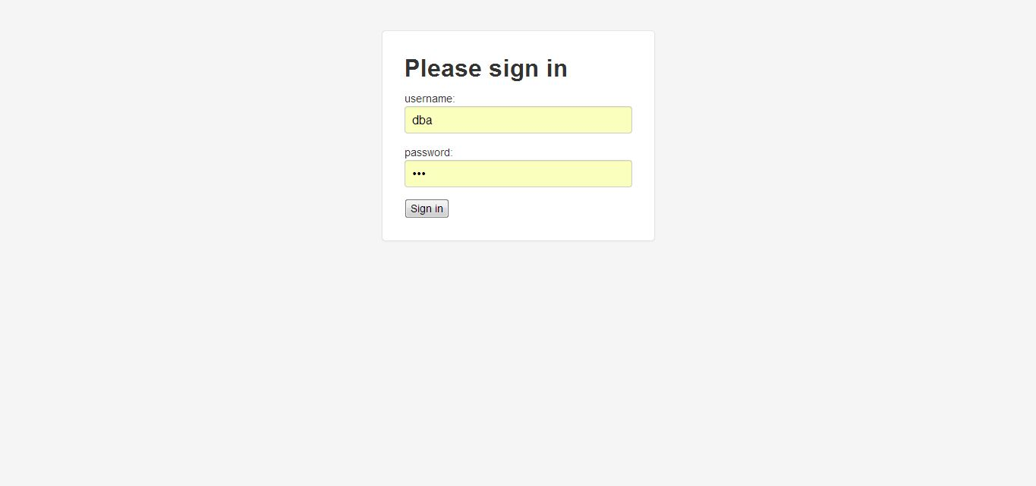
Login in as DBA before starting using the web application.

3.2. Overall Database
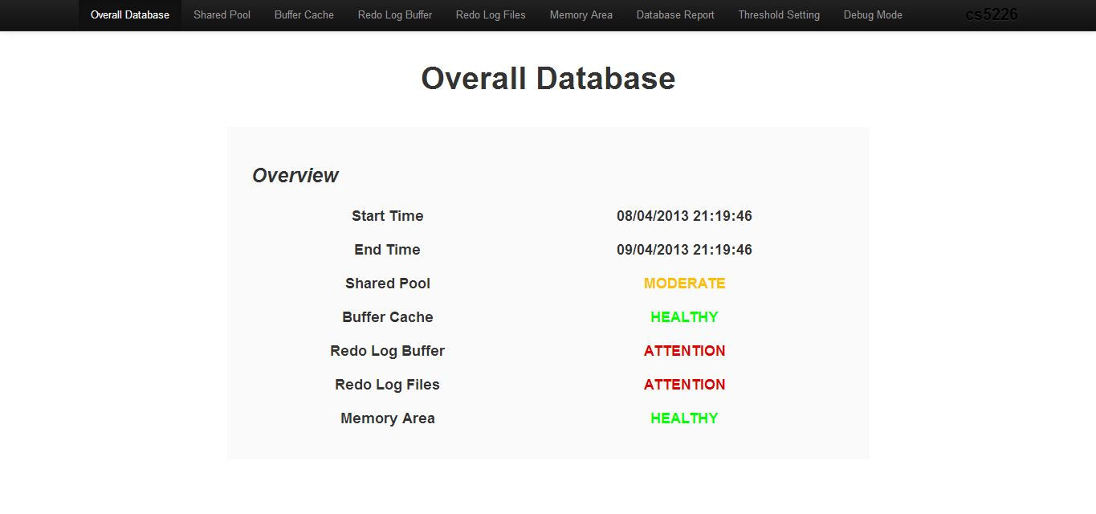

Home page contains an overall view of five monitored parameters of the database during last 24 hours. The status of ATTENTION is linking to an advisor page, will show in details in 3.3.
3.3. Overview
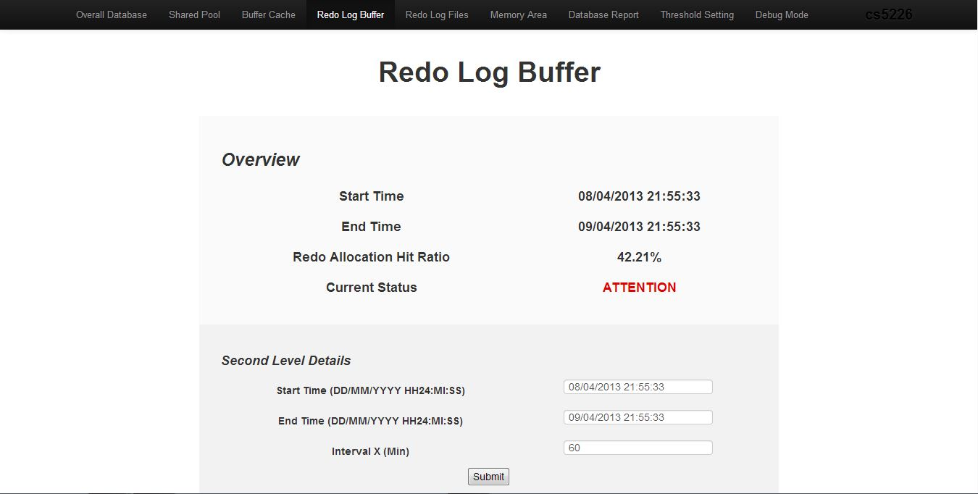

Overview of a parameter status in last 24 hours includes HEALTHY, MODERATE and ATTENTION. Provide DBA the option to choose any range and interval for second level details.
Here we also provide a special feature such that provides advisor on ATTENTION status, when click on the ATTENTION link, it will show the advisor for DBA. There are two types of advisor we provide, one is with quantified potential performance gain and the other is text suggestion. In addition, both types of advisor will provide link to official oracle document.

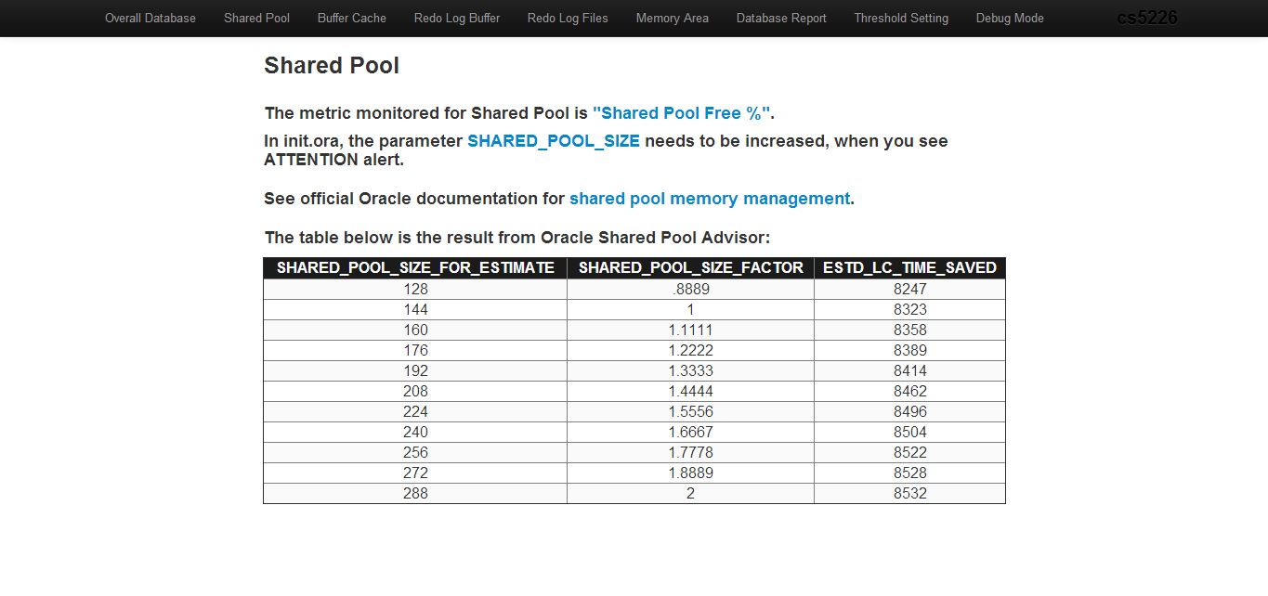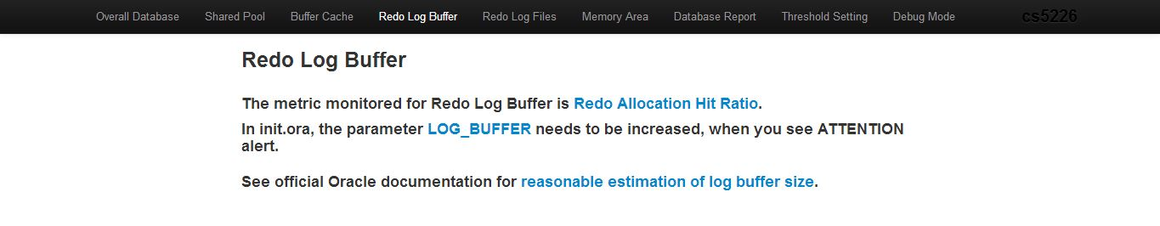
3.4. Second level details
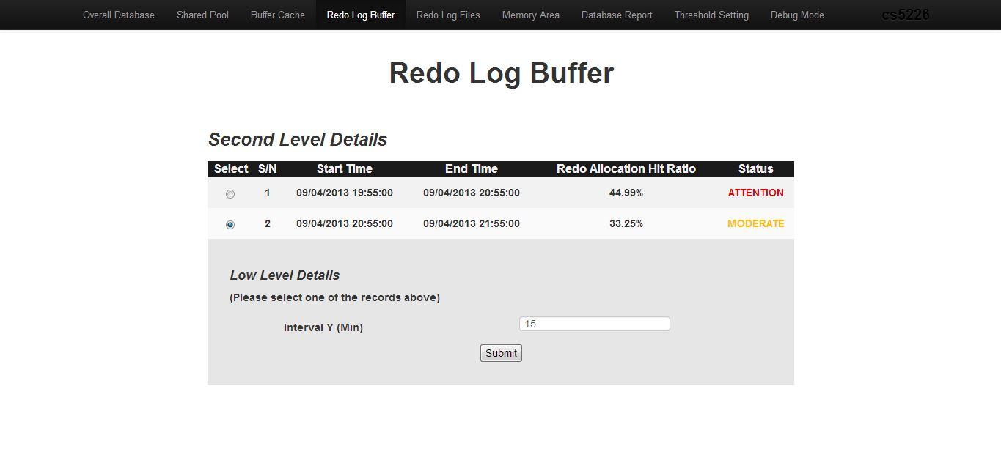
The second level details with range 2 hours and interval 60 minutes. Slightly different from Overview page, we provide DBA the option to choose certain date range and any interval. At this page, the status of ATTENTION is also linking to the advisor page.
3.5. Low level details
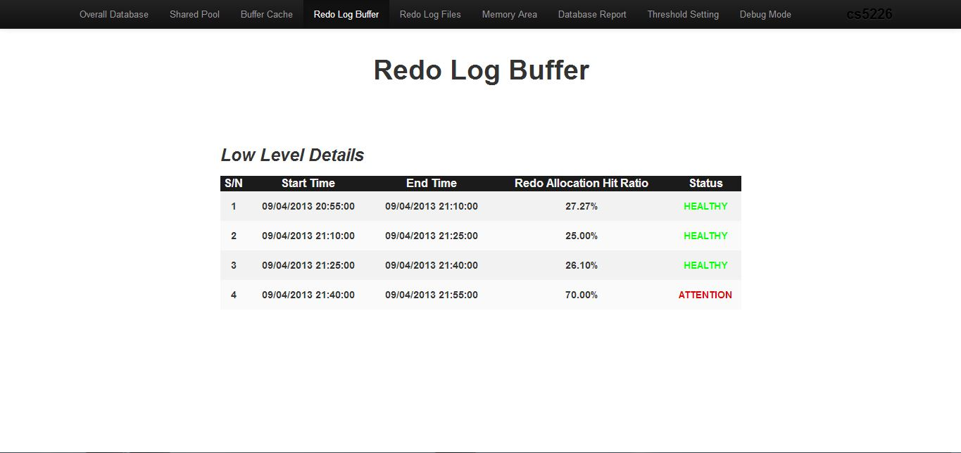

The low level details with interval 15 minutes. Similar to second level details, ATTENTION status is linked to an advisor page.
3.6. Database Report
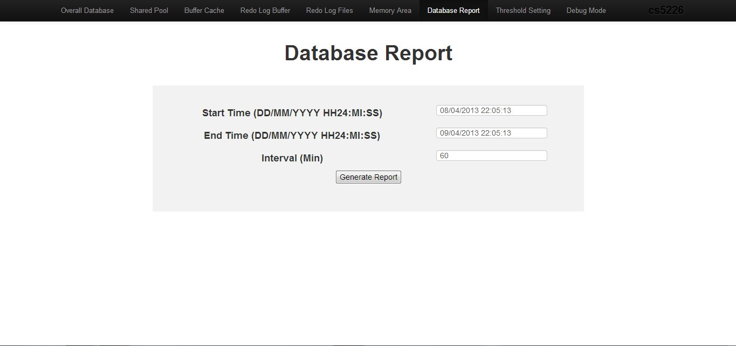

Choose the criteria of database report and then click generate report.

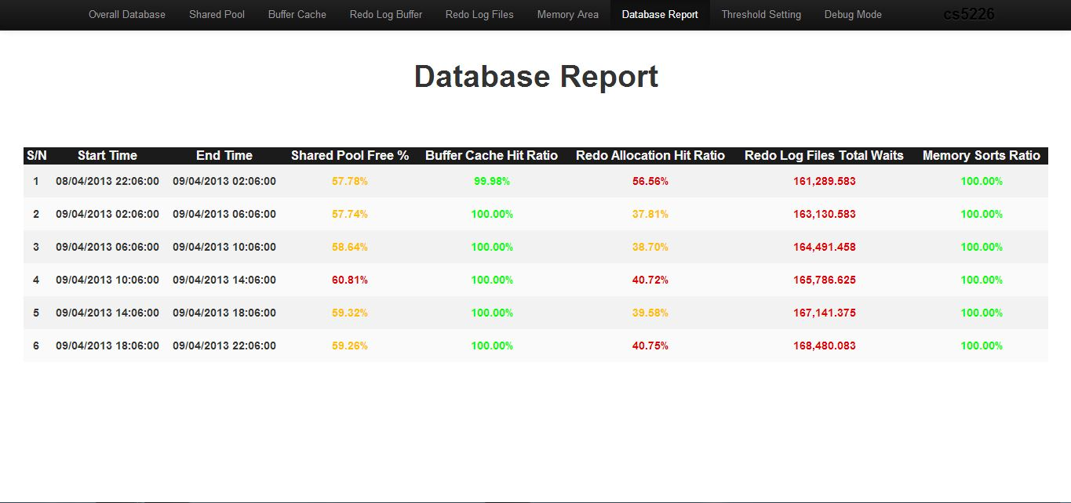

Database Report will be generated with all parameters’ status in choosing range and interval.
3.7. Debug Mode
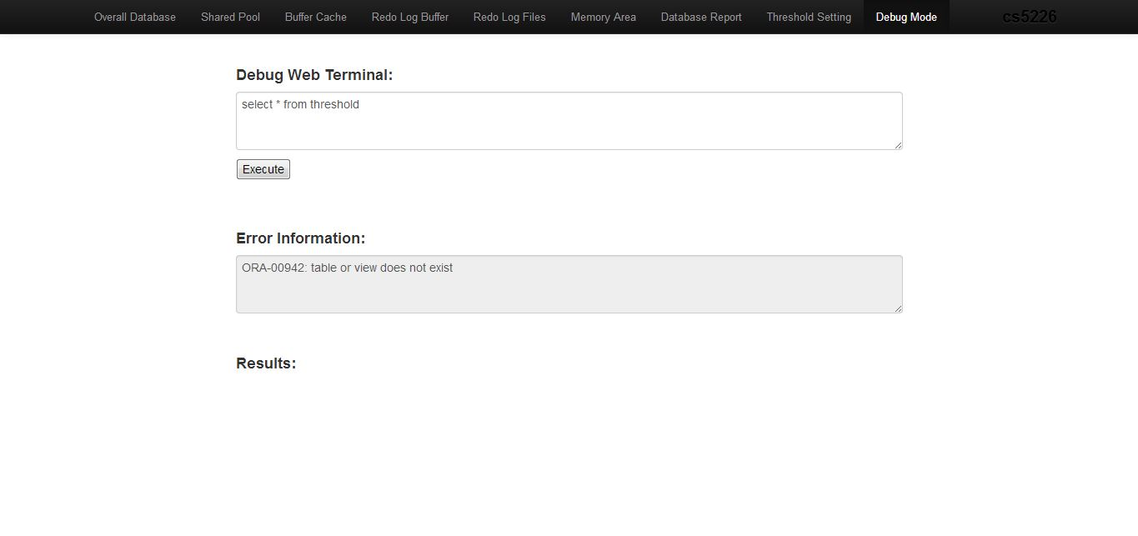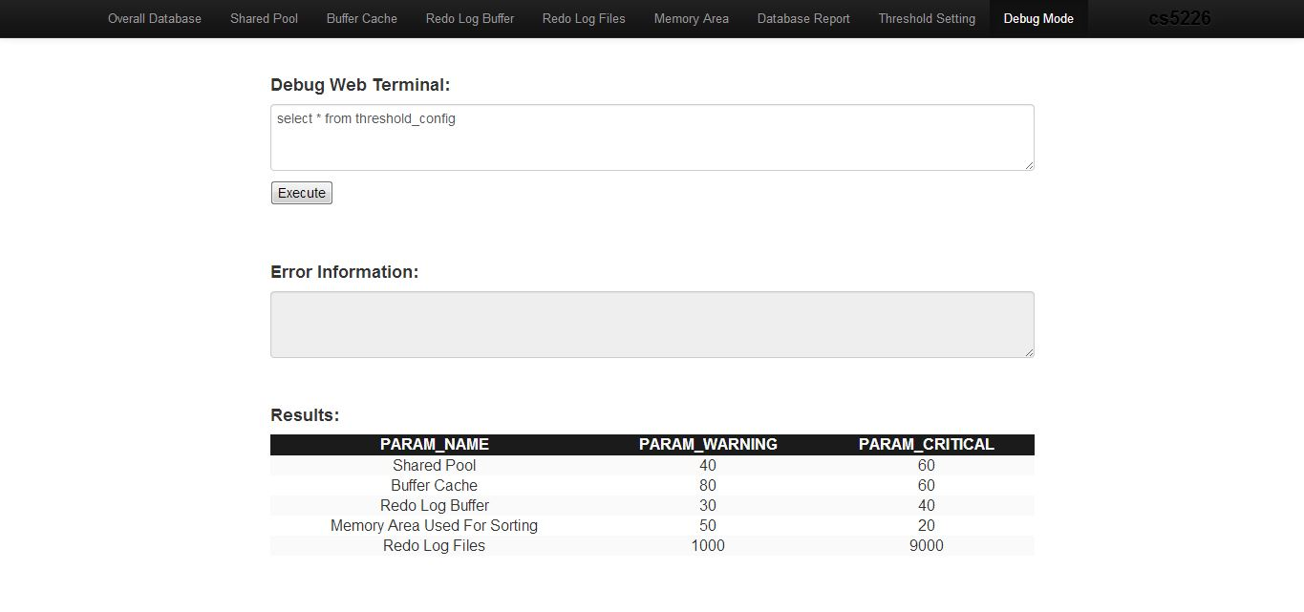
Debug mode executes the input query in database, then a result table will be populated in Results area or an error message will be shown at Error Information area.
3.8. Threshold Setting
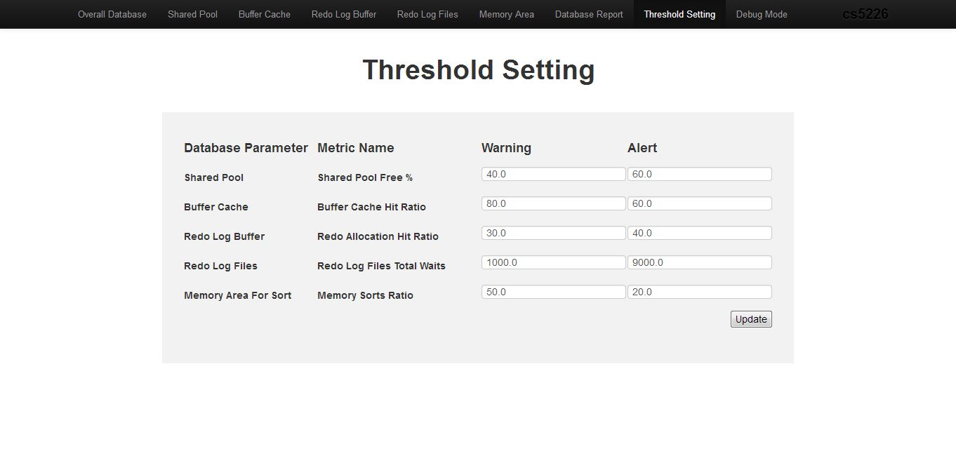
DBA is free to set the Threshold Setting through this page. After setting, just click Update and Threshold Setting will be updated.
Part 4. Discussion and Summary

We have developed a web application of database performance dashboard, which is able to monitor the health of the database and to support database performance investigation.
In this project, we get the idea of how to connect to the database as system user and get the table or view from the database (some table cannot be seen by normal user). We also learned how to get the information from the database which consists of snapshots that were done periodically by the Oracle database and use it to monitor the performance of the database. In order to have a real time value, we studied how to modify the period of the snap shot and we set the period of the snap shot to 10 minutes. We also get some idea about how to retrieve information faster from data base, such as disconnect the database only after we finish all the queries rather than start up a standalone connection for every single query. Another thing we do to make the query faster is to use group by and average in the query instead of getting all single records and calculating in the java side.
In our database performance dashboard application, all the information is extracted from three history tables, dba_hist_sysmetric_summary, dba_hist_system_event, and dba_hist_snapshot, which are updated regularly by Oracle. We store and present the average value of last 24 hours data from the current time in the dashboard. We also provide hourly breakdown and third level breakdown in every hour using the interval input by the user. If the user needs data from other intervals, they can choose to use our on demand report. The on demand report allows user to input the starting time, ending time as well as the breakdown interval. In the report, our application uses different colour for different status which can make the user easier to get the idea of the database. If our dashboard application notice the parameter is in attention range, the system will colour the status using red colour and append a hyperlink which carry the solution to this status value. In the solution page, our system suggests what the database administrator can do to solve the problem. The range of thresholds can be modified through our system's thresholds' configuration page. DBA can input two values for every field: warning and attention. A debug page is also provided for the user which allows user to test the queries and their performance. The result of the query will be display on the same page.
Our system have some limitations, the overall information page cannot refresh by itself, users need to refresh the page to get the latest information of the database; we only monitor 5 parameters from the database; These can be improved in the future for the dashboard application.

