Database Performance Dashboard
CS5226 Database Tuning Project
Present By
Gu Yang A0040661R
Lu Fangjian A0040740W
Yang Zhaoyu A0040953J
Zhang Haojun A0000000
2013/04/09

Project Admin
S/N | Task | Member*
1 | 3 levels of breakdown for each database parameter being monitored. | Lu Fangjian  Gu Yang
2 | Provide a configuration page(s) to define the various thresholds used to determine whether a specific database parameter is healthy, not so healthy or need DBA attention. | Lu Fangjian  Gu Yang
3 | For each of the performance issue identified that is in the “red” area, the application should provide information on the parameter in init.ora that should be modified in order to solve the performance issue. | Gu Yang
4 | On-demand reports – where the users can specify the date ranges for the database parameters being monitored. | Lu Fangjian
5 | A Debug interface – Allow the user to issue SQL commands to the database. The results should be displayed neatly on the webpage.
6 | README.txt | Gu Yang
7 | Database Setup Scripts | Gu Yang
8 | Configure the web development framework (Spring 3.2.0). Setup the project on google code. | Lu Fangjian
9 | UI design and modification. | Lu Fangjian
10 | Configure connection parameters to dbtune server. | Lu Fangjian
11 | Project Report writing. | Gu Yang  Lu Fangjian  Yang Zhaoyu  Zhang Haojun
12 | Additional stuff you have done | Append your names in this column
*Members are listed in alphabetic order

Part 1. System Designs and Architecture
The overall architecture and design of the application
The web application uses the pre-installed Oracle database in dbtune server to perform its main activities, which is to monitor a set of database parameters, and to query database through debug window. The database is also acted as permanent storage for the configuration data.
The development of the web interface follows the popular Model-View-Controller (MVC) approach using Spring Framework 3.2.0. The various application layers are separated distinctly in different classes. The detailed relations are illustrated below.
Class | Folder | Role
*TO.java | domain | Transfer objects are data carriers which are used in Presentation layer (web interface), Service layer and DAO layer.
*.jsp | view | Views are web pages which receive transfer objects from controller and display them to user. They also allow user to send inputs to controller for processing.
*Controller.java | controller | Controllers fetch the transfer objects and send them to the view for display. They also receive user inputs and send them to service layer for analysis.
*Service.java | service | Services are implemented with business logics to perform analysis. They may also fetch transfer objects from DAO layer during the process.
*Dao.java | dao | Data access objects retrieve data from permanent storages such as database, put them into transfer objects and send them to service layer for analysis.
*Util.java | util | Constants and static variables/methods which can be utilized to perform certain functions.
Part 2. Discussion on the database design for the tables used to support the application, and Details on how the various statistics are computed, and the SQL commands used to obtain the statistics
2.1. Database Support for the Dashboard

The dashboard requires some configuration parameters to be stored in the database. These configuration parameters determine the display color for the Gauge (red, yellow, and green). To store the configuration parameters, we build a single table and populate it with default values. The SQL scripts are setup.sql and data.sql (which are available in the CD-ROM):

Filename: setup.sql
DROP TABLE THRESHOLD_PARAM;

CREATE TABLE THRESHOLD_PARAM (
ID NUMBER(10, 0),
PARAM_NAME VARCHAR2(100 BYTE),
PARAM_MIN NUMBER(10, 2),
PARAM_MAX NUMBER(10, 2),
PARAM_WARNING NUMBER(10, 2),
PARAM_CRITICAL NUMBER(10, 2)
);

Filename: data.sql
DELETE FROM threshold_param;
INSERT INTO threshold_param(ID, PARAM_NAME, PARAM_MIN, PARAM_MAX, PARAM_WARNING, PARAM_CRITICAL) VALUES (1,'Shared Pool',0,100,75,85);
INSERT INTO threshold_param(ID, PARAM_NAME, PARAM_MIN, PARAM_MAX, PARAM_WARNING, PARAM_CRITICAL) VALUES (2,'Buffer Cache',0,100,65,80);
INSERT INTO threshold_param(ID, PARAM_NAME, PARAM_MIN, PARAM_MAX, PARAM_WARNING, PARAM_CRITICAL) VALUES (3,'Redo Log Buffer',0,100,65,90);
INSERT INTO threshold_param(ID, PARAM_NAME, PARAM_MIN, PARAM_MAX, PARAM_WARNING, PARAM_CRITICAL) VALUES (4,'Memory Area Used For Sorting',0,100,60,85);
INSERT INTO threshold_param(ID, PARAM_NAME, PARAM_MIN, PARAM_MAX, PARAM_WARNING, PARAM_CRITICAL) VALUES (5,'Rollback Segments',0,100,40,75);
INSERT INTO threshold_param(ID, PARAM_NAME, PARAM_MIN, PARAM_MAX, PARAM_WARNING, PARAM_CRITICAL) VALUES (6,'Redo Log Files',0,10000,1000,9000);
COMMIT;

There are 6 entries for the configuration that specifies the range values for each parameter we are monitoring. For example, the “Shared Pool” is healthy (the Gauge will point to the green region) when the value is between 0 to 75 (from PARAM_MIN to PARAM_WARNING) and it needs DBA attention when the value is between 76 to 85 (from PARAM_WARNING to PARAM_CRITICAL) notified by Gauge pointing at the yellow region and if the value exceeds 85 (from PARAM_CRITICAL to PARAM_MAX) then the Gauge will point to the red region.

Since it’s not always the case that low values denotes healthy, some of the range values are inverted. That is, the green and the red range are swapped. This is to signify that low values denote critical values. The information on the inverted red and green range is hard coded in the application. They are: Memory Area Used for Sorting and Buffer Cache. Of course it would be nice to put all information in the database so that we can easily add new database parameter to be monitored, but we leave that as possible future improvements.

2.2. The Statistics Computation

There are 6 statistics that are monitored by our dashboard applications: Shared Pool, Buffer Cache, Redo Log Buffer, Memory area used for sorting, Rollback segments, Redo log files. All except the “Redo log files”, the statistics can be acquired from dba_hist_sysmetric_summary table. We average the values over the last 7 days to approximate the healthiness. The SQL query to retrieve the values:

SELECT metric_id, metric_name, avg(average) value
FROM dba_hist_sysmetric_summary
WHERE
end_time > sysdate - interval '7' DAY
and metric_id in ('2114','2000','2001','2025','2002')
GROUP BY metric_id, metric_name

For the “Redo log files”, we averaged from the dba_hist_system_event table combined with the dba_hist_snapshot to get the time information over the last 7 days:

SELECT avg(a.total_waits)
FROM dba_hist_system_event a, dba_hist_snapshot b
WHERE
b.snap_id = a.snap_id and
a.event_name ='log file parallel write' and
b.end_interval_time > sysdate - interval '7' DAY

The output of the above queries can be seen in the Screenshots section on the SQL Debug interface. The query result values will then be displayed on the dashboard using Gauge chart according to the healthiness configuration specified in the database.

While the top-level breakdown shows the aggregated values for the past week (7 days) from the current time, the second-level breakdown splits the result into 7 rows which summarizes the performance of the database parameter for each day of the 7 days. The low-level breakdown then split the result of each day to 24 rows which summarizes the performance every hour on that day.

We note that the requirement says that the user can specify the unit of time for the second-level and low-level breakdown. However, we feel that this is can be done easily using the On Demand Report feature which allows the user to specify not only the interval time unit but the date range as well. Therefore, by fixing the time unit for the second and low level breakdown doesn’t necessarily remove the feature.
Part 3. Screenshots

3.1. Login
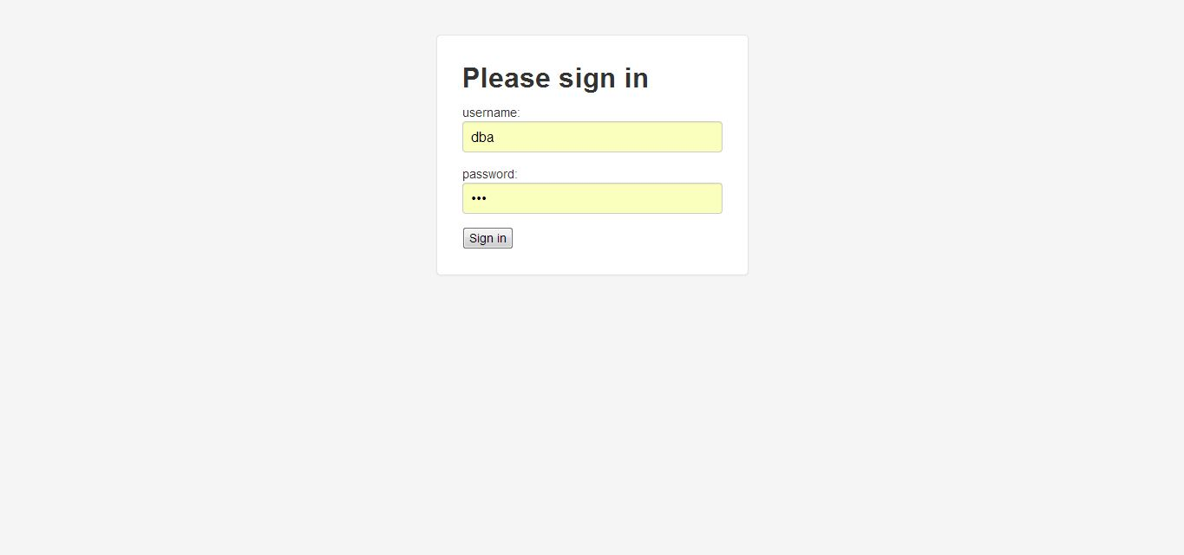
Login in as DBA before starting using the web application.

3.2. Overall Database

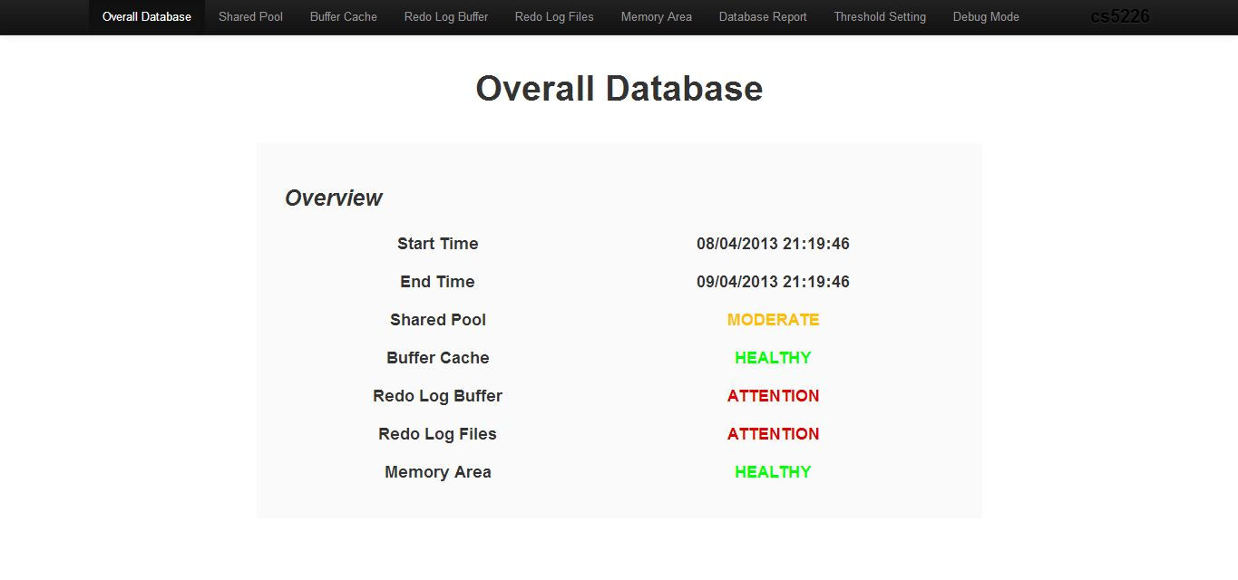

Home page contains an overall view of five monitored parameters of the database during last 24 hours. The status of ATTENTION is linking to an advisor page, will show in details in 3.3.

3.3. Overview
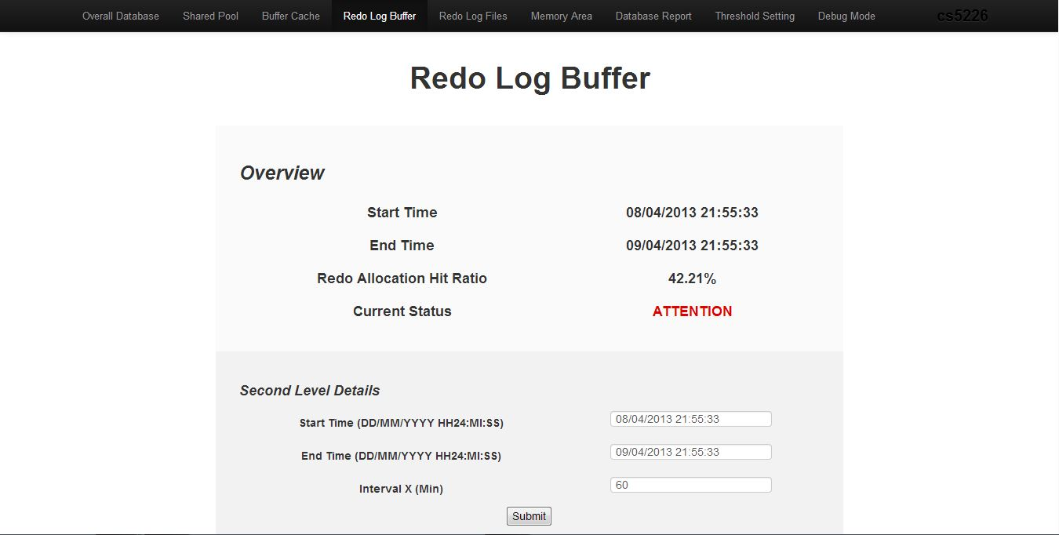

Overview of a parameter status in last 24 hours includes HEALTHY, MODERATE and ATTENTION. Provide DBA the option to choose any range and interval for second level details.

Here we also provide a special feature such that provides advisor on ATTENTION status, when click on the ATTENTION link, it will show the advisor for DBA. There are two types of advisor we provide, one is with quantified potential performance gain and the other is text suggestion. In addition, both types of advisor will provide link to official oracle document.

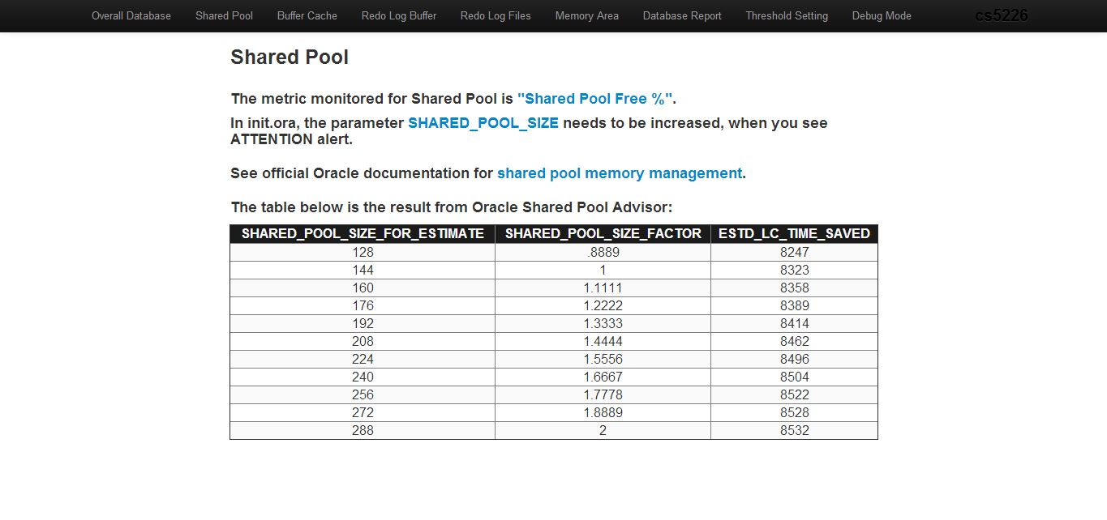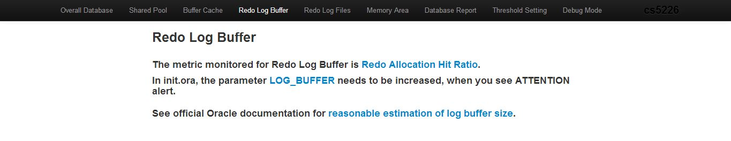
3.4. Second level details
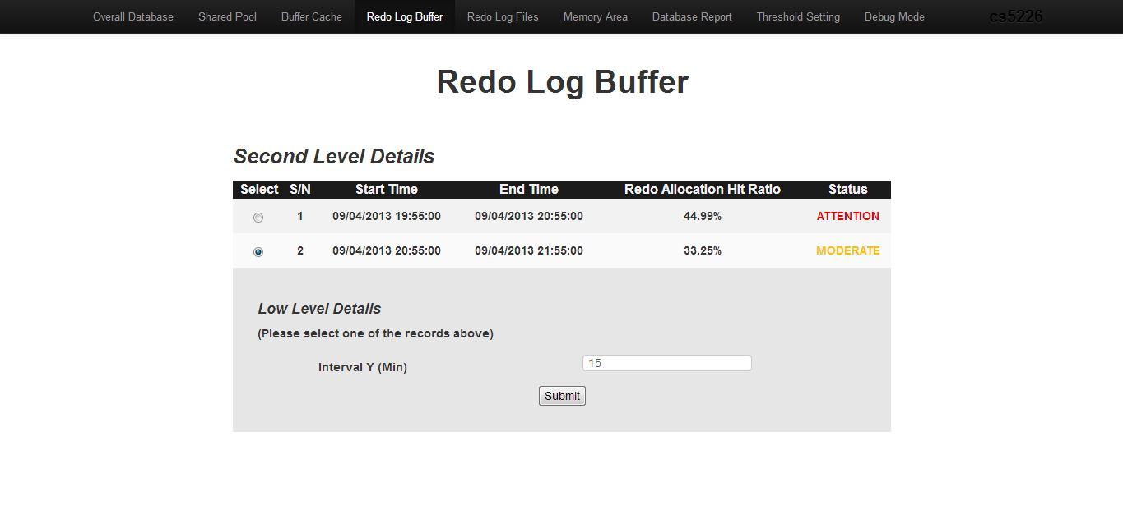
The second level details with range 2 hours and interval 60 minutes. Slightly different from Overview page, we provide DBA the option to choose certain date range and any interval. At this page, the status of ATTENTION is also linking to the advisor page.

3.5. Low level details
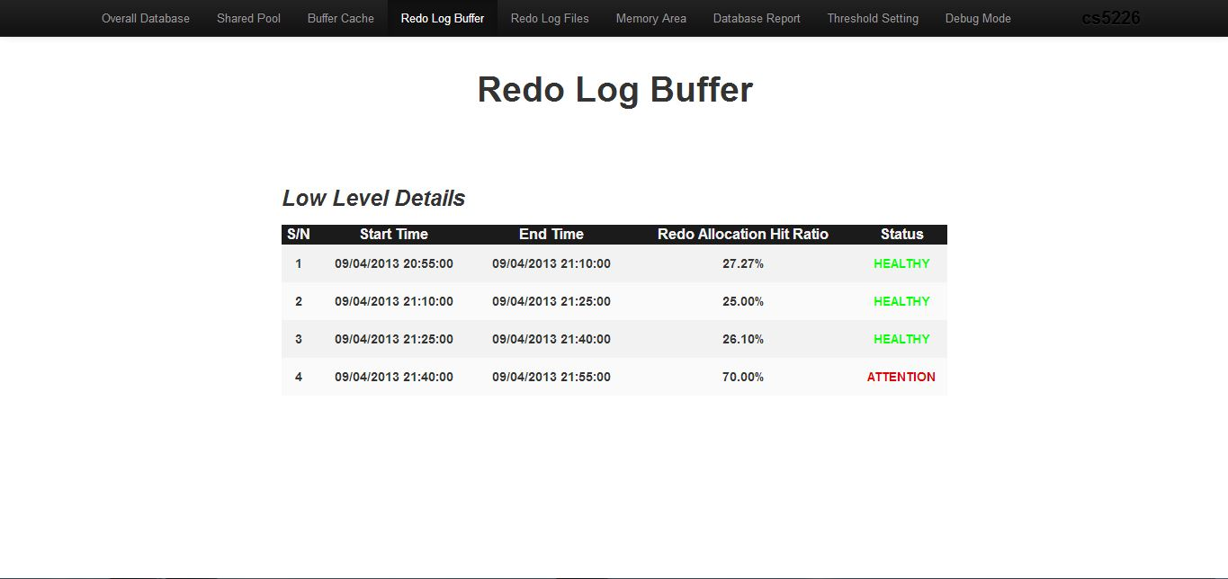
The low level details with interval 15 minutes. Similar to second level details, ATTENTION status is linked to an advisor page.

3.6. Database Report
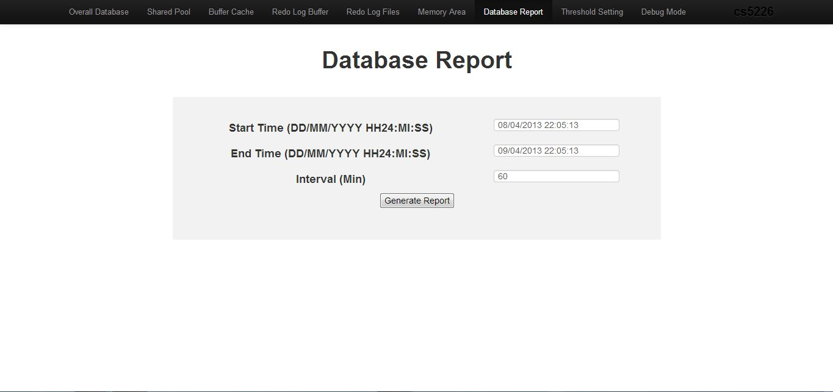
Choose the criteria of database report and then click generate report.

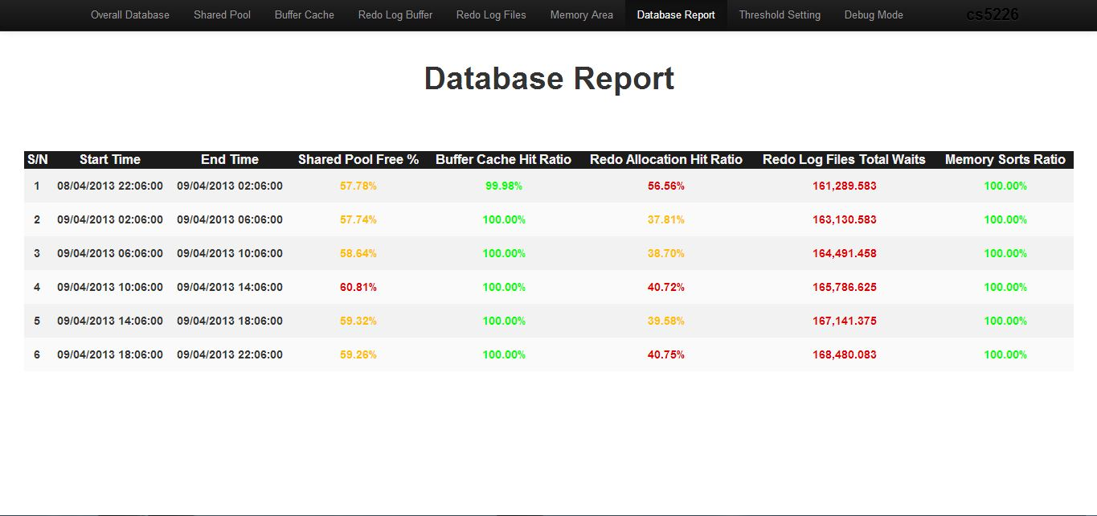

Database Report will be generated with all parameters’ status in choosing range and interval.

3.7. Debug Mode
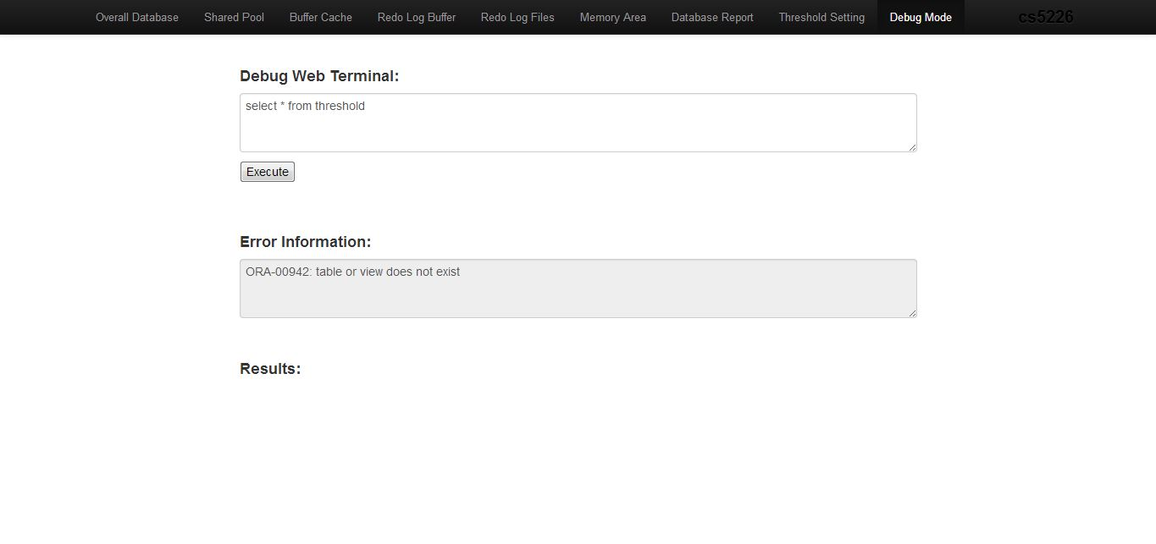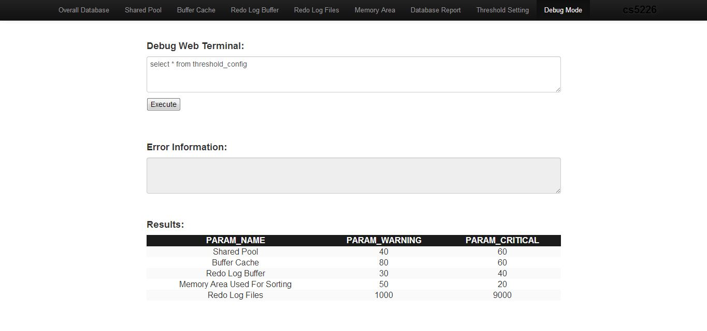

Debug mode executes the input query in database, then a result table will be populated in Results area or an error message will be shown at Error Information area.

3.8. Threshold Setting
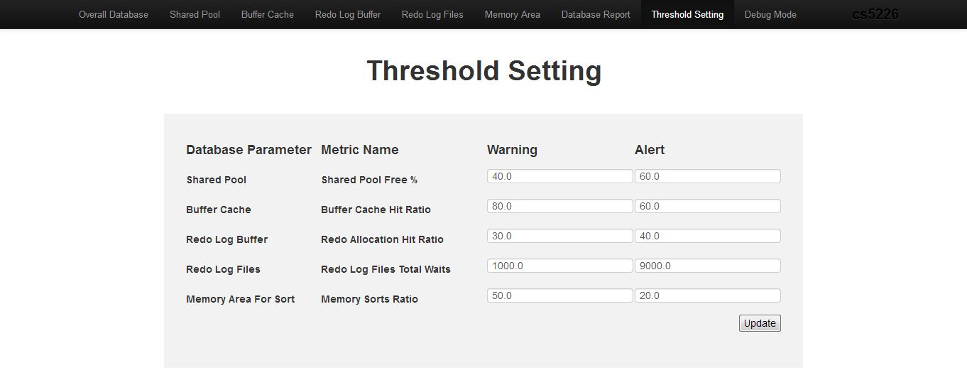
DBA is free to set the Threshold Setting through this page. After setting, just click Update and Threshold Setting will be updated.

Part 4. Discussion and Summary

We have built a database performance dashboard web application that is able to monitor the healthiness of the database system in a convenient way. In this project, we learned how to extract information out from Oracle database which consists of snapshots that were done regularly by the Oracle database and use it to monitor the performance of the database. The information extracted comes from these three history tables dba_hist_sysmetric_summary, dba_hist_system_event, dba_hist_snapshot that are updated regularly by Oracle. We present the last 7 days from the current time in the dashboard using Gauge chart so that we can assess the performance conveniently. The second level breakdown shows the aggregated values for each day for the last 7 days and the low level breakdown shows each hour. In case we need to see different interval or specific date range, we can always go to the On Demand Report to see it. Whenever the Gauge points to the red area, we display a tuning guide just below the Gauge to help the DBA address the performance issues on the critical database parameter that being displayed. The range of values (thresholds) that determines whether it is healthy/not healthy/critical can be configured easily. SQL commands can be executed using the SQL Debug interface which allows the DBA to query other information regarding the database performance.

We added several features that are outside the project requirements. They includes support for multiple SQL commands for the SQL Debug interface, showing the “N/A” values when there are no data available to be displayed on the report, and the red/yellow/green color for each result set for the On Demand Report, giving a convenience for the DBA to skim through the report.

Currently the 6 database parameters are hard coded in the application thus limiting the usage. It will be nice to have a feature to add additional database parameters to be monitored. This can be listed as a possible improvement for the dashboard application.

