**《虚拟现实技术》课程作业**

Unity坦克游戏

院系：软件学院

班级：1804

学号：U201816816

姓名：杨子越

**Unity坦克游戏**

说明文档

# 一、介绍

该项目以虚拟现实技术课程中老师所教授UnityChan相关 人物角色动画控制为基础，引入室外场景模型并添加光照和阴影；添加交互性元素如 发射炮弹，键盘按钮移动坦克；实现第一、三人称视角切换。

开发平台为Unity 2018.4.21f1（64-bit），操作系统为Windows 10（64位）。

# 二、操作说明

使用Visual Studio编译这个游戏，然后运行。

## 1、这个是游戏刚开始进入时的场景

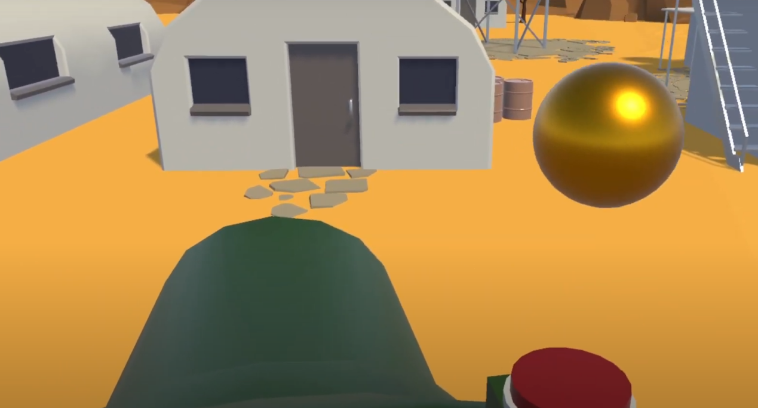

## 2、移动人物漫游场景

WSAD键用来控制坦克的位置，行走用户以第三人称视角在整个场景中进行移动。

## 3、移动鼠标切换视角

可以移动鼠标，来切换视角

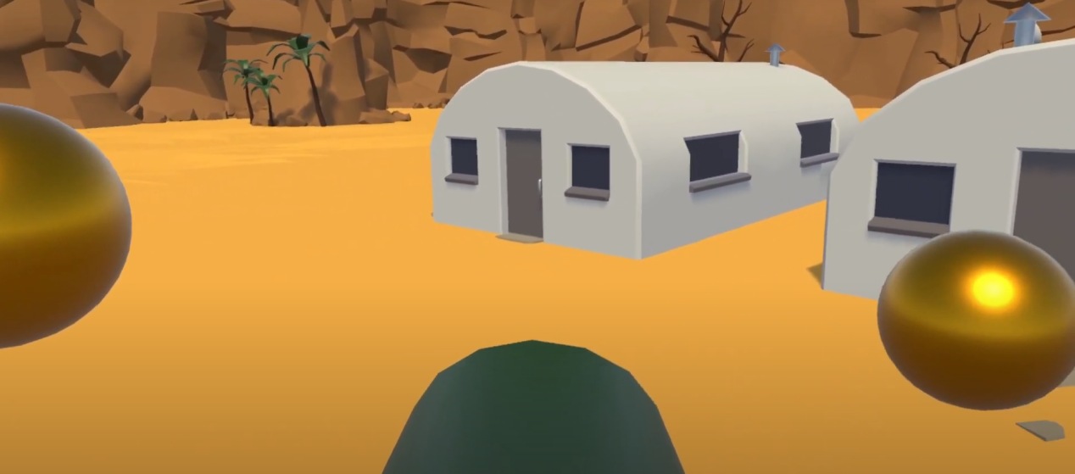

## 4、鼠标点击发射炮弹

点击鼠标的时候，可以发射炮弹到一个位置，观看到炸弹爆炸的效果

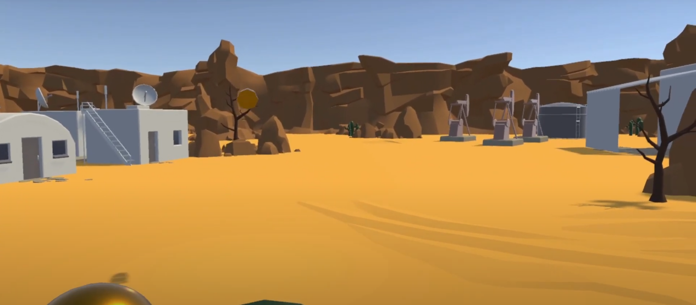

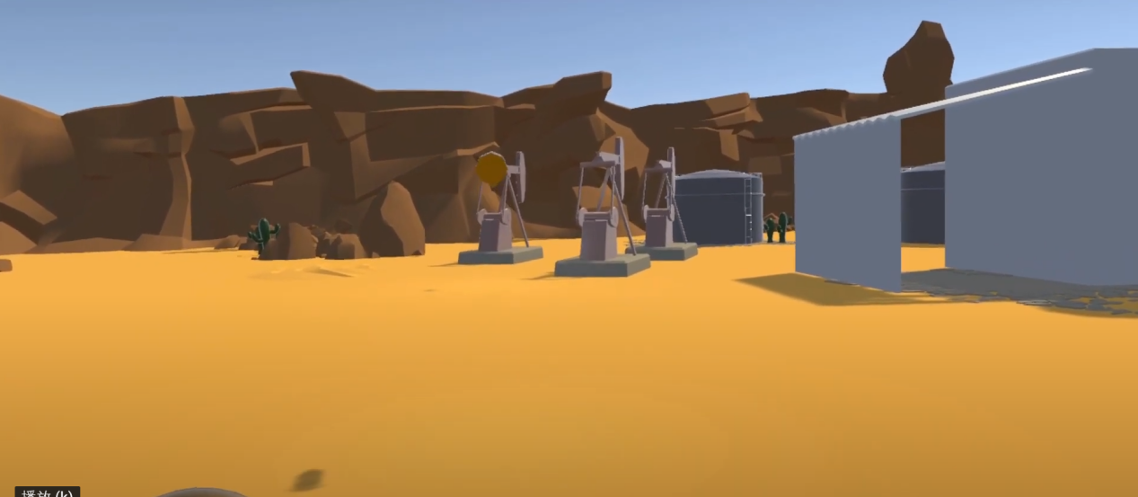

# 三、探索的技术

## （1） 多摄像机切换

using UnityEngine;

public class CameraControl : MonoBehaviour

{

public float m_DampTime = 0.2f;

public float m_ScreenEdgeBuffer = 4f;

public float m_MinSize = 6.5f;

[HideInInspector] public Transform[] m_Targets;

private Camera m_Camera;

private float m_ZoomSpeed;

private Vector3 m_MoveVelocity;

private Vector3 m_DesiredPosition;

private void Awake()

{

m_Camera = GetComponentInChildren<Camera>();

}

private void FixedUpdate()

{

Move();

Zoom();

}

private void Move()

{

FindAveragePosition();

transform.position = Vector3.SmoothDamp(transform.position, m_DesiredPosition, ref m_MoveVelocity, m_DampTime);

}

private void FindAveragePosition()

{

Vector3 averagePos = new Vector3();

int numTargets = 0;

for (int i = 0; i < m_Targets.Length; i++)

{

if (!m_Targets[i].gameObject.activeSelf)

continue;

averagePos += m_Targets[i].position;

numTargets++;

}

if (numTargets > 0)

averagePos /= numTargets;

averagePos.y = transform.position.y;

m_DesiredPosition = averagePos;

}

private void Zoom()

{

float requiredSize = FindRequiredSize();

m_Camera.orthographicSize = Mathf.SmoothDamp(m_Camera.orthographicSize, requiredSize, ref m_ZoomSpeed, m_DampTime);

}

private float FindRequiredSize()

{

Vector3 desiredLocalPos = transform.InverseTransformPoint(m_DesiredPosition);

float size = 0f;

for (int i = 0; i < m_Targets.Length; i++)

{

if (!m_Targets[i].gameObject.activeSelf)

continue;

Vector3 targetLocalPos = transform.InverseTransformPoint(m_Targets[i].position);

Vector3 desiredPosToTarget = targetLocalPos - desiredLocalPos;

size = Mathf.Max (size, Mathf.Abs (desiredPosToTarget.y));

size = Mathf.Max (size, Mathf.Abs (desiredPosToTarget.x) / m_Camera.aspect);

}

size += m_ScreenEdgeBuffer;

size = Mathf.Max(size, m_MinSize);

return size;

}

public void SetStartPositionAndSize()

{

FindAveragePosition();

transform.position = m_DesiredPosition;

m_Camera.orthographicSize = FindRequiredSize();

}

}

1. 坦克生命值切换

using UnityEngine;

using UnityEngine.UI;

public class TankHealth : MonoBehaviour

{

public float m_StartingHealth = 100f;

public Slider m_Slider;

public Image m_FillImage;

public Color m_FullHealthColor = Color.green;

public Color m_ZeroHealthColor = Color.red;

public GameObject m_ExplosionPrefab;

private AudioSource m_ExplosionAudio;

private ParticleSystem m_ExplosionParticles;

private float m_CurrentHealth;

private bool m_Dead;

private void Awake()

{

m_ExplosionParticles = Instantiate(m_ExplosionPrefab).GetComponent<ParticleSystem>();

m_ExplosionAudio = m_ExplosionParticles.GetComponent<AudioSource>();

m_ExplosionParticles.gameObject.SetActive(false);

}

private void OnEnable()

{

m_CurrentHealth = m_StartingHealth;

m_Dead = false;

SetHealthUI();

}

public void TakeDamage(float amount)

{

m_CurrentHealth -= amount;

SetHealthUI();

if (m_CurrentHealth <= 0f && !m_Dead)

{

OnDeath();

}

}

private void SetHealthUI()

{

m_Slider.value = m_CurrentHealth;

m_FillImage.color = Color.Lerp(m_ZeroHealthColor, m_FullHealthColor, m_CurrentHealth / m_StartingHealth);

}

private void OnDeath()

{

m_Dead = true;

m_ExplosionParticles.transform.position = transform.position;

m_ExplosionParticles.gameObject.SetActive(true);

m_ExplosionParticles.Play();

m_ExplosionAudio.Play();

gameObject.SetActive(false);

}

# 四、参考资源

**Unity Standard Assets**