Template: Search
Related to Chapter 2 of the thesis guide.
You can use this template to support you as create a strategy to search for sources you want to use in your project. You can also keep this template to record your search strategy to refer to and adapt in the future.

Date
Main information search question

2a. Select an Information Source
Related to Chapter 2a of the thesis guide.
Please consult the library website for discipline-related sources and select the initial and follow-up databases you want to use for your research:
Information Resource(s) selected for this search plan (i.e. Scopus, WorldCat or Espacenet) | For which document type?  (i.e. Articles, patents, books)

2b. Create a Keyword Search
Related to Chapter 2b of the thesis guide.

1: Define concepts, synonyms and related terms
Derive concepts from your information search question, A) write down each concept in the first row of the search table below and then B) write down synonyms and alternative terms for each concept.
A) Concepts | Concept 1 | Concept 2 | Concept 3 | Concept 4
B) Synonyms and/or related terms

2: Combining synonyms and related terms
- Check the help file of your chosen database to make sure you are using search operators like wildcards, Booleans and brackets correctly.

- Combine all synonyms and related terms for each concept with OR.
Example: Your query for concept 1 will look like this: (“concept 1” OR “synonym 1” OR “synonym 2”)

- Combine all the query concepts with AND to make your search query.
Example: Your complete search query will look like: “(Query concept 1) AND (Query concept 2) AND (Query concept 3)”
My complete search query:

2c. Check and Refine your Keyword Search
Related to Chapter 2c of the thesis guide.

1: Check your Keyword Search
Perform the search query in the selected information resource (database or search engine) and follow the steps in the image provided below to check if your query is working well for what you’re searching for:
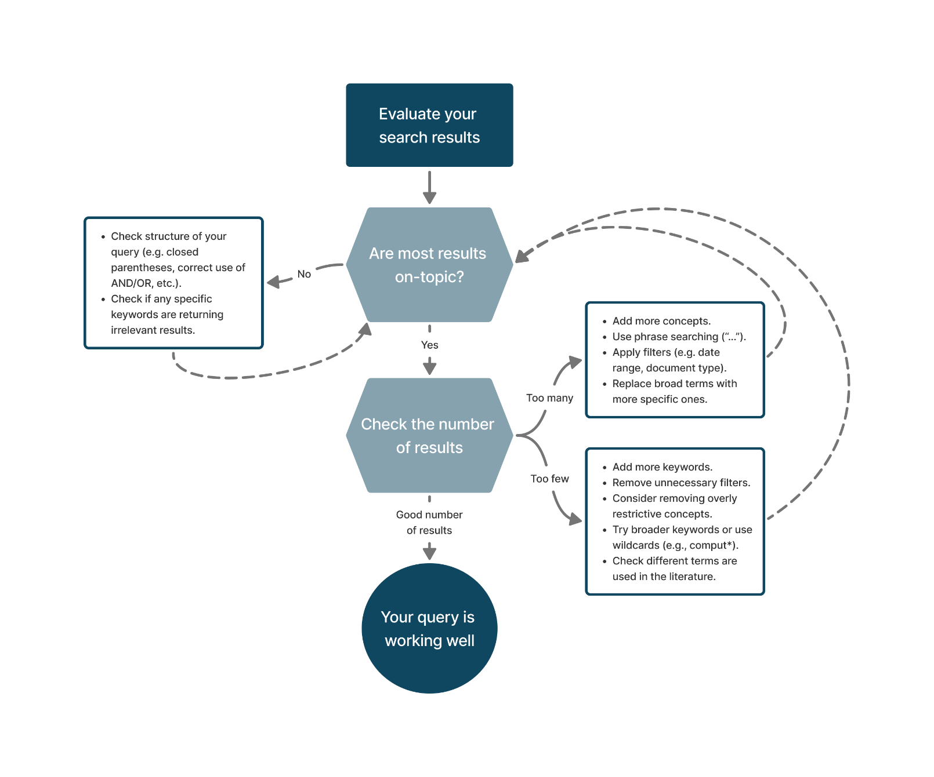
“Evaluating your search results” by TU Delft Library Education Support is licensed under CC-BY-4.0

2: Refine your Query
If your query is not returning the results you are looking for, you will probably need to adapt it. Searching is a trial and error process, don’t worry if you don’t get it right from the start!

How did you refine your search? | How did it change the search results?

2d. Additional Search Methods
Related to Chapter 2d of the thesis guide.
To find additional literature, I will make use of (fill out all that apply)

Forward Snowballing / Backward Snowballing
Relevant source(s) used for snowballing:

Similar Document Searching
Text inserted for Similar Document Searching

Academic AI Tools
! Warning: please check with your supervisor if you are allowed to use AI, and keep a record of the tools and prompts you used so you can report them in your thesis.
Academic AI Tool used

Question(s)/prompt(s) entered

2e. Keeping Track of your Search
Related to Chapter 2e of the thesis guide.

1: Check if you need a search alert
Discuss with your supervisor / reflect: do you expect new research to come out on your topic and do you need to stay up to date on the latest research?
If yes, use the template below to set up a search alert for your topic, you can discuss with your supervisor how they stay updated in the field and what they would recommend in your situation.

2: Set up your search alerts

Databases used
To make sure I don’t miss any new articles, I will set up the alerts in the following database(s):

Alerts to set up (check all that apply)
☐ Alert for new sources found in my search
Query for the search alert:

☐ Alert when someone cites articles relevant to my research
Articles to include

☐ Table of content alert for a specific journal
Journals to include

Follow the guides from TUlib to learn in more detail how to set up search alerts.

