Information Literacy Master Thesis Guide: Templates & Recap

Version September 14, 2026
Created by Library Education Support at Delft University of Technology. Licensed CC-BY-4.0

Recap of the guide

When doing your master thesis, there are multiple points where you will need information from others. To be able to do this effectively and responsibly during your master thesis, you will need the following information skills:


Adapted from “Visualisatie leerlijn Information Literacy” by Edo-Jan Meijer is licensed under CC-BY-NC.

- Explore: Apply basic steps for orientation on the topic or question of your master thesis
- Search: Set up and store a basic search strategy for scientific literature for your master thesis
- Evaluate: Use basic ways to assess relevance and reliability of sources, select information for your master thesis and know how to store information effectively
- Process: Understand how to read, summarise and synthesise during your master thesis
- Share: Apply correct citation and copyright practices when handing in your master thesis. Know about open science principles when publishing your research.

Template: Explore
Related to Chapter 1 of the thesis guide.

You can use this template to support you as you do a general orientation, explore academic literature and formulate information search questions. Fill out the template, or copy the sections relevant for your own workflow if helpful.

1a. General Orientation on a Topic
Related to Chapter 1a of the thesis guide.

1: Choose a topic and write what you know

Decide on an initial topic
Questions to help you decide:
- What topics do I like?
- What do I want to do for my future career?
- Are there any current events that I find interesting?
- What existing research that I can build on do I know about?

My initial topic is:

Write what you know about the topic
Study the different brainstorm techniques in the thesis guide and write what you already know about the topic:

Perform general searches on your topic.
Access a couple of resources and do a general search for information around your topic (for suggestions, see related sections in thesis guide). For reference, write down what you searched for and what your observations were.

Resource used | Query / prompt used | Observations

Interesting sources I want to study further:

1b. Exploring Academic Literature
Related to Chapter 1b of the thesis guide.

1: Create an Initial Exploration Strategy
My exploration question
Database used for exploration

Exact query used

Filters applied

Number of results

Check your Query:
- I have used a broad question (not a specific research question)
- I have chosen a multidisciplinary database
- I have applied relevant filters
- I have between 2000 – 10000 results

2: Find and Analyse Basic Information on Your Topic

Find basic information
Top 5 journals | 1.  2.  3.  4.  5.
Top 5 subject areas | 1.  2.  3.  4.  5.
Top keywords
Other worthy first impressions

Analyse the information
Analyse the number of publications per year on your topic, what do you notice?

Analyse the top 5 journals and the top 5 subject areas and write a short reflection on your research field

Look at the top keywords used in your exploration results. What does this say about your topic? Can you create separate clusters?

Have a look at the most relevant abstracts and the top keywords. What words can help you in your keyword search?

1c. Formulate an Information Search Question
Related to Chapter 1c of the thesis guide.

1: Define the components of your information search question.
Define the who, what, where and why, and bring the different parts together with how. See the thesis guide for an example
WHO
WHAT
WHERE
WHY
HOW
* Not all components in your information search question need to be specific. For example, if you are looking for specific methodologies, the components of your question might not need to be highly detailed about the where or the who, but more about what others have done and why.

2: Further Specifying Your Question

Making components of your question more broad or narrow
For each of your components, fill in how you have currently defined them. Reflect for each of the components if you need to make them more or less specific and adapt your question if needed.
 | Current question | Does it need to be more or less specific (yes/no)? | Updated component
WHO
WHAT
WHERE
WHY
HOW

Subquestions:
What additional questions do you need to ask to make your information search question more manageable? Fill in your relevant subquestions below
Information need | Question | Your subquestion
Definitions of terms | What...
Relations between terms | How...
Benefits of research | Why...
Target Group | Who...
Geographical information | Where...

Template: Search
Related to Chapter 2 of the thesis guide.
You can use this template to support you as create a strategy to search for sources you want to use in your project. You can also keep this template to record your search strategy to refer to and adapt in the future.

Date
Main information search question

2a. Select an Information Source
Related to Chapter 2a of the thesis guide.
Please consult the library website for discipline-related sources and select the initial and follow-up databases you want to use for your research:
Information Resource(s) selected for this search plan (i.e. Scopus, WorldCat or Espacenet) | For which document type?  (i.e. Articles, patents, books)

2b. Create a Keyword Search
Related to Chapter 2b of the thesis guide.

1: Define concepts, synonyms and related terms
Derive concepts from your information search question, A) write down each concept in the first row of the search table below and then B) write down synonyms and alternative terms for each concept.
A) Concepts | Concept 1 | Concept 2 | Concept 3 | Concept 4
B) Synonyms and/or related terms

2: Combining synonyms and related terms
- Check the help file of your chosen database to make sure you are using search operators like wildcards, Booleans and brackets correctly.

- Combine all synonyms and related terms for each concept with OR.
Example: Your query for concept 1 will look like this: (“concept 1” OR “synonym 1” OR “synonym 2”)

- Combine all the query concepts with AND to make your search query.
Example: Your complete search query will look like: “(Query concept 1) AND (Query concept 2) AND (Query concept 3)”
My complete search query:

2c. Check and Refine your Keyword Search
Related to Chapter 2c of the thesis guide.

1: Check your Keyword Search
Perform the search query in the selected information resource (database or search engine) and follow the steps in the image provided below to check if your query is working well for what you’re searching for:
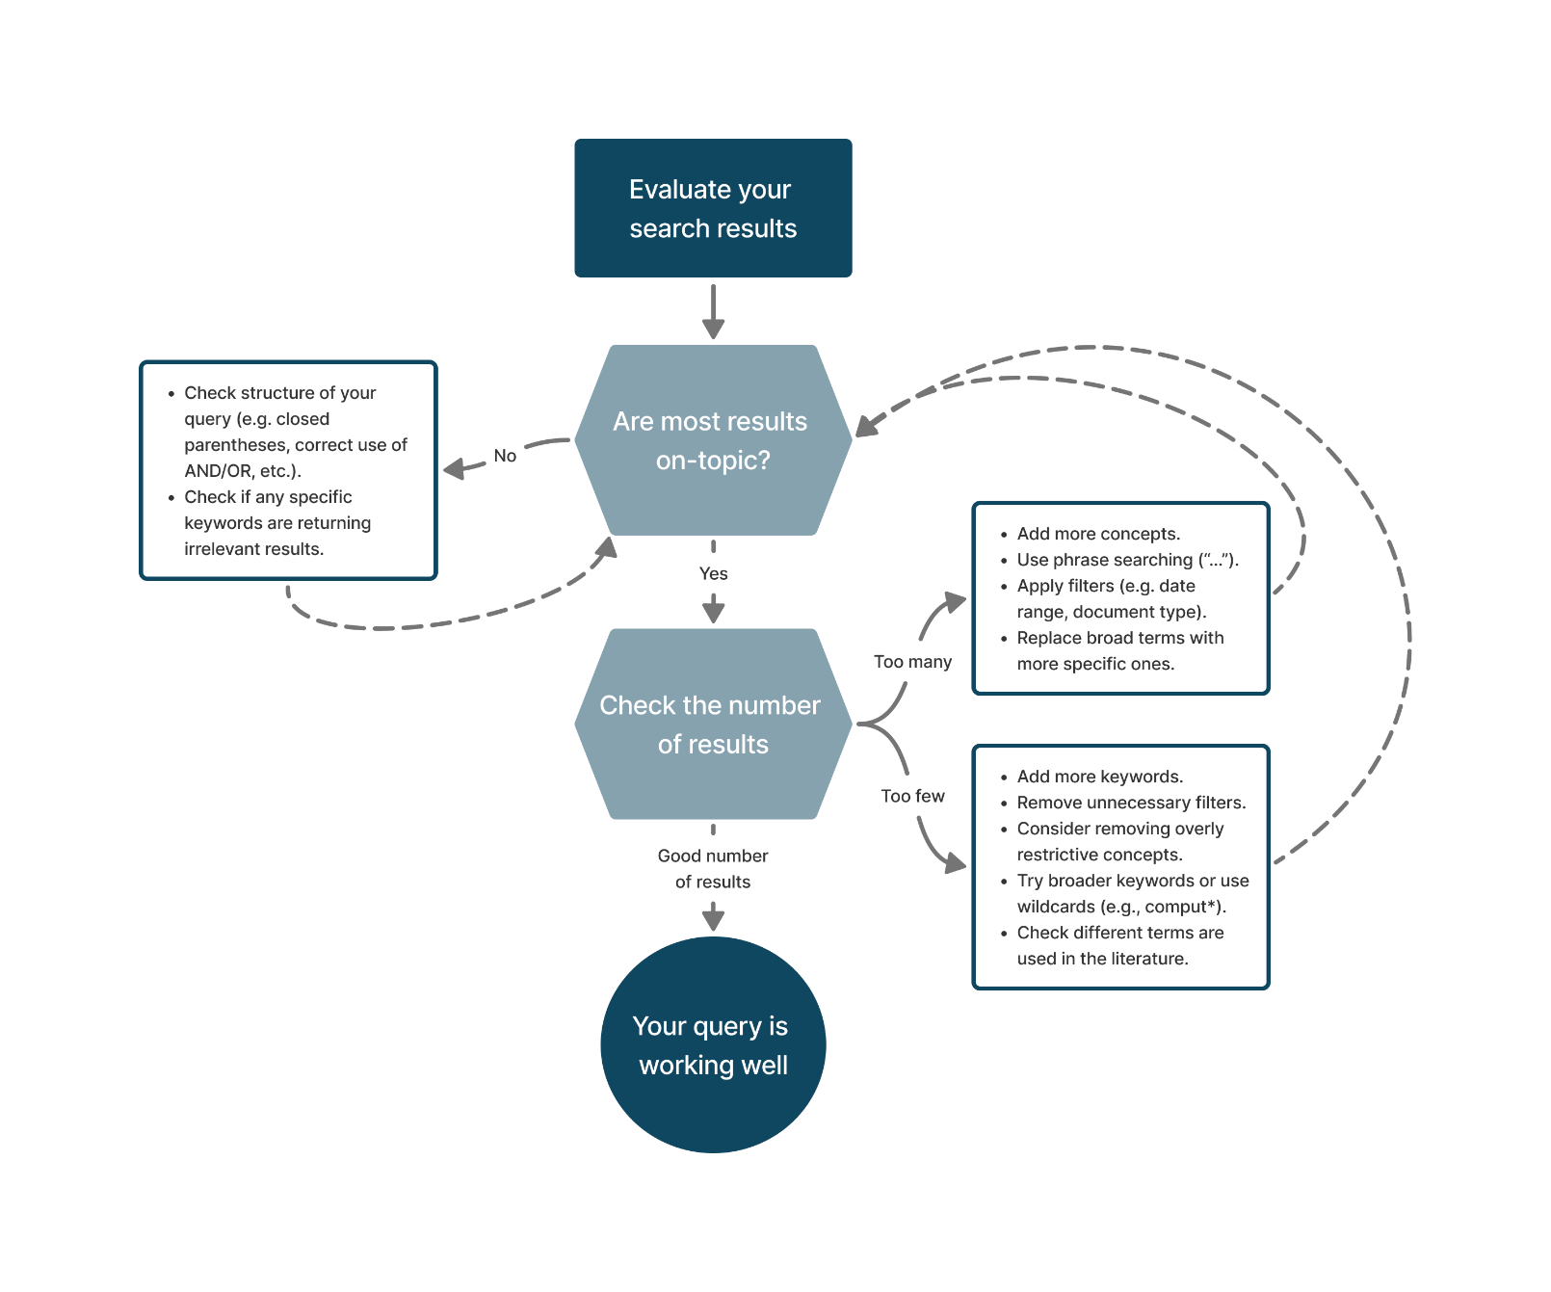
“Evaluating your search results” by TU Delft Library Education Support is licensed under CC-BY-4.0

2: Refine your Query
If your query is not returning the results you are looking for, you will probably need to adapt it. Searching is a trial and error process, don’t worry if you don’t get it right from the start!

How did you refine your search? | How did it change the search results?

2d. Additional Search Methods
Related to Chapter 2d of the thesis guide.
To find additional literature, I will make use of (fill out all that apply)

Forward Snowballing / Backward Snowballing
Relevant source(s) used for snowballing:

Similar Document Searching
Text inserted for Similar Document Searching

Academic AI Tools
! Warning: please check with your supervisor if you are allowed to use AI, and keep a record of the tools and prompts you used so you can report them in your thesis.
Academic AI Tool used

Question(s)/prompt(s) entered

2e. Keeping Track of your Search
Related to Chapter 2e of the thesis guide.

1: Check if you need a search alert
Discuss with your supervisor / reflect: do you expect new research to come out on your topic and do you need to stay up to date on the latest research?
If yes, use the template below to set up a search alert for your topic, you can discuss with your supervisor how they stay updated in the field and what they would recommend in your situation.

2: Set up your search alerts

Databases used
To make sure I don’t miss any new articles, I will set up the alerts in the following database(s):

Alerts to set up (check all that apply)
☐ Alert for new sources found in my search
Query for the search alert:

☐ Alert when someone cites articles relevant to my research
Articles to include

☐ Table of content alert for a specific journal
Journals to include

Follow the guides from TUlib to learn in more detail how to set up search alerts.

Template: Evaluate and Select Sources
Related to Chapter 3 of the thesis guide
You have a number of search results, and want to decide which sources you want to add to your reading list to study further. We provide here some strategies to narrow down your initial search results to a reading list, based on the number of sources you want to include in your project and how many results you have from your search.
Note that evaluating and selecting sources is an iterative process, and you may find yourself going back and forth between the different strategies presented here.

0: Check before starting:
My information search question:

- I am happy with the results from my search and my search strategy (see also 2c: Check and Refine Your Keyword Search)
- I have chosen a reference manager or another approach to store the sources I want to add to my reading list (see also 3d: Storing Sources)

Selection
Related to section 3c of the thesis guide

1: First Selection
You have done an initial search, are happy with your results, and now have to select articles to save.
- Scan through the titles and abstracts of your sources and ignore the ones that immediately do not seem relevant or reliable

- Things to look out for:
  - The source addresses my actual topic
  - I trust the reliability of the source and authors (see also 3b: Evaluate Sources Broadly)

- Store the ones that you potentially want to include in your project in your preferred reference manager

2: Second Selection
You feel the sources you have included are at least related to your topic and reliable, but you still have too many to process for your project.
- Read in more detail the abstracts of the sources remaining
- Check for each source:
  - How can I use this source in my project? For example:
    - as background context
    - for definitions
    - to re-use data
    - to re-use graphics
    - as inspiration for my research methodology or experimental set-up.
    - Introduces a perspective about the topic I would like to respond to in my report
  - Do I understand the source at a level where I can actually use it, or imagine I will be able to understand it in the future after reading more about the topic.
  - Does the source cover the right breadth for my topic? Is it not too general or too specific?
- When you select a source that you want to use in your project, store it in a relevant folder in your preferred reference management tool and/or add a tag denoting what you want to use it for (see also 3d: Storing Sources)).

Number of sources left:
The number of sources left seems manageable for me to evaluate in more detail
- Yes --> move on to the next section to start evaluating your sources in more detail or start processing your sources (see also 4: Process Sources)

- No --> try going through the sources you have left again, focusing more specifically on your information search question, prioritizing the ones that seem the most relevant or high quality.

Evaluating Your Sources in More Detail:
You have done a broad selection, have only a few sources left, and want to assess the quality of your selected sources in more detail. You can use the table below to analyse in more detail the quality of your sources and decide which ones to add to your reading list (see also 3b: Evaluate Sources Broadly for an explanation of the CRAAP test)
Category | Source 1 | Source 2 | Source 3 | ….
Source
Currency
Relevance
Authority
Accuracy
Purpose
Conclusion

Template: Process Sources
Related to Chapter 4 of the thesis guide.
You can use this template to support you as you start reading, summarising and synthesizing your sources. You can fill out the template as is, or copy sections you deem relevant into your own workflow.

4a. Reading
Related to Chapter 4a of the thesis guide.
If helpful, paste the list of articles you have selected after your content search in the table below, or open them up in your reference manager.

1: Decide on Your Reading Order
Scan and skim through your articles and categorize them to help you decide your reading order. You can use the table below. If preferred, you could also use the categories as tags or notes in your reference manager, or in another organizing system (e.g. Excel, Notion, Obsidian)
 | Estimated time for reading (minutes) | Type of information offered (foundational / specific / recent research) | Connection to my specific Information Search Question (strong, medium, low) | Source Type (peer reviewed article, preprint, conference paper, other non-scholarly types, etc.) | Source highly relevant to your field or recommended by your lecturer or peers?
Source 1
Source 2
Source 3
…

After categorizing your sources, use the following questions to decide on your reading order based on:
- How much time do you have?
- What type of information you need first (foundational, specific research, recent developments) ?
- Which sources are the most relevant for your research question?
- Which sources are impactful in your field, or recommended by your peers?
I will close read in this order:
Reading Order | Source | Why is this high/low on your list?
1
2
3
4

2: Close reading and notetaking
You can use this template to help you start close reading and notetaking on a source. Note that this is only one approach, and there are other ways that might work for you. However, you can use the steps and questions included here to set up your own reading practices.
Source Title:

I am reading this source with the following purpose:

Read the abstract, introduction, discussion and conclusion.
What are your first thoughts about the source and its relevance to your information search question?

Close Read with Critical Questions in Mind:
- How does the author know this and do they give any scientific evidence?
- Is this in line with my knowledge or does it contradict any knowledge I already have?
- Is the method well explained and justified?
- Are the results, methods and conclusions consistent with each other?
- Does the author correctly explain any surprising results?
- What are my own thoughts and beliefs compared to the author’s findings?

Do more specific notetaking, choose categories to include, for example:
- Important concepts / findings
- Summary
- Quote / Paraphrase
- Own ideas, thoughts and comments
- Action points / things to look up
- Important terms
- Additional keywords for my search

3: Deciding when to stop Reading:
Answering yes to (at least one of) these questions might suggest that it is time to stop reading:
- Do I feel I have enough information to answer my information search questions?
- Have I discussed my findings with my supervisor/lecturer and do they think it is time to stop reading?
- Have I spent a third of the time available for the project reading?

4b. Summarise
Related to Chapter 4b of the thesis guide.
You can use this template to summarise a source that is highly relevant for your project.

Choose a Summary Format/tool
Study the different summary types in the thesis guide and pick or build on a format that works best for your personal workflow.

I have included the following standard elements in my preferred summary format:
- Bibliographical information. For example, author, publication, year. All the details you need to include to relocate the source later in your project.
- Topic / Research Question
- Methods used
- Main results
- Connection to previous studies
- Limitations of the study
- Implications of the findings

4c. Synthesise
Related to Chapter 4c of the thesis guide.

0: Check before starting:
My information search question:

- I have a summary of my main sources and findings
- I have evaluated the quality of my main sources and know the strengths and weaknesses of each source

1: Comparing the main findings and conclusions:
Take some time to go through your initial summaries and findings and answer the questions below to help you compare the different sources. You can use these questions to help you organise your thoughts as you get started with synthesizing:
How do research questions from different authors relate – do they differ, diverge, overlap, build upon each other?

Do authors build upon earlier conclusions of other authors/resources? Or completely approach it from another angle?

Where do authors use similar methods, or very different methods? Why?

Do authors find similar data/results, or different results?

Do authors arrive at similar conclusions, or strongly different?

Major themes or concepts that keep coming up in the literature I am reading:

What knowledge gaps are discussed?

2: Decide What Lens to Focus on:
Have a look at the answers to your questions, your information search questions, and the different ways of organising your findings in (Chapter 4c) and decide how you will organise your findings:
I will organise my findings around:
- Specific methods used in my field
- Important topics in my field
- Different discussions going on in my field
- Presenting the development of my topic
- Other:__________

3: Compare Sources in Detail:
You can use a synthesis matrix to help you compare the different sources based on main information and ideas you want to extract from your sources, and to draw your conclusions.
 | Source 1  Title:  Author: | Source 2  Title:  Author: | Source 3  Title:  Author: | Source 4  Title:  Author: | Source 5  Title:  Author: | My Thoughts / Conclusions
Main finding 1

Main finding 2

Main finding 3

Main finding 4

Main finding 5
Adapted from The Synthesis Matrix from Utah State University, University Libraries is licensed under CC-BY-NC

Template: Share
Related to Chapter 5 of the thesis guide.

You can use this template to support you as you prepare to share your master thesis. Use it to check if you have taken care of references, AI reporting and Copyright needs.

Checklist for Sharing Your Master Thesis

Reference Style
- The reference style I have chosen is: ____________(e.g. APA, IEEE).
- I have formatted my references according to the chosen reference style .
- The references are formatted consistently in my thesis.

Texts
- I have provided a reference each time I:
  - give an overview of research carried out previously.
  - use factual (e.g. statistical) data that I did not collect myself.
  - make a statement (to indicate that it is based on research).
  - sometimes, but not too often, to illustrate a point I’m making.
  - use texts generated by AI tools (such as Chat GPT).
- I do not provide references for things that are considered common knowledge.

Images, figures, datasets, tables
- Images, figures and datasets I reuse in my work are cited three times:
  - in the text
  - in the caption beneath the image (including a copyright statement)
  - in the reference list
- I have included a copyright statement for figures I reuse.
- If reused works are copyrighted I have contacted the authors and gotten written permission to reuse the work or I use my Right to Quote.

Reference list
- I have included a reference list which includes:
  - All publications (including figures, graphs, tables, etc.) I reuse or refer to.
  - The references ordered according to the chosen style (i.e. by number, or author name).
  - The references formatted consistently according to the chosen citation style.

GenAI Reporting
- I have checked with my supervisor if I am allowed to use genAI
- I have included a statement on how I have used genAI in my thesis, including:
  - The tools I used and when
  - The purpose of the use
  - The prompts
  - What I did with the output

